Supplementary Materials Figure 1
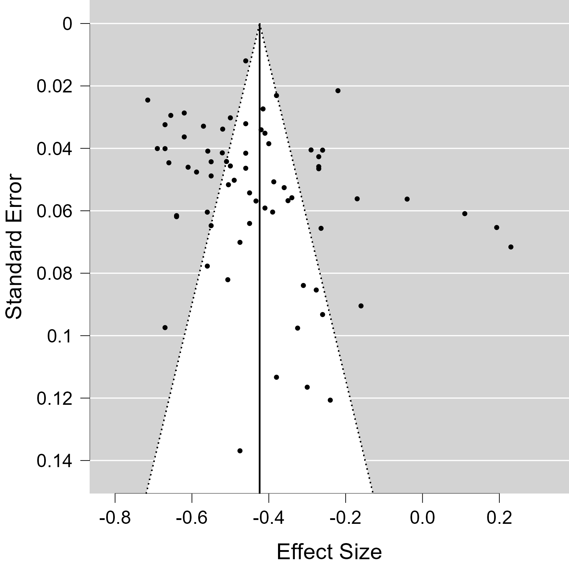

Funnel Plot for Perfectionistic Concerns and Self-Esteem

Supplementary Materials Figure 2
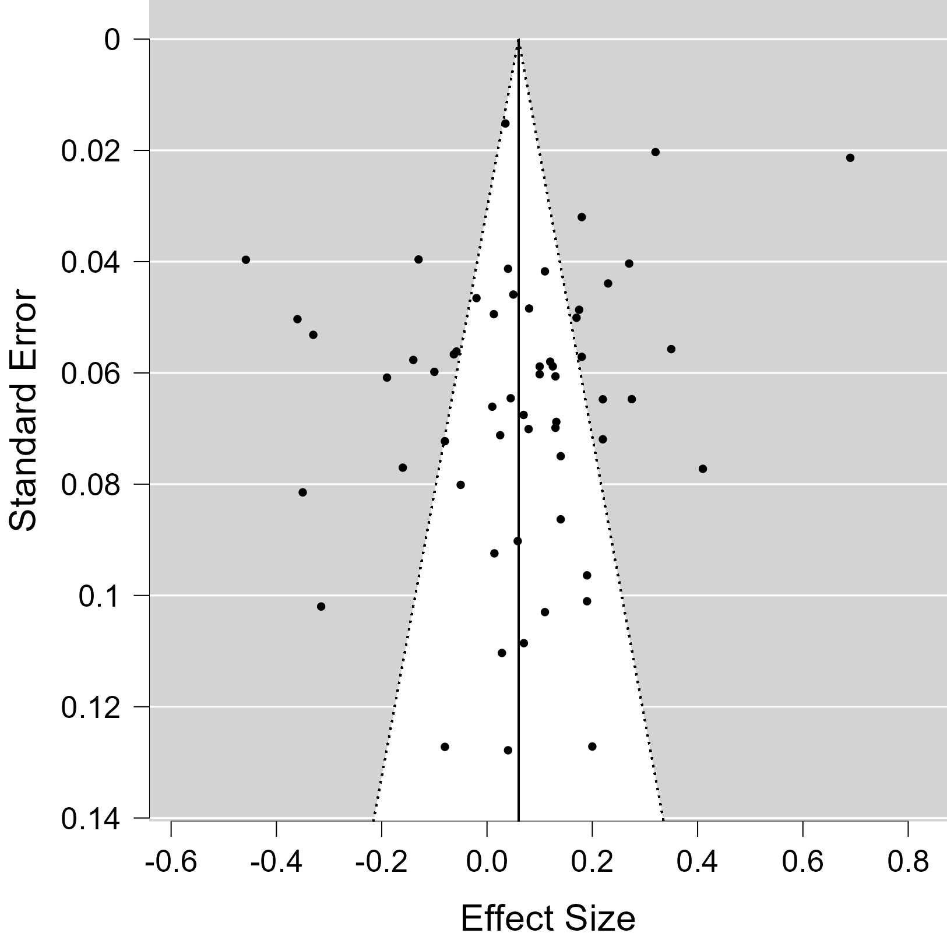
Funnel Plot

Funnel Plot for Perfectionistic Strivings and Self-Esteem

