Enhancing Self-Esteem in Adults with Body Dysmorphic Symptoms: Experimental Testing and Initial Evaluation of a Brief Internet-Based Training

Supplement
Figure S1

Estimated Marginal Means and Standard Errors of the Linear Mixed Model for Pre-Intervention, Post-Intervention, and Follow-Up Assessment of the Three Domains of Self-Esteem in Study 1

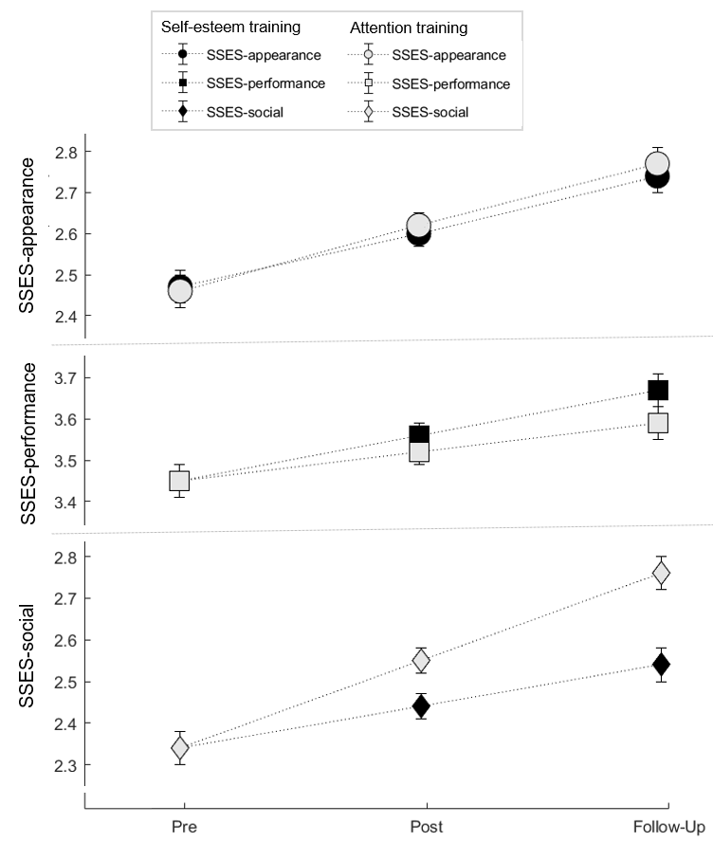

Note. The Figure shows the estimated marginal means of the linear mixed model. SSES ranged from one to five. There are significant time effects for all three domains of self-esteem. Time point*intervention group interaction is significant for SSES-social. SSES = State Self-Esteem Scale; SSES-appearance = appearance self-esteem; SSES-performance = performance self-esteem; SSES-social = social self-esteem.

Figure S2

The Flow of Participants (Study 2)
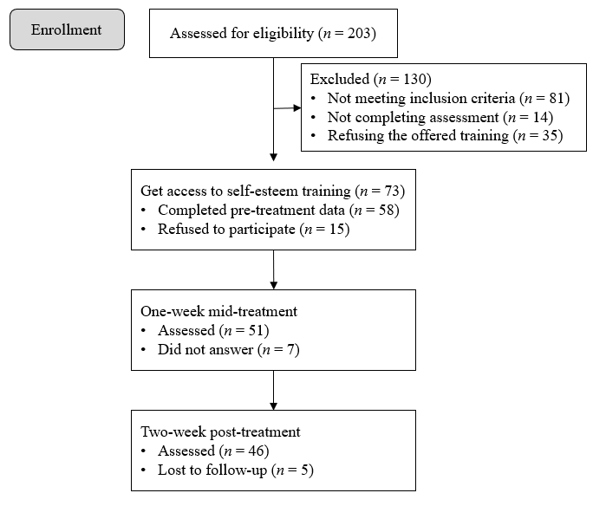

Table S1
Content of the Unguided Self-Esteem and Attention Training Evaluated in Studies 1 and 2
 | Study 1: Self-Esteem | Study 1: Attention | Study 2: Self-esteem
First Week
Monday | pre-measure | pre-measure | pre-measure
Tuesday | psychoeducation: model of unstable self-esteem | psychoeducation: role of self-focused attention | psychoeducation: model of unstable self-esteem
Wednesday | reality-check: self-attacking thoughts, inner rules, and ideals | reality-check: observing self-focused attention | reality-check: inner rules and ideals
Thursday | behavior-change: facets of self-esteem | behavior-change: shifting attention-focus (mindful walking) | behavior-change: pillars of self-esteem
Friday and weekend | behavior-change: intentional self-care | behavior-change: behavioral experiment on self-focused attention | behavior-change: intentional self-care
Second Week
Monday | overall reflection  post-measure | post-measure | mid-treatment-measure  reflection on self-care
Tuesday | - | - | reality-check: exploring self-attacking thoughts
Wednesday | - | - | behavior-change: introducing self-serving thoughts
Thursday | - | - | behavior-change: developing self-serving thoughts
Friday | - | - | overall reflection  post-measure
Third Week
Monday | follow-up-measure | follow-up-measure

Table S2

Adherence to Internet-based Trainings of Participants in Study 1 and 2
Variable | Study 1:  Self-esteem  (n = 112) |  | Study 1:  Attention  (n = 108) |  | Study 2:  Self-esteem  (n = 58)
 | M (SD) |  | M (SD) |  | M (SD)
Adherence (active training days) | 4.5 (1.06) |  | 4.35 (1.23) |  | 8.93 (2.42)
Adherence | n | % | n | % | n | %
1 active training day  2 active training days  3 active training days  4 active training days  5 active training days  6 active training days  7 active training days  8 active training days  9 active training days  10 active training days | 4  5  9  7  87 | 3.47  4.46  8.04  6.25  77.68 | 8  3  11  7  79 | 7.41  2.78  10.19  6.48  73.15 | 2  2  1  1  0  0  1  2  8  41 | 3.45  3.45  1.72  1.72  0  0  1.72  3.45  13.79  70.69

Note. In study 1, there were a maximum of five active training days, and in study 2, there were a maximum of ten active training days. A day was counted as active as soon as the participants logged in and had access to the training content.

Table S3
Fixed Effects Estimates of the Linear Mixed Model for Pre-Intervention, Post-Intervention, and Follow-Up Assessment of Appearance Self-Esteem in Study 1
Predictor | Estimate (B) |  | SE | df | t | p
Intercept |  | -0.050 | .075 | 322.436 | -0.660 | .510
SSESa baseline value |  | 0.958 | .027 | 230.662 | 35.273 | <.001
Intervention group |  | 0.019 | .042 | 426.201 | 0.439 | .661
Time point |  | 0.183 | .022 | 372.816 | 8.390 | <.001
Time point * intervention group |  | -0.015 | .022 | 375.291 | -0.689 | .491
Note. B = unstandardized estimator of the fixed effects; SE = Standard Error; df = degrees of freedom; estimate of df with Satterthwaite approximation; SSESa = appearance state self-esteem.
Table S4
Fixed Effects Estimates of the Linear Mixed Model for Pre-Intervention, Post-Intervention, and Follow-Up Assessment of Performance Self-Esteem in Study 1
Predictor | Estimate (B) |  | SE | df | t | p
Intercept |  | 0.200 | .100 | 303.364 | 1.989 | .048
SSESp baseline value |  | 0.911 | .027 | 252.246 | 33.898 | <.001
Intervention group |  | -0.027 | .042 | 424.227 | -0.635 | .526
Time point |  | 0.112 | .022 | 377.094 | 5.130 | <.001
Time point * intervention group |  | 0.027 | .022 | 377.489 | 1.213 | .226
Note. B = unstandardized estimator of the fixed effects; SE = Standard Error; df = degrees of freedom; estimate of df with Satterthwaite approximation; SSESp = performance state self-esteem.

Table S5
Fixed Effects Estimates of the Linear Mixed Model for Pre-Intervention, Post-Intervention, and Follow-Up Assessment of Social Self-Esteem in Study 1
Predictor | Estimate (B) |  | SE | df | t | p
Intercept |  | 0.180 | .072 | 362.645 | 2.495 | .013
SSESs baseline value |  | 0.848 | .025 | 226.572 | 33.996 | <.001
Intervention group |  | 0.070 | .046 | 419.396 | 1.502 | .134
Time point |  | 0.195 | .024 | 376.508 | 8.165 | <.001
Time point * intervention group |  | -0.070 | .024 | 377.713 | -2.945 | .003
Note. B = unstandardized estimator of the fixed effects; SE = Standard Error; df = degrees of freedom; estimate of df with Satterthwaite approximation; SSESs = social state self-esteem.

Table S6
Fixed Effects Estimates of the Linear Mixed Model for Pre-Intervention, Post-Intervention, and Follow-Up Assessment of Self-Focused Attention in Study 1
Predictor | Estimate (B) |  | SE | df | t | p
Intercept |  | 3.199 | .437 | 399.711 | 7.319 | <.001
FAQs baseline value |  | 0.743 | .035 | 250.746 | 21.422 | <.001
Intervention group |  | 0.043 | .283 | 417.061 | 0.151 | .880
Time point |  | -0.926 | .145 | 372.957 | -6.364 | <.001
Time point * intervention group |  | 0.149 | .145 | 373.098 | 1.026 | .305
Note. B = unstandardized estimator of the fixed effects; SE = Standard Error; df = degrees of freedom; estimate of df with Satterthwaite approximation; FAQs = self-focused attention.

Table S7
Fixed Effects Estimates of the Linear Mixed Model for Pre-Intervention, Post-Intervention, and Follow-Up Assessment of Other-Focused Attention in Study 1
Predictor | Estimate (B) |  | SE | df | t | p
Intercept |  | 2.025 | .360 | 394.675 | 5.627 | <.001
FAQo baseline value |  | 0.770 | .029 | 239.559 | 26.402 | <.001
Intervention group |  | 0.265 | .235 | 415.739 | 1.128 | .260
Time point |  | 0.221 | .121 | 373.584 | 1.822 | .069
Time point * intervention group |  | -0.280 | .121 | 373.352 | -2.301 | .022
Note. B = unstandardized estimator of the fixed effects; SE = Standard Error; df = degrees of freedom; estimate of df with Satterthwaite approximation; FAQo = other-focused attention.
Table S8
Fixed Effects Estimates of the Linear Mixed Model for Pre-Intervention, Post-Intervention, and Follow-Up Assessment of Body Dysmorphic Symptom Severity in Study 1
Predictor | Estimate (B) |  | SE | df | t | p
Intercept |  | 4.944 | .903 | 332.445 | 5.476 | <.001
FKS baseline value |  | 0.919 | .028 | 238.335 | 32.426 | <.001
Intervention group |  | -0.062 | .458 | 430.182 | -0.137 | .891
Time point |  | -3.212 | .233 | 372.457 | -13.775 | <.001
Time point * intervention group |  | 0.138 | .233 | 372.725 | 0.592 | .554
Note. B = unstandardized estimator of the fixed effects; SE = Standard Error; df = degrees of freedom; estimate of df with Satterthwaite approximation; FKS = body dysmorphic symptom severity.

Table S9
Fixed Effects Estimates of the Linear Mixed Model for Pre-Intervention, Post-Intervention, and Follow-Up Assessment of Euthymia in Study 1
Predictor | Estimate (B) |  | SE | df | t | p
Intercept |  | 1.961 | .440 | 371.609 | 4.458 | <.001
STADIeuth baseline value |  | 0.805 | .035 | 243.097 | 22.919 | <.001
Intervention group |  | 0.098 | .277 | 415.909 | 0.353 | .725
Time point |  | 0.166 | .144 | 381.613 | 1.151 | .250
Time point * intervention group |  | -0.045 | .143 | 382.746 | -0.312 | .755
Note. B = unstandardized estimator of the fixed effects; SE = Standard Error; df = degrees of freedom; estimate of df with Satterthwaite approximation; STADIeuth = euthymia.

Table S10
Fixed Effects Estimates of the Linear Mixed Model for Training for Pre-Intervention, Post-Intervention, and Follow-Up Assessment of Dysthymia in Study 1
Term | Estimate (B) |  | SE | df | t | p
Intercept |  | 1.603 | .380 | 417.503 | 4.215 | <.001
STADIdys baseline value |  | 0.817 | .032 | 253.461 | 25.317 | <.001
Intervention group |  | 0.006 | .252 | 417.767 | 0.025 | .980
Time point |  | -0.150 | .130 | 374.714 | -1.148 | .252
Time point * intervention group |  | -0.018 | .130 | 376.124 | -0.137 | .891
Note. B = unstandardized estimator of the fixed effects; SE = Standard Error; df = degrees of freedom; estimate of df with Satterthwaite approximation; STADIdys = dysthymia.

Table S11

Within-Group Intervention Effects (Estimated Trends) of the Self-Esteem and Attention Training for Pre-Intervention, Post-Intervention, and Follow-Up Assessment in Study 1
 |  |  |  |  |  |  |  | 95 % CI
Variable | Condition | Slope | SE |  | df |  | Lower |  | Upper |  | t |  | p |  | d
SSES – appearance | Self-Esteem | 0.17 | .03 |  | 370.83 |  | 0.11 |  | 0.23 |  | 5.50 |  | <.001 |  | 0.29
 | Attention | 0.20 | .03 |  | 377.15 |  | 0.14 |  | 0.26 |  | 6.39 |  | <.001 |  | 0.33
SSES – performance | Self-Esteem | 0.14 | .03 |  | 374.45 |  | 0.08 |  | 0.20 |  | 4.52 |  | <.001 |  | 0.23
 | Attention | 0.09 | .03 |  | 380.03 |  | 0.02 |  | 0.15 |  | 2.75 |  | .006 |  | 0.14
SSES –  social | Self-Esteem | 0.13 | .03 |  | 373.58 |  | 0.06 |  | 0.19 |  | 3.72 |  | <.001 |  | 0.19
 | Attention | 0.27 | .03 |  | 380.53 |  | 0.20 |  | 0.33 |  | 7.81 |  | <.001 |  | 0.25
FAQ - self | Self-Esteem | -0.78 | .21 |  | 370.20 |  | -1.18 |  | -0.37 |  | -3.80 |  | <.001 |  | -0.20
 | Attention | -1.08 | .21 |  | 375.77 |  | -1.48 |  | -0.67 |  | -5.20 |  | <.001 |  | -0.29
FAQ - other | Self-Esteem | -0.06 | .17 |  | 370.93 |  | -0.39 |  | 0.28 |  | -0.34 |  | .733 |  | -0.02
 | Attention | 0.50 | .17 |  | 375.94 |  | 0.16 |  | 0.84 |  | 2.90 |  | .004 |  | 0.15
FKS | Self-Esteem | -3.07 | .33 |  | 370.50 |  | -3.72 |  | -2.43 |  | -9.36 |  | <.001 |  | -0.49
 | Attention | -3.35 | .33 |  | 374.64 |  | -4.00 |  | -2.70 |  | -10.11 |  | <.001 |  | -0.52
STADI - euthymia | Self-Esteem | 0.12 | .20 |  | 380.32 |  | -0.28 |  | 0.52 |  | 0.60 |  | .550 |  | 0.03
 | Attention | 0.21 | .20 |  | 383.98 |  | -0.19 |  | 0.61 |  | 1.03 |  | .304 |  | 0.05
STADI - dysthymia | Self-Esteem | -0.17 | .18 |  | 372.81 |  | -0.53 |  | 0.19 |  | -0.92 |  | .361 |  | -0.05
 | Attention | -0.13 | .19 |  | 377.95 |  | -0.50 |  | 0.23 |  | -0.71 |  | .477 |  | -0.04
Notes. FKS = Body Dysmorphic Symptoms Inventory as an indicator of symptom severity; SSES = State Self-Esteem Scale; FAQ = Focus of Attention Questionnaire; STADI = State-Trait-Angst-Depressions-Inventory; SE = Standard Error; df = degrees of freedom; CI = Confidence Interval.

Table S12
Fixed Effects Estimates of the Linear Mixed Model for Pre-, Mid- and Post-Intervention Assessment of Appearance Self-Esteem in Study 2
Predictor | Estimate (B) |  | SE | df | t | p
Intercept |  | 0.275 | .140 | 81.745 | 1.966 | .053
SSESa baseline value |  | 0.831 | .048 | 56.277 | 17.278 | <.001
Time point |  | 0.155 | .032 | 109.084 | 4.866 | <.001
Note. B = unstandardized estimator of the fixed effects; SE = Standard Error; df = degrees of freedom; estimate of df with Satterthwaite approximation; SSESa = appearance state self-esteem.

Table S13
Fixed Effects Estimates of the Linear Mixed Model for Pre-, Mid- and Post-Intervention Assessment of Performance Self-Esteem in Study 2
Predictor | Estimate (B) |  | SE | df | t | p
Intercept |  | 0.448 | .248 | 64.763 | 1.806 | .076
SSESp baseline value |  | 0.830 | .068 | 56.152 | 12.185 | <.001
Time point |  | 0.135 | .036 | 109.372 | 3.786 | <.001
Note. B = unstandardized estimator of the fixed effects; SE = Standard Error; df = degrees of freedom; estimate of df with Satterthwaite approximation; SSESp = performance state self-esteem.

Table S14
Fixed Effects Estimates of Linear Mixed Model for Pre-, Mid- and Post-Intervention Assessment of Social Self-Esteem in Study 2
Predictor | Estimate (B) |  | SE | df | t | p
Intercept |  | -0.013 | .141 | 93.464 | -0.094 | .925
SSESs baseline value |  | 0.912 | .052 | 57.926 | 17.616 | <.001
Time point |  | 0.209 | .038 | 110.352 | 5.540 | <.001
Note. B = unstandardized estimator of the fixed effects; SE = Standard Error; df = degrees of freedom; estimate of df with Satterthwaite approximation; SSESs = social state self-esteem.

Table S15
Fixed Effects Estimates of the Linear Mixed Model for Pre-, Mid- and Post-Intervention Assessment of Body Dysmorphic Symptom Severity in Study 2
Predictor | Estimate (B) |  | SE | df | t | p
Intercept |  | 4.812 | 1.391 | 96.172 | 3.459 | <.001
FKS baseline value |  | 0.916 | .044 | 58.919 | 20.777 | <.001
Time point |  | -2.531 | .362 | 109.288 | -7.001 | <.001
Note. B = unstandardized estimator of the fixed effects; SE = Standard Error; df = degrees of freedom; estimate of df with Satterthwaite approximation; FKS = body dysmorphic symptom severity.
Table S16
Fixed Effects Estimates of the Linear Mixed Model for Pre-, Mid- and Post-Intervention Assessment of Euthymia in Study 2
Predictor | Estimate (B) |  | SE | df | t | p
Intercept |  | 1.891 | .830 | 103.555 | 2.280 | .025
STADIeuth baseline value |  | 0.677 | .070 | 57.360 | 9.645 | <.001
Time point |  | 1.119 | .240 | 108.027 | 4.672 | <.001
Note. B = unstandardized estimator of the fixed effects; SE = Standard Error; df = degrees of freedom; estimate of df with Satterthwaite approximation; STADIeuth = euthymia.

Table S17
Fixed Effects Estimates of the Linear Mixed Model for Pre-, Mid- and Post-Intervention Assessment of Dysthymia in Study 2
Predictor | Estimate (B) |  | SE | df | t | p
Intercept |  | 3.114 | .782 | 110.464 | 3.984 | <.001
STADIdys baseline value |  | 0.704 | .065 | 55.713 | 10.831 | <.001
Time point |  | -0.518 | .243 | 107.574 | -2.134 | .035
Note. B = unstandardized estimator of the fixed effects; SE = Standard Error; df = degrees of freedom; estimate of df with Satterthwaite approximation; STADIdys = dysthymia.

Table S18

Within-Group Intervention Effects (Estimated Trends) for Mid- and Post-Intervention Assessment in Study 2
 |  |  |  |  |  |  | 95 % CI
Variable | Slope |  | SE |  | df | Lower |  | Upper |  | t |  |  | p | d
SSES – appearance | 0.13 |  | .06 |  | 46.92 | 0.01 |  | 0.24 |  | 2.24 |  |  | .030 | 0.33
SSES – performance | 0.14 |  | .07 |  | 47.44 | 0.00 |  | 0.29 |  | 1.96 |  |  | .056 | 0.28
SSES – social | 0.22 |  | .08 |  | 49.14 | 0.05 |  | 0.39 |  | 2.61 |  |  | .012 | 0.37
FKS | -2.98 |  | .73 |  | 47.11 | -4.45 |  | -1.52 |  | -4.10 |  |  | < .001 | -0.60
STADI - euthymia | 0.88 |  | .40 |  | 47.13 | 0.09 |  | 1.68 |  | 2.23 |  |  | .030 | 0.33
STADI - dysthymia | -0.39 |  | .43 |  | 46.44 | -1.26 |  | 0.49 |  | -0.89 |  |  | .378 | -0.13
Notes. FKS = Body Dysmorphic Symptoms Inventory as an indicator of symptom severity; SSES = State Self-Esteem Scale; STADI = State-Trait-Angst-Depressions-Inventory; SE = Standard Error; df = degrees of freedom; CI = Confidence Interval.

