Supplementary Table 1. Eligible GAD-related Pharmacotherapies
Drug Class | Generic Name
Selective serotonin reuptake inhibitors | - Citalopram  - Escitalopram  - Fluoxetine  - Paroxetine  - Sertraline
Serotonin-norepinephrine reuptake inhibitors | - Desvenlafaxine  - Duloxetine  - Levomilnacipran  - Milnacipran  - Venlafaxine
Atypical antidepressants | - Bupropion  - Esketamine  - Mirtazapine  - Nefazodone  - Trazadone  - Vilazodone  - Vortioxetine
Anxiolytics | - Buspirone
Benzodiazepines* | - Alprazolam  - Clonazepam  - Diazepam  - Lorazepam
Monoamine oxidase inhibitors | - Phenelzine  - Tranylcypromine
Antihistamines | - Hydroxyzine
Tricyclic antidepressants | - Amitriptyline  - Amoxapine  - Clomipramine  - Imipramine  - Nortriptyline  - Trimipramine
Atypical antipsychotics | - Quetiapine
Anticonvulsants** | - Gabapentin  - Pregabalin
Beta-blockers** | - Atenolol  - Metoprolol  - Propranolol
*Not included as an index treatment for treatment patterns analysis
**Not considered as an inclusion factor for patient identification

Supplementary Figure 1. Sankey Diagram of Treatment Patterns Among Patients with Established GAD
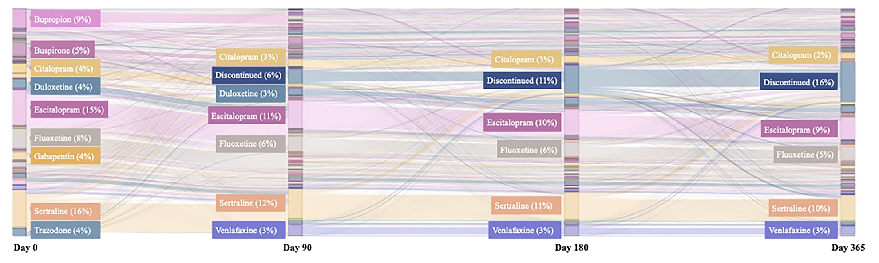

Supplementary Figure 1. Sankey Diagram of Treatment Patterns Among Patients with Established GAD. Sankey diagram depicting the proportion of patients in the established GAD cohort who remained persistent with their initial therapy, transitioned between different treatments over time (at 0-, 90-, 180-, and 365-days post-index), or discontinued treatment. Each node in the diagram represents a specific treatment regimen at a defined time point, whereas the connecting flows indicate the number of patients transitioning from one regimen to another.

