**SUPPLEMENTARY MATERIALS**

**Table S1**. Search string implemented in systematic search of OVID (MedLine, Embase, AMED, PsychINFO, JBI EBP Database), EBSCO CINAHL Plus, Scopus, and Web of Science. Final search string implemented in the systematic search was “1” AND “2” AND (“3” OR “4” OR “5” OR “6” OR “7” OR “8” OR “9” OR “10” OR “11”).

|  |  |  |
| --- | --- | --- |
| **#** | **Topic** | **Search String** |
| 1 | Ketamine | (“ketamine” OR “esketamine” OR “rketamine” OR “r-ketamine” OR “s-ketamine” OR “N-methylketamine” OR “ci 581” OR “ci-581” OR “ci581” OR “o18yuo0i83” OR “690g0d6v8h” OR calipsol* OR calypsol* OR kalipsol* OR ketalar* OR ketanest* OR ketaset*) |
| 2 | RCT | (“efficacy” OR “randomized controlled trial” OR “randomized clinical trial” OR “RCT” OR “clinical trial” OR “controlled clinical trial” OR “phase 1 clinical trial” OR “phase 2 clinical trial” OR “phase II clinical trial” OR “phase 3 clinical trial” OR “phase III clinical trial” OR “phase 4 clinical trial” OR “phase IV clinical trial”) |
| 3 | Alcohol Use Disorder | (“alcohol use disorder” OR “AUD” OR “problematic alcohol use” OR “alcohol-related disorders” OR “alcohol related disorder” OR “alcohol-induced disorders” OR “alcohol dependence” OR “alcoholism” OR “alcoholics” OR “alcohol abstinence” OR “drinking behavior” OR “alcohol drinking” OR “binge drinking” OR “heavy drinking” OR “craving” OR “alcohol withdrawal” OR “withdrawal” OR “alcohol withdrawal seizures” OR alcohol* OR drink* OR binge drink* OR alcohol addict* OR heavy drink* OR alcohol intoxicat* OR alcohol dependen* OR “alcohol consumption” OR “alcohol abuse”) |
| 4 | Anxiety Disorders | (“anxiety disorder” OR “anxiety” OR anxi* OR general* anxiety OR “GAD” OR “generalized anxiety disorder” OR “social anxiety” OR “social anxiety disorder” OR “separation anxiety disorder” OR “SAD” OR “selective mutism” OR “panic” OR “panic disorder” OR “agoraphobia” OR “separation” OR “separation anxiety” OR “phobia” OR “social phobia” OR “simple phobia” OR “specific phobia”) |
| 5 | Obsessive Compulsive Disorder | (“obsessive-compulsive” OR “obsessive compulsive” OR “obsessive-compulsive disorder” OR “obsessive compulsive disorder” OR “OCD” OR obsess* OR compulsi*) |
| 6 | Post-Traumatic Stress Disorder | (“PTSD” OR “posttraumatic stress disorder” OR “posttraumatic stress symptoms” OR “posttraumatic stress” OR “acute stress disorder”) |
| 7 | Substance Use Disorders | (“substance withdrawal syndrome” OR “stimulant use disorder” OR “substance related disorders” OR “substance use” OR “addictive drugs” OR “addiction” OR “drug use” OR “drug abuse” OR “substance abuse” OR “cocaine” OR “methamphetamine” OR “stimulant” OR “opiate” OR “heroin” OR “opioid” OR “marijuana” OR “cannabis” OR “illicit drug” OR “substances” OR “dual disorder” OR “polysubstance” OR “dual diagnosis” OR “amphetamine”) |
| 8 | Eating Disorders | (“eating disorder” OR “pica” OR “rumination disorder” OR “avoidant food intake disorder” OR “restrictive food intake disorder” OR “anorexia” OR “anorexia nervosa” OR “atypical anorexia nervosa” OR “restricting type” OR “binge eating type” OR “binge-eating type” OR “binge eating” OR “binge-eating” OR “binge-eating disorder” OR “binge eating disorder” OR “purging” OR “purging type” OR “purging disorder” OR “bulimia nervosa” OR “bulimia” OR “night eating syndrome” OR “unspecified feeding” OR “unspecified eating disorder” OR “EDNOS”) |
| 9 | Schizophrenia Spectrum Disorder | (“schizophrenia” OR “schizophrenia spectrum disorders” OR “catatonic schizophrenia” OR “disorganized schizophrenia” OR “hebephrenic schizophrenia” OR “paranoid schizophrenia” OR “residual schizophrenia” OR “undifferentiated schizophrenia”) |
| 10 | Borderline Personality Disorder | (“Borderline Personality Disorder"[Mesh] OR "Borderline Disorder"[ti] OR "Borderline Personality Disorder"[tiab] OR "borderline-patient"[ti] OR "borderline patient"[ti] OR "borderline patients"[ti] OR "borderline patients"[ti]) |

**Table S2.** Modified Cochrane Collaboration tool for assessing risk of bias for each study design [(18,19)](https://paperpile.com/c/eHh0U5/w2oO+i0LP). Gray boxes represent bias domains and sources of bias that have been removed from methodological quality assessment due to the nature of the study design. “X” represents the sources of bias considered when assessing the methodological quality.

|  |  |  |  |
| --- | --- | --- | --- |
| **Bias Domain** | **Source of Bias** | **RCT** | **Open Label Study** |
| Selection Bias | Random sequence generation | x |  |
| Allocation concealment | x |  |
| Performance Bias | Blinding of participants and personnel | x |  |
| Detection Bias | Blinding of outcome assessment | x |  |
| Attrition Bias | Incomplete outcome data | x | x |
| Reporting Bias | Selective Reporting | x | x |
| Other Bias | Anything else, ideally prespecified | x | x |

**Figure S1. Funnel Plot for PTSD Studies.**

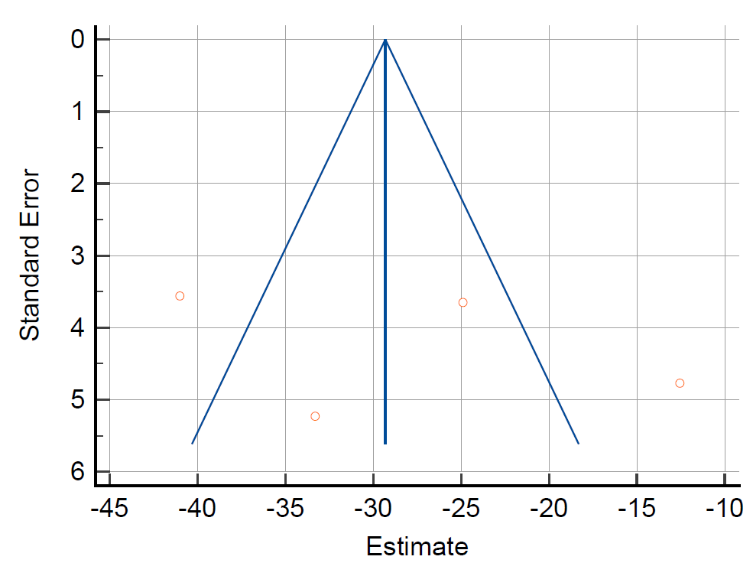

**Figure S2. Funnel Plot for TR-PTSD Studies.**

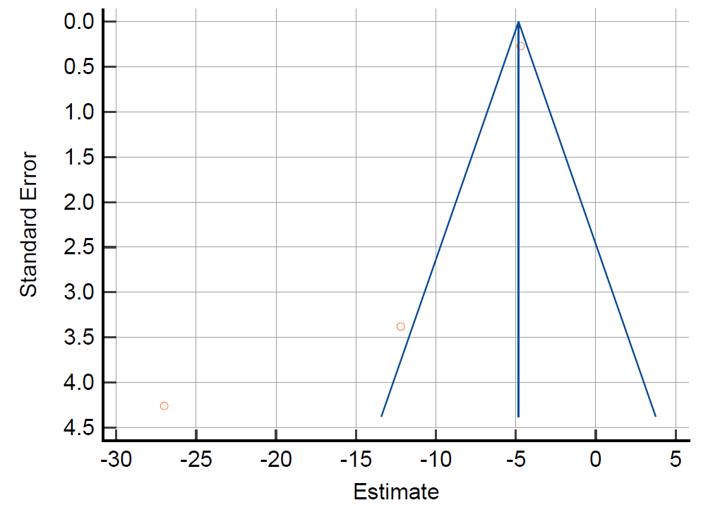

**Figure S3. Funnel Plot for OCD Studies.**

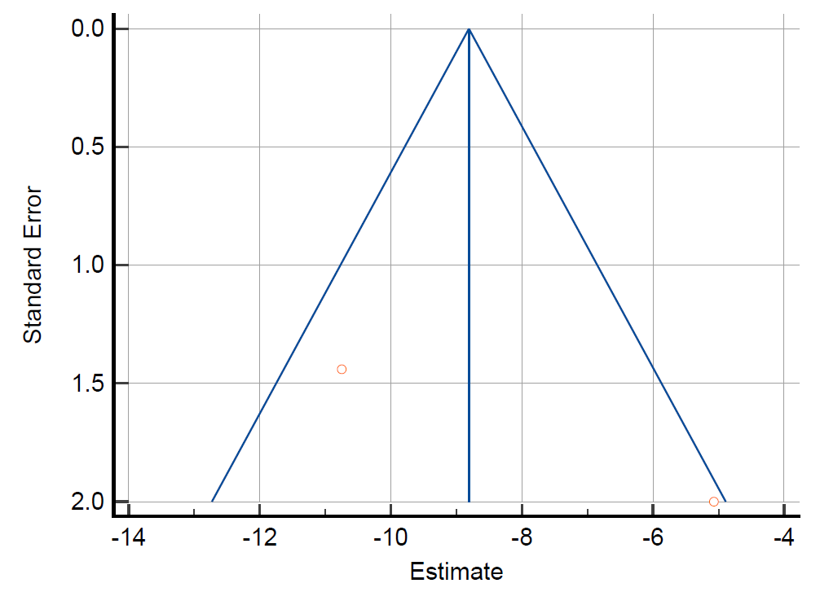

**Search Strategies**

**OVID**

***n* = 7949**

Embase Classic+Embase <1947 to 2023 June 07>

APA PsycInfo <1806 to May Week 5 2023>

AMED (Allied and Complementary Medicine) <1985 to May 2023>

JBI EBP Database <Current to May 24, 2023>

Ovid MEDLINE(R) ALL <1946 to June 07, 2023>

1 (ketamine or estketamine or rketamine or r-ketamine or s-ketamine or N-methylketamine or ci 581 or ci-581 or ci581 or o18yuo0i83 or 690g0d6v8h or calipsol* or calypsol* or kalipsol* or ketalar* or ketanest* or ketaset*).af. 107887

2 limit 1 to randomized controlled trial 25238

3 limit 2 to english language 24393

4 limit 3 to adult <18 to 64 years> 23150

5 limit 4 to humans 22821

6 limit 5 to journal article 20602

7 1 and 2 and 3 and 4 and 5 and 6 20602

8 (efficacy or randomized controlled trial or randomized clinical trial or RCT or clinical trial or controlled clinical trial or phase 1 clinical trial or phase 2 clinical trial or phase 3 clinical trial or phase 4 clinical trial or phase I clinical trial or phase II clinical trial or phase III clinical trial or phase IV clinical trial).af. 6496822

9 7 and 8 10883

10 (alcohol use disorder OR AUD OR problematic alcohol use OR alcohol-related disorders OR alcohol related disorder OR alcohol-induced disorders OR alcohol dependence OR alcoholism OR alcoholics OR alcohol abstinence OR drinking behavior OR alcohol drinking OR binge drinking OR heavy drinking OR craving OR alcohol withdrawal OR withdrawal OR alcohol withdrawal seizures OR alcohol* OR drink* OR binge drink* OR alcohol addict* OR heavy drink* OR alcohol intoxicat* OR alcohol dependen* OR alcohol consumption OR alcohol abuse).af. 2391352

11 (anxiety disorder or anxiety or anxi* or general* anxiety or GAD or generalized anxiety disorder or social anxiety or social anxiety disorder or separation anxiety disorder or SAD or selective mutism or panic or panic disorder or agoraphobia or separation or separation anxiety or phobia or social phobia or simple phobia or specific phobia).af. 2462668

12 (substance withdrawal syndrome or substance related disorders or addictive drugs or addiction or drug abuse or substance abuse or cocaine or methamphetamine or stimulant or opiate or heroin or opioid or marijuana or cannabis or illicit drug or substances or dual disorder or polysubstance or dual diagnosis or amphetamine).af. 2241919

13 (eating disorder or pica or rumination disorder or avoidant food intake disorder or restrictive food intake disorder or anorexia or anorexia nervosa or atypical anorexia nervosa or restricting type or binge eating type or binge-eating type or binge eating or binge-eating or binge-eating disorder or binge eating disorder or purging or purging type or purging disorder or bulimia nervosa or bulimia or night eating syndrome or unspecified feeding or unspecified eating disorder or EDNOS).af. 305183

14 (schizophrenia or schizophrenia spectrum disorders or catatonic schizophrenia or disorganized schizophrenia or hebephrenic schizophrenia or paranoid schizophrenia or residual schizophrenia or undifferentiated schizophrenia).af. 751982

15 (obsessive-compulsive or obsessive compulsive or obsessive-compulsive disorder or obsessive compulsive disorder or OCD or obsess* or compulsi*).af. 236965

16 (PTSD or posttraumatic stress disorder or posttraumatic stress symptoms or posttraumatic stress or acute stress disorder).af. 293598

17 10 or 11 or 12 or 13 or 14 or 15 or 16 6956317

18 9 and 19 **7949**

**SCOPUS**

***n* = 7487**

( ( ( "ketamine" OR "esketamine" OR "rketamine" OR "r-ketamine" OR "s-ketamine" OR "N-methylketamine" OR "ci 581" OR "ci-581" OR "ci581" OR "o18yuo0i83" OR "690g0d6v8h" OR "2-(2-chlorophenyl)-2-(methylamino)cyclohexanone" OR calipsol* OR calypsol* OR kalipsol* OR ketalar* OR ketanest* OR ketaset* ) AND ( "efficacy" OR "randomized controlled trial" OR "randomized clinical trial" OR "RCT" OR "clinical trial" OR "controlled clinical trial" OR "phase 1 clinical trial" OR "phase 2 clinical trial" OR "phase II clinical trial" OR "phase 3 clinical trial" OR "phase III clinical trial" OR "phase 4 clinical trial" OR "phase IV clinical trial" ) ) AND ( ( "alcohol use disorder" OR "AUD" OR "problematic alcohol use" OR "alcohol-related disorders" OR "alcohol related disorder" OR "alcohol-induced disorders" OR "alcohol dependence" OR "alcoholism" OR "alcoholics" OR "alcohol abstinence" OR "drinking behavior" OR "alcohol drinking" OR "binge drinking" OR "heavy drinking" OR "craving" OR "alcohol withdrawal" OR "withdrawal" OR "alcohol withdrawal seizures" OR alcohol* OR drink* OR binge AND drink* OR alcohol AND addict* OR heavy AND drink* OR alcohol AND intoxicat* OR alcohol AND dependen* OR "alcohol consumption" OR "alcohol abuse" ) OR ( "anxiety disorder" OR "anxiety" OR anxi* OR general* AND anxiety OR "GAD" OR "generalized anxiety disorder" OR "social anxiety" OR "social anxiety disorder" OR "separation anxiety disorder" OR "SAD" OR "selective mutism" OR "panic" OR "panic disorder" OR "agoraphobia" OR "separation" OR "separation anxiety" OR "phobia" OR "social phobia" OR "simple phobia" OR "specific phobia" ) OR ( "obsessive-compulsive" OR "obsessive compulsive" OR "obsessive-compulsive disorder" OR "obsessive compulsive disorder" OR "OCD" OR obsess* OR compulsi* ) OR ( "PTSD" OR "posttraumatic stress disorder" OR "posttraumatic stress symptoms" OR "posttraumatic stress" OR "acute stress disorder" ) OR ( "substance withdrawal syndrome" OR "stimulant use disorder" OR "substance related disorders" OR "substance use" OR "addictive drugs" OR "addiction" OR "drug use" OR "drug abuse" OR "substance abuse" OR "cocaine" OR "methamphetamine" OR "stimulant" OR "opiate" OR "heroin" OR "opioid" OR "marijuana" OR "cannabis" OR "illicit drug" OR "substances" OR "dual disorder" OR "polysubstance" OR "dual diagnosis" OR "amphetamine" ) OR ( "eating disorder" OR "pica" OR "rumination disorder" OR "avoidant food intake disorder" OR "restrictive food intake disorder" OR "anorexia" OR "anorexia nervosa" OR "atypical anorexia nervosa" OR "restricting type" OR "binge eating type" OR "binge-eating type" OR "binge eating" OR "binge-eating" OR "binge-eating disorder" OR "binge eating disorder" OR "purging" OR "purging type" OR "purging disorder" OR "bulimia nervosa" OR "bulimia" OR "night eating syndrome" OR "unspecified feeding" OR "unspecified eating disorder" OR "EDNOS" ) OR ( "schizophrenia" OR "schizophrenia spectrum disorders" OR "catatonic schizophrenia" OR "disorganized schizophrenia" OR "hebephrenic schizophrenia" OR "paranoid schizophrenia" OR "residual schizophrenia" OR "undifferentiated schizophrenia" ) AND ( LIMIT-TO ( EXACTKEYWORD , "Human" ) OR LIMIT-TO ( EXACTKEYWORD , "Humans" ) OR LIMIT-TO ( EXACTKEYWORD , "Ketamine" ) OR LIMIT-TO ( EXACTKEYWORD , "Randomized Controlled Trial" ) ) AND ( LIMIT-TO ( DOCTYPE , "ar" ) ) AND ( LIMIT-TO ( LANGUAGE , "English" ) ) AND ( LIMIT-TO ( SRCTYPE , "j" ) ) AND ( LIMIT-TO ( PUBSTAGE , "final" ) ) AND ( LIMIT-TO ( OA , "all" ) )

**Web of Science**

***n* = 207 Alcohol Use Disorder**

(ALL=(“ketamine” OR “esketamine” OR “rketamine” OR “r-ketamine” OR “s-ketamine” OR “N-methylketamine” OR “ci 581” OR “ci-581” OR “ci581” OR “o18yuo0i83” OR “690g0d6v8h” OR “2-(2-chlorophenyl)-2-(methylamino)cyclohexanone” OR calipsol* OR calypsol* OR kalipsol* OR ketalar* OR ketanest* OR ketaset*) AND ALL=(“efficacy” OR “randomized controlled trial” OR “randomized clinical trial” OR “RCT” OR “clinical trial” OR “controlled clinical trial” OR “phase 1 clinical trial” OR “phase 2 clinical trial” OR “phase II clinical trial” OR “phase 3 clinical trial” OR “phase III clinical trial” OR “phase 4 clinical trial” OR “phase IV clinical trial”) AND ALL=(“alcohol use disorder” OR “AUD” OR “problematic alcohol use” OR “alcohol-related disorders” OR “alcohol related disorder” OR “alcohol-induced disorders” OR “alcohol dependence” OR “alcoholism” OR “alcoholics” OR “alcohol abstinence” OR “drinking behavior” OR “alcohol drinking” OR “binge drinking” OR “heavy drinking” OR “craving” OR “alcohol withdrawal” OR “withdrawal” OR “alcohol withdrawal seizures” OR alcohol* OR drink* OR binge drink* OR alcohol addict* OR heavy drink* OR alcohol intoxicat* OR alcohol dependen* OR “alcohol consumption” OR “alcohol abuse”)) and Article (Document Types) and English (Languages)

***n* = 345 Anxiety Disorder**

((ALL=(“ketamine” OR “esketamine” OR “rketamine” OR “r-ketamine” OR “s-ketamine” OR “N-methylketamine” OR “ci 581” OR “ci-581” OR “ci581” OR “o18yuo0i83” OR “690g0d6v8h” OR “2-(2-chlorophenyl)-2-(methylamino)cyclohexanone” OR calipsol* OR calypsol* OR kalipsol* OR ketalar* OR ketanest* OR ketaset*)) AND ALL=(“efficacy” OR “randomized controlled trial” OR “randomized clinical trial” OR “RCT” OR “clinical trial” OR “controlled clinical trial” OR “phase 1 clinical trial” OR “phase 2 clinical trial” OR “phase II clinical trial” OR “phase 3 clinical trial” OR “phase III clinical trial” OR “phase 4 clinical trial” OR “phase IV clinical trial”)) AND ALL=(“anxiety disorder” OR “anxiety” OR anxi* OR general* anxiety OR “GAD” OR “generalized anxiety disorder” OR “social anxiety” OR “social anxiety disorder” OR “separation anxiety disorder” OR “SAD” OR “selective mutism” OR “panic” OR “panic disorder” OR “agoraphobia” OR “separation” OR “separation anxiety” OR “phobia” OR “social phobia” OR “simple phobia” OR “specific phobia”) and Article (Document Types) and English (Languages)

***n =* 20 OCD**

“ketamine” OR “esketamine” OR “rketamine” OR “r-ketamine” OR “s-ketamine” OR “N-methylketamine” OR “ci 581” OR “ci-581” OR “ci581” OR “o18yuo0i83” OR “690g0d6v8h” OR “2-(2-chlorophenyl)-2-(methylamino)cyclohexanone” OR calipsol* OR calypsol* OR kalipsol* OR ketalar* OR ketanest* OR ketaset* (All Fields) and “efficacy” OR “randomized controlled trial” OR “randomized clinical trial” OR “RCT” OR “clinical trial” OR “controlled clinical trial” OR “phase 1 clinical trial” OR “phase 2 clinical trial” OR “phase II clinical trial” OR “phase 3 clinical trial” OR “phase III clinical trial” OR “phase 4 clinical trial” OR “phase IV clinical trial” (All Fields) and “obsessive-compulsive” OR “obsessive compulsive” OR “obsessive-compulsive disorder” OR “obsessive compulsive disorder” OR “OCD” OR obsess* OR compulsi* (All Fields) and Article (Document Types) and English (Languages)

***n* = 87 PTSD**

((ALL=(“ketamine” OR “esketamine” OR “rketamine” OR “r-ketamine” OR “s-ketamine” OR “N-methylketamine” OR “ci 581” OR “ci-581” OR “ci581” OR “o18yuo0i83” OR “690g0d6v8h” OR “2-(2-chlorophenyl)-2-(methylamino)cyclohexanone” OR calipsol* OR calypsol* OR kalipsol* OR ketalar* OR ketanest* OR ketaset*)) AND ALL=(“efficacy” OR “randomized controlled trial” OR “randomized clinical trial” OR “RCT” OR “clinical trial” OR “controlled clinical trial” OR “phase 1 clinical trial” OR “phase 2 clinical trial” OR “phase II clinical trial” OR “phase 3 clinical trial” OR “phase III clinical trial” OR “phase 4 clinical trial” OR “phase IV clinical trial”)) AND ALL=(“PTSD” OR “posttraumatic stress disorder” OR “posttraumatic stress symptoms” OR “posttraumatic stress” OR “acute stress disorder”) and Article (Document Types) and English (Languages)

***n* = 23 Substance Withdrawal Syndrome**

(((((ALL=(“ketamine” OR “esketamine” OR “retamine” OR “r-ketamine” OR “s-ketamine” OR “N-methylketamine” OR “ci 581” OR “ci-581” OR “ci501” OR “o18yuo0i83” OR “690g0d6v8h” OR “2-(2-chlorophenyl)-2-(methylamino)cyclohexanone” OR calipsol* OR calypsol* OR kalipsol* OR ketalar* OR ketanest* OR ketaset*)) AND ALL=(“efficacy” OR “randomized controlled trial” OR “randomized clinical trial” OR “RCT” OR “clinical trial” OR “controlled clinical trial” OR “phase 1 clinical trial” OR “phase 2 clinical trial” OR “phase II clinical trial” OR “phase 3 clinical trial” OR “phase III clinical trial” OR “phase 4 clinical trial” OR “phase IV clinical trial”)) AND ALL=(“PTSD” OR “posttraumatic stress disorder” OR “posttraumatic stress symptoms” OR “posttraumatic stress” OR “acute stress disorder”)) AND ALL=(“ketamine” OR “esketamine” OR “retamine” OR “r-ketamine” OR “s-ketamine” OR “N-methylketamine” OR “ci 581” OR “ci-581” OR “ci501” OR “o18yuo0i83” OR “690g0d6v8h” OR “2-(2-chlorophenyl)-2-(methylamino)cyclohexanone” OR calipsol* OR calypsol* OR kalipsol* OR ketalar* OR ketanest* OR ketaset*)) AND ALL=(“efficacy” OR “randomized controlled trial” OR “randomized clinical trial” OR “RCT” OR “clinical trial” OR “controlled clinical trial” OR “phase 1 clinical trial” OR “phase 2 clinical trial” OR “phase II clinical trial” OR “phase 3 clinical trial” OR “phase III clinical trial” OR “phase 4 clinical trial” OR “phase IV clinical trial”)) AND ALL=(“substance withdrawal syndrome” OR “stimulant use disorder” OR “substance related disorders” OR “substance use” OR “addictive drugs” OR “addiction” OR “drug use” OR “drug abuse” OR “substance abuse” OR “cocaine” OR “methamphetamine” OR “stimulant” OR “opiate” OR “heroin” OR “opioid” OR “marijuana” OR “cannabis” OR “illicit drug” OR “substances” OR “dual disorder” OR “polysubstance” OR “dual diagnosis” OR “amphetamine”) and Article (Document Types) and English (Languages)

***n =* 10 Eating Disorder**

“ketamine” OR “esketamine” OR “rketamine” OR “r-ketamine” OR “s-ketamine” OR “N-methylketamine” OR “ci 581” OR “ci-581” OR “ci581” OR “o18yuo0i83” OR “690g0d6v8h” OR “2-(2-chlorophenyl)-2-(methylamino)cyclohexanone” OR calipsol* OR calypsol* OR kalipsol* OR ketalar* OR ketanest* OR ketaset* (All Fields) and “efficacy” OR “randomized controlled trial” OR “randomized clinical trial” OR “RCT” OR “clinical trial” OR “controlled clinical trial” OR “phase 1 clinical trial” OR “phase 2 clinical trial” OR “phase II clinical trial” OR “phase 3 clinical trial” OR “phase III clinical trial” OR “phase 4 clinical trial” OR “phase IV clinical trial” (All Fields) and “eating disorder” OR “pica” OR “rumination disorder” OR “avoidant food intake disorder” OR “restrictive food intake disorder” OR “anorexia” OR “anorexia nervosa” OR “atypical anorexia nervosa” OR “restricting type” OR “binge eating type” OR “binge-eating type” OR “binge eating” OR “binge-eating” OR “binge-eating disorder” OR “binge eating disorder” OR “purging” OR “purging type” OR “purging disorder” OR “bulimia nervosa” OR “bulimia” OR “night eating syndrome” OR “unspecified feeding” OR “unspecified eating disorder” OR “EDNOS” (All Fields) and English (Languages) and Article (Document Types)

***n* = 178 Schizophrenia**

((ALL=(“ketamine” OR “esketamine” OR “rketamine” OR “r-ketamine” OR “s-ketamine” OR “N-methylketamine” OR “ci 581” OR “ci-581” OR “ci581” OR “o18yuo0i83” OR “690g0d6v8h” OR “2-(2-chlorophenyl)-2-(methylamino)cyclohexanone” OR calipsol* OR calypsol* OR kalipsol* OR ketalar* OR ketanest* OR ketaset*)) AND ALL=(“efficacy” OR “randomized controlled trial” OR “randomized clinical trial” OR “RCT” OR “clinical trial” OR “controlled clinical trial” OR “phase 1 clinical trial” OR “phase 2 clinical trial” OR “phase II clinical trial” OR “phase 3 clinical trial” OR “phase III clinical trial” OR “phase 4 clinical trial” OR “phase IV clinical trial”)) AND ALL=(“schizophrenia” OR “schizophrenia spectrum disorders” OR “catatonic schizophrenia” OR “disorganized schizophrenia” OR “hebephrenic schizophrenia” OR “paranoid schizophrenia” OR “residual schizophrenia” OR “undifferentiated schizophrenia” ) and Article (Document Types) and English (Languages)

**CINAHL Plus**

***n* = 1,549**

(((“ketamine” OR “esketamine” OR “rketamine” OR “r-ketamine” OR “s-ketamine” OR “N-methylketamine” OR “ci 581” OR “ci-581” OR “ci581” OR “o18yuo0i83” OR “690g0d6v8h” OR “2-(2-chlorophenyl)-2-(methylamino)cyclohexanone” OR calipsol* OR calypsol* OR kalipsol* OR ketalar* OR ketanest* OR ketaset*) AND (“efficacy” OR “randomized controlled trial” OR “randomized clinical trial” OR “RCT” OR “clinical trial” OR “controlled clinical trial” OR “phase 1 clinical trial” OR “phase 2 clinical trial” OR “phase II clinical trial” OR “phase 3 clinical trial” OR “phase III clinical trial” OR “phase 4 clinical trial” OR “phase IV clinical trial”)) AND ((“alcohol use disorder” OR “AUD” OR “problematic alcohol use” OR “alcohol-related disorders” OR “alcohol related disorder” OR “alcohol-induced disorders” OR “alcohol dependence” OR “alcoholism” OR “alcoholics” OR “alcohol abstinence” OR “drinking behavior” OR “alcohol drinking” OR “binge drinking” OR “heavy drinking” OR “craving” OR “alcohol withdrawal” OR “withdrawal” OR “alcohol withdrawal seizures” OR alcohol* OR drink* OR binge drink* OR alcohol addict* OR heavy drink* OR alcohol intoxicat* OR alcohol dependen* OR “alcohol consumption” OR “alcohol abuse”) OR (“anxiety disorder” OR “anxiety” OR anxi* OR general* anxiety OR “GAD” OR “generalized anxiety disorder” OR “social anxiety” OR “social anxiety disorder” OR “separation anxiety disorder” OR “SAD” OR “selective mutism” OR “panic” OR “panic disorder” OR “agoraphobia” OR “separation” OR “separation anxiety” OR “phobia” OR “social phobia” OR “simple phobia” OR “specific phobia”) OR (“obsessive-compulsive” OR “obsessive compulsive” OR “obsessive-compulsive disorder” OR “obsessive compulsive disorder” OR “OCD” OR obsess* OR compulsi*) OR (“PTSD” OR “posttraumatic stress disorder” OR “posttraumatic stress symptoms” OR “posttraumatic stress” OR “acute stress disorder”) OR (“substance withdrawal syndrome” OR “stimulant use disorder” OR “substance related disorders” OR “substance use” OR “addictive drugs” OR “addiction” OR “drug use” OR “drug abuse” OR “substance abuse” OR “cocaine” OR “methamphetamine” OR “stimulant” OR “opiate” OR “heroin” OR “opioid” OR “marijuana” OR “cannabis” OR “illicit drug” OR “substances” OR “dual disorder” OR “polysubstance” OR “dual diagnosis” OR “amphetamine”) OR (“eating disorder” OR “pica” OR “rumination disorder” OR “avoidant food intake disorder” OR “restrictive food intake disorder” OR “anorexia” OR “anorexia nervosa” OR “atypical anorexia nervosa” OR “restricting type” OR “binge eating type” OR “binge-eating type” OR “binge eating” OR “binge-eating” OR “binge-eating disorder” OR “binge eating disorder” OR “purging” OR “purging type” OR “purging disorder” OR “bulimia nervosa” OR “bulimia” OR “night eating syndrome” OR “unspecified feeding” OR “unspecified eating disorder” OR “EDNOS”) OR (“schizophrenia” OR “schizophrenia spectrum disorders” OR “catatonic schizophrenia” OR “disorganized schizophrenia” OR “hebephrenic schizophrenia” OR “paranoid schizophrenia” OR “residual schizophrenia” OR “undifferentiated schizophrenia”).

**Limiters/Expanders**

Limiters - Full Text; English Language; Research Article; Human; Randomized Controlled Trials; Publication Type: Randomized Controlled Trial; Age Groups: All Adult

Expanders - Also search within the full text of the articles

Search modes - SmartText Searching

**Last Run Via**

Interface - EBSCOhost Research Databases

Search Screen - Advanced Search

Database - CINAHL Plus with Full Text

**Results**

1,549