**SUPPLEMENTARY MATERIAL**

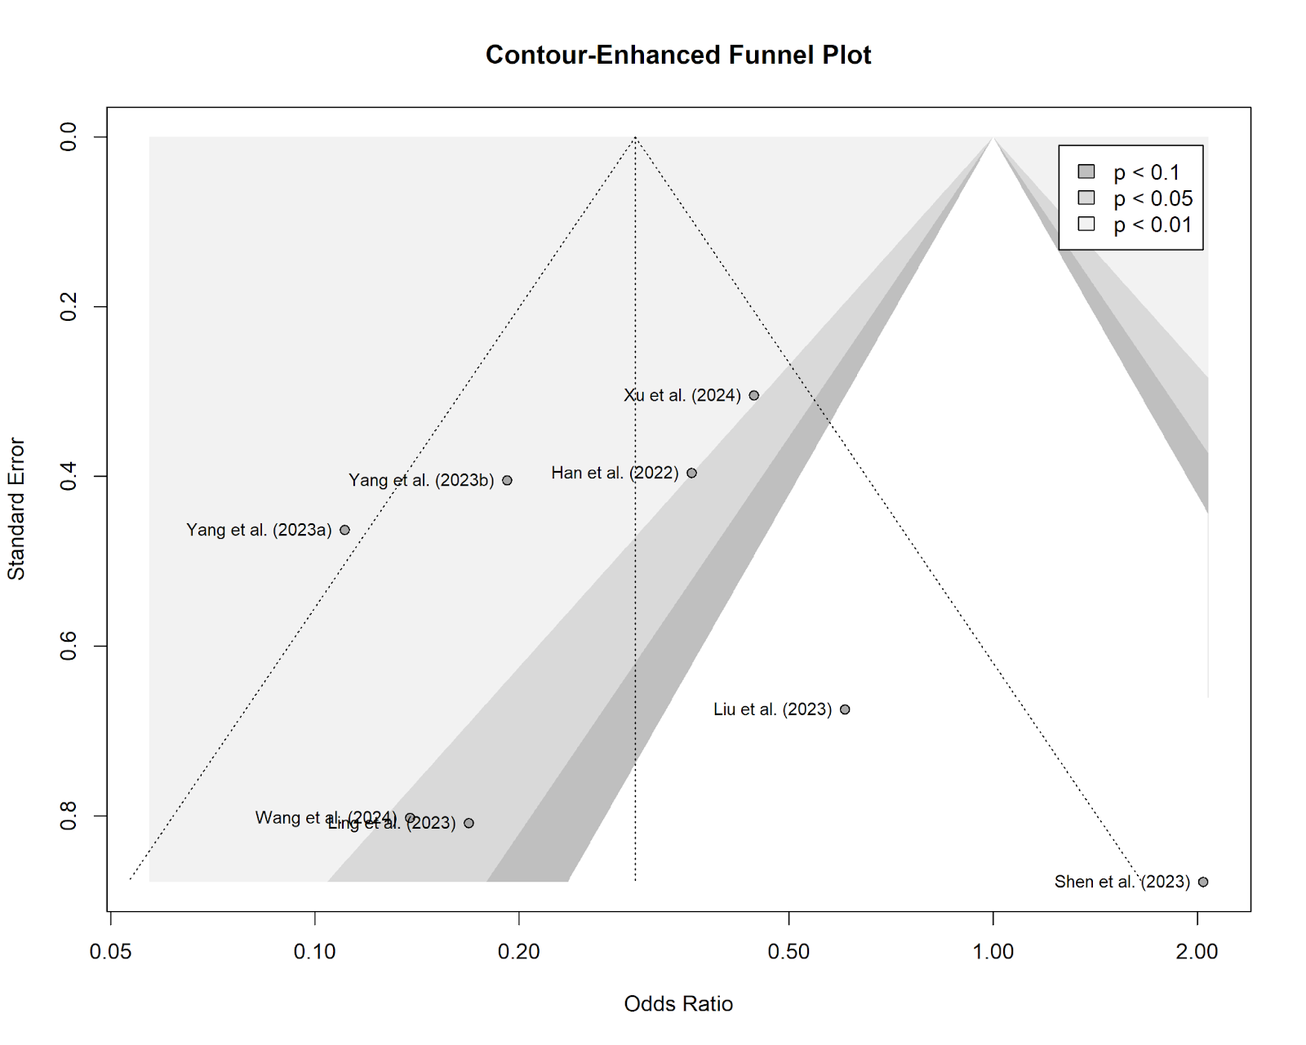

**Supplementary Figure 1.** Funnel Plot of Odds Ratios of Postpartum Depression Within 1 Week of Delivery.

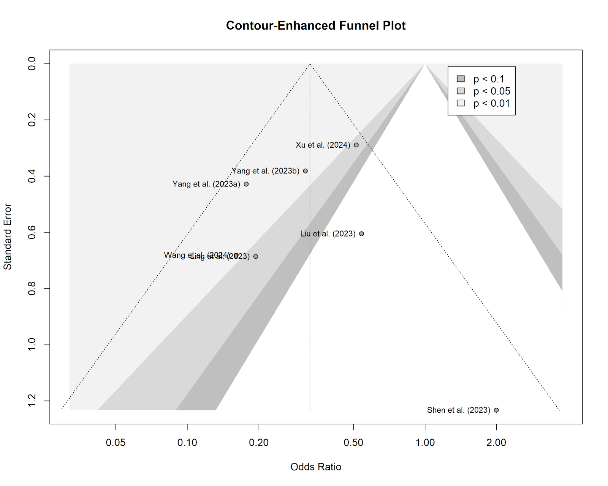

**Supplementary Figure 2.** Funnel Plot of Odds Ratios of Postpartum Depression Between 4-6 Weeks Following Delivery.