Table S1: Quality Scoring Grid.

PAPER | TTM diagnosed using recognised tool | Report of comorbidities using validated instrument (or excluded based on valid instrument) | Report and exclusion of substance misuse using appropriate instrument | Report and / or exclusion of ICDs using appropriate instrument | Education and / or IQ | Study reports most appropriate outcome measure(s) | Numerical report (mean, SD, n) within paper | Controls defined and screened for psychiatric disease | Were the cognitive tests clearly defined, valid, reliable, and implemented consistently across all study participants? | Total
Bohne et al., 2005 | 1 | 0.5 | 1 | 0 | 1 | 1 | 1 | 1 | 1 | 7.5
Bohne et al., 2008 | 1 | 0.5 | 1 | 0 | 1 | 1 | 1 | 1 | 1 | 7.5
Brennan et al., 2016 | 1 | 1 | 0 | 0 | 1 | 1 | 1 | 1 | 1 | 7
Chamberlain et al., 2007 | 1 | 1 | 1 | 1 | 1 | 1 | 1 | 1 | 1 | 9
Chamberlain et al., 2006 | 1 | 1 | 0 | 0 | 1 | 1 | 1 | 0.5 | 1 | 6.5
Coetzer et al., 1999 | 0.5 | 0.5 | 1 | 0 | 1 | 1 | 1 | 0.5 | 1 | 6
Demirci et al., 2021 | 1 | 1 | 1 | 0 | 1 | 1 | 1 | 1 | 0.5 | 7.5
Grant et al., 2011 | 0.5 | 1 | 0 | 0 | 1 | 1 | 1 | 1 | 0.5 | 6
Flessner et al., 2016 | 1 | 1 | 0 | 0 | 0 | 1 | 1 | 1 | 1 | 6
Keuthen et al., 1996 | 0.5 | 0.5 | 1 | 0 | 1 | 1 | 1 | 0 | 1 | 6
Martin et al., 1993 | 1 | 0 | 0 | 0 | 1 | 1 | 1 | 0.5 | 1 | 5.5
Odlaug et al., 2014 | 1 | 1 | 1 | 0 | 1 | 1 | 0 | 1 | 1 | 7
Odlaug et al., 2012 | 1 | 1 | 1 | 0 | 1 | 1 | 1 | 1 | 0.5 | 7.5
Odlaug et al., 2013 | 1 | 1 | 1 | 1 | 1 | 1 | 1 | 1 | 0.5 | 8.5
Peris et al., 2021 | 1 | 1 | 1 | 0 | 0 | 1 | 1 | 1 | 1 | 7
Rettew et al., 1991 | 1 | 0.5 | 1 | 0 | 1 | 1 | 1 | 1 | 1 | 7.5
Stanley et al., 1997 | 1 | 1 | 1 | 0 | 1 | 1 | 1 | 1 | 1 | 8
Wilton et al., 2020 | 1 | 1 | 0 | 0 | 0 | 0.5 | 1 | 1 | 1 | 5.5

Figure S1a: ID shifting

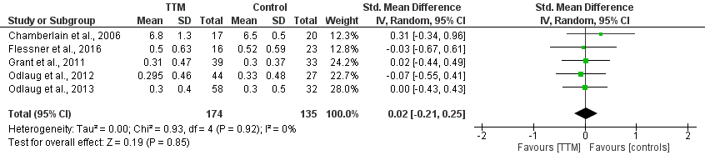

Figure S1b: ED shifting

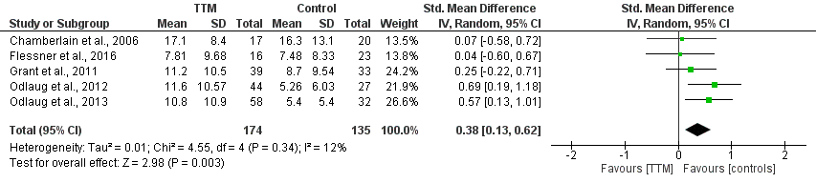

Figure S2: Stop Signal
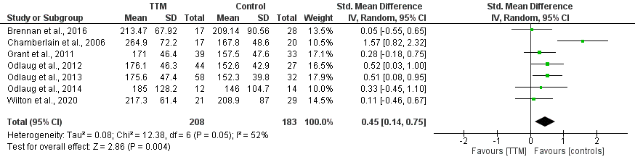

Figure S3: Stroop
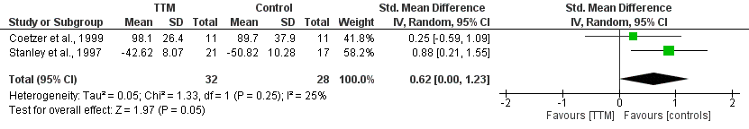

Figure S4: California Verbal Learning
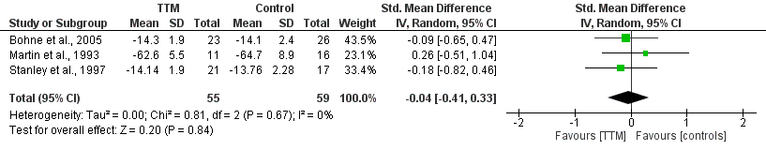

Figure S5: Wisconsin Card sorting
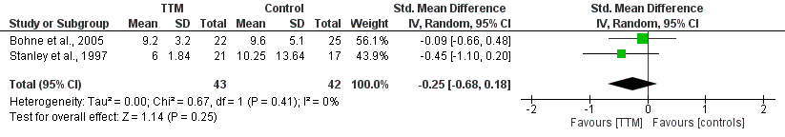

Figure S6: Money’s Road Map
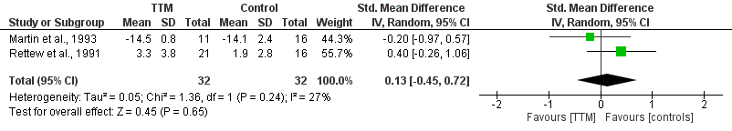

Figure S7: Pattern recognition memory
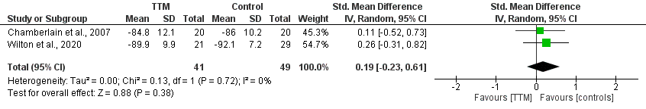

Figure S8: Rey-Osterrieth Complex Figures test
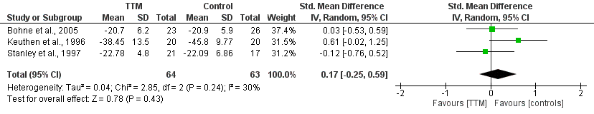

Figure S9: Rey-Osterrieth Copy test
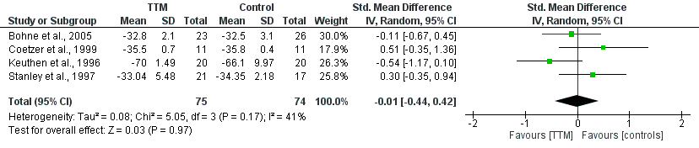

Figure S10: Spatial span
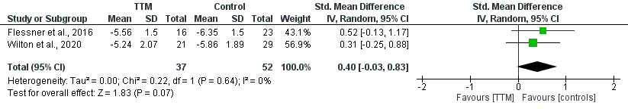

Figure S11: Tower of London
