Randomized Controlled Trial Evaluating Policies to Control Local Pollution Generated by Latin American Firms
Protocol for the collection of the end-line data on sustainable takeout and delivery packaging in Honduras
The purpose of this protocol is to outline the data collection process to estimate the sustainability of takeout and delivery packaging among Honduran restaurants. Data will be collected on a single item from each restaurant, which must be representative of the type of restaurant, and ideally require a single container and add-ons (i.e., fork and knife). Only restaurants for which the research team has baseline data on their packaging will be visited for this end-line.
Background
From January 27th to April 12th of 2023, the research team of the project collected data on 75 restaurants located in different parts of Honduras, with most located in the central district of the country, where the capital city Tegucigalpa is located. The baseline survey collected data on the demographics of the restaurant (i.e., type of restaurant, type of ownership, and proxies for size, such as average number of clients and employees, among other information), sustainability concern, factors affecting the choice of packaging, attitudes, and manager/owner demographics. Additionally, to the baseline survey, data was collected on the packaging of three random main dishes for takeout or delivery coming out of the kitchen at the moment the data collector was present. The packaging data was then used to estimate the sustainability score of the takeout and delivery packaging of each restaurant.
In this end-line data collection, only data on the takeout and delivery packaging will be collected. The collected data will be merged for analysis with the data collected during the baseline survey and packaging data.
Data collection
Personnel
One person will be in charge of collecting the data for the 79 restaurants. This person has been identified, and she holds a B.Sc. in environmental sciences, which will allow her to quickly get acquainted with the literature of the project, packaging materials, and the estimation of the sustainability score. She also has a vehicle and is available to make the visits to the restaurants.
Additionally, a cell-phone with an active number will be provided to the data collector. This cell-phone was activated exclusively for this project, and is the number that has been used to contact the participants.
Restaurant addresses
The researchers of the project do not have a list with the addresses of the restaurants, but a list with the names of the restaurants, location (department or municipality), and name and contact information of the owner/manager. Most of the restaurants are findable using Google Maps and Waze, but the addresses of certain types of restaurants, such as dark kitchens, are not publicly available. For the restaurants that are not findable using navigation apps, their managers/owners will be contacted to request permission to visit the restaurant.
Geographical distribution
The restaurants to visit are located in the following locations:
Location | Frequency
Distrito Central (Tegucigalpa y Comayaguela) | 28
Cedeño | 18
Marcovia | 9
Danlí | 4
Gracias | 4
San Antonio de Oriente | 2
San Pedro Sula | 2
Tela | 2
La Esperanza | 1
Santa Cruz de Yojoa | 1
La Unión | 1
Valle de Angeles | 1
Santa Lucía | 1
Choluteca | 1
Campamento | 1
Yamaranguila | 1
Ojochalito | 1
Omoa | 1

Estimation of the sustainability score
The data collector will receive in-house training in the estimation of the sustainability score. In addition to the training, the following resources are available at any moment through the website of the project (link to the website of the project).
The resources available are:
- Packaging material identification guide. Available here.
- Sustainability score calculation tutorial. Available here.
- Excel file to calculate the score. Available here.
The data collector will record the materials used in the take-out/delivery of the food item at each restaurant and then calculate the sustainability score.
Data collection process
The data collector will adhere to the following process and food item selection criteria.
Data collection process

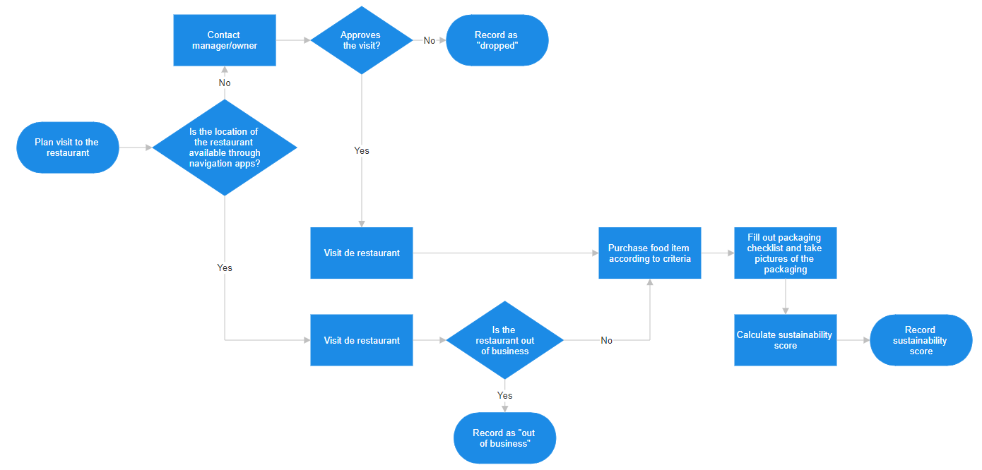

Food item selection criteria
At each restaurant, a single food item will be purchased for take-out. The item selected must meet the following criteria:
- Must be a main dish.
- Must require add-ons for its consumption (fork and knife).
- Would require a single container.
Behavior protocol
The data collector will adhere to the following protocol to ensure consistency of the orders:
- Will explore the menu and identify eligible food items, as would a regular consumer.
- If multiple food items fulfill the selection criteria, the data collector will select the first item presented in the menu.
  - If due to the nature of the restaurant, none of the main dishes require add-ons (i.e., finger food restaurants), this criterion can be omitted.
- The data collector will not request add-ons but wait for them to be offered or given with the order.
- The data collector will not request a drink with the purchase. If the drink is automatically given with the purchase, the data collector will not include it in the calculation of the sustainability score.
Final data set
At the end of the data collection process, endline sustainability scores will be merged with the baseline database using the restaurant ID. Afterward, all identifiable information will be erased.
---

This is to be consistent with the data collected in the baseline survey, in which all food items were main dishes. This automatically excludes appetizers, salads, soups, and desserts.
It was suggested that the data collector could choose the item closest to the median price. However, median estimations might be complicated especially at heavy foot traffic hours or at restaurants with long and complex menus. Hence, we assume the restaurant would order their main dishes placing the “star” dishes at the top of the options.

