Appendix
Multi-peril crop insurance – Indemnity type
Imagine you are offered the following multi-peril insurance for the crop that is most important to you. The entire acreage of the crop is insured. The insurance offered is a crop-specific damage-based insurance. This means that the indemnity is based on the actual natural yield loss of a crop. In this insurance, the yield loss is not attributed to specific causes, but any yield loss is compensated (e.g. frost damage, drought, pest infestation, etc.). The reference is the average yield of the insured crop over the last 10 years. The starting point for the amount of compensation is also a value per hectare freely chosen by the farmer (expected price times expected yield). However, indemnities do not compensate for the entire yield loss, but only up to a coverage level of 70% of the average yield. The deductible is therefore 30%. This is illustrated in the following diagram.
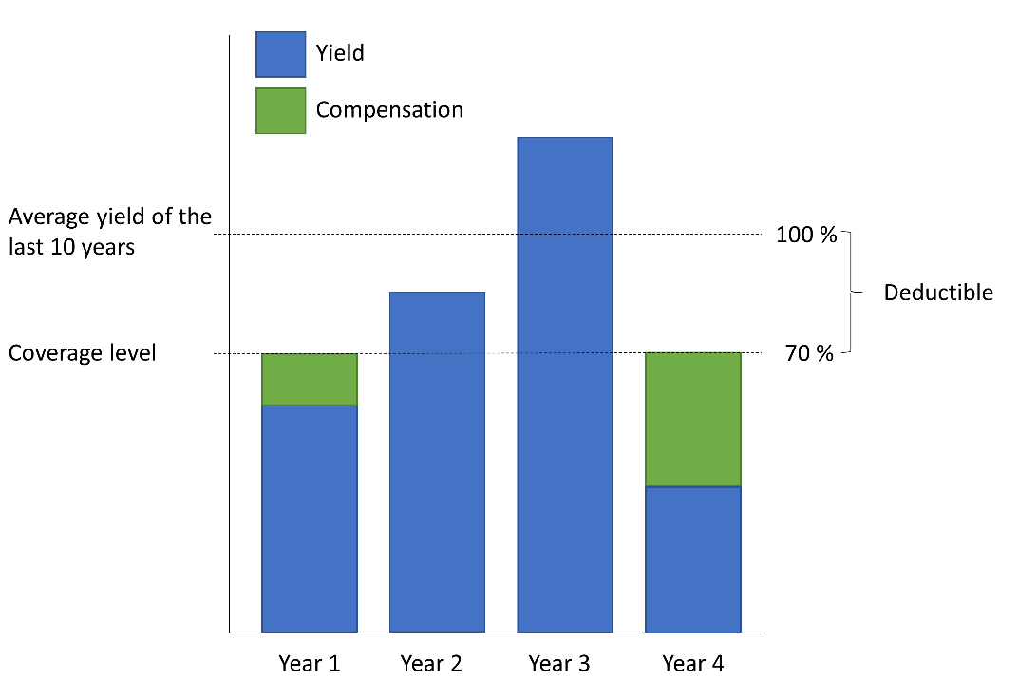
So, let's imagine you choose a hectare value of €2,000 and the yield achieved by the insured crop is 60% of the average yield of the last 10 years, based on the hectare value this is €1,200. At the coverage level of 70%, which corresponds to a hectare value of €1,400, you would receive a compensation payment of €200 from the insurance company. This is because you have to bear the first 30% yield loss yourself (deductible = €600 of the hectare value).
Please select the maximum percentage of the hectare value (expected price times expected yield) you would pay for this insurance. When making your decision, please keep in mind that the total price you pay for the insurance is made up of two components: the fair premium and the surcharge. The fair premium corresponds to the average expected insurance benefit, i.e. the amount that you will receive from the insurance company on average over the years. The surcharge is used by the insurer to cover administrative costs and to generate a profit.
0%● 1%● 2%● 3%● 4%● 5%● 6%● 7%● 8%●
If none of the values seems suitable for you, you can specify your own value here: _____%
Please imagine that the government takes over 50% of the total price (= fair premium + surcharge) to support you in your risk management. Please select what percentage of the value of the hectare you would pay as the maximum total price for this insurance if the state paid the other half of this total price.
0%● 1%● 2%● 3%● 4%● 5%● 6%● 7%● 8%●
If none of the values seems suitable for you, you can specify your own value here: _____%

Multi-peril crop insurance – Index type
Imagine you were offered the following index insurance for the crop that is most important to you. The entire acreage of the crop is insured. The insurance offered is a crop specific index-based insurance. This means that the index insurance offered is NOT contingent upon proof of an actual loss occurring to the crop you have selected. Instead, your historical yields are derived from historical weather data from nearby official weather stations. This is done by considering, on a model basis, the weather variables (e.g. heavy frost in February, rainfall deficits in May, etc.) that best explain your historical yields. The model provides an index value that usually does not reflect your historical yields perfectly, but 75% to 90%. After all, returns do not only depend on the weather. The yield of your insured crop for the coming harvest is then determined with this model, which is adjusted to your historical yields in the best possible way. The weather data actually measured at the contractually agreed weather station during the risk period are used. A payment is made if the index value falls below your trend-adjusted yield average of the last 10 years minus a deductible of 30%. You can decide which price you attach to an index point. The starting point for the compensation amount is therefore a value per hectare freely determined by the farmer, which corresponds to the price per index point chosen by you multiplied by the expected index value (= trend-adjusted yield average). So, let's imagine you have hedged your most important crop with a value of 20 €/dt crop. Accordingly, one index point (1 dt/ha) would also be worth 20€/dt. If the long-term, trend-adjusted average yield were 100dt/ha, considering the deductible of 30%, a payment would be made if the index value fell below 70dt/ha. If the index value in the insurance year is 60dt/ha, 70dt/ha minus 60dt/ha = 10dt/ha times 20€/dt = 200 €/ha will be compensated. The following diagram illustrates this.

Please select the maximum percentage of the hectare value (expected price times expected yield) you would pay for this insurance. When making your decision, please keep in mind that the total price you pay for the insurance is made up of two components: the fair premium and the surcharge. The fair premium corresponds to the average expected insurance benefit, i.e. the amount that you will receive from the insurance company on average over the years. The surcharge is used by the insurer to cover administrative costs and to generate a profit.
0%● 1%● 2%● 3%● 4%● 5%● 6%● 7%● 8%●
If none of the values seems suitable for you, you can specify your own value here: _____%
Please imagine that the government takes over 50% of the total price (= fair premium + surcharge) to support you in your risk management. Please select what percentage of the value of the hectare you would pay as the maximum total price for this insurance if the state paid the other half of this total price.
0%● 1%● 2%● 3%● 4%● 5%● 6%● 7%● 8%●
If none of the values seems suitable for you, you can specify your own value here: _____%

Invitation
Dear farmers,
The last few years have been characterised by extreme weather events such as droughts and floods, which have challenged you as farm managers with major challenges. Politicians were also confronted with the task of looking for adequate solutions and assistance to support your farms in their risk management in the best possible way during these times.
Against this background, the Saxon State Ministry for Energy, Climate Protection, Environment and Agriculture (SMEKUL) has commissioned a feasibility study on the topic of "Multi-peril crop insurance in agriculture in the Free State of Saxony". In this context, you will also be asked about your status quo as well as your wishes and ideas regarding operational risk management and the role of politics in this regard.
For the success of the feasibility study commissioned by the SMEKUL, it is important that you participate in the survey in large numbers. By participating in the survey, you can actively help to ensure that your opinions on this topic are heard in the context of shaping Saxony's agricultural policy. Despite the personal approach, there is no way to infer individuals and your information in the survey - the survey will be evaluated completely anonymously.
As an expense allowance you will receive a €10 cash voucher. In addition, you can win one of 5 Makita construction site radios!
We thank you in advance for your participation!
Disclaimer: We have received your e-mail address via the SMEKUL exclusively for contacting you for this survey. The address will be deleted after contact has been established.

