Supplementary material

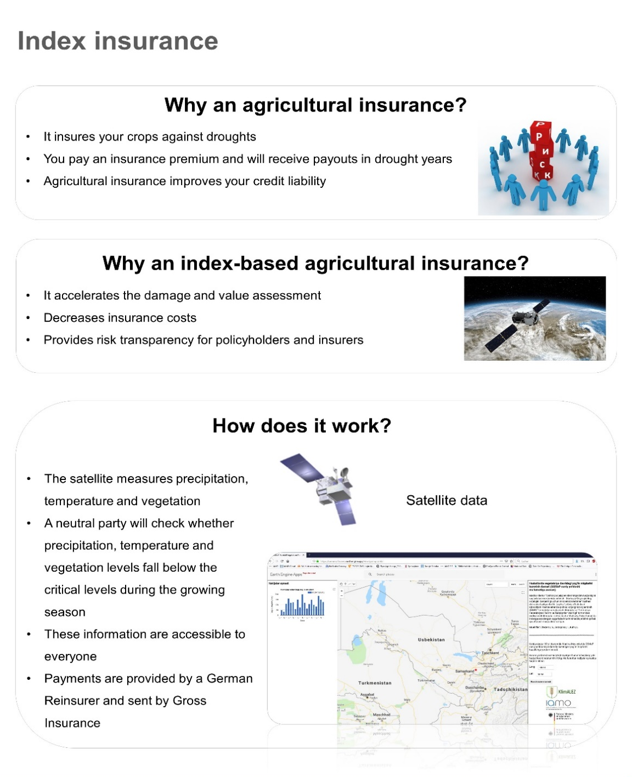
Figure A1. Translated insurance poster

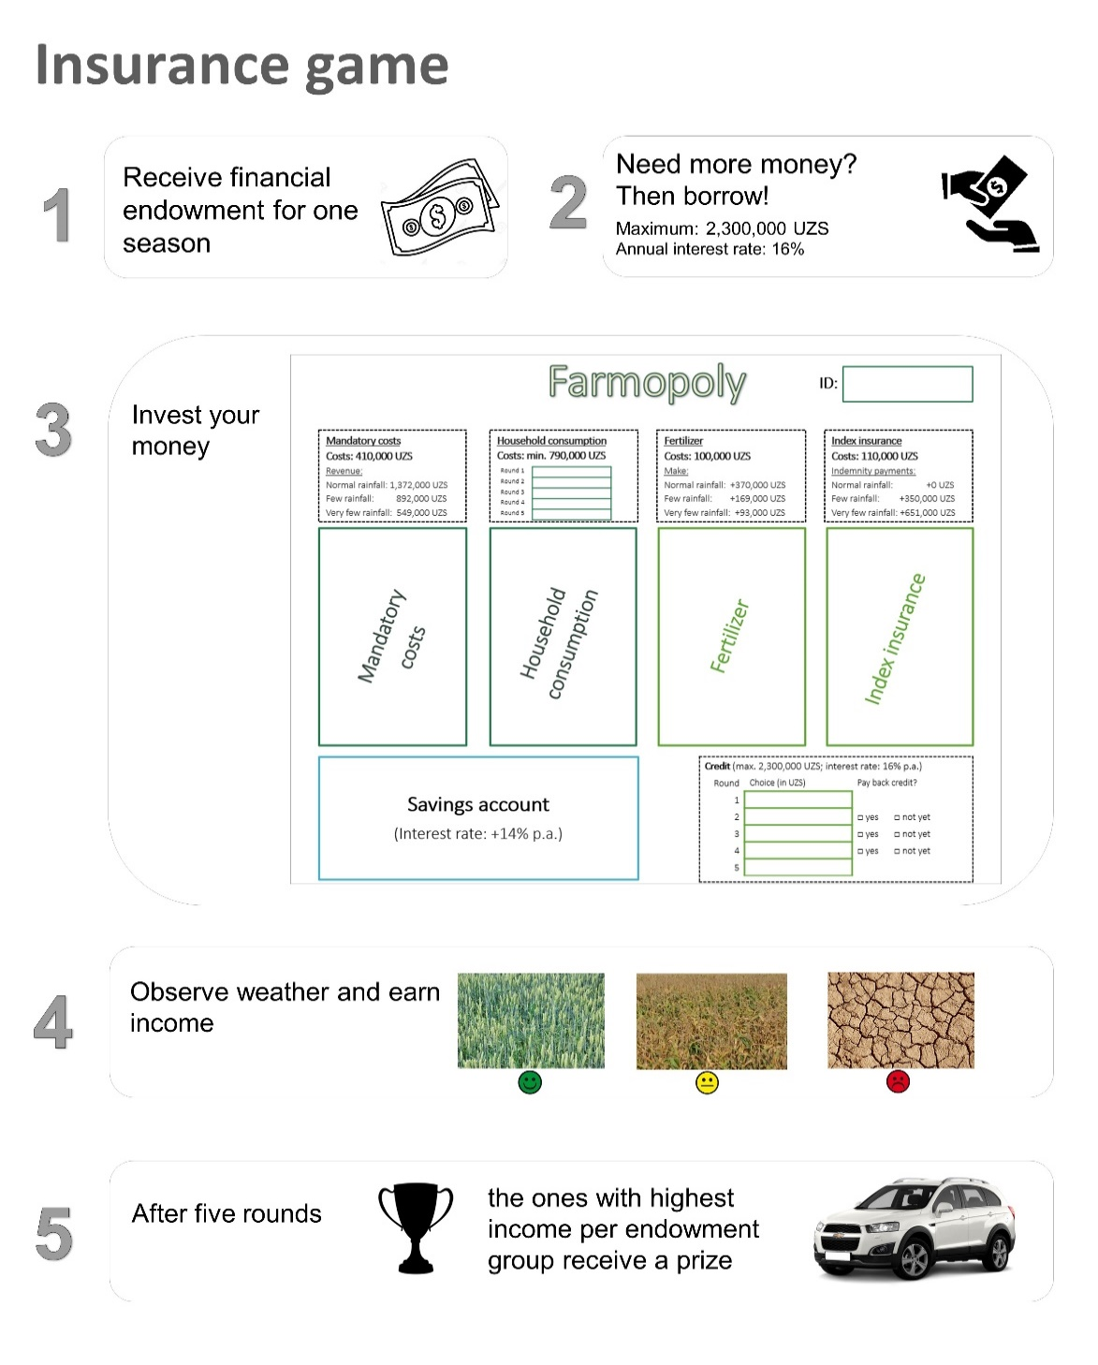
Figure A2. Translated game poster
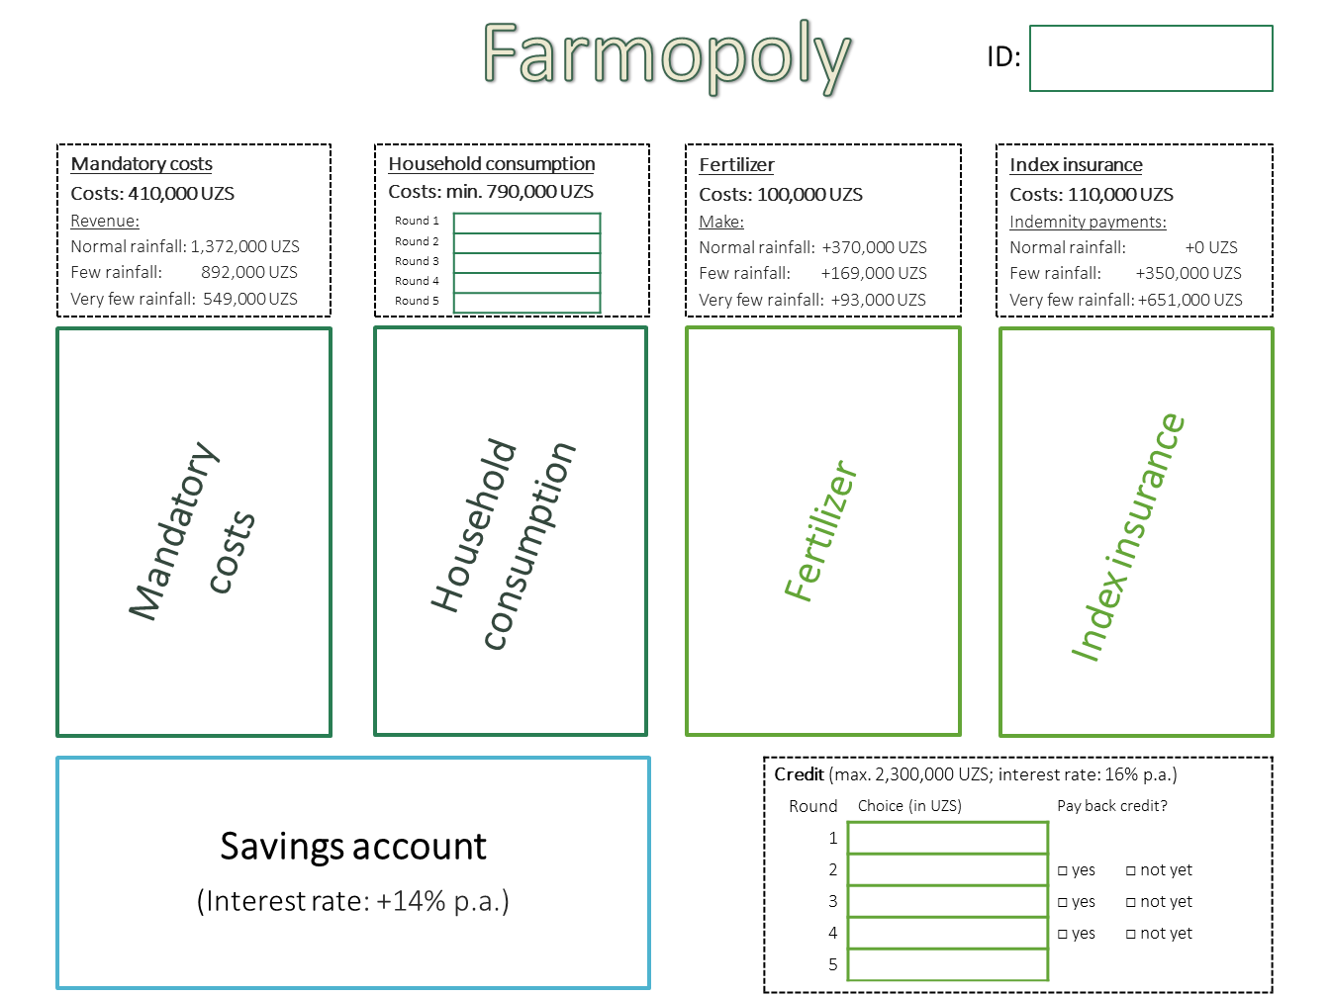
Figure A3. Translated game sheet

Figure A4. Summarized game procedure

Table A1. Summary statistics
 | Obs. | Mean | Std. Dev. | Min | Max | Population mean
Own portfolio | 863 | 2.025 | 1.051 | 0 | 3 | /
Ø session peer portfolio | 863 | 2.025 | 0.568 | 0.200 | 3 | /
Ø game group peer portfolio | 863 | 2.025 | 0.662 | 0 | 3 | /
Ø neighbor peer portfolio | 863 | 2.060 | 0.883 | 0 | 3 | /
Lagged own portfolio choice | 690 | 1.936 | 1.059 | 0 | 3 | /
Lagged Ø session peer portfolio | 690 | 1.934 | 0.589 | 0.200 | 3 | /
Lagged Ø game group peer portfolio | 690 | 1.935 | 0.678 | 0 | 3 | /
Lagged Ø neighbor peer portfolio | 690 | 1.970 | 0.898 | 0 | 3 | /
Ø session peer land size | 173 | 34.32 | 9.077 | 18.49 | 59.75 | /
Ø session peer education | 173 | 3.942 | 0.192 | 3.474 | 4.333 | /
Ø session peer age | 173 | 45.01 | 2.116 | 35.80 | 49 | /
Ø game group peer land size | 173 | 34.32 | 12.03 | 11.40 | 72 | /
Ø game group peer education | 173 | 3.942 | 0.307 | 3 | 5 | /
Ø game group peer age | 173 | 45.01 | 4.786 | 28.50 | 58 | /
Ø neighbor peer land size | 173 | 37.30 | 23.20 | 0.200 | 207 | /
Ø neighbor peer education | 173 | 3.858 | 0.635 | 2 | 5 | /
Ø neighbor peer age | 173 | 43.75 | 9.291 | 20 | 84 | /
Session peer size | 173 | 19.59 | 6.322 | 7 | 30 | /
Game group peer size | 173 | 7.873 | 2.025 | 3 | 10 | /
Neighbor peer size | 173 | 1.734 | 0.443 | 1 | 2 | /
% session peer from own village | 173 | 0.468 | 0.315 | 0 | 0.923 | /
% game group peer from own village | 173 | 0.522 | 0.351 | 0 | 1 | /
% neighbor peer from own village | 173 | 0.636 | 0.418 | 0 | 1 | /
Previous game weather | 863 | 1.599 | 0.800 | 1 | 3 | /
Credit uptake | 863 | 0.211 | 0.408 | 0 | 1 | /
Endowment group | 173 | 2.035 | 0.820 | 1 | 3 | /
Round | 863 | 2.997 | 1.415 | 1 | 5 | /
Age | 173 | 45.01 | 10.51 | 25 | 84 | 43.86
Highest educational level | 173 | 3.942 | 0.737 | 2 | 5 | 3.885
Household size | 173 | 4.717 | 1.496 | 2 | 10 | 4.835
Risk aversion | 173 | 0.526 | 0.501 | 0 | 1 | 0.594
Index insurance distrust (insurer or product) | 173 | 0.387 | 0.489 | 0 | 1 | 0.415
Sophisticated insurance understanding | 173 | 0.653 | 0.477 | 0 | 1 | 0.615
% Agriculture/total income | 173 | 62.69 | 28.85 | 0 | 100 | 62.41
Rainfed land size (ha) | 173 | 31.70 | 23.71 | 0 | 140 | 26.60
Continued on next page
Table A1 – continued from previous page
Danger drought-related risk | 173 | 4.099 | 1.278 | 0 | 5 | 3.956
Average yield lost | 173 | 68.68 | 24.85 | 2 | 100 | 67.21
Notes: Previous game weather is coded as: 1=normal rainfall, 2=little rainfall, 3=very little rainfall. Education is classified as: 1=elementary school, 2=junior high school, 3=senior junior high school, 4= technical school, 5=university degree. Sophisticated index insurance understanding is categorized as: 0=zero to imperfect understanding, 1=perfect theoretical understanding but no trust in online weather information, 2=perfect theoretical understanding and trust in online weather information.

Table A2. Average marginal effects of climate adaptation choices (baseline model)
 | (1) | (2) | (3) | (4)
 | None | Only Savings | Only Insurance | Both
Experimental characteristics
Previous game weather
Little vs. normal rainfall | -0.0739*** | -0.0164 | 0.0016 | 0.0886***
 | (0.0269) | (0.0175) | (0.0339) | (0.0277)
Very little vs. normal rainfall | 0.1570*** | -0.0086 | 0.0764 | -0.2248***
 | (0.0529) | (0.0223) | (0.0532) | (0.0325)
Credit uptake (0/1) | 0.0351 | -0.0560*** | 0.3389*** | -0.3179***
 | (0.0355) | (0.0183) | (0.0423) | (0.0388)
Endowment group
Medium vs. Low | -0.0255 | 0.0128 | -0.0366 | 0.0493
 | (0.0349) | (0.0251) | (0.0478) | (0.0507)
High vs. Low | -0.1142*** | 0.0107 | -0.0427 | 0.1463***
 | (0.0345) | (0.0221) | (0.0450) | (0.0502)
Round (1-5) | -0.0553*** | -0.0001 | -0.0335*** | 0.0888***
 | (0.0141) | (0.0062) | (0.0126) | (0.0076)
Individual characteristics
Age2 | 2.47e-06 | -1.92e-05 | 2.68e-05 | -1.0e-05
 | (1.55e-05) | (1.22e-05) | (2.19e-05) | (2.19e-05)
Highest educational level
Senior vs. junior high school | -0.0823 | -0.2821** | 0.0080 | 0.3564***
 | (0.0632) | (0.1290) | (0.1880) | (0.0688)
Technical school vs. junior high | -0.1046* | -0.2601** | 0.0489 | 0.3158***
school | (0.0603) | (0.1301) | (0.1864) | (0.0654)
University degree vs. junior high | -0.0707 | -0.2512* | 0.0125 | 0.3094***
school | (0.0713) | (0.1337) | (0.1896) | (0.0776)
Household size | -0.0045 | -0.0009 | -0.0064 | 0.0118
 | (0.0101) | (0.0061) | (0.0140) | (0.0133)
Risk aversion (0/1) | -0.0020 | -0.0497** | 0.0979*** | -0.0461
 | (0.0283) | (0.0209) | (0.0375) | (0.0417)
Distrust (0/1) | 0.0098 | 0.0384* | -0.0326 | -0.0155
 | (0.0292) | (0.0225) | (0.0394) | (0.0411)
Sophisticated insurance understanding | 0.0225 | 0.0182 | -0.0217 | -0.0190
(0/1) | (0.0293) | (0.0198) | (0.0428) | (0.0455)
Farm characteristics
Rainfed land size2 (ha) | -2.26e-06 | -1.41e-05** | 4.06e-06 | 1.23e-05
 | (7.59e-06) | (6.45e-06) | (6.10e-06) | (7.94e-06)
% Agriculture/total income | -0.0011** | -0.0001 | 0.0012* | -7.72e-06
 | (0.0005) | (0.0003) | (0.0007) | (0.0008)
Danger drought-related risk (0-5) | -0.0075 | -0.0033 | 0.0041 | 0.0066
 | (0.0116) | (0.0070) | (0.0143) | (0.0190)
Average yield loss (%) | 0.0010* | 0.0005 | -0.0019** | 0.0003
Continued on next page
Table A2 – Continued from previous page
 | (0.0006) | (0.0004) | (0.0008) | (0.0009)
Observations | 863 (173 farmers)
AIC | 1863.866
BIC | 2125.689
Pseudo R2 | 0.1597
Notes: Serial correlation robust standard errors in parentheses: *** p<0.01, ** p<0.05, * p<0.1.

Table A3. All average marginal effects of climate adaptation choices with game group peer imitation
 | (1) |  | (2) | (3) | (4)
 | None |  | Only Savings | Only Insurance | Both
Peer imitation
Ø game group peer portfolio choice | -0.0458*** |  | 0.0368* | -0.0994*** | 0.1084***
 | (0.0165) |  | (0.0206) | (0.0309) | (0.0277)
Peer group characteristics
Ø game group peer land size | 0.0113* |  | 0.0024 | -0.0058 | -0.0078*
 | (0.0065) |  | (0.0031) | (0.0060) | (0.0042)
Ø game group peer education | -0.1418 |  | -0.2813* | 0.5218** | -0.0986
 | (0.2336) |  | (0.1654) | (0.2434) | (0.3280)
Ø game group peer age | -0.0099 |  | -0.0005 | 0.0166 | -0.0062
 | (0.0088) |  | (0.0073) | (0.0139) | (0.0160)
Peer fixed effects | YES
Other experimental characteristics
Previous game weather
Little vs. normal rainfall | -0.0684*** | -0.0195 |  | 0.0303 | 0.0575**
 | (0.0263) | (0.0168) |  | (0.0347) | (0.0280)
Very little vs. normal rainfall | 0.1164** | 0.0170 |  | 0.0501 | -0.1835***
 | (0.0483) | (0.0304) |  | (0.0513) | (0.0346)
Credit uptake (0/1) | 0.0338 | -0.0468** |  | 0.2790*** | -0.2660***
 | (0.0331) | (0.0211) |  | (0.0447) | (0.0433)
Endowment group
Medium vs. Low | -0.0293 | 0.0056 |  | -0.0048 | 0.0286
 | (0.0358) | (0.0225) |  | (0.0472) | (0.0506)
High vs. Low | -0.1270*** | 0.0022 |  | -0.0215 | 0.1463***
 | (0.0343) | (0.0198) |  | (0.0436) | (0.0485)
Round (1-5) | -0.0416*** | -0.0063 |  | -0.0158 | 0.0638***
 | (0.0126) | (0.0069) |  | (0.0129) | (0.0089)
Individual characteristics
Age2 | 4.73e-06 | -1.74e-05 |  | 3.04e-05 | -1.77e-05
 | (2.09e-05) | (2.12e-05) |  | (3.37e-05) | (3.66e-05)
Highest educational level
Senior vs. junior high school | 0.0156 | -0.5073*** |  | 0.1450* | 0.3467***
 | (0.0858) | (0.0960) |  | (0.0850) | (0.0861)
Technical school vs. junior high | -0.0290 | -0.5558*** |  | 0.2663*** | 0.3185***
school | (0.0971) | (0.1189) |  | (0.0888) | (0.0780)
University degree vs. junior high | -0.0329 | -0.6015*** |  | 0.3548*** | 0.2797**
school | (0.1259) | (0.1355) |  | (0.1243) | (0.1255)
Household size | 0.0005 | -0.0054 |  | -0.0012 | 0.0061
 | (0.0113) | (0.0075) |  | (0.0136) | (0.0145)
Risk aversion (0/1) | -0.0306 | -0.0436** |  | 0.0824** | -0.0083
 | (0.0301) | (0.0216) |  | (0.0389) | (0.0423)
Distrust (0/1) | -0.0102 | 0.0631** |  | -0.0291 | -0.0238
 | (0.0300) | (0.0274) |  | (0.0379) | (0.0440)
Sophisticated insurance understanding | 0.0237 | 0.0360* |  | -0.0507 | -0.0090
Continued on next page
Table A3 – Continued from previous page
(0/1) | (0.0309) | (0.0189) |  | (0.0396) | (0.0456)
Farm characteristics
Rainfed land size2 (ha) | 2.48e-05** | -1.12e-05 |  | -1.21e-05 | -1.50e-06
 | (1.23e-05) | (8.70e-06) |  | (1.10e-05) | (1.2e-05)
% Agriculture/total income | -0.0013** | 0.0003 |  | 0.0009 | 0.0001
 | (0.0006) | (0.0005) |  | (0.0007) | (0.0009)
Danger drought-related risk (0-5) | -0.0132 | -0.0005 |  | 0.0030 | 0.0107
 | (0.0110) | (0.0061) |  | (0.0107) | (0.0177)
Average yield loss (%) | 0.0015** | 0.0008* |  | -0.0025*** | 0.0002
 | (0.0007) | (0.0004) |  | (0.0008) | (0.0009)
Observations | 863 (173 farmers)
AIC | 1825.705
BIC | 2487.403
Pseudo R2 | 0.2584
Notes: Serial correlation robust standard errors in parentheses: *** p<0.01, ** p<0.05, * p<0.1.

Table A4. All average marginal effects of climate adaptation choices with neighbor peer imitation
 | (1) |  | (2) | (3) | (4)
 | None |  | Only Savings | Only Insurance | Both
Peer imitation
Ø neighbor peer portfolio | -0.0720*** |  | -0.0140 | -0.0486** | 0.1346***
 | (0.0125) |  | (0.0100) | (0.0200) | (0.0203)
Peer group characteristics
Ø neighbor peer land size | -0.0012** |  | -0.0001 | 0.0003 | 0.0010
 | (0.0006) |  | (0.0003) | (0.0007) | (0.0007)
Ø neighbor peer education | -0.0292 |  | -0.0127 | -0.0080 | 0.0499*
 | (0.0193) |  | (0.0140) | (0.0282) | (0.0270)
Ø neighbor peer age | -0.0009 |  | 0.0006 | -0.0017 | 0.0019
 | (0.0013) |  | (0.0010) | (0.0022) | (0.0023)
Peer fixed effects | NO
Other experimental characteristics
Previous game weather
Little vs. normal rainfall | -0.0618** | -0.0119 |  | 0.0196 | 0.0541**
 | (0.0285) | (0.0186) |  | (0.0361) | (0.0270)
Very little vs. normal rainfall | 0.0926** | -0.0086 |  | 0.0758 | -0.1598***
 | (0.0456) | (0.0232) |  | (0.0508) | (0.0370)
Credit uptake (0/1) | 0.0131 | -0.0581*** |  | 0.3297*** | -0.2847***
 | (0.0322) | (0.0180) |  | (0.0431) | (0.0404)
Endowment group
Medium vs. low | -0.0306 | 0.0083 |  | -0.0466 | 0.0688
 | (0.0358) | (0.0255) |  | (0.0476) | (0.0500)
High vs. low | -0.1262*** | 0.0065 |  | -0.0570 | 0.1767***
 | (0.0329) | (0.0206) |  | (0.0458) | (0.0484)
Round (1-5) | -0.0353*** | 0.0008 |  | -0.0290** | 0.0635***
 | (0.0124) | (0.0059) |  | (0.0125) | (0.0085)
Individual characteristics
Age2 | 1.773e-06 | -2.10e-05* |  | 3.11e-05 | -1.19e-05
 | (1.48e-05) | (1.26e-05) |  | (2.27e-05) | (1.97e-05)
Highest educational level
Senior vs. junior high school | -0.0501 | -0.3093** |  | 0.0438 | 0.3156***
 | (0.0534) | (0.1354) |  | (0.1854) | (0.1007)
Technical school vs. junior high | -0.0659 | -0.2898** |  | 0.0720 | 0.2837***
school | (0.0503) | (0.1360) |  | (0.1832) | (0.0976)
Continued on next page
Table A4 – Continued from previous page
University degree vs. junior high | -0.0410 | -0.2808** |  | 0.0366 | 0.2852***
school | (0.0610) | (0.1424) |  | (0.1871) | (0.1062)
Household size | -0.0050 | -0.0012 |  | -0.0097 | 0.0159
 | (0.0098) | (0.0062) |  | (0.0139) | (0.0128)
Risk aversion (0/1) | -0.0179 | -0.0539** |  | 0.0865** | -0.0147
 | (0.0268) | (0.0218) |  | (0.0380) | (0.0402)
Distrust (0/1) | 0.0202 | 0.0403* |  | -0.0354 | -0.0251
 | (0.0279) | (0.0233) |  | (0.0395) | (0.0413)
Sophisticated insurance understanding | 0.0244 | 0.0190 |  | -0.0299 | -0.0135
(0/1) | (0.0283) | (0.0204) |  | (0.0438) | (0.0461)
Farm characteristics
Rainfed land size2 (ha) | 6.94e-07 | -1.38e-05** |  | 4.17e-06 | 8.92e-06
 | (6.97e-06) | (6.34e-06) |  | (6.29e-06) | (7.87e-06)
% Agriculture/total income | -0.0010** | -2.59e-05 |  | 0.0014** | -0.0004
 | (0.0005) | (0.0003) |  | (0.0007) | (0.0007)
Danger drought-related risk (0-5) | -0.0093 | -0.0038 |  | 0.0061 | 0.0070
 | (0.0109) | (0.0072) |  | (0.0149) | (0.0197)
Average yield loss (%) | 0.0010* | 0.0005 |  | -0.0019** | 0.0003
 | (0.0006) | (0.0004) |  | (0.0008) | (0.0008)
Observations | 863 (173 farmers)
AIC | 1804.377
BIC | 2123.325
Pseudo R2 | 0.1997
Notes: Serial correlation robust standard errors in parentheses: *** p<0.01, ** p<0.05, * p<0.1.

Table A5. Climate adaptation choices with observational learning (average marginal effects)
 | (1) |  | (2) |  | (3) |  |  | (4)
 | None |  | Only Savings |  | Only Insurance |  |  | Both
Model 1
Observational learning
Lagged Ø session peer |  | 0.1822** | 0.1249*** |  | 0.0062 |  |  | -0.3133***
portfolio | (0.0830) |  | (0.0417) |  | (0.0876) |  |  | (0.0786)
Session peer characteristics & FE |  | YES & YES
Experimental characteristics | YES
Individual characteristics | YES
Farm characteristics |  | YES
Observations |  | 690 (173 farmers)
AIC | 1366.342
BIC | 1801.865
Pseudo R2 | 0.2493
Model 2
Observational learning
Lagged Ø game group peer |  | 0.1567*** |  | 0.0139 |  | 0.0184 | -0.1890***
portfolio |  | (0.0486) |  | (0.0342) |  | (0.0589) | (0.0546)
Game group peer characteristics & FE |  | YES & YES
Experimental characteristics |  | YES
Individual characteristics |  | YES
Farm characteristics |  | YES
Observations |  | 690 (173 farmers)
AIC |  | 1369.802
BIC |  | 1968.645
Pseudo R2 |  | 0.2931
Continued on next page
Table A5 – Continued from previous page
Model 3
Observational learning
Lagged Ø neighbor peer | -0.0327** |  |  | -0.0191 |  | -0.0313 | 0.0830***
portfolio |  | (0.0140) |  | (0.0148) |  | (0.0270) | (0.0269)
Neighbor peer characteristics & FE |  | YES & NO
Experimental characteristics |  | YES
Individual characteristics |  | YES
Farm characteristics |  | YES
Observations |  | 690 (173 farmers)
AIC |  | 1411.317
BIC |  | 1724.348
Pseudo R2 |  | 0.1860
Notes: Serial correlation robust standard errors in parentheses: *** p<0.01, ** p<0.05, * p<0.1. To avoid calibration issues (nonsymmetric or highly singular variance matrix) the categorical variable Education is used as a continuous variable in model 1 and 2.

Table A6. Climate adaptation choices with individual lagged portfolio (average marginal effects)
 | (1) | (2) |  | (3) |  |  | (4)
 | None | Only Savings |  | Only Insurance |  |  | Both
Model 1
Individual lag
Lagged own portfolio | -0.0544*** | -0.0409*** |  | 0.0185 |  |  | 0.0768***
 | (0.0125) | (0.0109) |  | (0.0197) |  |  | (0.0197)
Peer imitation
Ø session peer portfolio | 0.2649*** | 0.0927 |  | 0.0340 |  |  | -0.3916***
 | (0.0653) | (0.0592) |  | (0.0937) |  |  | (0.0826)
Session peer characteristics & FE | YES
Experimental characteristics | YES
Individual characteristics | YES
Farm characteristics | YES
Observations | 690 (173 farmers)
AIC | 1309.56
BIC | 1758.693
Pseudo R2 | 0.2894
Model 2
Individual lag
Lagged own portfolio | -0.0435*** |  | -0.0330*** |  | 0.0179 | 0.0586***
 | (0.0122) |  | (0.0104) |  | (0.0193) | (0.0197)
Peer imitation
Ø game group peer portfolio | 0.1856*** |  | 0.0877*** |  | 0.0648 | -0.3380***
 | (0.0520) |  | (0.0313) |  | (0.0653) | (0.0604)
Game group peer characteristics & FE | YES
Experimental characteristics | YES
Individual characteristics | YES
Farm characteristics | YES
Observations | 690 (173 farmers)
AIC | 1310.143
BIC | 1931.67
Pseudo R2 | 0.3376
Continued on next page
Table A6 – Continued from previous page
Model 3
Individual lag
Lagged own portfolio | -0.0778*** |  | -0.0360*** |  | 0.0143 | 0.0995***
 | (0.0140) |  | (0.0123) |  | (0.0203) | (0.0201)
Peer imitation
Ø neighbor peer portfolio | -0.0117 |  | -0.0088 |  | -0.0501* | 0.0705***
 | (0.0135) |  | (0.0121) |  | (0.0256) | (0.0264)
Neighbor peer characteristics & FE | YES & NO
Experimental characteristics | YES
Individual characteristics | YES
Farm characteristics | YES
Observations | 690 (173 farmers)
AIC | 1348.497
BIC | 1670.602
Pseudo R2 | 0.2287
Notes: Serial correlation robust standard errors in parentheses: *** p<0.01, ** p<0.05, * p<0.1. To avoid multicollinearity or convergence problems the categorical variable Education is used as a continuous variable in model 1 and 2.

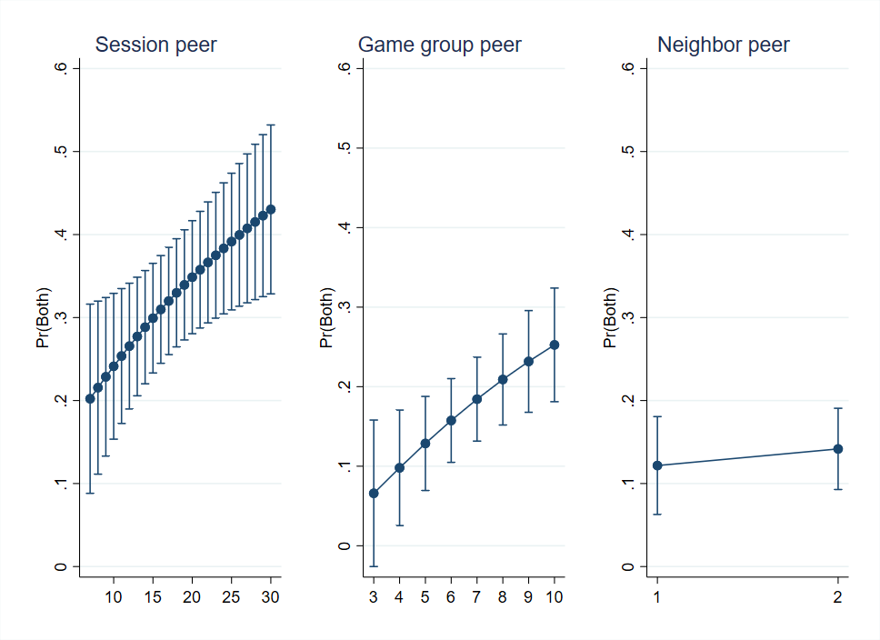
Figure A3. Average marginal peer imitation effect conditional on the respective peer size. Notes: Estimates are significant on the one percent significance level (p≤0.001) for session peer and neighbor peer. For game group peer and peer size≥4 (p≤0.008). Peer FEs are dropped to achieve convergence.
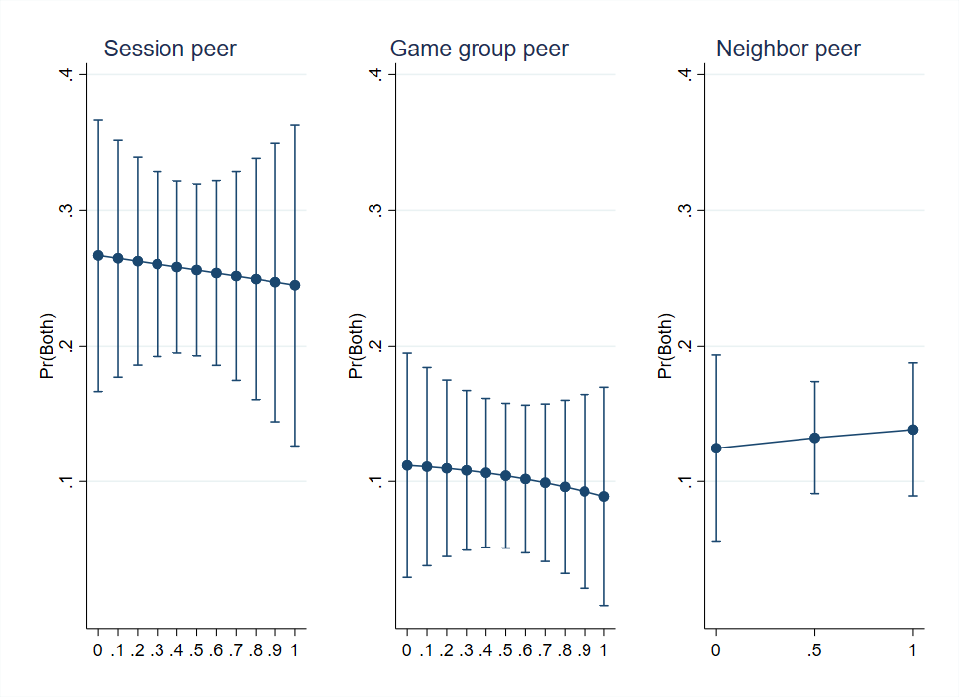
Figure A6. Average marginal peer imitation effect conditional on the share of peer from one’s village. Notes: Estimates significant for session peer (p<0.001), significant for game group peer (p≤0.003) and neighbor peer (p<0.001).

