Appendix A
Table A1. Ordered logit regression estimation on willingness to lease land for agrivoltaics (1 – Very Unlikely, 2 – Unlikely, 3 – Neutral, 4 – Likely, and 5 – Very Likely).
 | Coefficient | Standard Error
Additional Information | 0.406* | (0.220)
Female | -0.205 | (0.318)
Nonwhite | 0.344 | (0.296)
Bachelor or Higher | 0.399* | (0.207)
New Farmer | -0.891** | (0.408)
Financial Risk | 0.196*** | (0.0631)
Extension 6+ visits | -0.461** | (0.189)
Environmental tradeoff | -0.409* | (0.231)
Sales larger than $350k | -0.870** | (0.408)
Leafy Greens Program | 0.0995 | (0.436)
Beef Forage Program | -1.072** | (0.472)
Region: Upstate | 0.870** | (0.438)
Region: Peedee | 0.136 | (0.286)
Region: Midlands | 0.184 | (0.382)
Solar Irradiance (DNI) | -5.515** | (2.767)
$$μ_{1}$$ | -28.63** | (14.26)
$$μ_{2}$$ | -27.75* | (14.33)
$$μ_{3}$$ | -26.46* | (14.28)
$$μ_{4}$$ | -25.64* | (14.30)
Observations | 177
Note: Clustered standard errors at the week of the survey in parentheses. Significance level:* p < 0.1, ** p < 0.05, *** p < 0.01

Appendix B
Questions Used From Qualtrics
Lease
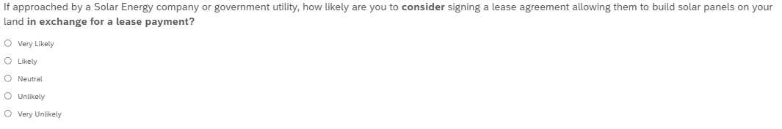
Unlikely
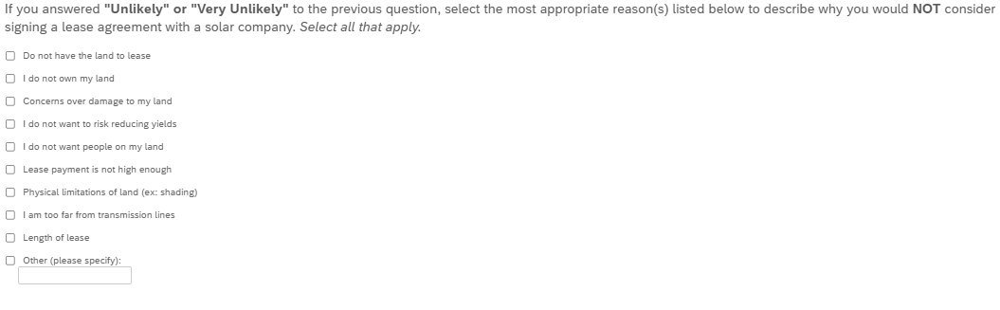
Risk
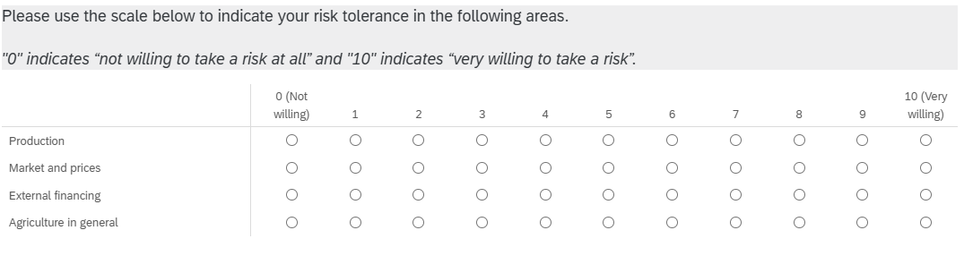

Sales
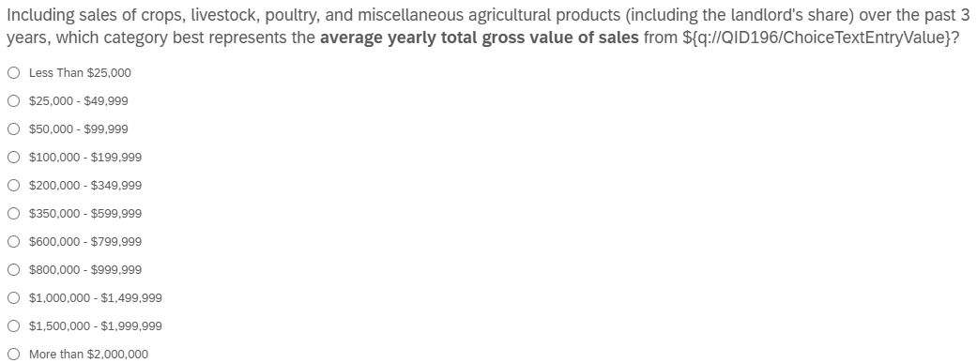

Environmental Tradeoff
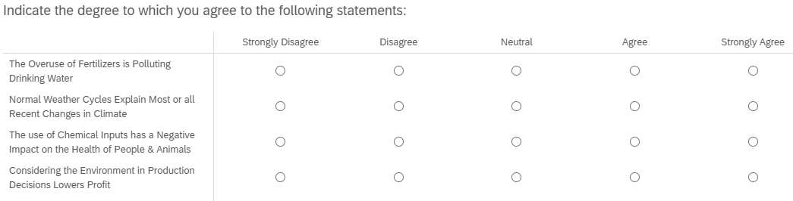

Sources of Information
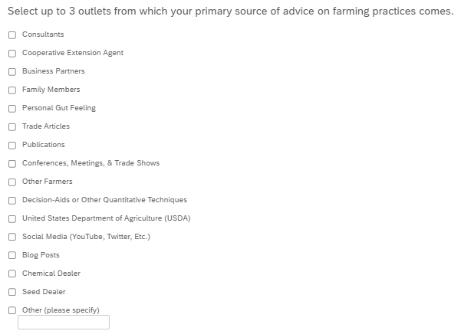
Extension
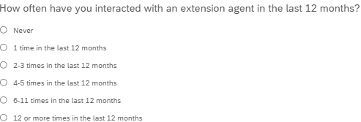
Accuracy of Information
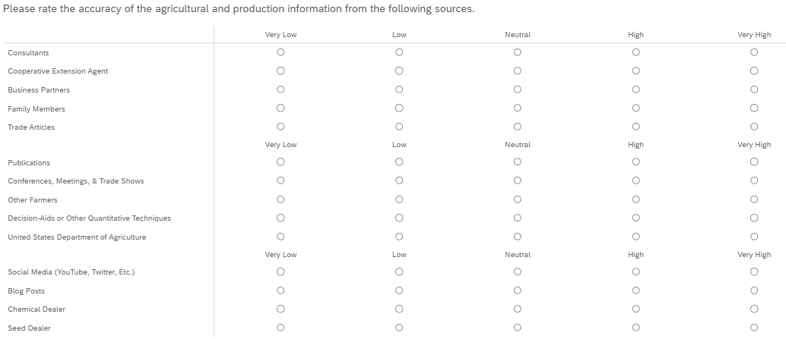

New Farmer
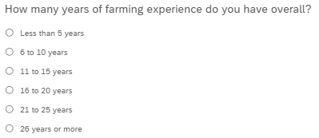
Gender

Education

Race


Appendix C
Additional table of production types by enrolled program for respondents.
Table: Types of production reported by respondents based on enrolled program (n=177).
 | Row Crop | Vegetables | Livestock | Poultry | Timber | Fruits | Total
Leafy Greens | 24 | 60 | 12 | 8 | 14 | 11 | 62
Peanut | 32 | 2 | 8 | 3 | 11 | 2 | 32
Forages for Beef Cattle | 20 | 4 | 83 | 6 | 34 | 1 | 83
Total | 76 | 66 | 103 | 17 | 59 | 14

