# 7. Appendices

## Appendix A

For the interior solution, the unique optimal solution with a well-defined steady state is defined in equations A1 and A2. We dropped the time subscripts, indicating the steady state in condition (9), and explicitly solved for $λ^{*}$ for a representative farmer such that

|  |  |
| --- | --- |
| $$λ^{*}=\frac{\overline{P}Q_{s}}{-ρG_{s}+1}$$ | (A1) |

where $-ρG_{s}+1>0$, since and .6F[1] Therefore, condition (7) can be further expressed as

|  |  |
| --- | --- |
| $$\overline{P}Q_{δ}+ρλ^{*}G_{δ}=C_{δ}+wh_{δ}$$ | (A2) |

Combining equation 12 and 13, we obtain the optimal degradation rate condition:

|  |  |
| --- | --- |
| $$\overline{P}\left(Q_{δ}+\frac{ρQ_{s}G_{δ}}{-ρG_{s}+1}\right)=C_{δ}+wh_{δ}$$ | (A3) |

We define the differentiable function $Ψ\left(.\right)$ in equation (15) below as

|  |  |
| --- | --- |
| $$Ψ\left(δ^{*},S^{*},z^{*}\right)=Q_{δ}+\frac{ρQ_{s}G_{δ}}{-ρG_{s}+1}$$ | (A4) |

In equation (A4), $Ψ\left(.\right)$ can be interpreted as the marginal effect of the degradation rate on long-term crop productivity. Specifically, $(\frac{ρQ_{s}G_{δ}}{-ρG_{s}+1})>0$ represents the value of saving the farmland soil productivity from the plastic pollutant stock by using more degradable plastic mulches. Due to the properties of the functional forms of Q (.) and G (.), then $Ψ\left(.\right)$ is a strictly decreasing function of $δ^{*}$ and $S^{*}$. Hence, equation (A3) can be rewritten as

|  |  |
| --- | --- |
| $$P_{t}Ψ\left(δ^{*},S^{*},z^{*}\right)=C_{δ}+wh_{δ}$$ | (A5) |

Therefore, the optimal degradation rate at the steady state satisfies the equation (A6)

|  |  |
| --- | --- |
| $$δ^{*}=Ψ^{-1}\left(\frac{C_{δ}+wh_{δ}}{\overline{P}}\right)$$ | (A6) |

**Proof of $Ψ\left(.\right)$ as a strictly decreasing function of $δ^{*}$ and $S^{*}$**

We defined $Γ(δ,z;S,w)=S-G(δ,z;S,w)$, and by assumption, $Γ(δ,z;S,w)$ will be twice continuously differentiable with $Γ_{s}>0$ and $Γ_{ss}≤0$. Therefore, there is unique $S=S(δ,z)$ such that $Γ\left(δ,z;S,w\right)=0.$ Therefore, for $0≤δ≤1$, condition (2) holds. According to the implicit function theory, we have the following:

$$\frac{∂Γ}{∂δ}=-\frac{∂G}{∂δ}$$

$$\frac{∂Γ}{∂S}=1-\frac{∂G}{∂S}$$

Since

$$\frac{∂S}{∂δ}=-\frac{\frac{∂Γ}{∂δ}}{\frac{∂Γ}{∂S}}$$

We have

$$\frac{∂S}{∂δ}=\frac{\frac{∂G}{∂δ}}{1-\frac{∂G}{∂S}}$$

To align the expression of the partial differentiation with the whole paper, we have

$$S_{δ}=\frac{G_{δ}}{1-G_{s}}≤0$$

The above partial differentiation indicates that the larger above-soil degradation rate will decrease the amount of plastic residue in the farmland soil.

If we consider $S$ as a function of $δ$, we find that the marginal effect of the degradation rate on the long-term crop productivity $ψ(.)$ is well-defined and continuously differentiable for $δ.$ Omitting arguments and differentiating, we have

$$ψ_{δ}=Q_{δδ}+Q_{δS}S_{δ}+\frac{ρ^{2}G_{δ}Q_{S}\left(G_{SS}S_{δ}+G_{Sδ}\right)}{{\left(1-ρG_{S}\right)}^{2}}+\frac{ρQ_{S}G_{δδ}+ρQ_{S}G_{δS}S_{δ}+ρQ_{Sδ}G_{δ}}{1-ρG_{S}}$$

According to the curvature assumptions on Q(.), G(.) and $0≤G_{S}≤1$, we have $ψ_{δ}<0$, so $ψ(.)$ is continuous in $δ$ and S and strictly decreasing in $δ$ through out its domain.

## Appendix B

**Postoptimality Analysis: Dynamic Path Approach**

In this appendix, we discuss the dynamic path approach to postoptimality analysis. Postoptimality analysis is useful for understanding how the controlled economic process responds to changes in model parameters or assumptions, including the steady state analysis and the dynamic path analysis. While the steady-state analysis discussed in the main manuscript examines the long-term equilibrium of the system, dynamic path analysis focuses on the system's evolution over time from a given starting point. To illustrate the dynamic path approach, we consider the scenario with a high disposal fee, where a stable steady-state is achievable[2]. We analyze the dynamic paths of our control variable, degradation rate, and state variable, plastic mulch pollutant stock.

Figure B.1 (a) depicts the optimal degradation rate as a function of the plastic pollutant stock in the farmland soil. The increasing pollutant stock will drive growers to use BDMs. When the pollutant stock in farmland soil cumulated to 5.5lb, the growers’ optimal choice is to use 100% degradable BDMs. Figure B.1 (c) indicates that both the degradation rate and the pollutant stock in the farmland soil will keep increasing, but over time converge to the steady-state, namely 61% for the degradation rate and 3.27 lb for the plastic pollutant stock in the farmland soil and 0 lb in the landfill. Therefore, comparing with the initial amount of plastic pollutants in the farmland soil (3.2 lb), the representative grower using 239.58 lb plastic mulches only contributes 0.07lb plastic pollutants to both the farmland soil and the landfill together in the long term. Figure B.1(b) shows the approximation function residual as a function of the plastic pollutant stock in the farmland soil. The residual exhibits strong volatility near 0 lb and 3.27 lb, which is common for spline approximation with the presence of discontinuities at 0 lb and 5.5 lb. The residuals are very nearly zero elsewhere. The cubic spline approximation is accurate with a residual error of order , **A graph of a stock market
**

**Figure B.1 Dynamic Path Analysis under the Project Landfill Tipping Fee in 20 Years[3]**a). Equilibrium Degradation Rate Function b). Approximation Residual c). Steady State Illustration

## Appendix C

**Empirical Model: Stochastic Environment**

We assume that plastic pollution accumulation occurs in a deterministic pattern, but the process is subject to many sources of uncertainties. The degradation of plastic pollutant stock in the soil will be affected by environmental factors, such as diurnal temperature range, maximum daily soil temperature, initial soil pH, and biotic variables, which will be mainly affected by weather and climate changes (Kyrikou & Briassoulis, 2007; Li et al., 2014). Weather and climate changes are unknown at the time the plastic mulch adoption decision is made (Kijchavengkul et al., 2008). Therefore, we introduce $ϵ_{i,t}$ which is exogenous and independently normally distributed over time with mean $μ$ and standard deviation $σ$ into the motion of plastic pollutant stock in equation (C1). The plastic pollutant stock with stochastic characteristics is defined as following:

|  |  |
| --- | --- |
| $$G_{it}=η_{0}-η_{1}δ_{it}+η_{2}S_{it}-η_{3}z_{it}-η_{13}δ_{it}z_{it}+η_{4}+ϵ_{i,t}$$ | (C1) |

We apply this to perform a comparative analysis in characterizing how the uncertainty affects the optimal choice in the plastic mulch degradation rate, the long-term plastic pollutant stock in the farmland soil, and the grower’s profit.

**Pollution Accumulation in a Stochastic Environment**

We set $μ$ equal to 0, and $σ$ equal to 0.1 as the stochastic baseline in equation C1.15F[4] The steady state means and standard deviation of the optimal degradation rate, the plastic pollutant stock in the farmland soil, and the lifetime profit are computed and listed in Table C1, where the landfill tipping fee is the projected value in twenty years, $0.105/lb.

**Table C1 Optimal Choices in Stochastic Environment Under the Projected Landfill Tipping Fee in 20 Years**

|  |  |  |  |  |  |  |
| --- | --- | --- | --- | --- | --- | --- |
|  |  | Ergodic Mean | | Diff. from Deterministic Steady State | Ergodic Standard Deviation | 95% Confidence Interval |
| **Deterministic Steady state**  (*Table 3-In 20 years) | Pollutant in farmland soil | | 3.274 | -- | -- |  |
| Degradation Rate | | 0.606 | -- | -- |  |
| Profit | | $136,740.86 | -- | -- |  |
| **Stochastic Baseline: $$μ=0$$ $$σ=0.1$$** | Pollutant in farmland soil | | 3.275 | 0.001 | 0.100 | (3.04, 3.50) |
| Degradation Rate | | 0.606 | 0.000 | 0.020 | (0.556, 0.65) |
| Profit | | $136,740.37 | -$0.49 | $25.30 | ($136,679.83, $136,679.83) |
| **Stochastic Scenario 1: $$μ=0$$ $$σ$$**  Increased 100% to 0.2 | Pollutant in farmland soil | | 3.276 | 0.002 | 0.200 | (2.81, 3.74) |
| Degradation Rate | | 0.606 | 0.000 | 0.040 | (0.51, 0.70) |
| Profit | | $136,739.19 | -$1.67 | $50.63 | ($136,679.83  $136,679.83) |
| **Stochastic Scenario 2: $$μ$$**  increased to 0.01 $$σ=0.1$$ | Pollutant in farmland soil | | 3.275 | 0.001 | 0.100 | (3.04, 3.51) |
| Degradation Rate | | 0.626 | 0.120 | 0.020 | (0.58, 0.67) |
| Profit | | $136,738.09 | -$2.77 | $25.30 | ($136,677.53, $136,795.74) |
| **Stochastic Scenario 3: $$μ$$**  increased to 0.3 $$σ=0.1$$ | Pollutant in farmland soil | | 3.389 | 0.115 | 0.100 | (3.16, 3.62) |
| Degradation Rate | | 1.000 | 0.394 | 0.000 | (0.99, 1.00) |
| Profit | | $136,668.60 | -$71.99 | $23.95 | ($136,609.43, $136,721.44) |

In addition to the baseline scenario, we explore three stochastic variations. First, we analyze a scenario where the variability of the plastic pollutant stock in the soil is doubled to 0.2 lb. Second, we consider a scenario where the degradation process slows down due to the grower's location, leading to an average increase of 0.01 lb in the plastic pollutant stock. Finally, we investigate a more extreme scenario where the slower degradation process results in an average increase of the plastic pollutant stock to 0.3 lb. The values of the remaining parameters correspond to the baseline listed in Table 1.

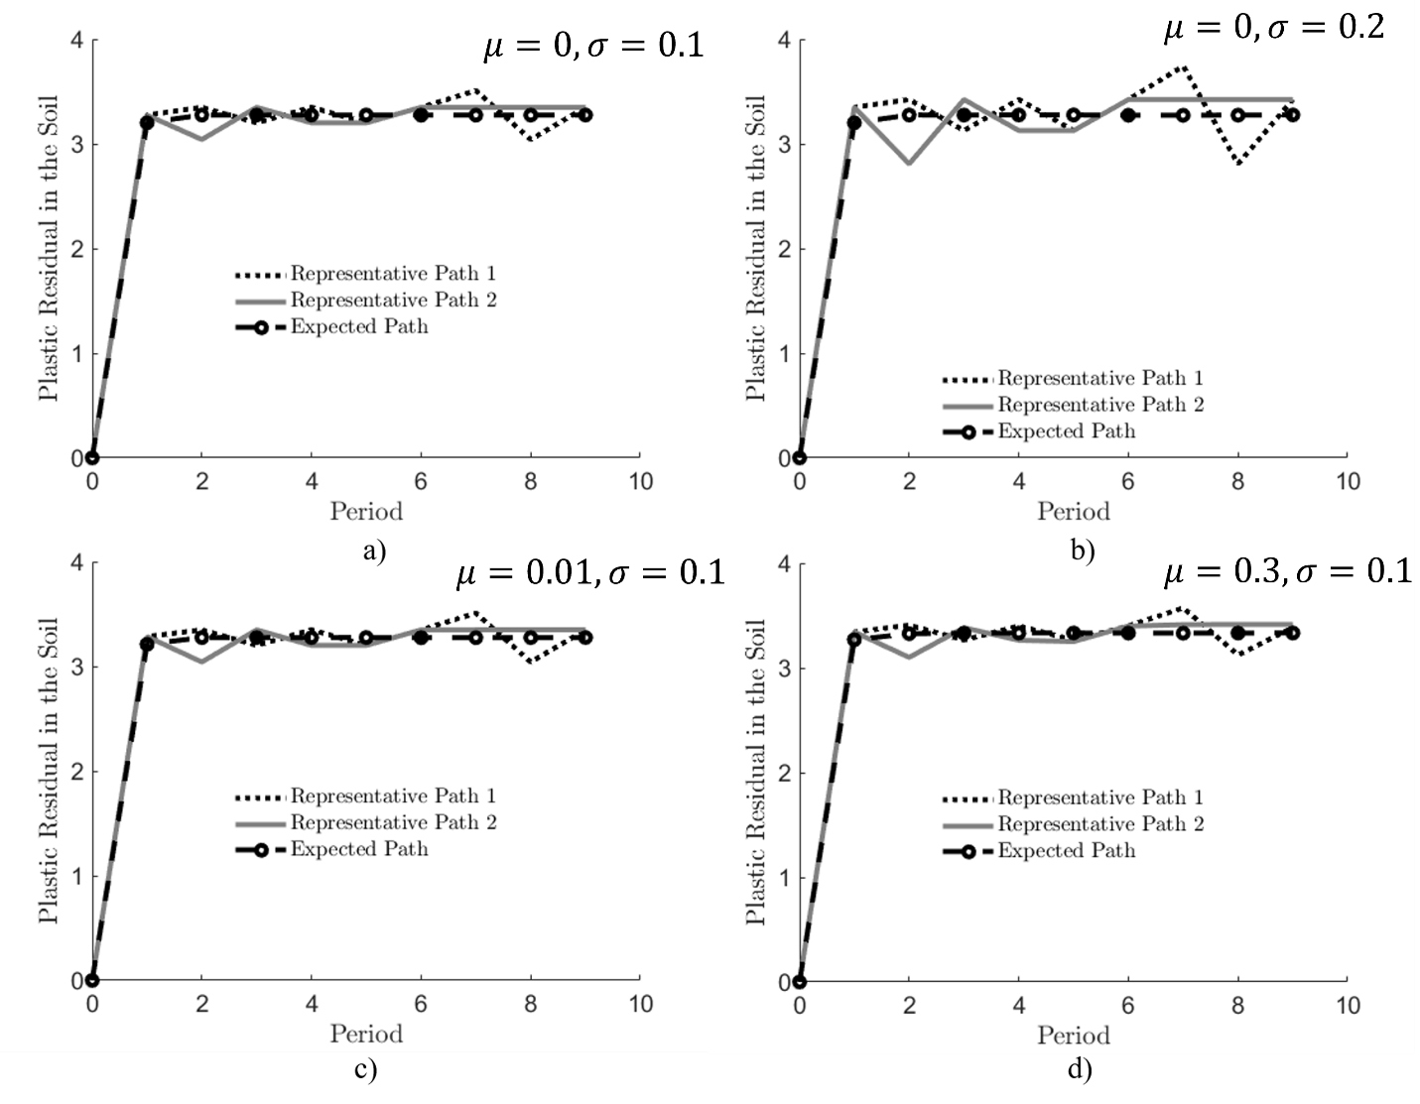

**Figure C1 Plastic Pollutant Stock Analysis in the Stochastic Environment Under the Projected Landfill Tipping Fee in 20 Years[5]**

a). Stochastic Baseline b). Stochastic Scenario 1 c). Stochastic Scenario 2 d). Stochastic Scenario 3

Figure C1 presents two representative steady-state distribution paths for the pollutant stock alongside an expected path from 50,000 simulations under four scenarios. As μ increases, signifying a persistent slowdown in degradation (e.g., due to climate change), the mean plastic pollutant level also rises (Figure C1 and Table C1). This trend incentivizes growers to adopt faster-degrading BDMs. For instance, Table C1 demonstrates that when μ surpasses the deterministic state by a constant 0.3 lb per season, growers shift towards completely degradable BDMs in the long term. Furthermore, increasing μ leads to a statistically significant rise (0.115 units) in the average plastic pollutant stock.16F[6]

Short-term weather fluctuations primarily influence the variability (σ) of plastic pollutant accumulation in farmland soil, as reflected in Table C1. Compared to the stochastic baseline and deterministic steady state, the increased σ in Stochastic Scenario 1 does not affect the average optimal degradation rate (60.6%) or the optimal pollutant stock level. Consequently, growers in regions with slower degradation and higher expected pollutant accumulation are more likely to adopt BDMs with a higher degradation rate. However, short-term fluctuations in the degradation process itself are unlikely to significantly impact BDM adoption or long-term pollutant accumulation.

Conversely, Table C1 also implies that increased variability in plastic pollutant stock can decrease expected grower profits and heighten profit uncertainty. For instance, when degradation slows, the average expected plastic pollutant stock in the soil is estimated to rise to 0.3 lb, with a corresponding average profit decrease of $71.99.

We present an analysis of the landfill tipping fee, assumed to be its current value of $0.042/lb, in Table C2. Compared to the deterministic scenario, a stochastic environment with this tipping fee does not significantly alter the optimal choices made by growers, the level of plastic pollutant in farmland soil, or production profit. This is because the current landfill tipping fee incentivizes the use of cheaper PEMs over BDMs. Additionally, as plastic waste does not accumulate in the soil to a degree that degrades soil quality, the uncertainty surrounding plastic pollutant degradation has a minimal impact on grower profitability.

**Table C.2 Optimal Choices in Stochastic Environment under Current Landfill Tipping Fee**

|  |  |  |  |  |
| --- | --- | --- | --- | --- |
|  |  | Ergodic Mean | Ergodic Standard Deviation | 95% Confidence Interval |
| **Deterministic Steady state** | Pollutant stock in the farmland soil | 0.056 | -- |  |
| Degradation Rate | 0.000 | -- |  |
| Profit | $136,689.86 | -- |  |
| **Stochastic Baseline: $μ=0$**  lb $σ=0.1$ lb | Pollutant stock in the farmland soil | 0.056 | 0.100 | (-0.171, 0.282) |
| Degradation Rate | 0.000 | 0.000 | (0,0) |
| Profit | $136,689.51 | $0.73 | ($136,686, $136,690) |
| **Stochastic Scenario 1: $μ=0$**  lb $$σ$$ Increased 100% to 0.2 lb | Pollutant stock in the farmland soil | 0.056 | 0.201 | (-0.398, 0.509) |
| Degradation Rate | 0.000 | 0.000 | (0,0) |
| Profit | $136,688.45 | $2.26 | ($136,680, $136,690) |
| **Stochastic Scenario 2: $$μ$$**  increased to 0.01 lb $$σ=0.1$$ | Pollutant stock in the farmland soil | 0.067 | 0.100 | (-0.160, 0.294) |
| Degradation Rate | 0.000 | 0.000 | (0,0) |
| Profit | $136,689.44 | $0.813 | ($136,686, $136,690) |
| **Stochastic Scenario 3: $$μ$$**  increased to 0.3 lb $$σ=0.1$$ | Pollutant stock in the farmland soil | 0.389 | 0.100 | (0.162, 0.616) |
| Degradation Rate | 0.000 | 0.000 | (0,0) |
| Profit | $136,683.87 | $2.96 | ($136,675, $136,688) |

**References**

Kyrikou, I., & Briassoulis, D. (2007). Biodegradation of Agricultural Plastic Films: A Critical Review. *Journal of Polymers and the Environment, 15*(2), 125-150. doi:<https://doi.org/10.1007/s10924-007-0063-6>

Kijchavengkul, T., Auras, R., Rubino, M., Ngouajio, M., & Fernandez, R. T. (2008). Assessment of Aliphatic–Aromatic Copolyester Biodegradable Mulch Films. Part I: Field study. *Chemosphere, 71*(5), 942-953. doi:<https://doi.org/10.1016/j.chemosphere.2007.10.074>

Li, C., Moore-Kucera, J., Miles, C., Leonas, K., Lee, J., Corbin, A., & Inglis, D. (2014). Degradation of Potentially Biodegradable Plastic Mulch Films at Three Diverse US locations. *Agroecology and sustainable food systems, 38*(8), 861-889. doi:<https://doi.org/10.1080/21683565.2014.884515>

1. represents the changes in the amount of plastic pollutant in the farmland soil in next period affect by the changes in the current period, which is reflected by the decay rate. Since the decay rate is between 0 and 1, $G_{s}$ will also be bounded by 0 and 1. $ρ$ is a discount factor, so it has to be smaller than 1. Therefore, $ρG_{s}<1$ and .
2. We used a 100-function cubic spline basis on the interval [0, 50] to approximate the value function along its continuous dimension.
3. While our analysis used a Monte Carlo simulation with 1,000 periods to identify the steady state, Figure B1 illustrates the first 10 periods for clarity. The 1,000-period simulation confirms that the system does not deviate from the steady state once reached.
4. The pollutant stock shock is discretized using a four-node Gaussian quadrature scheme, and Monte Carlo simulation is used to generate 5,000 paths of the controlled-state process with ten periods in duration.
5. While our analysis used a Monte Carlo simulation with 1,000 periods to identify the steady state, Figure C1 illustrates the first 10 periods for clarity. The 1,000-period simulation confirms that the system does not deviate from the steady state once reached
6. We rejected the null hypothesis that there is no statistically significant difference in the plastic pollutant stock between the stochastic baseline and the stochastic scenario 3 with 95% confidence, because the 95% confidence interval is between 0.1145 and 0.1155.