APPENDIX A: Question Wording

Question Wording
- Protest Attendance: For which of the following issues did you attend a march, demonstration, or rally, or attend a counter-protest to this issue?
As you select, indicate the issue or side you were supporting.
- In support of Black Lives Matter

- Donations to BLM : Thinking about your overall giving or donations to different organizations and causes, how much, if any, did you donate to the following:
- Black Lives Matter
- Local Police association
- Immigrant rights organization
- Your church or place of worship
- Local school

- “ Over the past year, did you participate in a Black Lives Matter protest or a protest against police brutality?”
- Yes
- No

- Based on everything you have heard or seen, how much do you support or oppose the Black Lives Matter movement?
- Strongly support
- Somewhat support
- Neither support nor oppose
- Somewhat oppose
- Strongly oppose

- How strongly do you agree or disagree with the following statements? “I have a responsibility to support the Black Lives Matter movement.”

- “Based on everything you have heard or seen, how much do you support or oppose the Black Lives Matter movement?”
- Strongly support
- Somewhat support
- Neither support nor oppose
- Somewhat oppose
- Strongly oppose

APPENDIX B : Additional Empirical Analyses
Table B1. Racial and Ethnic Self-Identification of Respondents (ISPU, 2020)
Category | Freq. | Percent
White | 266 | 34.41
Asian/Chinese/Japanese/Indian/Pakistani | 185 | 23.93
Black or African American | 164 | 21.22
Arab | 109 | 14.10
Mixed | 27 | 3.49
Other | 7 | 0.91
Native American/American Indian/Alaska Native | 7 | 0.91
Refused/No Answer | 4 | 0.52
Native Hawaiian and Other Pacific Islander | 2 | 0.26
Hispanic | 2 | 0.26
Total | 773 | 100.00
Note: Rows sorted by frequency.

Figure 1 : Support for Black Lives Matter; Multivariate Regression Results, (ISPU, 2019)
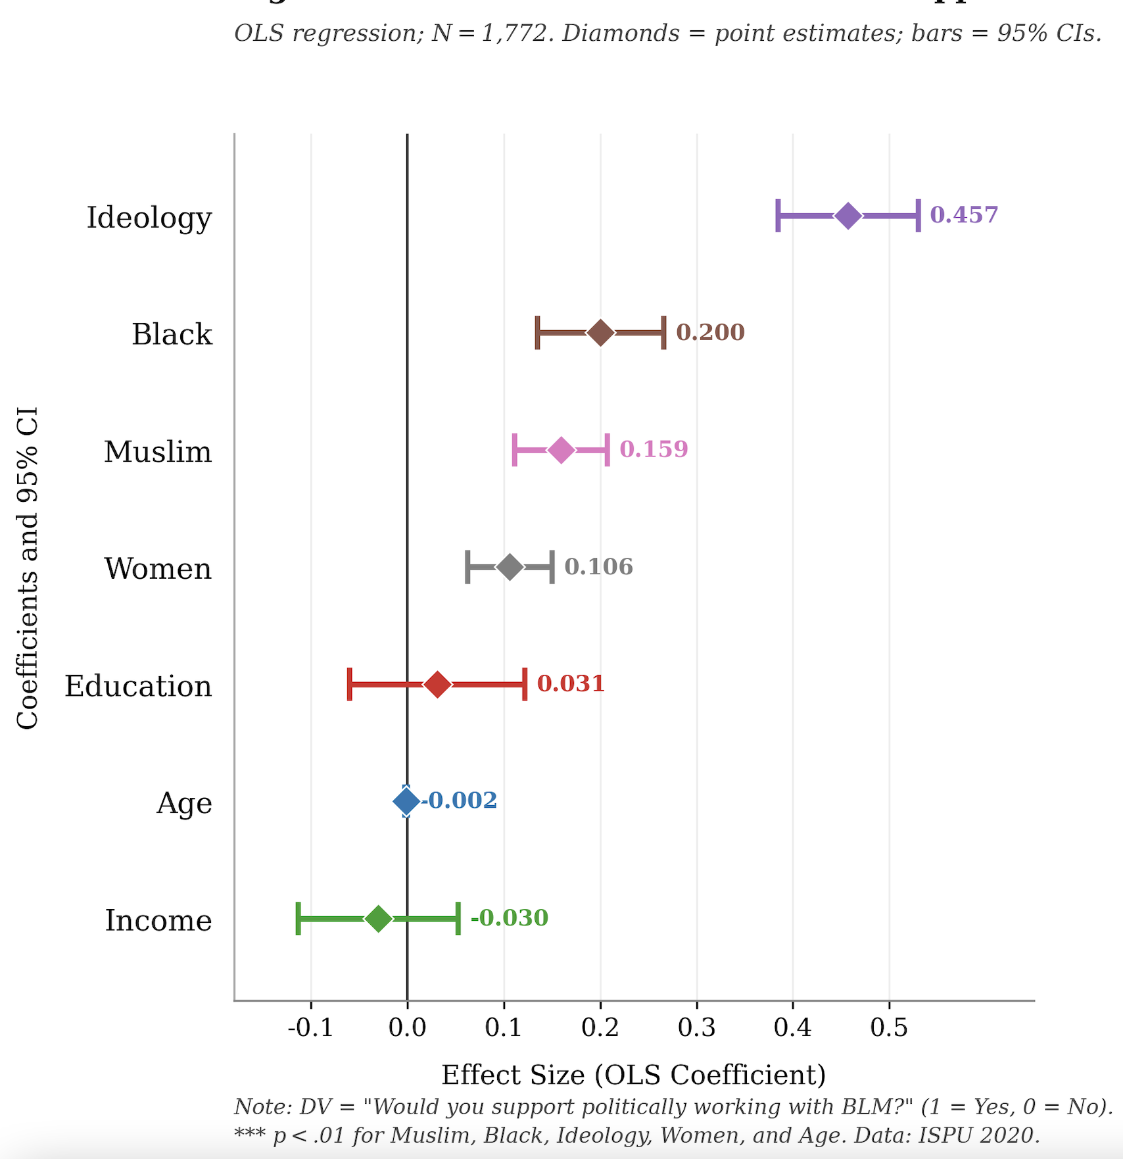

CMPS 2020

Table 1 : CMPS 2020 Racial Variation of American Muslims in Sample 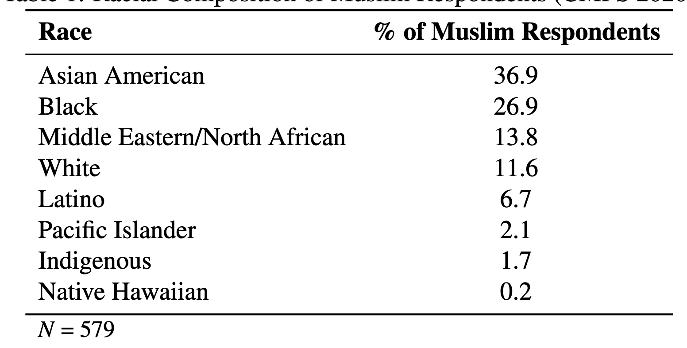

Figure 2 : Coefficient Plot for Model 1
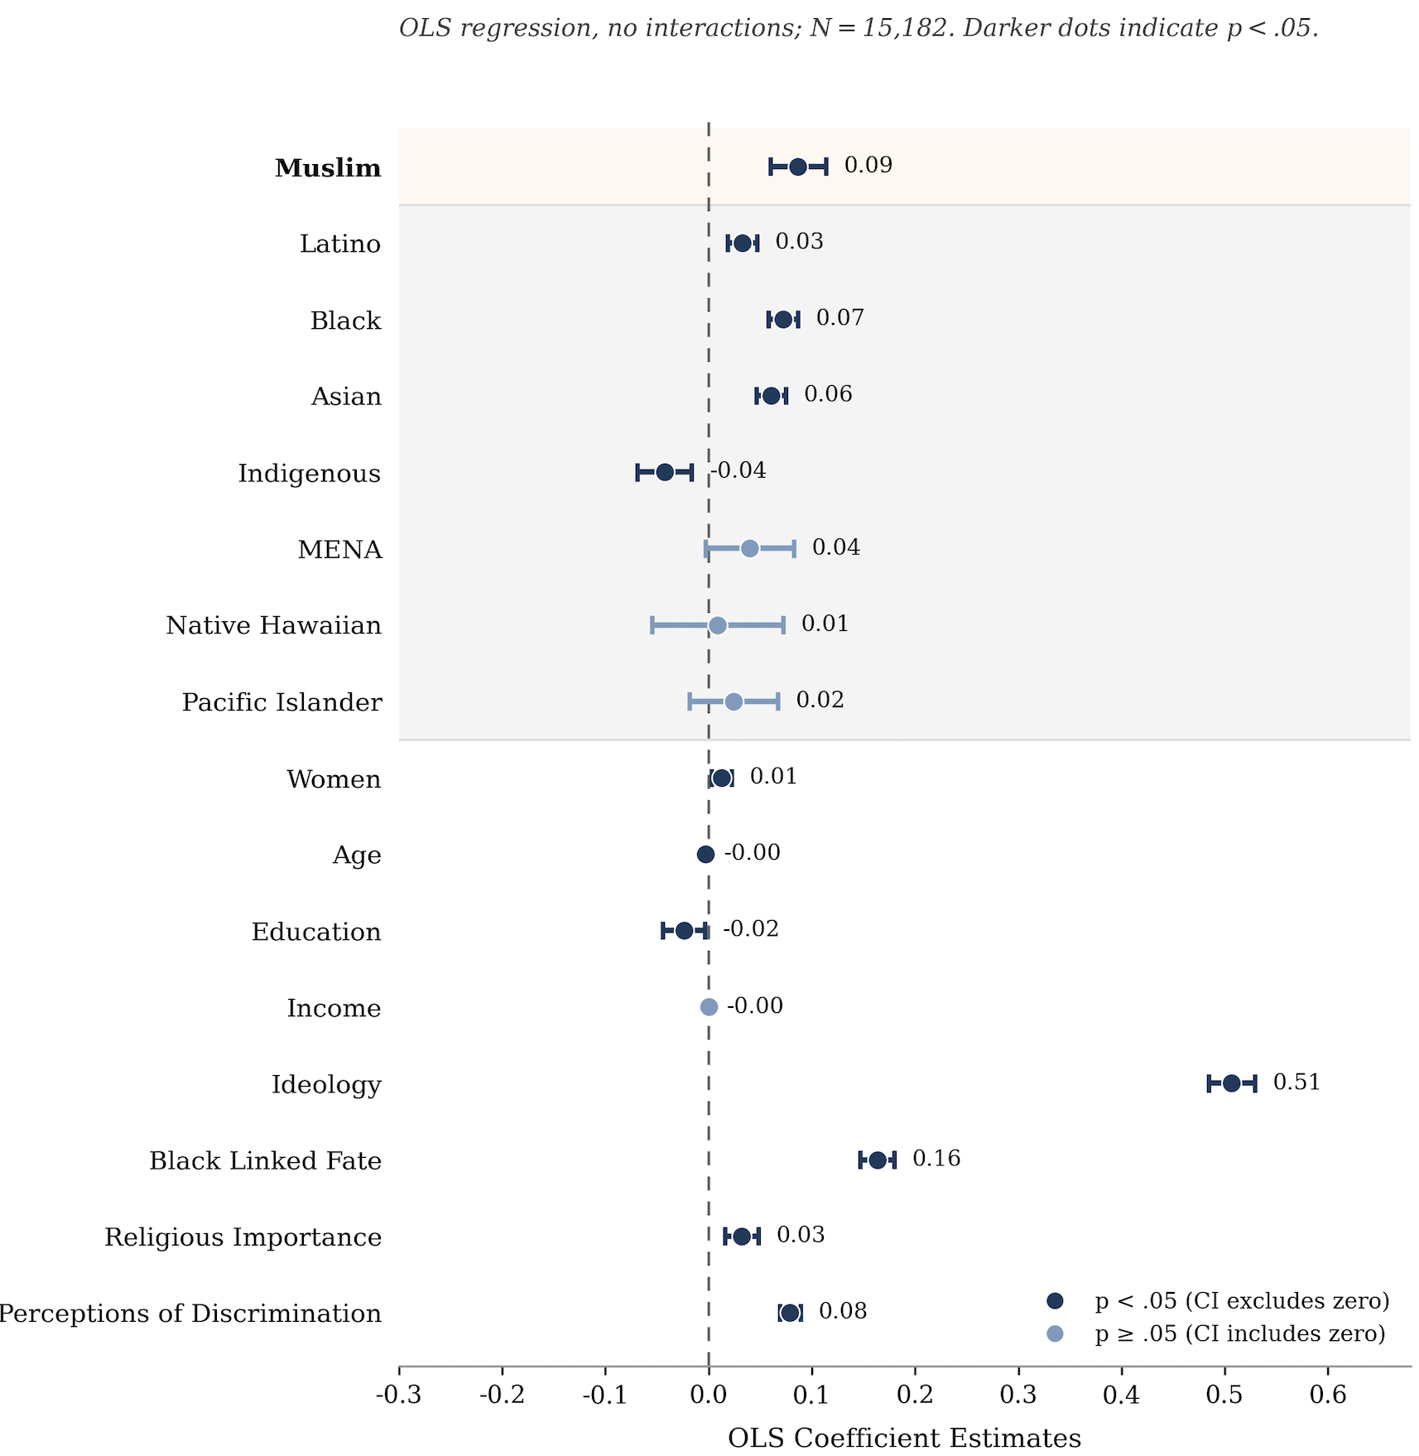

Figure 1 : Coefficient Plot for Model 2
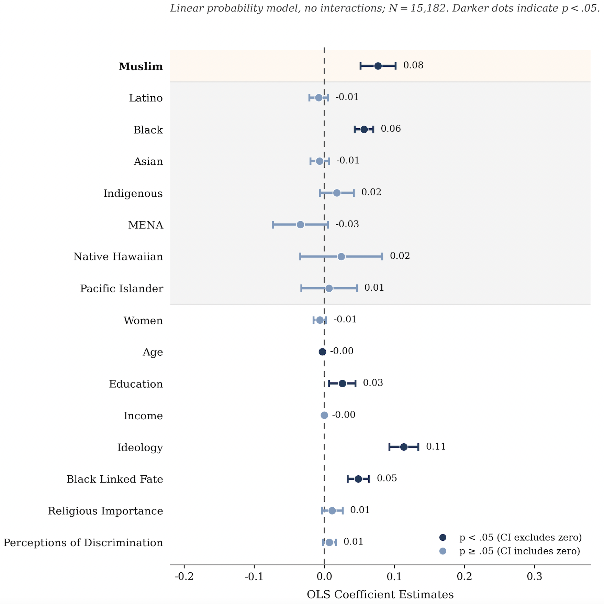
Table 2 : Model1 and Model 2’s results *with* interaction of Muslim and Racial Background

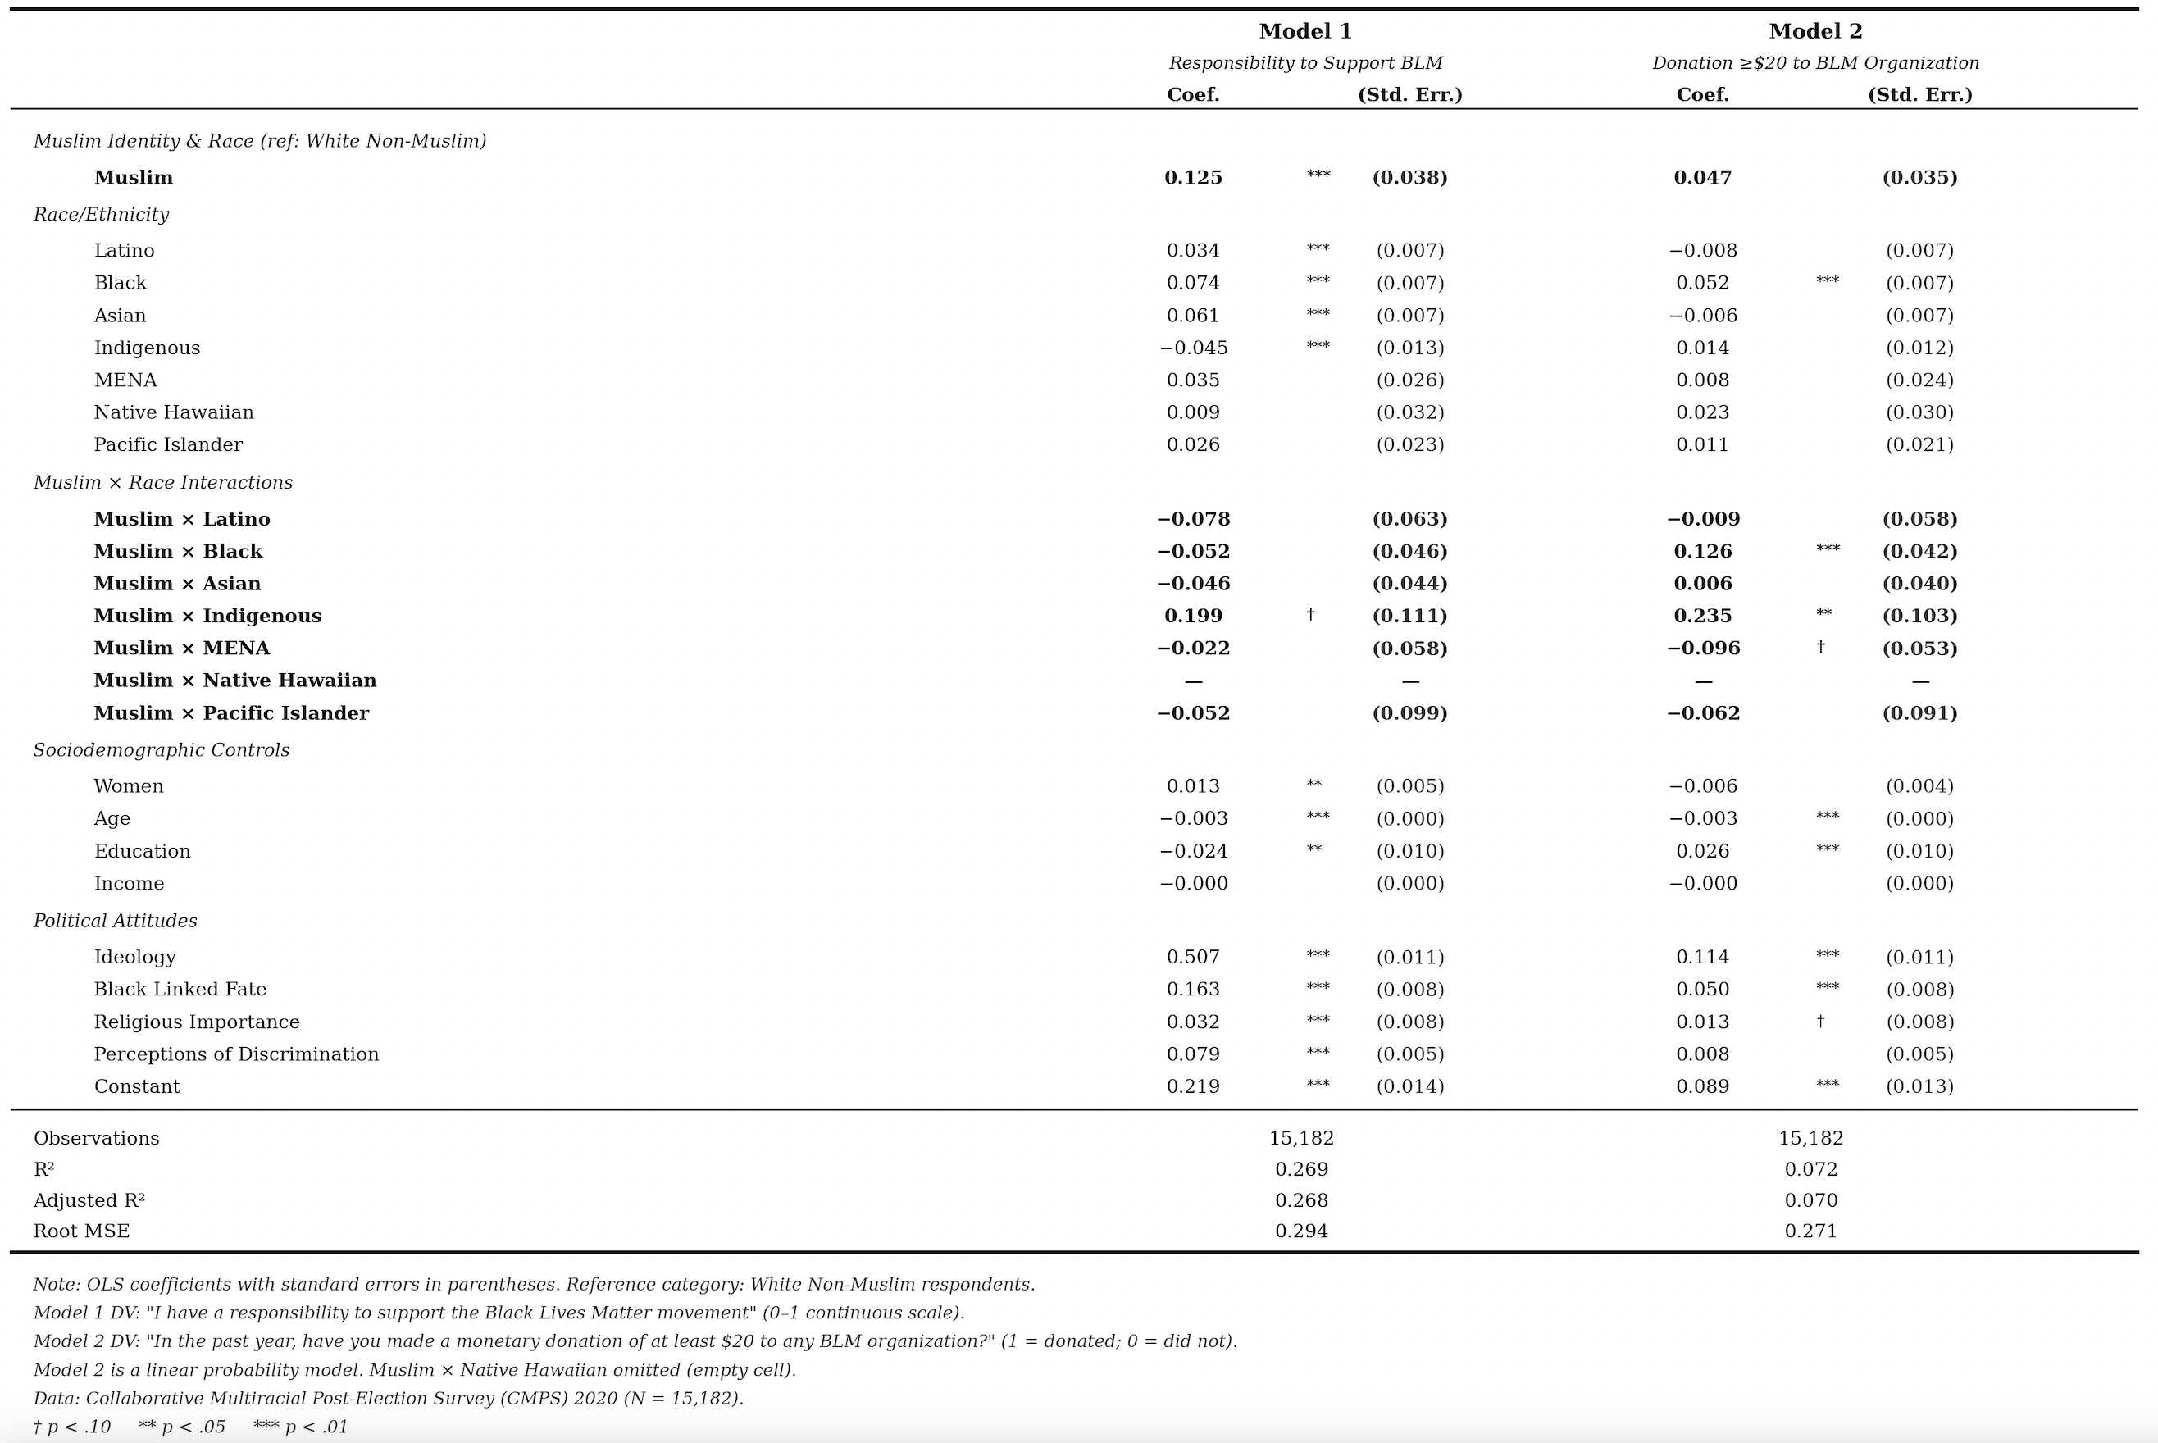

Table 3: Models 1 and 2 in Study 2, without Linked Fate Variable

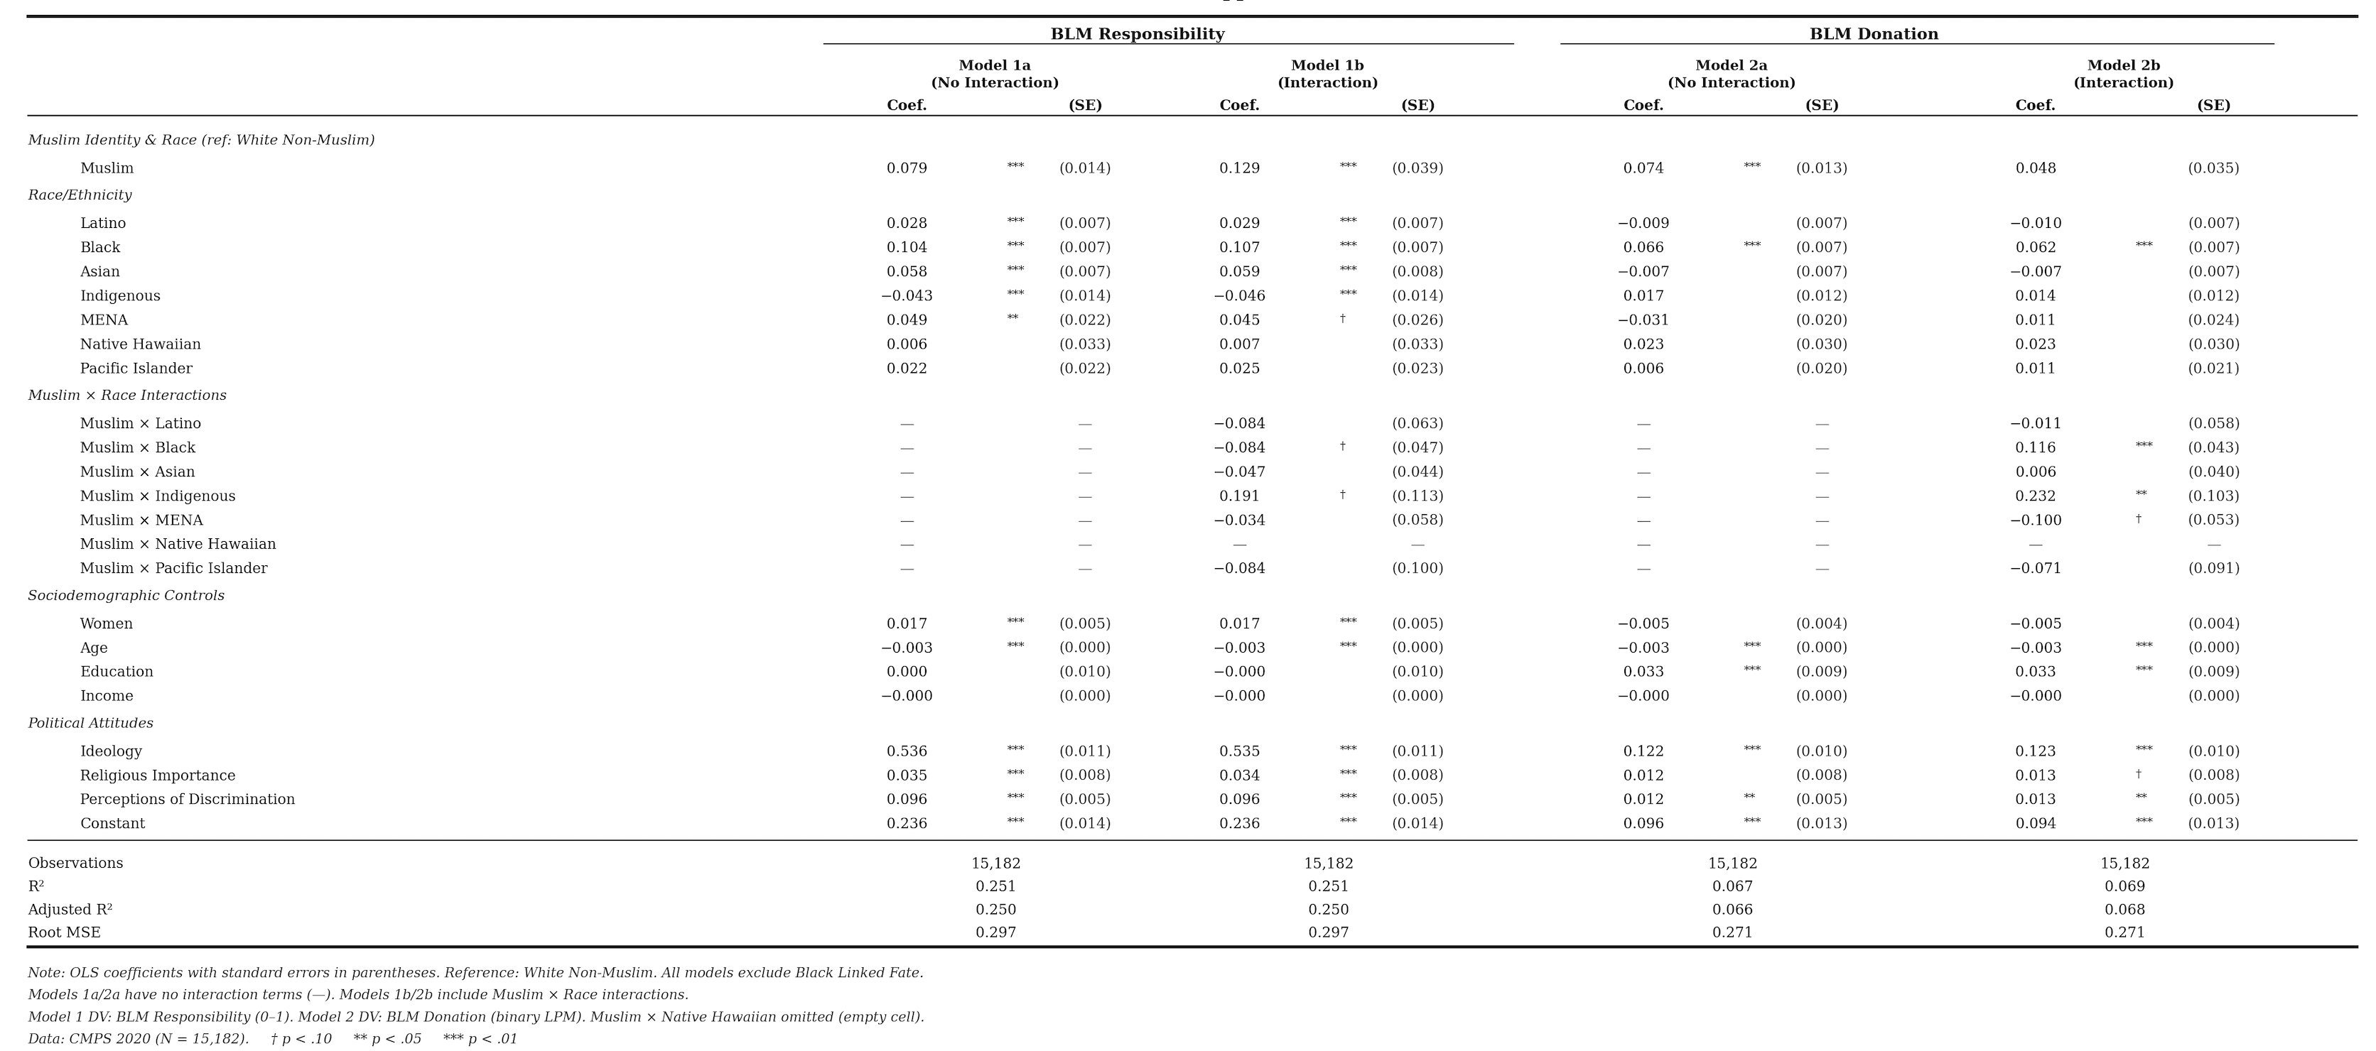

Table 4 : BLM Support Among Muslims Only
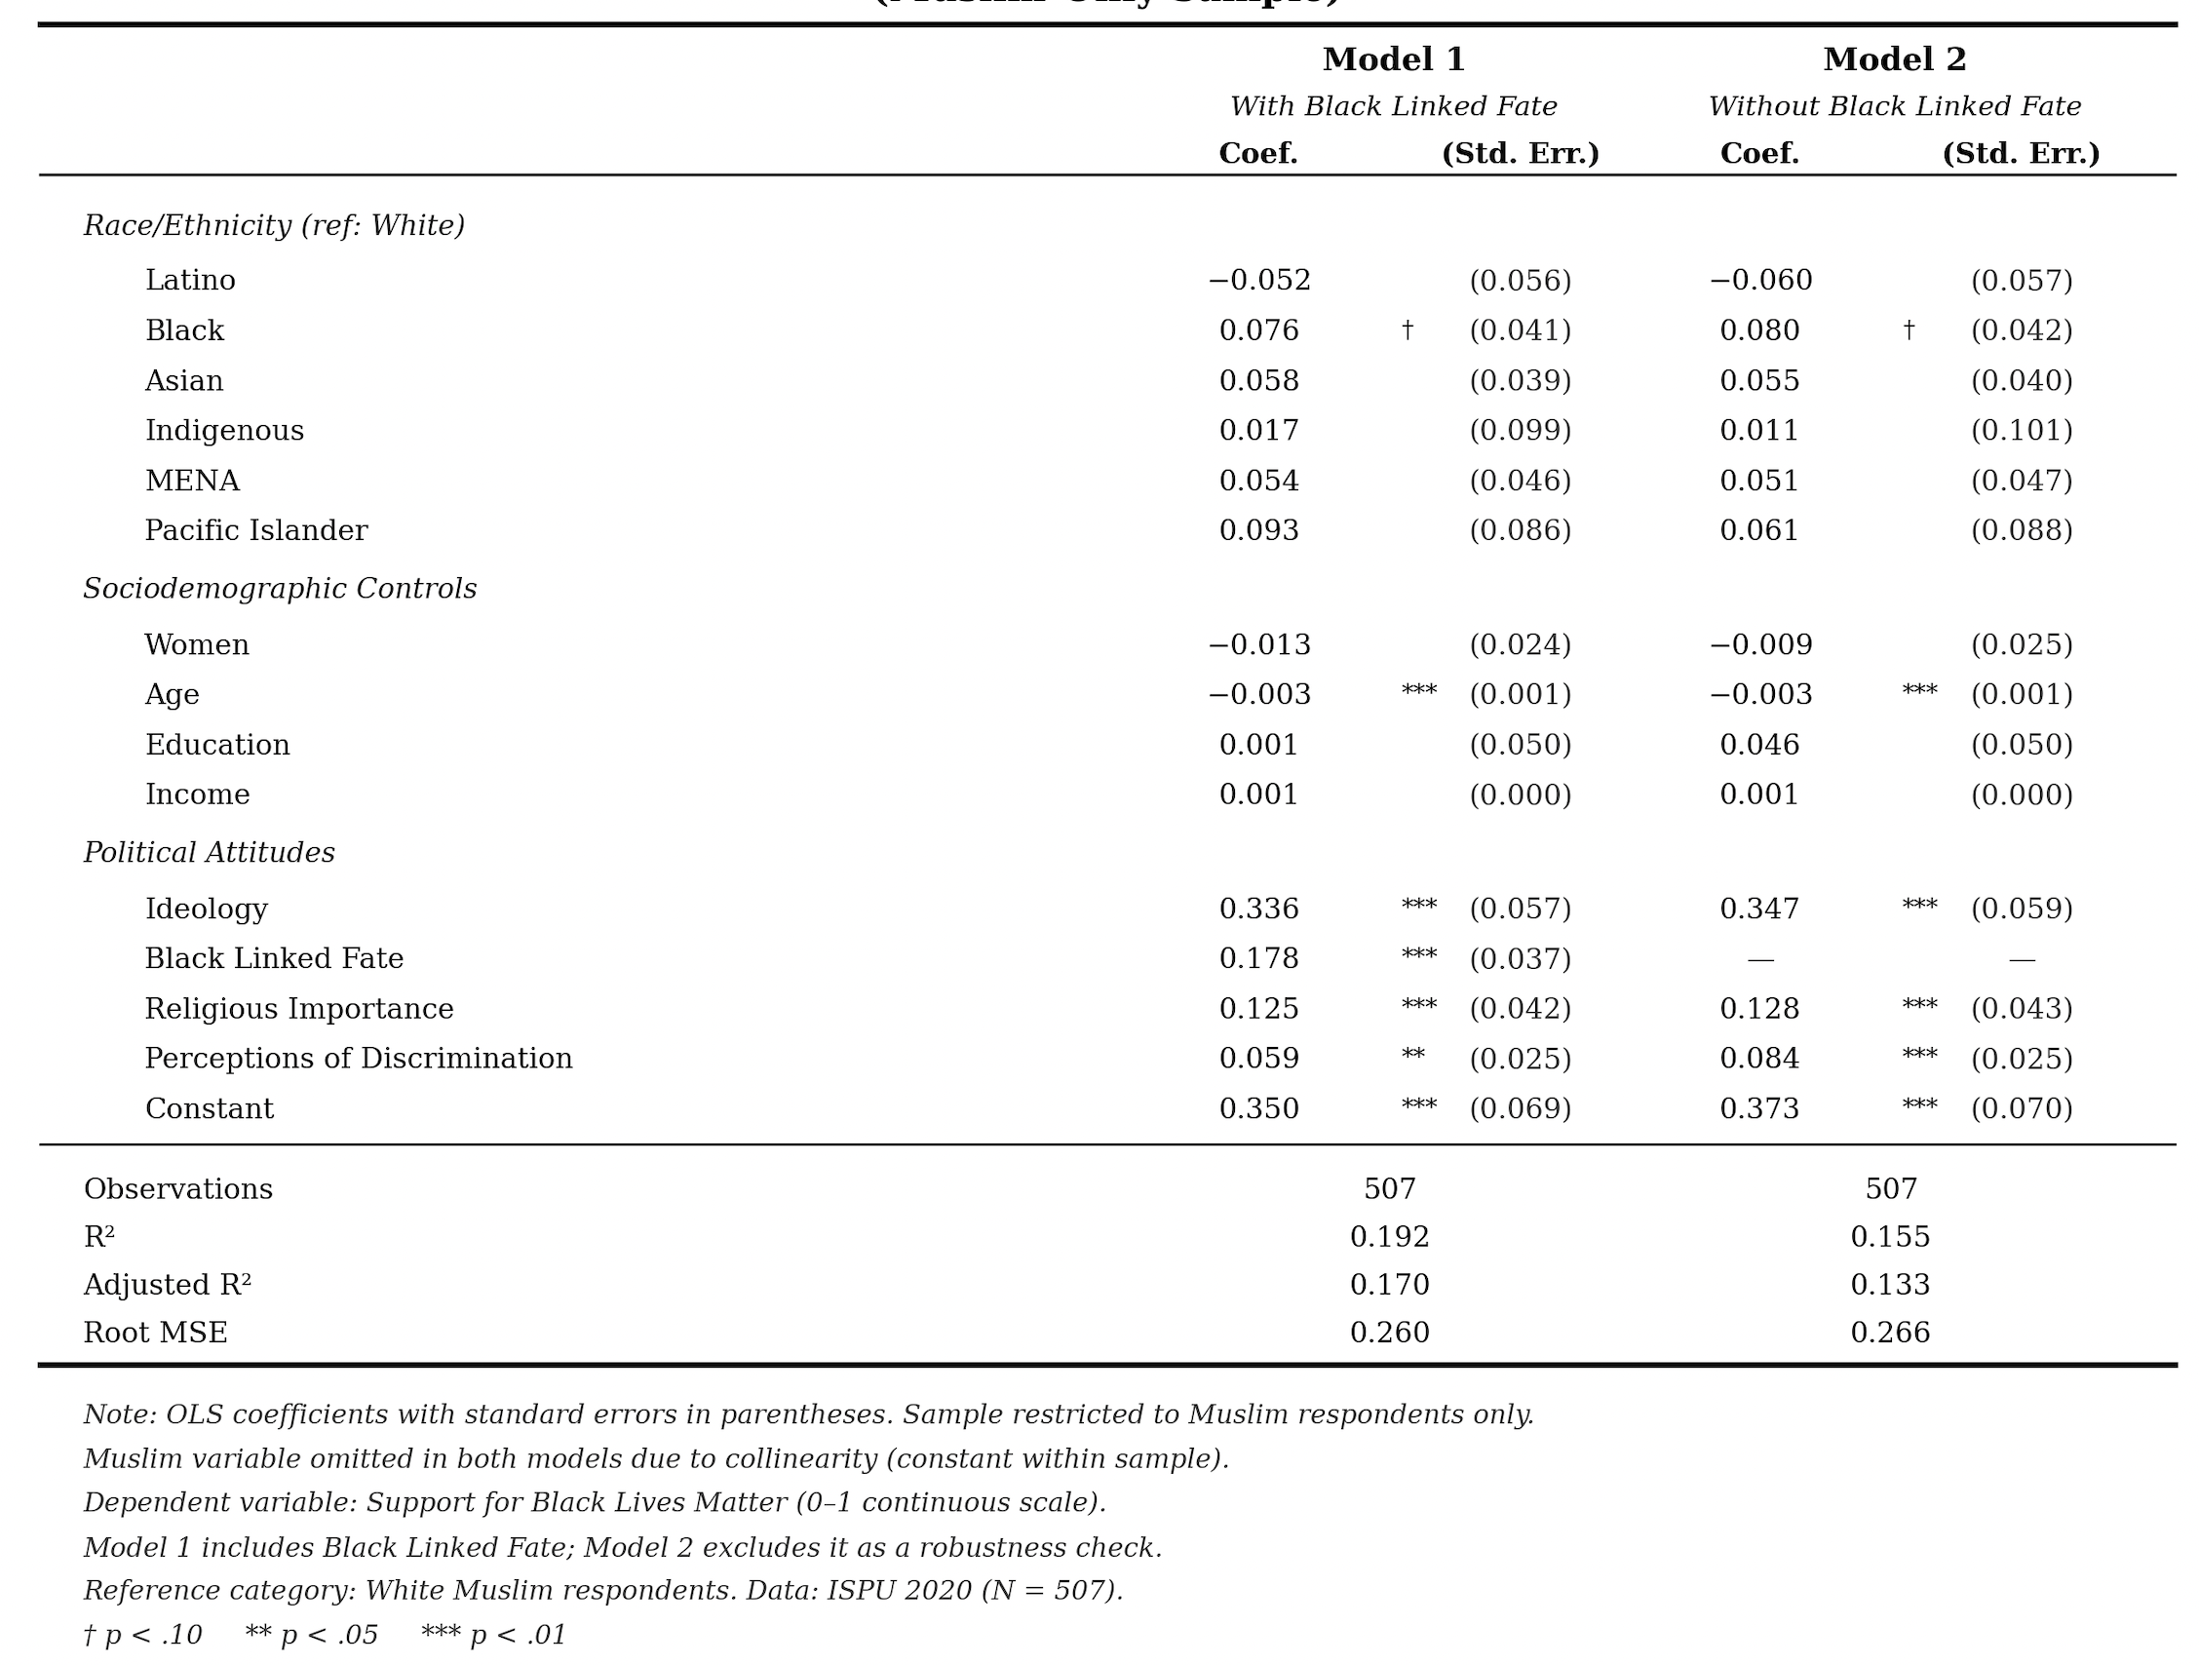

Additional CMPS Questions related to the study
Table 5 : BLM Protest Attendance
BLM Protest Attendance | Coef. |  | St.Err. | t-value |  | p-value | [95% Conf |  | Interval] |  | Sig
Muslim | .106 |  | .015 | 6.90 |  | 0 | .076 |  | .136 |  | ***
Women | -.041 |  | .006 | -7.32 |  | 0 | -.052 |  | -.03 |  | ***
Age | -.005 |  | 0 | -28.81 |  | 0 | -.005 |  | -.005 |  | ***
Black | .056 |  | .007 | 8.45 |  | 0 | .043 |  | .069 |  | ***
Education | -.015 |  | .011 | -1.34 |  | .179 | -.038 |  | .007
Income | 0 |  | 0 | -2.53 |  | .012 | 0 |  | 0 |  | **
Ideology | .198 |  | .013 | 15.30 |  | 0 | .173 |  | .224 |  | ***
Linked Fate with Black Americans | .032 |  | .01 | 3.36 |  | .001 | .013 |  | .051 |  | ***
Religious Importance | .069 |  | .009 | 7.45 |  | 0 | .051 |  | .087 |  | ***
Perceptions of Discrimination | .001 |  | .006 | 0.17 |  | .861 | -.01 |  | .012
Constant | .202 |  | .015 | 13.67 |  | 0 | .173 |  | .231 |  | ***
Mean dependent var |  | 0.147 |  |  | SD dependent var |  |  | 0.354
R-squared |  | 0.104 |  |  | Number of obs |  |  | 15182
F-test |  | 176.862 |  |  | Prob > F |  |  | 0.000
Akaike crit. (AIC) |  | 9933.751 |  |  | Bayesian crit. (BIC) |  |  | 10017.658
*** p<.01, ** p<.05, * p<.1

Table 6 : “Based on everything you have heard or seen, how much do you support or oppose the Black Lives Matter movement?”
Support for BLM | Coef. |  | St.Err. | t-value |  | p-value | [95% Conf |  | Interval] |  | Sig
Muslim | .05 |  | .012 | 4.04 |  | 0 | .026 |  | .074 |  | ***
Women | .035 |  | .004 | 7.75 |  | 0 | .026 |  | .044 |  | ***
Age | -.002 |  | 0 | -15.81 |  | 0 | -.002 |  | -.002 |  | ***
Black | .112 |  | .005 | 20.90 |  | 0 | .102 |  | .123 |  | ***
Education | -.006 |  | .009 | -0.66 |  | .511 | -.024 |  | .012
Income | 0 |  | 0 | 2.57 |  | .01 | 0 |  | 0 |  | **
Ideology | .588 |  | .01 | 56.22 |  | 0 | .568 |  | .609 |  | ***
Linked Fate with Black Americans | .208 |  | .008 | 26.74 |  | 0 | .192 |  | .223 |  | ***
Religious Importance | .021 |  | .007 | 2.80 |  | .005 | .006 |  | .036 |  | ***
Perceptions of Discrimination | .121 |  | .005 | 25.76 |  | 0 | .112 |  | .13 |  | ***
Constant | .148 |  | .012 | 12.45 |  | 0 | .125 |  | .172 |  | ***
Mean dependent var |  | 0.630 |  |  | SD dependent var |  |  | 0.346
R-squared |  | 0.387 |  |  | Number of obs |  |  | 15182
F-test |  | 957.050 |  |  | Prob > F |  |  | 0.000
Akaike crit. (AIC) |  | 3434.937 |  |  | Bayesian crit. (BIC) |  |  | 3518.844
*** p<.01, ** p<.05, * p<.1

Appendix C : References
Barreto, Matt A., Frasure-Yokley, Lorrie, Vargas, Edward D., and Wong, Janelle. 2018. “Best Practices in Collecting Online Data with Asian, Black, Latino, and White Respondents: Evidence from the 2016 Collaborative Multiracial Post-Election Survey.” Politics, Groups, and Identities 6 (1): 171–80.

Bonilla, T and Lajevardi, N. 2025. “How Minority Status and Transnational Solidarity Shape Sympathy, Foreign Policy Preferences, and Political Action in the War in Gaza,” Working paper.

Brown, H., & Jones, J. A. (2016). Immigrant rights are civil rights. Contexts, 15(2), 34-39.

Mercer, Andrew. 2016. “Oversampling Is Used to Study Small Groups, Not Bias Poll Results.” Washington, DC: Pew Research Center. www.pewresearch.org/fact- tank/2016/10/25/oversampling-is-used-to-study-small-groups-not-bias-poll- results.Google Scholar

Chan-Malik, S. (2018). Being Muslim: A cultural history of women of color in American Islam. NYU Press.

Chouhoud, Y., Dana, K., & Barreto, M. 2019. American Muslim political participation: Between diversity and cohesion. Politics and religion, 12(4), 736-765. https://doi.org/10.1017/S1755048319000317

Diouf, Sylviane A. 2013. Servants of Allah: African Muslims Enslaved in the Americas. New York: New York University Press.

Frasure, L., Wong, J., Barreto, M. A., Vargas, E. D. 2025. “Introduction to the Collaborative Multiracial Post-Election Survey (CMPS) Oversamples.”

Jamal, Amaney. 2005. "The Political Participation and Engagement of Muslim Americans: Mosque Involvement and Group Consciousness." American Politics Research 33(4):521-544. https://doi.org/10.1177/1532673X04274126 .

Kim, C. J. (2000). Bitter fruit: The politics of black-Korean conflict in New York City. Yale University Press.

Kuo, Rachel. 2017. “Reflections on #Solidarity: Intersectional Movements in AAPI Communities,” in The Routledge Companion to Asian American Media. Routledge.

Lajevardi, Nazita. 2020. Outsiders at Home: The Politics of American Islamophobia. Cambridge, UK; New York, NY: Cambridge University Press.

McClain, P. D. (1993). The Changing Dynamics of Urban Politics: Black and Hispanic Municipal Employment--Is There Competition?. The Journal of Politics, 55(2), 399-414.

Muslim Advocates, & Muslim Wellness Foundation. (2020, June 15). Black Lives Matter: An American Muslim community statement against police violence. https://muslimadvocates.org/police-violence-statement/.

Oskooii, Kassra A. R. 2016. "How Discrimination Impacts Sociopolitical Behavior: A Multidimensional Perspective." Political Psychology 37(5):613-640. https://doi.org/10.1111/pops.12294 .

Pérez, E. O. (2021). Diversity's child: People of color and the politics of identity. University of Chicago Press.

Pew Research Center. (2025, February 26). Age, race, education and other demographic traits of U.S. religious groups. Pew Research Center. https://www.pewresearch.org/religion/2025/02/26/age-race-education-and-other- demographic-traits-of-us-religious-groups/.

Sediqe, Nura A. 2020. "Stigma Consciousness and American Identity: The Case of Muslims in the United States." PS: Political Science & Politics 53(4):674-678. https://doi.org/10.1017/S1049096520000350.

Sediqe, Nura A. 2025. “When you bleed, I bleed too. Collective Community Responsibility as a Psychological Resource: The Influence of Ummah Consciousness on Political Protest for Muslims in the United States.” Working Paper.
.

