Appendix A: Details of the surveys
The study "The impact of the pandemic on work routines in Social Sciences" was coordinated by the Brazilian Political Science Association (ABCP) and supported by the National Association of Graduate Studies and Research in Social Sciences (ANPOCS), the Brazilian Anthropological Association (ABA), the Brazilian Association for International Relations (ABRI), and the Brazilian Society of Sociology (SBS). The survey responses were collected between June 10th and July 15th, 2020, reaching 1,073 social scientists, 274 of which were political scientists. The general results, as well as the survey’s methodology and discussion, were presented in the article "Social Sciences in the Covid-19 Pandemic: work routines and inequalities" (Candido et al, 2021).
The research that led to the second survey, "The Future of Academic Work in the Social Sciences," was initiated by ANPOCS and received support from ABCP, ABA, and SBS. In total, 1,380 social scientists were surveyed, of which 278 were political scientists. The survey was conducted between March 2nd and March 28th, 2022. The project also included a qualitative component, with in-depth interviews analyzing a selected population of social scientists who have recently earned their PhDs.

Comparison of the two databases and official information from the academic community
There is no official data regarding the gender and race profile of political scientists in Brazil. According to information about the names of professors and students linked to political science graduate programs in the country, provided by the Coordination for the Improvement of Higher Education Personnel (CAPES), a foundation related to the Ministry of Education of Brazil, we mobilized a R package (GenderBR) to impute gender. This categorization is restricted to demographic data analysis specific to Brazil and only considers the binary genders of "female" and "male." While this classification is not the most comprehensive possible, it provides an important overview about gender in Brazilian academia. Data for 2019 totalized 4,728 individuals, of which 46.29% were classified as female and 53.70% as male.

General information from the research database: "The impact of the pandemic on work routines in Social Sciences."
Total political science respondents = 274, about 6% of the universe of political scientists affiliated with graduate studies in Brazil, of which 54% were female and 46% were male.
• In the first survey, 72% of respondents were white and 28% were non-white.
• Combining the two subsets and considering that gender = declared sex, 31% of respondents were white males, 15% were non-white males, 41% were white females, and 13% were non-white females.

General information from the research database “The Future of Academic Work in the Social Sciences.”
Total political science respondents = 278, or approximately 6% of the universe of political scientists affiliated with graduate programs in Brazil, 47% of which were women and 53% of which were men. NOTE: 18 survey respondents were disregarded, of which 2 were agender respondents (because of their small number, it would be impossible to examine this group separately), 6 were respondents who preferred not to declare their race, and 10 were respondents who preferred not to declare their gender.
• The total valid second database respondents were 73% white and 27% non-white; in total, 40% of respondents were white males, 13% were non-white males, 33% were white females, and 14% were non-white females.

Differences in the classification of “sex” and “gender”
Although gender is a multidimensional concept, for the operationalization of the analysis we decided to use the dichotomic categories “women,” for all female respondents, and “men,” for all male respondents . While this representation of gender may not encompass all the complexities of the concept, it appears to be adequate given that only a small proportion of respondents in our 2020 and 2022 surveys identified as non-binary or outside of the binary gender categories. Due to the limited sample size, a response distribution analysis would not provide a sufficient representation to identify subtle variations or nuances. While our study provides a broad overview, it is crucial to conduct future research utilizing qualitative methods to gain a deeper understanding of the perception and challenges faced by political scientists during the pandemic period. This could provide a more detailed representation of their experiences and help identify areas for improvement.
• In the first database, the question was “What is your gender?” with the options “Female,” “Male,” and “Others...” (open answer option);
• In the second database, the question was “Which gender do you identify with?,” with the options “Cisgender woman (identifies with the gender assigned at birth),” “Transgender woman (does not identify with the gender assigned at birth),” “Cisgender male (identifies with the gender assigned at birth),” “Transgender male (identifies with the gender assigned at birth),” “ Non-binary person (gender not limited to the categories of woman or man),” “Agender (does not fit into any of the socially established genders),” and “I prefer not to answer.”
• In the analysis of the first database, “sex” was interpreted as a proxy for “gender.” In the analysis of the second database, the recoding used the terms “men,” “women,” and “others.” Unfortunately, we were forced to disregard those categorized as “others” due to the small numbers of respondents who placed themselves in this group, which was insufficient for drawing up graphs.

Differences in the classification of daily hours intended for each activity:
• In the first database, the question was “How many hours a day (during the pandemic) do you spend on these activities:”;
• In the second database, the question was “ON WEEKDAYS: In the remote work routine, on average, how many hours a day do you dedicate to the following activities? Please assign an estimate to each row”;
• We consider the questions in the first and second databases sufficiently similar to compare the data.

Questions that were not asked in both surveys:
The second dataset did not include a question that assessed the perception of balance in the distribution of domestic work, but it included an additional question on daily sleep hours.

Graphics details
Graph 1
To explore the 2020 data, we used the question: "How many hours a day (during the pandemic) do you spend on the following activities: academic work." The respondents included 85 white males, 41 non-white males, 112 white females, and 36 non-white females. To explore the 2022 data, we used the question “DURING WEEKDAYS: In the remote work routine, on average, how many hours a day do you dedicate to the following activities? Please assign an estimate to each row. – Academic work.” The respondents included 110 white males, 36 non-white males, 93 white females and 39 non-white females.

Graph 2
To explore the 2020 data, we used the question: "How many hours a day (during the pandemic) do you spend on the following activities: academic work." The respondents included 85 white males, 41 non-white males, 112 white females, and 36 non-white females. To explore the 2022 data, we used the question “DURING WEEKDAYS: In the remote work routine, on average, how many hours a day do you dedicate to the following activities? Please assign an estimate to each row. – Academic work.” The respondents included 110 white males, 36 non-white males, 93 white females and 39 non-white females.

Graph 3
To explore the 2020 data, we used the question: "How many hours a day (during the pandemic) do you spend on the following activities: academic work." The respondents included 85 white males, 41 non-white males, 112 white females, and 36 non-white females. To explore the 2022 data, we used the question “DURING WEEKDAYS: In the remote work routine, on average, how many hours a day do you dedicate to the following activities? Please assign an estimate to each row. – Academic work.” The respondents included 110 white males, 36 non-white males, 93 white females and 39 non-white females.

Graph 4
To explore the 2020 data, we used the question: "How many hours a day (during the pandemic) do you spend on the following activities: academic work." The respondents included 85 white males, 41 non-white males, 112 white females, and 36 non-white females. To explore the 2022 data, we used the question “DURING WEEKDAYS: In the remote work routine, on average, how many hours a day do you dedicate to the following activities? Please assign an estimate to each row. – Academic work.” The respondents included 110 white males, 36 non-white males, 93 white females and 39 non-white females.

Graph 5
To explore the 2020 data, we used the question “During the pandemic, are you the only one responsible for housework?” The respondents included 34 white males with children and 50 without children; 15 non-white males with children and 26 without children; 40 white females with children and 72 without children; and 12 non-white females with children and 24 without children. To explore the 2022 data, we used the question “In the remote work routine, are you the only one responsible for the housework?”. The respondents included 35 white males with children and 74 without children; 12 non-white males with children and 19 without children; 27 white females with children and 53 without children; and 8 non-white females with children and 26 without children.

Appendix B: Additional data
Graph 6: Perceptions of daily hours devoted to leisure (%) (2020 and 2022)
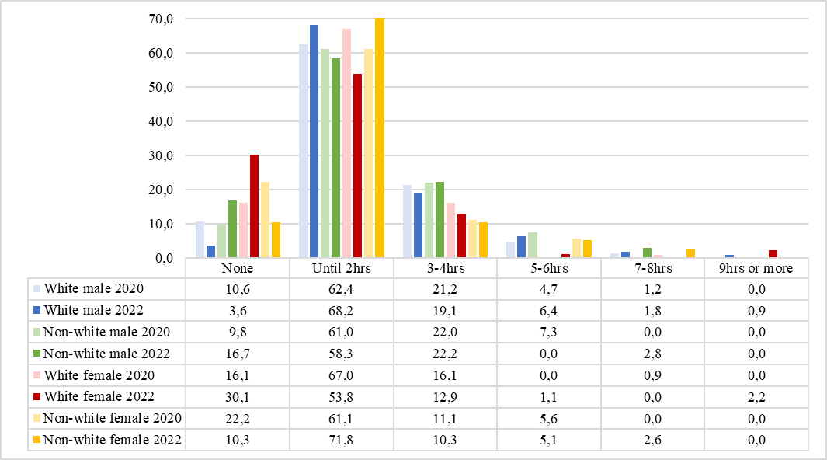
Source: our own elaboration, based on Marques et al (2022). To explore the 2020 data, we used the question “How many hours a day (during the pandemic) do you spend on these activities: Leisure”. The respondents included 85 white males, 41 non-white males, 112 white females, and 36 non-white females. To explore the 2022 data, we used the question “IN WEEKDAYS: In the remote work routine, on average how many hours a day do you dedicate to these activities? Please assign an estimate to each row. - Leisure.” The valid responses included 110 males, 36 non-white males, 93 white females and 39 non-white females.

Graph 7: Perceptions of the division of domestic work (%) (2020)
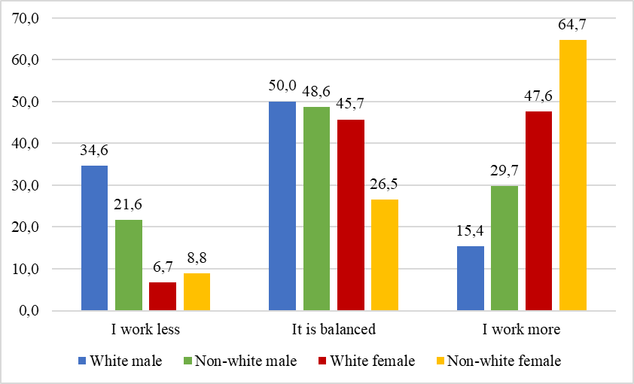
Source: our own elaboration, based on Marques et al (2022). Question: “Do you consider the division of domestic work (during the pandemic) balanced?”. The respondents included 78 white males, 37 non-white males, 105 white females, and 34 non-white females.

Graph 8: Perceptions of daily hours devoted to sleep (%) (2022)
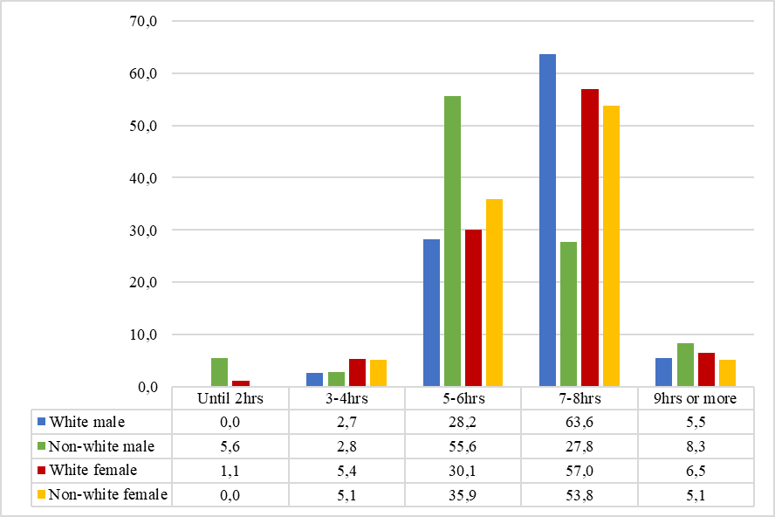

Source: authors elaboration based on Catelano et al (2022). Question: “IN WEEKDAYS: In the remote work routine, on average, how many hours a day do you dedicate to these activities? Please assign an estimate to each row. – Sleep”. The respondents included 110 white males, 36 non-white males, 93 white females and 39 non-white females.

In Portuguese, Associação Brasileira de Ciência Política. Website: https://cienciapolitica.org.br/web/ Accessed Oct 10, 2022.
In Portuguese, Associação Nacional de Pós-Graduação e Pesquisa em Ciências Sociais. Website: http://www.anpocs.com/ Accessed Oct 10, 2022.
In Portuguese, Associação Brasileira de Antropologia. Website: http://www.portal.abant.org.br/ Accessed Oct 10, 2022.
In Portuguese, Associação Brasileira de Relações Internacionais. Website: https://www.abri.org.br/ Accessed Oct 10, 2022.
In Portuguese, Sociedade Brasileira de Sociologia. Website: https://www.sbsociologia.com.br/ Accessed Oct 10, 2022.
See: https://github.com/meirelesff/genderBR Accessed Oct 25, 2022.
See more data here: Candido, Campos and Feres (2019) or Candido (2021).

