Supplementary Table 1

Supplementary Table 1. Diagnosis by ethnic group.
 | Overall (n=3,589) | White  (n=2,578) | South Asian  (n=634) | Black  (n=95) | Other  (n=201) | Missing (n=81)
Hypoplastic left heart syndrome | 61 (2) | 44 (2) | 13 (2) | 0 (0) | 4 (2) | 0 (0)
Functionally univentricular heart | 134 (4) | 88 (3) | 34 (5) | 4 (4) | 7 (3) | 1 (1)
Pulmonary atresia + IVS | 12 (<1) | 9 (<1) | 2 (<1) | 0 (0) | 1 (1) | 0 (0)
Pulmonary atresia + VSD, common arterial trunk | 118 (3) | 80 (3) | 24 (4) | 4 (4) | 6 (3) | 4 (5)
Transposition of Great Arteries | 234 (7) | 161 (6) | 47 (7) | 4 (4) | 22 (11) | 0 (0)
Tetralogy of Fallot | 355 (10) | 247 (10) | 78 (12) | 8 (9) | 16 (8) | 6 (8)
Atrioventricular septal defect | 328 (9) | 248 (10) | 40 (6) | 17 (18) | 20 (10) | 3 (4)
TAPVC | 67 (2) | 45 (2) | 16 (3) | 0 (0) | 4 (2) | 2 (3)
Aortic valve disease | 89 (2) | 69 (3) | 10 (2) | 2 (2) | 4 (2) | 4 (5)
Coarctation, hypoplastic/interrupted arch | 395 (11) | 309 (12) | 55 (9) | 11 (12) | 14 (7) | 6 (8)
ASD, VSD | 1,137 (32) | 801 (31) | 202 (32) | 27 (29) | 71 (35) | 36 (45)
PDA | 299 (8) | 211 (8) | 52 (8) | 11 (12) | 14 (7) | 11 (14)
Acquired | 55 (2) | 42 (2) | 7 (1) | 0 (0) | 4 (2) | 2 (3)
Other | 288 (8) | 211 (8) | 52 (8) | 6 (6) | 14 (7) | 5 (6)
Unknown | 17 (0) | 13 (1) | 2 (<1) | 1 (1) | 0 (0) | 1 (1)
IVS, intact ventricular septum; VSD, ventricular septal defect; TAPVC, total anomalous pulmonary venous connection; ASD, atrial septal defect; PDA, patent ductus arteriosus.
Supplementary Table 2

Supplementary Table 2. 1-year survival estimates (%) by ethnic group and time period.
 | 2005-2008 |  | 2009-2012 |  | 2013-2016 |  | 2017-2021
 | Survival (%) (95% CI) | HR* (95% CI) | Survival (%) (95% CI) | HR* (95% CI) | Survival (%) (95% CI) | HR* (95% CI) | Survival (%) (95% CI) | HR* (95% CI)
All children | 92.2 (90.1-93.8) | N/A | 93.6 (91.8-95.0) | N/A | 95.2 (93.6-96.4) | N/A | 95.6 (93.9-96.8) | N/A
Ethnic group
White | 93.5 (91.3-95.2) | 1.00 (ref) | 94.1 (92.0-95.6) | 1.00 (ref) | 95.7 (93.9-96.9) | 1.00 (ref) | 96.8 (94.9-97.9) | 1.00 (ref)
South Asian | 86.6 (80.0-91.1) | 1.74 (1.10-2.75) | 91.0 (85.5-94.5) | 1.27 (0.74-2.17) | 91.6 (86.2-94.9) | 1.41 (0.76-2.63) | 94.7 (89.8-97.3) | 1.66 (0.78-3.57)
Black | 88.2 (60.6-96.9) | 1.59 (0.50-5.09) | 92.0 (71.6-97.9) | 1.72 (0.62-4.78) | 95.2 (70.7-99.3) | 1.52 (0.37-6.33) | 90.6 (73.7-96.9) | 2.36 (0.70-7.97)
Other | 92.5 (78.5-97.5) | 1.21 (0.49-3.00) | 95.9 (84.7-99.0) | 0.97 (0.35-2.68) | - | - | 88.7 (76.5-94.7) | 3.06 (1.23-7.63)
*Adjusted for area-based income deprivation score.
HR, Hazard Ratio; CI, confidence interval.

Supplementary Figure 1
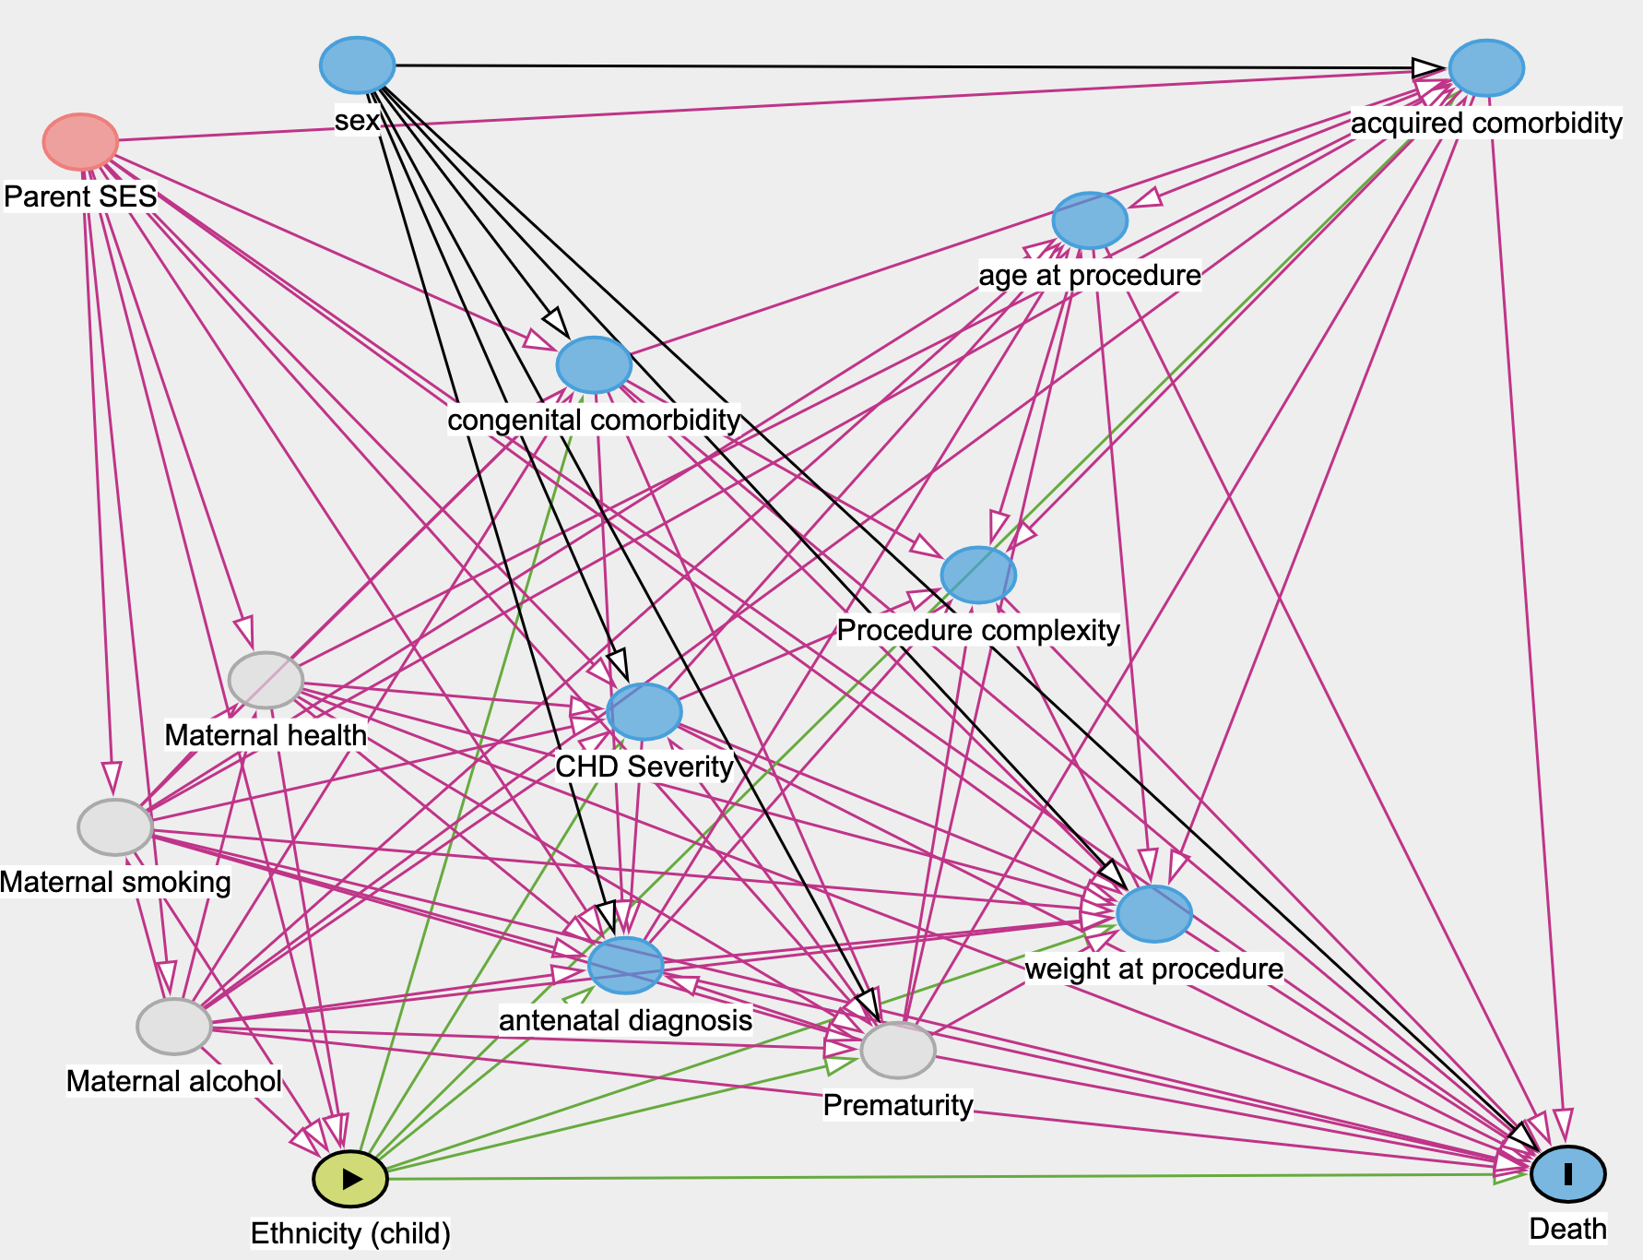

Supplementary Figure 2

