Supplemental Appendix

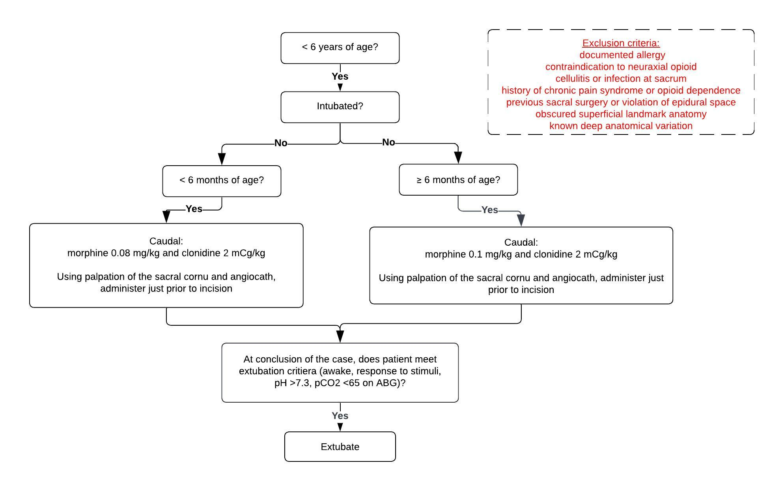Supplement Figure 1: Institutional Algorithm



Supplement Table 1. Reasons for Re-intubation

|  |  |  |  |  |  |  |
| --- | --- | --- | --- | --- | --- | --- |
| STAT | Age | Weight (kg) | Procedure | Clonidine Caudal (mcg/kg) | Morphine Caudal (mg/kg) | Reason for Re-intubation |
| 1 | Infant | 6.36 | VSD + ASD | 2.36 | 0.12 | Bradycardia |
| 1 | Child | 12.8 | Fontan | 3.13 | 0.23 | Hypotension  s/p chest fluid drainage |
| 1 | Infant | 5 | TOF | 2 | 0.1 | Hypercarbia |
| 1 | Child | 16.5 | ASD | 2.12 | 0.16 | Seizures / left lung opacification |
| 2 | Infant | 6.21 | Pulmonary atresia-VSD-MAPCA | 3.54 | 0.12 | Respiratory decompensation |
| 5 | Neonate | 3 | Norwood | 2 | 0.08 | Hypoxia |
| 3 | Neonate | 2.82 | Aortic Arch | 2.13 | 0.26 | Pulmonary hypertension |
| 2 | Infant | 4.8 | VSD | 2.5 | 0.1 | Respiratory acidosis |
| 3 | Infant | 5.1 | Palliation; Shunt | 1.6 | 0.08 | Bradycardia |
| 3 | Child | 8.5 | TOF | 2.82 | 0.12 | Respiratory failure |