Figure 1 Comparison of left ventricular functional and dimensional parameters between treated and control groups in patients with cardiomyopathy

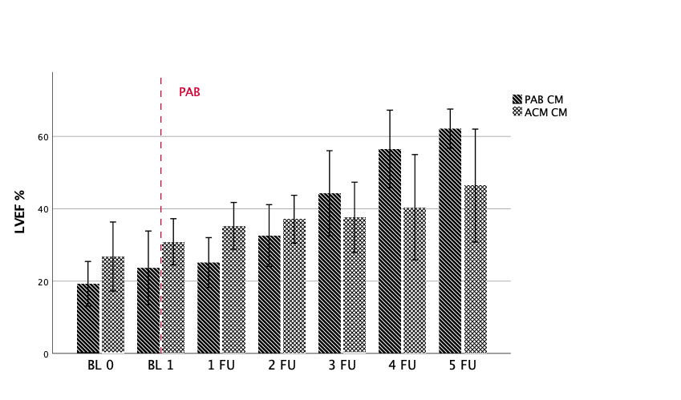 | 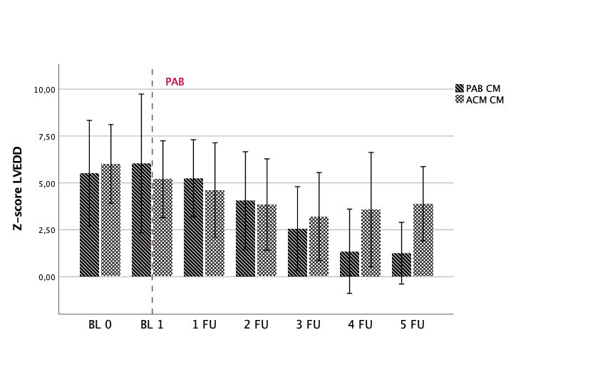
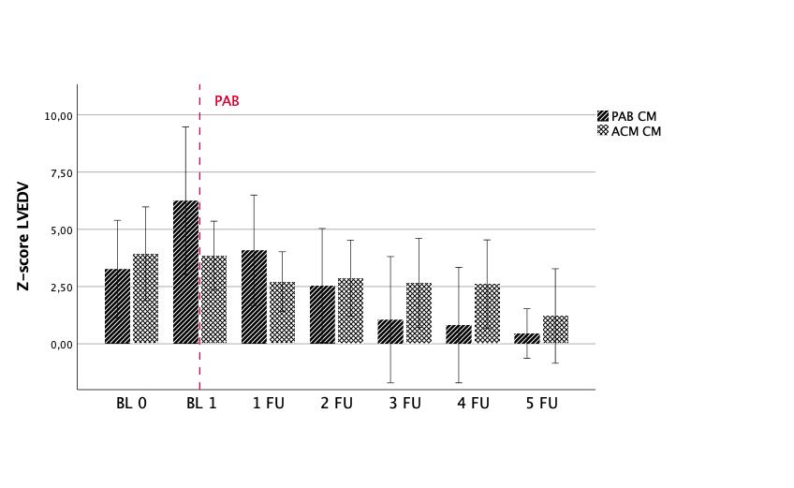

CM Cardiomyopathy
LVEF left ventricle ejection fraction
LVEDD left ventricle end-diastolic diameter
LVEDV left ventricle end-diastolic volume
BL 0 FU - baseline Follow-Up (FU) at admission and ACM starting,
BL 1 - Baseline time at PAB application
FU 1 - 1 month after PAB
FU 2 - 2 month after PAB
FU 3 - 3 months after PAB
FU 4 - 1 year after PAB
FU 5 - 5 years after PAB
ACM: Anti-congestion medication
PAB: Pulmonary artery banding

Figure 2 Comparison of left ventricular functional and dimensional parameters between treated and control groups in patients with LVNC

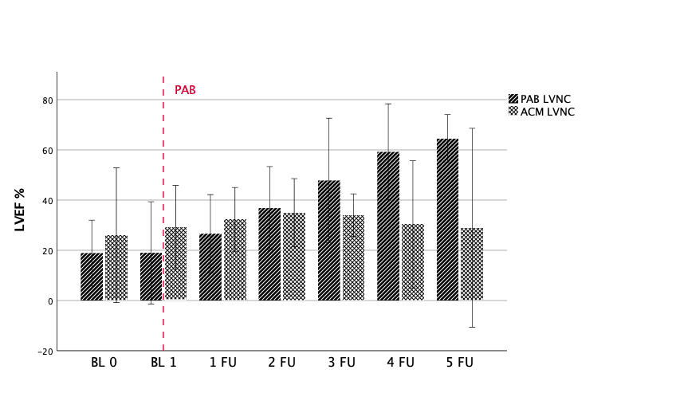 | 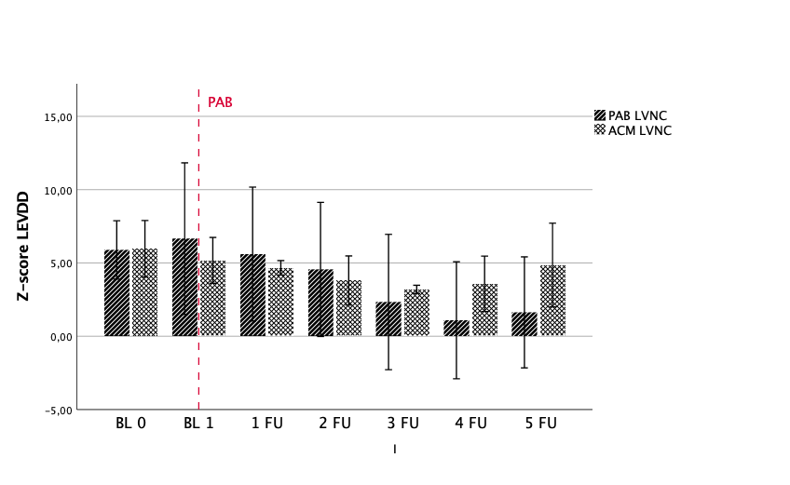
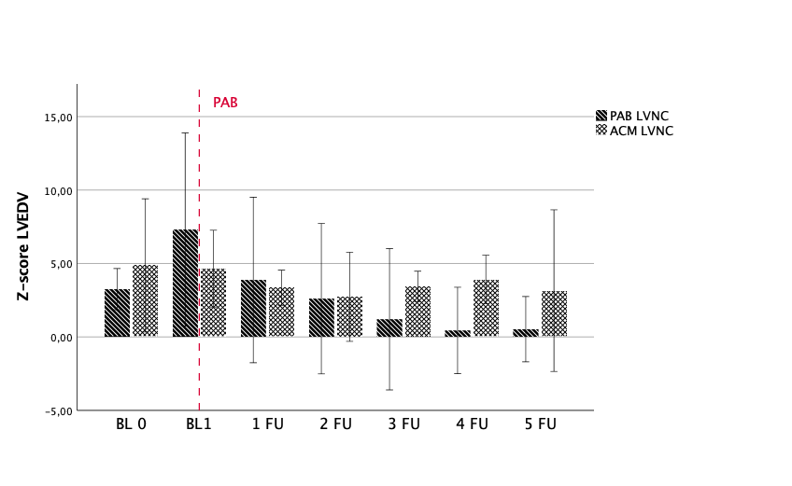

LVEF left ventricle ejection fraction
LVEDD left ventricle end-diastolic diameter
LVEDV left ventricle end-diastolic volume
LVNC: Left ventricular noncompaction cardiomyopathy
BL 0 FU - baseline Follow-Up (FU) at admission and ACM starting,
BL 1 - Baseline time at PAB application
FU 1 - 1 month after PAB
FU 2 - 2 month after PAB
FU 3 - 3 months after PAB
FU 4 - 1 year after PAB
FU 5 - 5 years after PAB
ACM: Anti-congestion medication
PAB: Pulmonary artery banding

