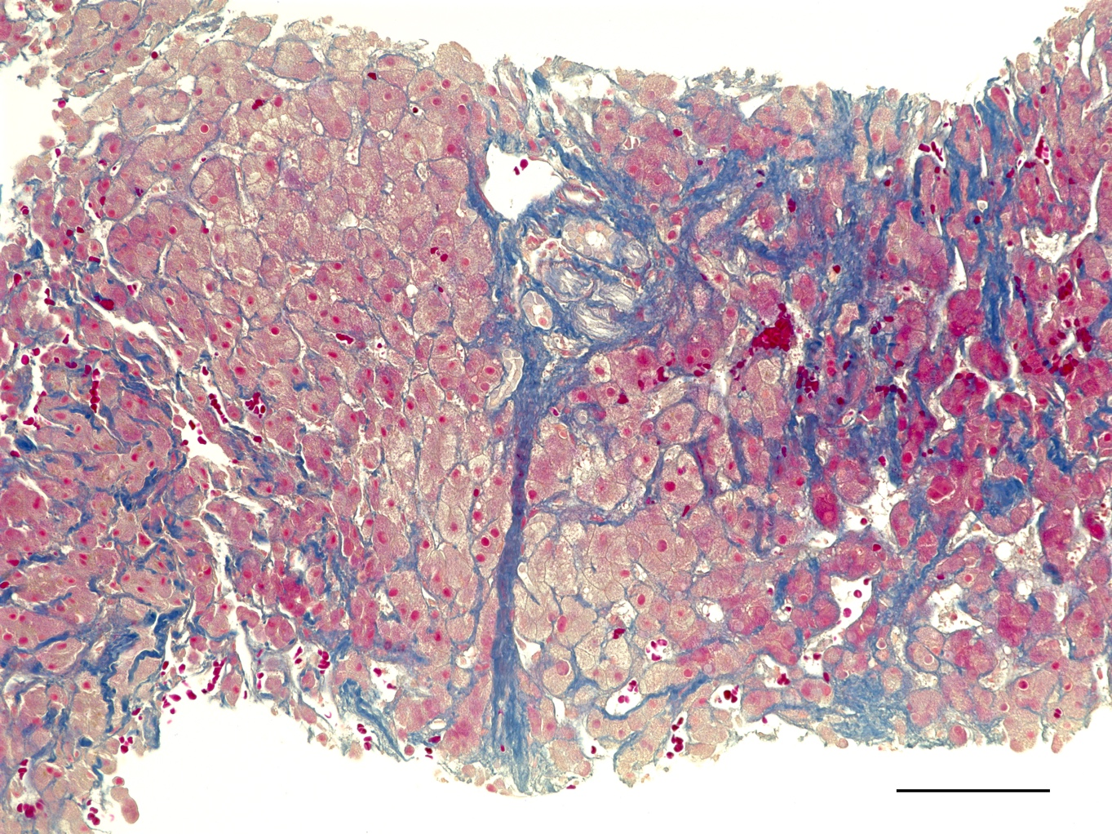
Supplementary Figure S1 Azan staining of liver from a case of cirrhosis (39-year-old male; 23 years since Fontan operation). Cross-linked fibrosis is formed in the portal area at center in the picture. The sinusoids are enlarged diffusely, and erythrocyte components can be identified. The length of the scale bar is 100 μm

