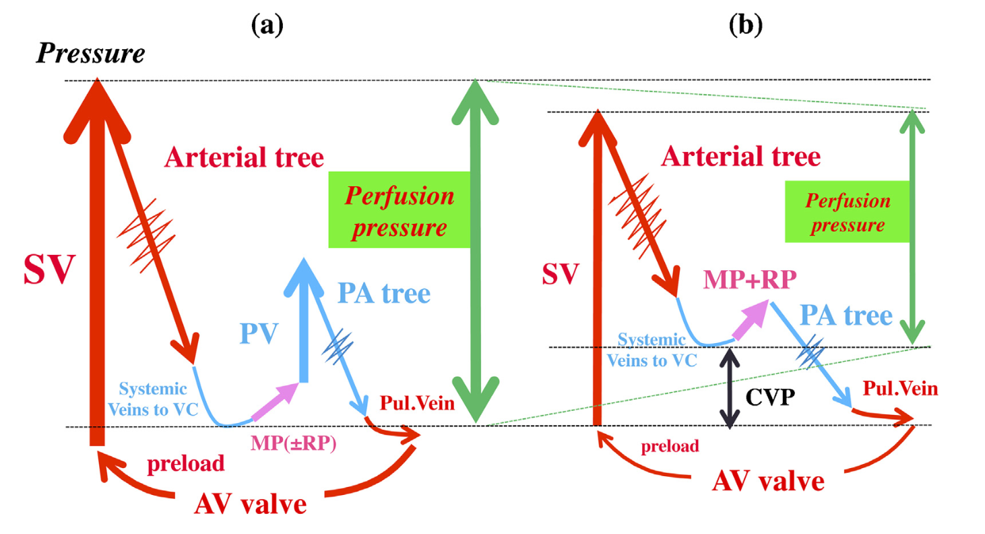
Supplementary Figure 1. Comparison of hemodynamics with patients with biventricular (a) and Fontan (b) physiology. PP is diminished due to high CVP and low systemic pressure.[2]
AV atrioventricular, CVP central venous pressure, MP Muscle pump, PP perfusion pressure, PV pulmonary ventricle, RP respiratory pumps, SV systemic ventricle, VC superior/inferior vena cava

