Supplemental Table S1: Hemodynamic Vulnerability Score
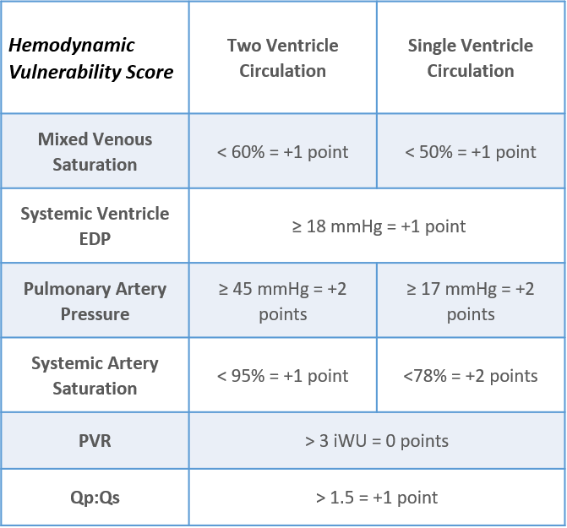
Abbreviations: EDP = end diastolic pressure; PVR = Pulmonary Vascular Resistance.

Supplemental Table S2: Adverse Event Severity Level Definitions
Level 3: Moderate  Tiers |  | Transient change in condition may be life-threatening if not treated, condition returns to baseline, required monitoring, required intervention such as reversal agent, additional medication, transfer to the intensive care unit for monitoring, or transcatheter intervention to correct condition.
3a |  | • Event resulting in minimal impact to patient’s baseline hemodynamics and/or condition; requires minor medical and/or transcatheter therapy to completely reverse the condition with little risk of any long-term impact  • Anticipated requirement for medical support during the intervention or in the immediate post-catheterization period necessary to treat the condition  • Transient and treatable events related to patient’s underlying condition which are exacerbated by the procedure
3b |  | • Transient event which results in moderate change in baseline hemodynamics and/or condition requiring moderate medical therapy or transcatheter intervention to treat the condition.
3c |  | • Event resulting in significant impact to patient’s baseline hemodynamics and/or condition requiring major medical therapy or complex transcatheter intervention.  • May require intensive care unit admission for invasive monitoring or prolonged need for medical or ventilatory support, including follow-up testing and non-surgical procedures.  • May result in a life-threatening event if intensive therapy is unable to promptly rescue the patient, preventing a major or catastrophic event from occurring
Level 4: Major |  | Change in the patient’s clinical condition, which is life-threatening and requires intense medical therapy, cardiopulmonary resuscitation, and/or major invasive transcatheter or urgent/emergent surgical intervention to treat the condition. These conditions may also result in the need for unplanned cardiopulmonary support in the form of heart-lung bypass (extracorporeal membrane oxygenation) to prevent a catastrophic event from occurring.
Level 5: Catastrophic |  | Any death, and emergent surgery or heart lung bypass support (ECMO) to prevent death with failure to wean from bypass support.

