Supplementary Material
“Arrhythmias in adult patients after Rastelli surgery: A single-center experience”
Sirish Chandra Srinath Patloori et al

Supplementary Tables
Table S1. Hemodynamic parameters

 | n = 55
Ventricular dysfunction  - Systemic ventricular dysfunction  - Venous ventricular dysfunction  - Biventricular | 35 (63.6)  8 (14.5)  7 (12.8)  20 (36.4)
Significant valve regurgitation  - Systemic AV valve  - Venous AV valve  - Aortic  - Pulmonary | 7 (12.7)  1 (1.8)  4 (7.3)  2 (3.6)  1 (1.8)
Significant residual shunt | 3 (5.5)
Significant systemic ventricular outflow obstruction | 11 (20.0)
Note: Data are number (%)

Table S2. Comparison between patients with and without arrhythmias

 | No arrhythmias  (n = 34) | Any arrhythmia  (n = 21) | P-Value
Age at Rastelli surgery | 4.0 (1.8 - 5.2) | 6.0 (3.5 - 12.0) | 0.022
Female sex | 14 (41.2) | 6 (28.6) | 0.345
Significant hemodynamic abnormalities | 25 (73.5) | 17 (81.0) | 0.745
Ventricular dysfunction | 19 (55.9) | 16 (76.2) | 0.128
≥ Moderate valve regurgitation | 5 (14.7) | 2 (12.5) | 0.696
≥ Moderate residual shunt | 1 (2.9) | 2 (9.5) | 0.551
Significant ventricular outflow obstruction | 9 (26.5) | 2 (9.5) | 0.174
Note: Data are mean ± standard deviation, number (%) or median (25th percentile - 75th percentile)

Supplementary Figures
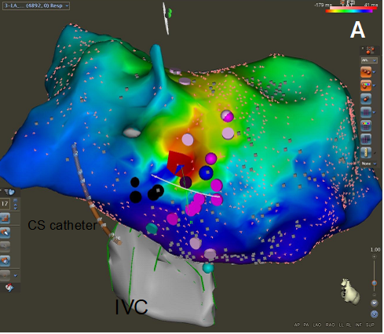
Figure S1. Three-dimensional activation map of an intra-atrial reentrant tachycardia. A modified right lateral view shows the isthmus in the lateral atriotomy scar. Purple tags represent areas of fractionation. Black tags represent areas with right phrenic nerve capture. The critical isthmus for the tachycardia was in the gap in the atriotomy scar.

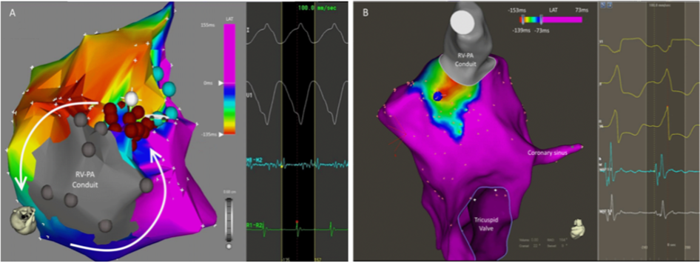
Figure S2. Three-dimensional activation maps of ventricular tachycardia examples. A: Superior view of RV showing macro-reentry circuit around the base of RV-PA conduit. Arrows indicate a VT circuit with critical isthmus 1 to 2 ‘O’ clock location in this figure. Brown tags represent RF lesions. B: Postero-superior view of RV showing a focal source from the base of RV-PA conduit. (RV: Right ventricle, PA: Pulmonary artery). The earliest point of activation is tagged with a blue sphere.

