Variables included in ECMO use model:
Age; underweight; chromosomal syndrome; extracardiac anomaly; STS pre-operative factors including cardiac arrest, shock, organ injury, and pre-operative mechanical circulatory support; pre-operative mechanical ventilation; STAT category (including non-classifiable)
Variables included in mortality model:
Age; underweight; pre-operative factors including cardiac arrest, shock, organ injury, and pre-operative mechanical circulatory support; pre-operative mechanical ventilation; STAT category (including non-classifiable); any other specific pre-operative risk factor (excluding neurological deficit and renal failure due to not being significant on univariate analysis and low incidence, respectively.)

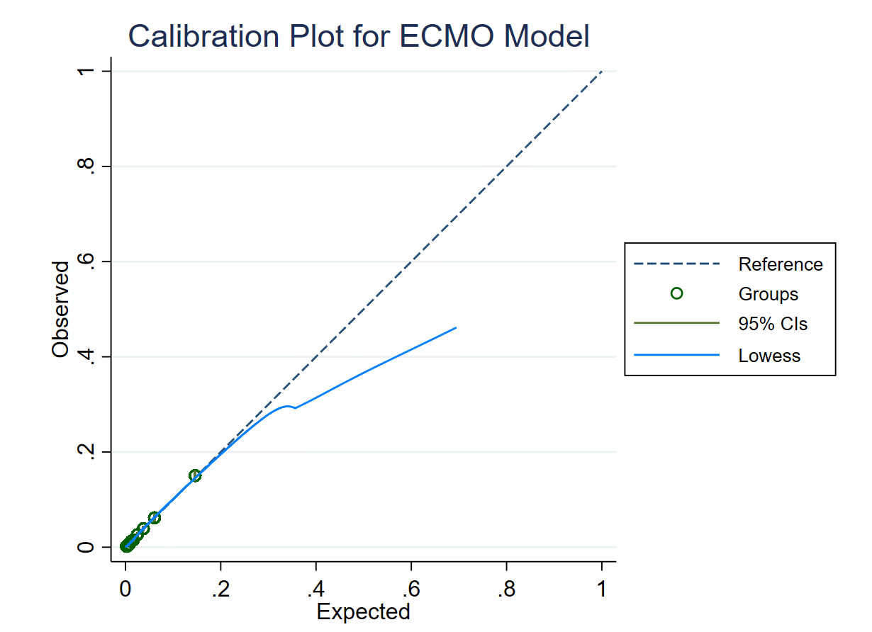
Supplemental Figure 1a. Calibration plot for ECMO use model

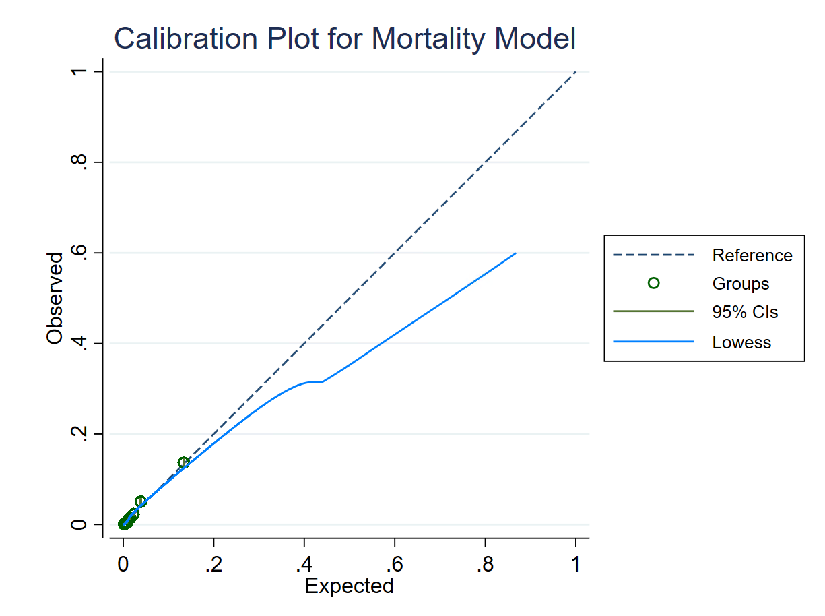
Supplemental Figure 1b. Calibration plot for mortality model

Supplemental Figure 2a. Observed and case-mix adjusted post-operative mortality rate for ECMO hospitalizations

Supplemental Figure 2b. Observed and case-mix adjusted post-operative mortality rate for non-ECMO hospitalizations

Risk Adjusted ECMO Use Tertile | Overall | Low ECMO Use Hospital | Middle ECMO Use Hospital | High ECMO Use Hospital | P Value
# Hospitals | 37 | 14 | 13 | 10
# ECMO runs (total) | 1802 | 286 | 731 | 785
First Post Op ECMO timing
Intra-operative ECMO (% of all surgical cases) | 479 (1.1%) | 86 (0.6%) | 193 (1.1%) | 203 (1.6%) | <0.0001
CPB time for ECMO placed on intra-operative | 246(170-344) | 293(224-401) | 210(154-312) | 255(155-354) | 0.0001
Intra-operative ECMO (% of all post-op ECMO cases) | 479 (34.3%) | 86 (36.8%) | 193 (33%) | 203 (34%) | 0.664
Post-operative ECMO course initiated preoperatively (% of all post-op ECMO cases) | 84 (6%) | 11 (4.7%) | 30 (5.2%) | 43 (7.3%) | 0.2
First Post Op ECMO indication | N=1397 | N=234 | N=577 | N=586
Systemic circulatory failure | 660 (47.2%) | 97 (41.5%) | 272 (47.1%) | 291 (49.7%) | 0.1
ECPR | 442 (31.6%) | 81 (34.6%) | 183 (31.7%) | 178 (30.4%) | 0.5
Other | 295 (21.1%) | 56 (23.9%) | 122 (21.1%) | 117 (20%) | 0.45
Hypoxemia | 156 (11.2%) | 35 (15%) | 62 (10.7%) | 59 (10.1%)
Arrhythmia | 28 (2%) | 2 (0.9%) | 17 (2.9%) | 9 (1.5%)
Bleeding | 10 (0.7%) | 1 (0.4%) | 6 (1%) | 3 (0.5%)
Hypercarbic respiratory failure | 42 (3%) | 13 (5.6%) | 18 (3.1%) | 11 (1.9%)
Shunt occlusion | 39 (2.8%) | 3 (1.3%) | 8 (1.4%) | 28 (4.8%)
Multisystem organ failure | 13 (0.9%) | 2 (0.9%) | 5 (0.9%) | 6 (1%)
Unknown | 7 (0.5%) | 0 | 6 (1%) | 1 (0.2%)
Supplemental Table 1. ECMO cannulation timing and indications by ECMO use tertile
 | Overall | Low ECMO Use Hospital (<2.5%) | Middle ECMO Use Hospital  (2.6-4.4%) | High ECMO Use Hospital (>4.5%) | P Value
Hospitals | 37 | 14 | 13 | 10
% of surgical hospitalizations | N=43,640 (100%) | N=13,272 (30%) | N=17,693 (41%) | N=12,675 (29%)
ECMO runs, N | 1,397 | 234 | 577 | 586
% ECMO patients | 3.21% | 1.76% | 3.26% | 4.62% | <0.0001
% ECMO patients with ECPR as indication | 0.99% | 0.54% | 1.02% | 1.40% | <0.0001
% ECMO patients without ECPR indication | 2.22% | 1.22% | 2.24% | 3.22% | <0.0001
Patient covariate
Age | # (column %) | # (column %) | # (column %) | # (column %) | <0.0001
Preterm neonate | 1,114 (2.6%) | 4405 (33.2%) | 6134 (34.7%) | 4207 (33.2%)
Full term neonate | 7,135 (16.4%) | 5675 (42.8%) | 7205 (40.7%) | 5367 (42.3%)
Infant | 14,746 (33.8%) | 312 (2.4%) | 478 (2.7%) | 324 (2.6%)
Child | 18,247 (41.8%) | 2083 (15.7%) | 2970 (16.8%) | 2082 (16.4%)
Adult | 2,398 (5.5%) | 797 (6.0%) | 906 (5.1%) | 695 (5.5%)
Chromosomal anomaly | 10,146 (23.3%) | 3154 (23.8%) | 4113 (23.3%) | 2879 (22.7%) | 0.135
Extra-cardiac anomaly | 7,548 (17.3%) | 2278 (17.2%) | 3247 (18.4%) | 2023 (16.0%) | <0.0001
Under Weight | 10,047 (23.0%) | 2903 (21.9%) | 4111 (23.2%) | 3033 (23.9%) | <0.0001
High risk pre-op | 1,089 (2.5%) | 419 (3.2%) | 368 (2.1%) | 302 (2.4%) | <0.0001
Low risk pre-op | 13,076 (30.0%) | 4085 (30.8%) | 5466 (30.9%) | 3525 (27.8%) | <0.0001
Pre-operative mechanical ventilation | 4,428 (10.2%) | 1176 (8.9%) | 1990 (11.3%) | 1262 (10.0%) | <0.0001
STAT category |  |  |  |  | <0.0001
1 | 12,115 (27.8%) | 3703 (27.8%) | 4870 (27.5%) | 3542 (27.9%)
2 | 13,731 (31.5%) | 4306 (32.4%) | 5521 (31.2%) | 3904 (30.8%)
3 | 5,644 (12.9%) | 1563 (11.8%) | 2322 (13.1%) | 1759 (13.9%)
4 | 10,021 (23.0%) | 3108 (23.4%) | 4086 (23.1%) | 2827 (22.3%)
5 | 1,941 (4.5%) | 549 (4.1%) | 822 (4.7%) | 570 (4.5%)
Non-classifiable | 188 (0.4%) | 43 (0.3%) | 72 (0.4%) | 73 (0.6%)
Post-operative mechanical ventilation | 28,383 (65.0%) | 9523 (71.8%) | 11544 (65.3%) | 7886 (62.2%) | <0.0001
Post-operative arrhythmia | 3,236 (7.4%) | 1001 (7.5%) | 1130 (6.4%) | 1105 (8.7%) | <0.0001
CPB time- overall cohort* (min) | 91 (53-144) | 103 (59-158) | 85 (47-137) | 90 (54-138) | <0.0001
CPB time- ECMO cohort* (min) | 168 (97-263) | 201.5 (127-300) | 161 (88-250) | 162.5 (99-256) | <0.0001
Post-operative VIS* | 5 (0-8) | 5 (0-6.9) | 5 (2-8) | 5 (0-8.5) | <0.0001
# of prior cardiothoracic operations |  |  |  |  | <0.0001
0 | 28,764 (65.9%) | 8734 (65.8%) | 11664 (65.9%) | 8366 (66.0%)
1 or 2 | 10,845 (24.9%) | 3339 (25.2%) | 4478 (25.3%) | 3028 (23.9%)
3 or more | 4,031 (9.2%) | 1199 (9.0%) | 1551 (8.8%) | 1281 (10.1%)
Supplemental Table 2. Patient and surgical characteristics by ECMO use tertile

