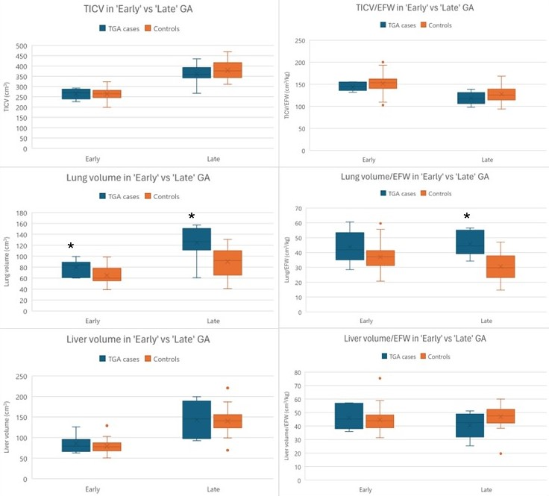
S4: Boxplots of organ volumes of fetuses with and without transposition of the great arteries (TGA) with and without correction for estimated fetal weight (EFW). ‘Early’ gestational age (GA) groups consist of fetuses in GA 29-34, and the ‘Late’ GA consist of fetuses in GA 35-39. Measures were compared by student t-test. * Statistical significance at p<0.05.

