Combination Pulmonary Hypertension Drug Exposure in Critically Ill Infants

Supplementary Material
Supplementary Figure S1
Supplementary Table S1
Supplementary Table S2
Supplementary Figure S2
Supplementary Table S3
Supplementary Table S4
Supplementary Table S5
Supplementary Figure S1. Flow diagram of infants included in the study
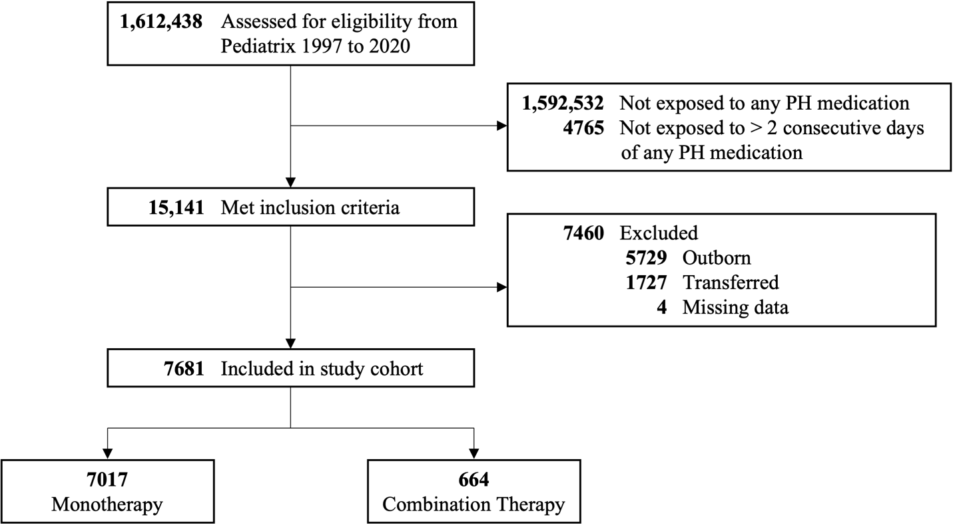
Abbreviations: PH, pulmonary hypertension

Supplementary Table S1. Therapy or Support At or Before First PH Medication Exposure
Therapy or Support | Monotherapy | Combination Therapy | p-Value
 | (n = 7017) | (n = 664)
Postnatal steroids | 982 (14) | 221 (33) | <0.001
Diuretics | 1003 (14) | 250 (38) | <0.001
Inotropes | 1779 (25) | 231 (35) | <0.001
Highest level of respiratory support
Non-Invasive | 3272 (47) | 217 (33) | <0.001
Mechanical Ventilation | 3745 (53) | 447 (67)
Days on ventilator | 1 (0, 3) | 3 (0, 30) | <0.001
FiO2 (%) | 75 (40, 100) | 70 (38, 100) | 0.09
Days with FiO2 > 21% | 1 (0, 3) | 3 (0, 45) | <0.001
Tracheostomy | 23 (0) | 15 (2) | <0.001
ECMO | 13 (0) | 6 (1) | <0.001
Continuous and categorical variables presented as median (25th, 75th percentile) and frequency (%), respectively
ECMO, extracorporeal membrane oxygenation; FiO2, fraction of inspired oxygen; PH, pulmonary hypertension

Supplementary Table S2. Combination Pulmonary Hypertension Medication Use
PH Medication Combination |  |  |  | N | Gestational Age | PNA at First Exposure | PMA at First Exposure | Duration of Use | Frequency of Use
iNO | Sildenafil | Epoprostenol | Bosentan |  | (Weeks) | (Days) | (Weeks) | (Days) | At Discharge | At Death
✓ | — | — | — | 7104 | 31 (26, 37) | 1 (0, 4) | 33 (27, 38) | 6 (4, 9) | 0 (0) | 957 (13)
— | ✓ | — | — | 968 | 27 (24, 36) | 73 (20, 117) | 40 (37, 43) | 25 (10, 54) | 437 (45) | 119 (12)
— | — | ✓ | — | 18 | 38 (35, 39) | 10 (3, 29) | 38 (36, 42) | 4 (2, 7) | 0 (0) | 4 (22)
— | — | — | ✓ | 6 | 32 (25, 39) | 108 (28, 141) | 44 (43, 46) | 16 (6, 34) | 0 (0) | 3 (50)
✓ | ✓ | — | — | 599 | 28 (25, 36) | 45 (11, 107) | 39 (35, 42) | 11 (5, 26) | 0 (0) | 115 (48)
✓ | — | ✓ | — | 45 | 37 (32, 38) | 2 (1, 11) | 38 (35, 39) | 6 (4, 10) | 0 (0) | 6 (33)
✓ | — | — | ✓ | 5 | 30 (25, 34) | 132 (91, 172) | 43 (43, 47) | 11 (9, 26) | 0 (0) | 1 (33)
— | ✓ | ✓ | — | 13 | 38 (37, 38) | 15 (2, 29) | 40 (38, 42) | 9 (7, 19) | 0 (0) | 1 (17)
— | ✓ | — | ✓ | 33 | 28 (24, 36) | 161 (78, 198) | 48 (45, 53) | 55 (10, 84) | 17 (52) | 4 (44)
— | — | ✓ | ✓ | 0 | N/A | N/A | N/A | N/A | N/A | N/A
✓ | ✓ | ✓ | — | 38 | 32 (26, 38) | 24 (2, 114) | 40 (36, 42) | 8 (6, 20) | 0 (0) | 10 (42)
✓ | ✓ | — | ✓ | 49 | 26 (24, 30) | 135 (105, 177) | 45 (42, 50) | 14 (7, 33) | 0 (0) | 14 (48)
✓ | — | ✓ | ✓ | 1 | 28 (28, 28) | 204 (204, 204) | 57 (57, 57) | 78 (78, 78) | 0 (0) | 0 (0)
— | ✓ | ✓ | ✓ | 2 | 38 (37, 39) | 33 (29, 37) | 42 (42, 43) | 26 (3, 48) | 0 (0) | 0 (0)
✓ | ✓ | ✓ | ✓ | 7 | 28 (26, 38) | 94 (53, 173) | 46 (39, 50) | 131 (44, 286) | 0 (0) | 1 (14)
Continuous and categorical variables presented as median (25th, 75th percentile) and frequency (%), respectively
iNO, inhaled nitric oxide; PH, pulmonary hypertension; PNA, postnatal age; PMA, postmenstrual age

Supplementary Figure S2. Alluvial flow diagram illustrating the dynamic changes in pulmonary hypertension medication combinations from initial to final exposure among all infants in our study. Each flow stream in the diagram represents a singular sequence and demonstrates the complex transitions of medication combinations over time. The height of a flow stream represents the number of unique sequences and not the frequency of occurrences for each sequence.

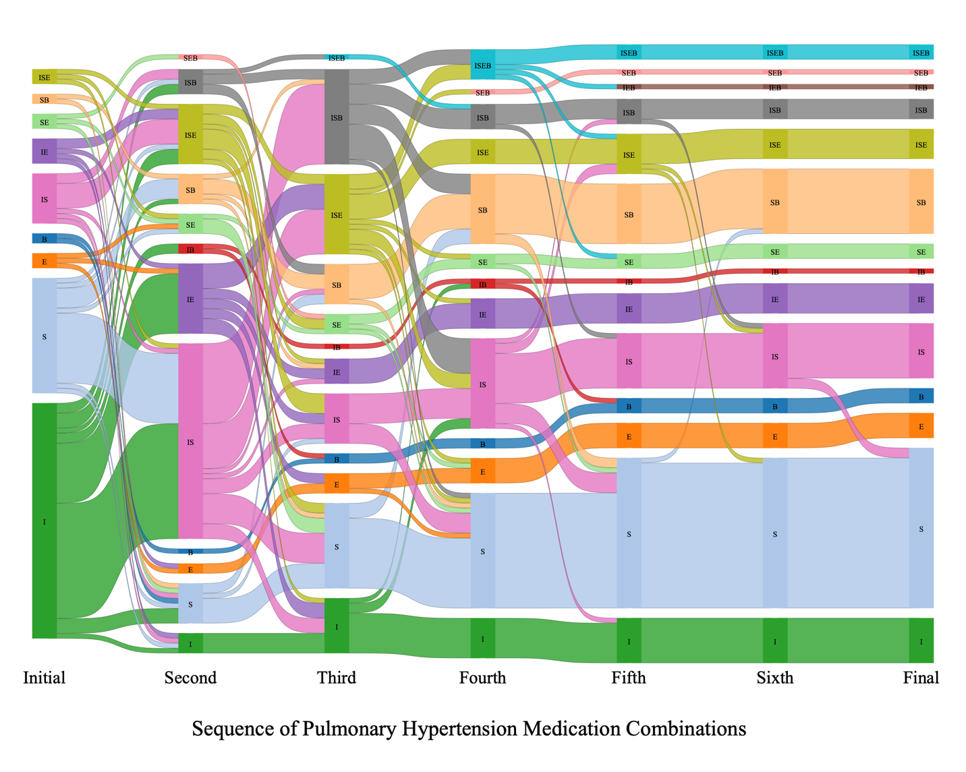
Abbreviations: B, bosentan; E, epoprostenol; I, inhaled nitrc oxide; S, sildenafil

Supplementary Table S3. Any Pulmonary Hypertension Medication Use in Infants with BPD
Characteristic | iNO | Sildenafil | Epoprostenol | Bosentan
 | (n = 2576) | (n = 883) | (n = 48) | (n = 74)
Gestational age (weeks) | 26 (24, 30) | 26 (24, 31) | 33 (26, 38) | 26 (24, 32)
PNA at first exposure (days) | 4 (0, 24) | 87 (35, 119) | 24 (2, 121) | 134 (91, 175)
PMA at first exposure (weeks) | 29 (26, 35) | 39 (36, 43) | 40 (36, 43) | 46 (42, 50)
Duration of use (days) | 8 (5, 19) | 40 (17, 78) | 12 (7, 40) | 32 (10, 85)
Frequency of use
Any single use | 2455 (95) | 749 (85) | 8 (17) | 5 (7)
Any combination use | 468 (18) | 460 (52) | 0 (0) | 72 (97)
At discharge | 0 (0) | 375 (42) | 0 (0) | 16 (22)
In isolation | 0 (0) | 359 (96) | 0 (0) | 0 (0)
In combination | 0 (0) | 16 (4) | 0 (0) | 16 (100)
At death | 180 (7) | 202 (23) | 15 (31) | 26 (35)
In isolation | 76 (42) | 97 (48) | 15 (100) | 3 (12)
In combination | 104 (58) | 105 (52) | 0 (0) | 23 (88)
Continuous and categorical variables presented as median (25th, 75th percentile) and frequency (%), respectively
BPD, bronchopulmonary dysplasia; iNO, inhaled nitric oxide; PNA, postnatal age; PMA, postmenstrual age

Supplementary Table S4. Any Pulmonary Hypertension Medication Use in Infants with CHD
Characteristic | iNO | Sildenafil | Epoprostenol | Bosentan
 | (n = 1032) | (n = 297) | (n = 18) | (n = 15)
Gestational age (weeks) | 32 (26, 37) | 30 (25, 37) | 33 (26, 38) | 29 (25, 35)
PNA at first exposure (days) | 1 (0, 9) | 54 (15, 104) | 20 (4, 138) | 94 (69, 133)
PMA at first exposure (weeks) | 34 (28, 38) | 39 (36, 42) | 38 (36, 42) | 44 (42, 45)
Duration of use (days) | 6 (4, 12) | 27 (12, 54) | 12 (7, 39) | 25 (10, 62)
Frequency of use
Any single use | 995 (96) | 249 (84) | 3 (17) | 1 (7)
Any combination use | 155 (15) | 153 (52) | 17 (94) | 0 (0)
At discharge | 0 (0) | 120 (40) | 0 (0) | 3 (20)
In isolation | 0 (0) | 117 (98) | 0 (0) | 0 (0)
In combination | 0 (0) | 3 (2) | 0 (0) | 3 (100)
At death | 189 (18) | 64 (22) | 6 (33) | 4 (27)
In isolation | 153 (81) | 27 (42) | 1 (17) | 4 (100)
In combination | 36 (19) | 37 (58) | 5 (83) | 0 (0)
Continuous and categorical variables presented as median (25th, 75th percentile) and frequency (%), respectively
CHD, congenital heart disease; iNO, inhaled nitric oxide; PNA, postnatal age; PMA, postmenstrual age

Supplementary Table S5. Any Pulmonary Hypertension Medication Use in Infants with CDH
Characteristic | iNO | Sildenafil | Epoprostenol | Bosentan
 | (n = 276) | (n = 97) | (n = 21) | (n = 14)
Gestational age (weeks) | 38 (37, 39) | 38 (37, 39) | 38 (36, 39) | 37 (37, 39)
PNA at first exposure (days) | 0 (0, 1) | 15 (7, 26) | 3 (1, 21) | 34 (28, 54)
PMA at first exposure (weeks) | 38 (37, 39) | 40 (38, 41) | 39 (37, 40) | 43 (42, 46)
Duration of use (days) | 10 (6, 20) | 39 (17, 60) | 10 (6, 19) | 38 (11, 82)
Frequency of use
Any single use | 258 (93) | 72 (74) | 6 (29) | 1 (7)
Any combination use | 75 (27) | 72 (74) | 18 (86) | 13 (93)
At discharge | 0 (0) | 36 (37) | 0 (0) | 4 (29)
In isolation | 0 (0) | 32 (89) | 0 (0) | 0 (0)
In combination | 0 (0) | 4 (11) | 0 (0) | 4 (100)
At death | 59 (21) | 20 (21) | 5 (24) | 1 (7)
In isolation | 43 (73) | 5 (25) | 2 (40) | 1 (100)
In combination | 16 (27) | 15 (75) | 3 (60) | 0 (0)
Continuous and categorical variables presented as median (25th, 75th percentile) and frequency (%), respectively
CDH, congenital diaphragmatic hernia; iNO, inhaled nitric oxide; PNA, postnatal age; PMA, postmenstrual age

