Supplemental Material

Table 1: Cortisol and alpha amylase values of the children before and after surgery

|  |  |  |  |  |  |  |
| --- | --- | --- | --- | --- | --- | --- |
|  | Overall (n=51) | Mother's voice (MM) (n=26) | Control (MO)(n=25) | Missing | Adjusted mean difference | P=value |
| Cortisol value (nmol l-1)  (T1) |  |  |  | MM (7)  MO (6) |  |  |
| mean (±SD) | 11.9 (±10.8) | 12.4 (±11.4) | 11.3 (±10.4) |  |  |  |
| Cortisol value (nmol l-1)  (T5) |  |  |  | MM (12)  MO (8) |  |  |
| mean (±SD) | 15.2 (±14.7) | 18.3 (±17.6) | 12.7 (±11.9) |  | 3.5 (±4.2) | 0.424 |
| Alpha-amylase value  (U l-1) (T1) |  |  |  | MM (5)  MO (2) |  |  |
| mean (±SD) | 86.4 (±155.0) | 114.0 (±208.0) | 61.2 (±78.9) |  |  |  |
| Alpha-amylase value  (U l-1) (T5) |  |  |  | MM (5)  MO (5) |  |  |
| mean (±SD) | 135.0 (±162.0) | 172.0 (±204.0) | 95.2 (±90.2) |  | 26.0 (±60.7) | 0.670 |

The mean differences and p values are based on linear mixed models with random patient-specific intercepts and adjusted for the T1 levels in cortisol and alpha-amylase level, respectively.  
T1: Transfer OR, T2: Induction of sedation, T3: Cannulation by cardiologists, T4: +30 min after cannulation by the cardiologists, T5: End of cardiac catheterization, n=number of patients

Table 2: Perioperative parameters

|  |  |  |  |  |  |  |
| --- | --- | --- | --- | --- | --- | --- |
|  | Mother´s voice group (MM) n = 26 | Control group (MO) n = 25 | Overall patients  n = 51 | Missing | Adjusted mean difference | P-value |
| **T = 1** |  |  |  |  |  |  |
| Heart beats per minute; mean (±SD) | 110 (±23.6) | 114 (±20.7) | 112 (±22.2) |  |  |  |
| Systolic blood pressure, mean (±SD) | 75.3 (±15.0) | 82.0 (±17.7) | 78.8 (±16.6) | MM (5)  MO(2) |  |  |
| Diastolic blood pressure, mean (±SD) | 39.5 (±9.40) | 42.8 (±8.96) | 41.2 (±9.22) | MM (5)  MO(2) |  |  |
| Narcotrend index, mean (±SD) | 57.8 (±24.5) | 61.5 (±22.1) | 59.7 (±23.1) | MM (4)  MO (2) |  |  |
| **T = 2** |  |  |  |  |  |  |
| Heart beats per minute; mean (±SD) | 106 (±17.3) | 114 (±20.4) | 110 (±19.2) |  | -2.22 (±4.68) | 0.636 |
| Systolic blood pressure, mean (±SD) | 79.4 (±11.9) | 81.6 (±13.1) | 80.5 (±12.4) | MM (1)  MO (0) | 4.61 (±3.25) | 0.1579 |
| Diastolic blood pressure, mean (±SD) | 39.7 (±9.85) | 44.8 (±11.7) | 42.3 (±11.0) | MM (1)  MO(0) | -2.85 (±2.61) | 0.276 |
| Narcotrend index, mean (±SD) | 53.1 (±25.1) | 60.0 (±17.9) | 56.6 (±21.8) | MM (4)  MO (2) | -3.20 (±5.96) | 0.591 |
| **T = 3** |  |  |  |  |  |  |
| Heart beats per minute; mean (±SD) | 107 (±15.1) | 112 (±16.7) | 109 (±15.9) | 0 | -0.39 (±4.65) | 0.934 |
| Systolic blood pressure, mean (±SD) | 78.2 (±12.1) | 81.4 (±10.4) | 79.8 (±11.3) | 0 | 3.81 (±3.31) | 0.239 |
| Diastolic blood pressure, mean (±SD) | 38.5 (±9.81) | 40.6 (±9.20) | 39.5 (±9.47) | 0 | 0.54 (±2.60) | 0.835 |
| Narcotrend index, mean (±SD) | 50.8 (±22.1) | 49.1 (±17.7) | 49.9 (±19.7) | MM (5)  MO (2) | 4.94 (±6.01) | 0.412 |
| **T = 4** |  |  |  |  |  |  |
| Heart beats per minute; mean (±SD) | 109 (±18.9) | 114 (±15.2) | 111 (±17.3) |  | 0.34 (±4.77) | 0.944 |
| Systolic blood pressure, mean (±SD) | 81.8 (±12.7) | 82.0 (±10.8) | 81.9 (1±1.7) | MM (1)  MO (3) | 6.12 (±3.31) | 0.066 |
| Diastolic blood pressure, mean (±SD) | 41.3 (±10.4) | 39.0 (±5.97) | 40.2 (±8.63) | MM (1)  MO (3) | 4.41 (±2.66) | 0.098 |
| Narcotrend index, mean (±SD) | 58.3 (±22.6) | 56.5 (±18.0) | 57.3 (±20.1) | MM (5)  MO (2) | 5.07 (±6.01) | 0.340 |
| **T = 5** |  |  |  |  |  |  |
| Heart beats per minute; mean (±SD) | 108 (±20.9) | 114 (±19.8) | 111 (±20.3) |  | -1.61 (±4.80) | 0.738 |
| Systolic blood pressure, mean (±SD) | 87.4 (±17.9) | 82.0 (±11.2) | 84.7 (±14.9) | MM (4)  MO (2) | 13.29 (±3.35) | <0.001* |
| Diastolic blood pressure, mean (±SD) | 43.9 (±10.0) | 41.3 (±6.70) | 42.6 (±8.49) | MM (4)  MO (2) | 6.00 (±2.69) | 0.027* |
| Narcotrend index, mean (±SD) | 60.7 (±25.4) | 60.3 (±16.8) | 60.5 (2±1.1) | MM (5)  MO (2) | 3.67 (±6.01) | 0.542 |
| **T = 6** |  |  |  |  |  |  |
| Heart beats per minute; mean (±SD) | 112 (±22.4) | 119 (±18.2) | 116 (±20.3) |  | -0.27(±5.40) | 0.961 |

The mean differences and p values are based on linear mixed models with random patient-specific intercepts and adjusted for the measurements at T1 and trend over time.  
* = clinically significant with P<0.05, SD= standard deviation, N= number of patients, NIPE= Newborn Infant Parasympathetic Evaluation, T1: Transfer OR, T2: Induction of sedation, T3: Cannulation by cardiologists, T4: +30 min after cannulation by the cardiologists, T5: End of cardiac catheterization, T6: Recovery room

Table 3: Results of questionnaires

|  |  |  |  |  |  |
| --- | --- | --- | --- | --- | --- |
|  | Overall (n=51) | Mother's voice (n=26) | Control (n=25) | P-value | Missing |
| KUSS score |  |  |  | 0.027* | MM (2)  MO (3) |
| Median [Q1, Q3] | 3.5 [1.0, 5.0] | 2.0 [0.0, 5.0] | 4.5 [3.0, 6.0] |  |  |
| PAED Score |  |  |  | 0.272 | MM (2)  MO (3) |
| Median [Q1, Q3] | 3.0 [2.3, 5.8] | 2.0 [1.0, 5.0] | 3.0 [2.3, 5.8] |  |  |
| mYPAS score (port) |  |  |  | 0.288 | MM (3)  MO (3) |
| Median [Q1, Q3] | 27 [23, 40] | 23 [23, 45] | 28 [23, 45] |  |  |
| mYPAS score (way to OR) |  |  |  | 0.743 | MM (2)  MO (5) |
| Median [Q1, Q3] | 26 [23, 64] | 26 [23, 57] | 26 [23, 67] |  |  |
| mYPAS score (OR arrival) |  |  |  | 0.780 | MM (3)  MO (4) |
| Median [Q1, Q3] | 25 [23, 64] | 23 [23, 53] | 27 [23, 67] |  |  |
| mYPAS score (start anesthesia) |  |  |  | 0.092 | MM (3)  MO (0) |
| Median [Q1, Q3] | 70 [41, 90] | 50 [33, 84] | 81 [50, 92] |  |  |

P values are based on Mann-Whitney U Tests.  
KUSS = Kindliche Unbehagen- und Schmerzskala nach Büttner (Child discomfort and pain scale according to Büttner), PAED = Pediatric Anaesthesia Emergence Delirium, mYPAS = modified Yale Preoperative Anxiety Scale, OR = operation room, SD = standard deviation, n=number of patients, *significant with P<0.05

Figure 1: Results of the NIPE measurement

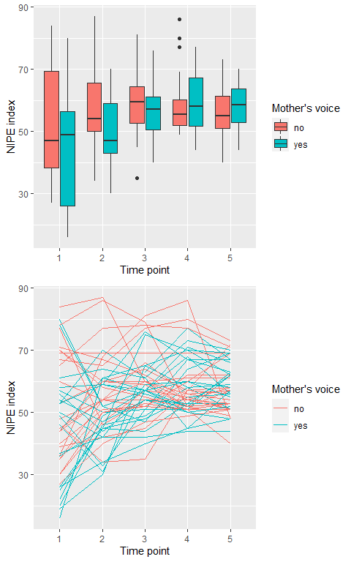

T1: Transfer OR, T2: Induction of sedation, T3: Cannulation by cardiologists, T4: +30 min after cannulation by the cardiologists, T5: End of cardiac catheterization

Power calculations

The main target variable of this study is stress level, which is determined by the parameters cortisol and alpha-amylase. To test whether significant differences exist between the study groups with regard to the main target variables the one-factorial analysis of variance (ANOVA) was used.

The parameters alpha and beta for the error probabilities of the first and second type of error are set at 2.5% and 20.0%, respectively. Since two main target variables are defined in this study, the first type error was reduced to 2.5% in order to adjust for the multiple testing problem.

Cortisol levels were described as normally distributed (Stadler et al., 2016). The minimum relevant range between the two groups with regard to the target parameters results from an expected difference of 2 (nmol/l) for cortisol. A previous study found an estimated standard deviation of σ = 0.9 (nm/l) (Stadler et al., 2016). Homogeneity of variances can be assumed on the basis of these studies. The sample size calculation is based on Tukey's MCA method for testing for pairwise equality of population means results in N=22 per group for the target parameter cortisol.

Since the sample size was calculated assuming normal distribution and variance homogeneity of the main target parameters, the calculated sample size is increased by 12.0% to account for possible power loss. This results in a total sample size of N = 50 patients.

References

1. Stadler T et al. Assessment of the cortisol awakening response: Expert consensus guidelines. Psychoneuroendocrinology. 2016; 63: 414–32.