Supplementary material
Table S1. Patient characteristics
 | MIS-C^{b} (n = 48) | Normal range laboratory values
Age at diagnosis (years) | 11.9 (6.9-14.5)
Sex  Female  Male | 20 (41.7%)  28 (58.3%)
Symptomsª  Fever^{c}  Rash  Conjunctivitis  Oral changes  Cervical lymphadenopathy  Changes of the extremitiesª  Respiratory symptoms  Gastro-intestinal symptoms  Neurological symptoms | 48 (100%)  29 (60.4%)  34 (70.8%)  28 (58.3%)  24 (50.0%)  21 (43.8%)  12 (25.0%)  44 (91.7%)  27 (56.3%)
Complete KD | 32 (66.7%)
Complications  Shock^{d}  O2 therapy required  High flow O2 therapy required  Consolidations chest radiography  Acute kidney injury  Appendectomy | 28 (58.3%)  6 (12.5%)  10 (20.8%)  11 (22.9%)  13 (27.1%)  3 (6.3%)
Laboratory findings  CRP (mg/L)  Leukocytes (x109/L)  Thrombocytes (x109/L)  Hemoglobin (mmol/L)  Albumin (g/L)  ASAT (U/L)  ALAT (U/L)  BSE (mm/U)  NT-pro-BNP (ng/L)  Troponin T (ng/L)  Urea (mmol/L)  Creatinin (µmol/L)  Sodium (mmol/L)  Potassium (mmol/L)  Neutrophils (x109/L)  Lymphocytes (x109/L)  Triglycerides (mmol/L)  D-dimer (mg/L)  Fibrinogen (g/L)  Ferritin (µmol/L) | 187.9 (134.0-270.0)  16.8 (11.7-22.3)  348.5 (207.5-541.0)  6.5 (5.7-7.2)  28.5 (25.0-36.0)  39.0 (28.0-58.0)  30.0 (19.0-54.5)  57.0 (33.5-109.0)  4299.5 (1942.0-12064.3)  62.0 (15.0-101.5)  7.5 (4.8-10.3)  50.5 (34.0-63.5)  131.0 (128.0-134.0)  3.8 (3.3-4.5)  11.2 (7.7-15.8)  1.5 (0.7-2.6)  2.0 (1.4-3.0)  2.6 (1.9-4.1)  6.9 (5.9-7.8)  750.5 (433.5-1129.8) | 0.0-5.0  4.0-14.0  150.0-450.0  6.5-10.0  37.0-55.0  0.0-40.0  0.0-45.0  0.0-20.0  <125  0.0-14.0  1.8-6.4  46.0-83.0  135.0-145.0  3.5-5.0  1.5-8.0  1.0-5.0  <2.0  0.0-0.5  2.0-3.9  15.0-150.0
Treatment  IVIG  IVIG <10 days  Second dose of IVIG  Corticosteroids  Methylprednisolone pulse  Milrinone  Noradrenaline  Anakinra | 45 (93.8%)  43 (95.6%)  9 (20.0%)  39 (81.3%)  30 (62.5%)  16 (33.3%)  18 (37.5%)  8 (16.7%)
ICU admission | 24 (50.0%)
Second KD-episode | 0 (0%)
Coronary artery aneurysms  None  Z score ≥2.5 to <5.0  Z score ≥5 to <10  Z score ≥10 | 42 (87.5%)  4 (8.3%)  1 (2.1%)  0 (0%)
Data are n (%) or median (interquartile range)
ªAmerican Heart Association criteria for the definition of Kawasaki disease (KD) is to have persistent fever and 4 of the following 5 mucocutaneous features: erythema and cracking of lips, strawberry tongue, and/or erythema of oral and pharyngeal mucosa; bilateral bulbar conjunctival injection without exudate; rash (maculopapular, diffuse erythroderma); erythema and edema of the hands and feet in acute phase and/or periungual desquamation in subacute phase; and cervical lymphadenopathy (>1.5 cm diameter). Incomplete KD was defined by at least 2 clinical criteria compatible with KD and additional laboratory or cardiac criteria.
^{b}MIS-C according to criteria by Centers for Disease Control and Prevention (CDC) and World Health Organization (WHO)
^{c}Fever >38 °C
^{d}Shock defined as needing inotropic support or fluid rescuscitation >20 ml/kg
Abbreviations: KD = Kawasaki disease, MIS-C = Multisystem Inflammatory Syndrome in Children, IVIG = intravenous immune globulin, ICU = intensive care unit.

Figure S1. Example of speckle tracking results of a patient with a normal LVEF, but abnormal GLS at initial presentation ([A] GLS = -7.8%, LVEF = 50%) that persisted at 2 months of follow-up ([B] GLS = -15.8%, LVEF = 50%) and normalized before the last visit 6 months post-admission ([C] GLS = -21.8%, LVEF = 51%)
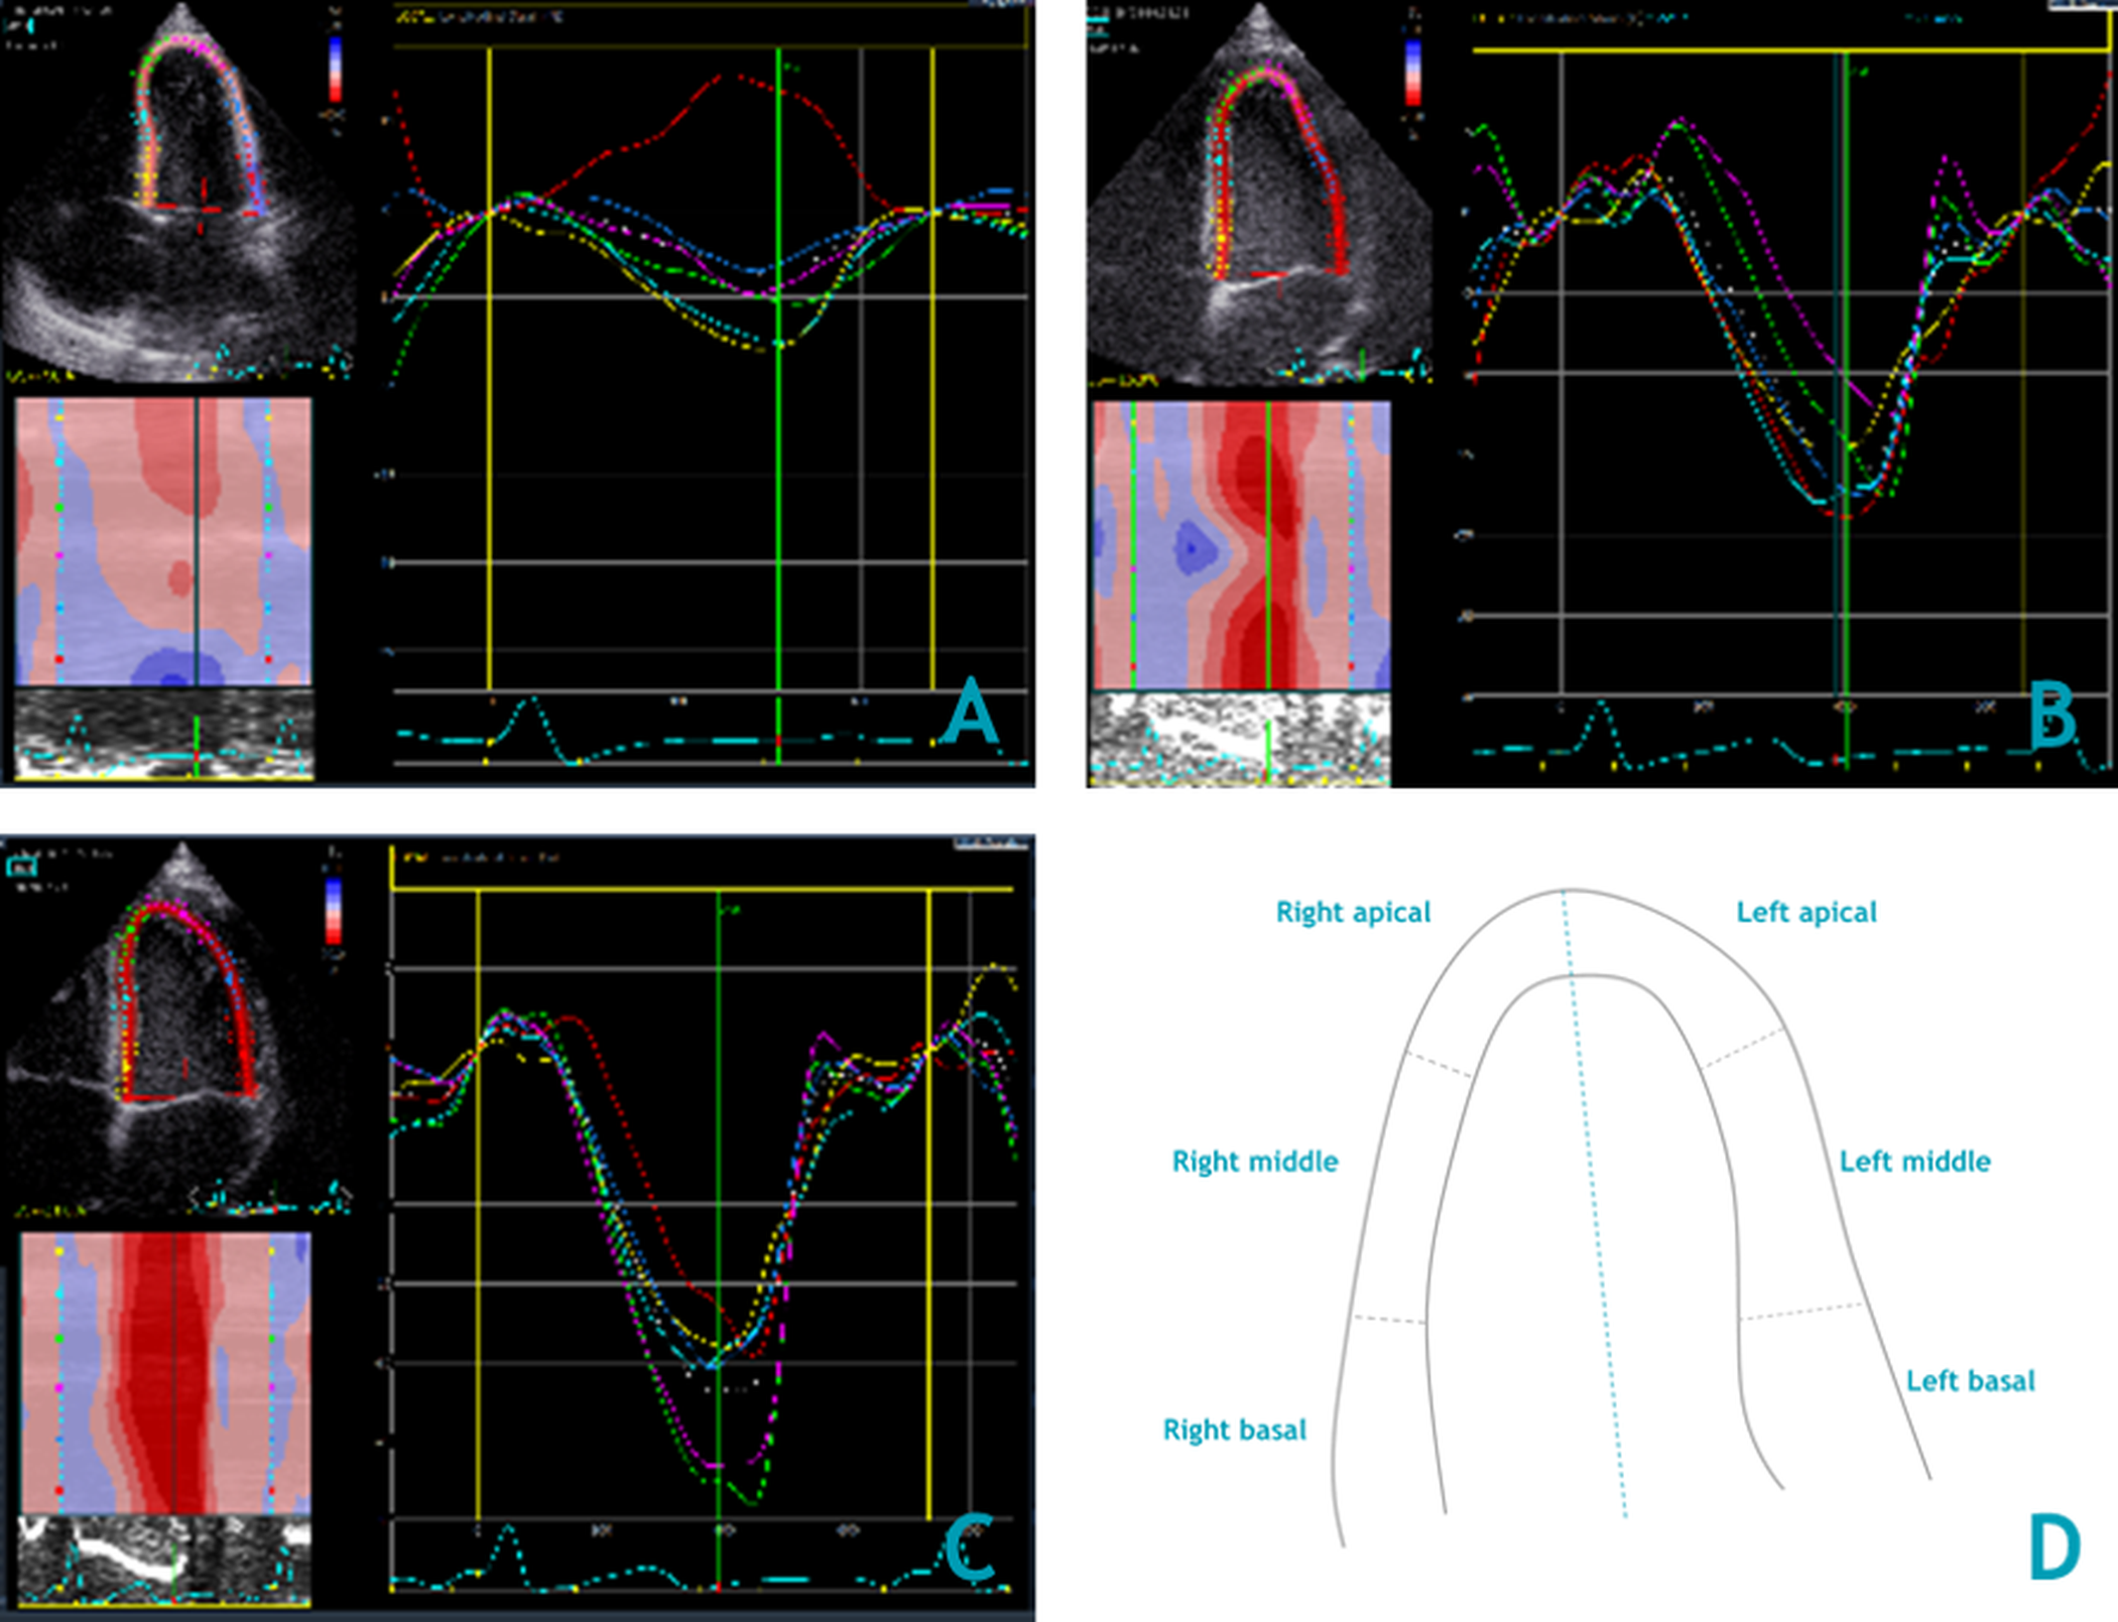
Table S2. Over-time changes of LVEF, FS and GLS
Parameter | Timeframe | Median (IQR) | Overall significance, P valueª
LVEF (%), n = 41 | Acute | 39.0 (33.0-49.0) | < 0.001
 | 6 weeks post-onset | 52.0 (50.0-56.0)
 | 6 months post-onset | 56.0 (51.0-58.8)
FS (%), n = 37 | Acute | 26.9 (21.3-32.0) | < 0.001
 | 6 weeks post-onset | 36.9 (33.3-39.0)
 | 6 months post-onset | 38.7 (35.8-40.8)
GLS (%), n = 36 | Acute | -12.5 ([-15.5]-[-8.8]) | < 0.001
 | 6 weeks post-onset | -16.4 ([-18.4]-[-14.7])
 | 6 months post-onset | -17.3 ([-19.7]-[15.6])
ªBased on Friedman test for patient series with complete data in all three timepoints
Abbreviations: IQR = interquartile range, LVEF = left ventricle ejection fraction, FS = fractional shortening, GLS = global longitudinal strain

Figure S2. Correlation of EF, FS and GLS values (Spearman)

