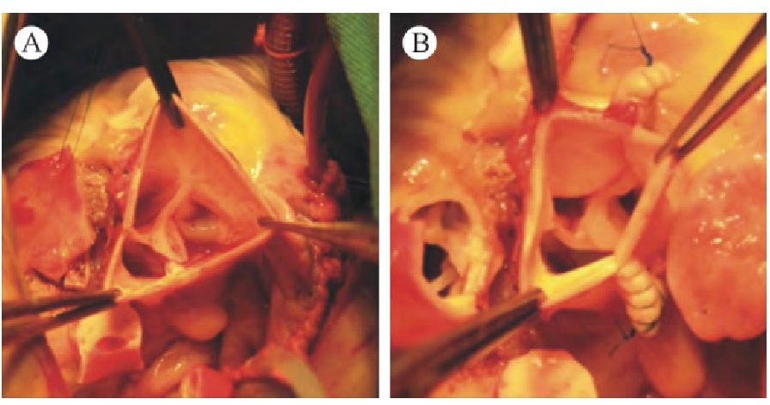
Supplementary Figure 1 (A) Dilated new aortic wall; (B) The aortic wall at the sinus-tube junction was folded. By folding the new aortic wall at the level of the sinus tubular junction, the diameter ratio of the sinus tubular junction to the aortic annulus of the new aorta was 0.8, which was closer to the normal aortic root anatomy.

