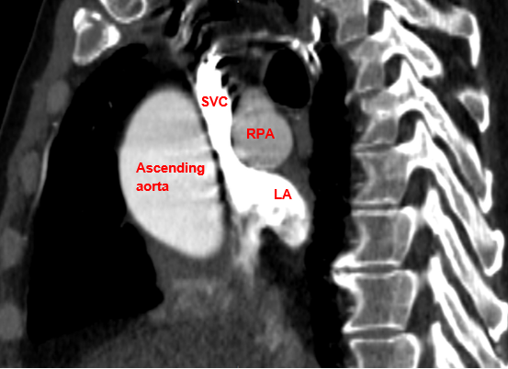
Supplemental Figure 1. Sagittal oblique view of sinus venosus atrial septal defect on CT. LA = left atrium, RPA = right pulmonary artery, SVC = superior vena cava

