SUPPLEMENTAL MATERIAL
Table S1. Summary of findings for study outcomes.
First Author  (year) |  | Tool | Statistics | N
Disease-related knowledge (n=5)
Goossense (2015) |  | LKQ-CHD | - 27-month follow-up*  MD±SD=1.18±9.65 | Exp.=106  Cont.=65
Lee (2019) |  | LKQ-CHD  (Korean version) | - Post*  MD±SD=10.64±15.12 | Exp.=27  Cont.=25
Mackie (2014) |  | MyHeart | - 1-month follow-up  MD=14.0±21.94  - 6 month follow up*  MD±SD=15.0±21.94 | Exp.=24  Cont.=26
Mackie (2018) |  | MyHeart | - 18-month follow-up*  Hedge’s g=0.72  V_{g}=0.04 | Exp.=58  Cont.=63
Mackie (2022) |  | MyHeart | - 6-month follow-up*  MD±SD=20.00±22.10 | Exp.=27  Cont.=25
Loss to follow-up (n=4)
Bushee (2021) | - |  | - For 3 years*  OR=0.38, LogOR=-0.96,  V_{logOR}=0.08 | Exp.=212  Cont.=216
Gaydos (2020) | - |  | - For 26 months*  OR=0.23, LogOR=-1.49,  V_{logOR}=0.46 | Exp.=41  Cont.=54
Hergenroeder  (2018) | - |  | - For 3 years*  OR=0.06, LogOR=-2.77,  V_{logOR}=2.21 | Exp.=15  Cont.=30
Mackie (2018) | - |  | - For 24 months*  OR=0.76, LogOR=-0.27,  V_{logOR}=0.16 | Exp.=58  Cont.=63
Self-management (n=4)
Lee (2019) |  | Self-care of Heart Failure Index | - Post*  MD=10.02±8.56 | Exp.=27  Cont.=25
Mackie (2014) |  | TRAQ:  self-management | - 1-month follow-up  MD=0.22±0.95  - 6 month follow up*  MD±SD=0.61±1.00 | Exp.=24  Cont.=26
Mackie (2018) |  | TRAQ:  self-management | - 18-month follow-up*  Hedge’s g=0.46  V_{g}=0.03 | Exp.=58  Cont.=63
Mackie (2022) |  | TRANSITION-Q | - 6-month follow-up*  MD±SD=11.89±0.67 | Exp.=27  Cont.=25

Table S1. Continued.

First Author  (year) | Tool | Statistics | N
Quality of life (n=3)
Hwang (2022) | PCQLI | - Post*  MD=6.49±3.66  - 1-month follow-up  MD±SD=5.84±3.69 | Exp.=14  Cont.=14
Lee (2017) | PCQLI | - Post*  MD=1.58±14.57  - 6-month follow-up  MD±SD=1.36±14.23 | Exp.=25  Cont.=31
Lee (2019) | PedsQL (generic) | - Post  MD±SD=0.94±15.12 | Exp.=27  Cont.=25
 | PedsQL (cardiac) | - Post*  MD±SD=2.35±13.37
Excess time between pediatric and ACHD care (n=2)
Hergenroeder  (2018) | - | - MD±SD=-5±0.28 | Exp.=15  Cont.=30
Mackie (2018) | - | - MD±SD=-10.7±14.63 | Exp.=58  Cont.=63
Self-advocacy (n=2)
Mackie (2014) | TRAQ:  self-advocacy | - 1-month follow-up  MD=0.27±0.71  - 6-month follow-up  MD±SD=0.49±0.78 | Exp.=24  Cont.=26
Mackie (2018) | TRAQ:  self-advocacy | - 18-month follow-up  Hedge’s g=0.09  V_{g}=0.03 | Exp.=58  Cont.=63
Health behavior (n=1)
Hwang (2022) | Average daily steps (step/day) | - Post  MD=1599.45±638.66  - 1-month follow-up  MD±SD=2626.73±590.76 | Exp.=14  Cont.=14
 | Weekdays sedentary behavior (min/day) | - Post  MD=-60.46±25.34  - 1-month follow-up  MD±SD=-105.68±25.56
 | Weekend sedentary behavior (hr/day) | - Post  MD=-2.23±0.76  - 1-month follow-up  MD±SD=-0.45±0.77
 | Average MVPA per day (min/day) | - Post  MD=9.91±9.12  - 1-month follow-up  MD±SD=31.12±9.41

Table S1. Continued.
First Author  (year) | Tool | Statistics | N
Health behavior (n=1)
Hwang (2022) | Consumption of convenience food | - Post  OR=0.72, 95% CI=0.24 to  2.18  - 1-month follow-up  OR=0.72, 95% CI=0.39 to  1.34 | Exp.=14  Cont.=14
 | Total sleep time (min/day) | - Post  MD=0.43±16.24  - 1-month follow-up  MD±SD=-22.09±16.05
Transition to ACHD care (n=1)
Bushee (2021) | - | - For 2 years  OR=1.62, LogOR=0.48,  V_{logOR}=019 | Exp.=212  Cont.=216
Unplanned cardiac hospitalizations (n=1)
Bushee (2021) | - | - For 2 years  OR=0.60, LogOR=-0.52,  V_{logOR}=0.15 | Exp.=350  Cont.=303
Deterioration of heart failure status (n=1)
Hergenroeder  (2018) | NYHAFS | - For 2 years  OR=0.10, LogOR=-2.92,  V_{logOR}=2.24 | Exp.=15  Cont.=30
ACHD: adult congenital heart disease; CI: confidence interval; Cont.: control group; Exp.: experimental or exposure group; LKQ-CHD: Leuven Knowledge Questionnaire for Congenital Heart Disease; MD: mean difference; MVPA: moderate to vigorous intensity physical activity; NYHAFS: The New York Heart Association Functional Classification of Heart failure; OR: odds ratio; PCQLI: Pediatric Cardiac Quality of Life Inventory; PedsQL: Pediatric Quality of Life; SD: standard difference; TRAQ: Transition Readiness Assessment Questionnaire; V_{g}: variance of Hedge’s g; V_{logOR}: variance of logOR.
*Statistics utilized for meta-analysis.

Table S2. GRADE scores of transition programs to adulthood for adolescents and young adults with congenital feart disease.
Patient or population: adolescents or young adults with congenital heart disease
Setting: hospital-based or community-based settings
Intervention: transition programs to adult health care
Comparison: usual care or no intervention
Outcomes | No. of Participants (Studies) | Anticipated Effects  (95% CI) | Certainty of  the Evidence (GRADE) | Comments
Disease-related knowledge | 414  (5) | Hedge's g=0.89  (0.29 lower to  1.48 higher) | ⊕⊕⊝⊝^{abc}  Low | Transition interventions may increase disease-related knowledge.
Self-management | 243  (4) | Hedge's g=0.67  (0.38 lower to  0.95 higher) | ⊕⊝⊝⊝^{d}  Very low | The evidence is very uncertain about the effect of transition intervention on self-management.
Disease-related QoL | 136  (3) | Hedge's g=0.60  (-0.24 lower to  1.44 higher) | ⊕⊝⊝⊝^{ade}  Very low | The evidence is very uncertain about the effect of transition intervention on disease-related QoL.
Loss to follow-up | 689  (4) | OR=0.41  (0.22 lower to  0.77 higher) | ⊕⊕⊝⊝^{af}  Low | Transition interventions may decrease loss to follow-up.
GRADE Working Group grades of evidence
High certainty: we are very confident that the true effect lies close to that of the estimate of the effect.
Moderate certainty: we are moderately confident in the effect estimate: the true effect is likely to be close to the estimate of the effect, but there is a possibility that it is substantially different.
Low certainty: our confidence in the effect estimate is limited: the true effect may be substantially different from the estimate of the effect.
Very low certainty: we have very little confidence in the effect estimate: the true effect is likely to be substantially different from the estimate of effect.
CI: confidence interval; OR: odds ratio; QoL: quality of life.
ªThere was a high risk of bias in some of the studies included. Therefore, the certainty of evidence was downgraded by 1 level due to risk of bias.
^{b}Statistical heterogeneity was considerable (I² > 80%). However, it was explained using a sub-group analysis. Therefore, we decided not to downgrade the
evidence by 1 level due to inconsistency.
^{c}The Hedge's g showed a large effect size (Hedge’s g > 0.75). Therefore, the certainty of evidence was upgraded by 1 level due to large effect;
^{d}Imprecise due to small sample size (< 400) (Higgins et al., 2022). Therefore, the certainty of evidence was downgraded by 1 level due to imprecision.
^{e}Statistical heterogeneity was considerable (I² > 80%). Therefore, the certainty of evidence was downgraded by 1 level due to inconsistency.
^{f}The OR showed a large effect size (OR < 0.5). Therefore, the certainty of evidence was upgraded by 1 level due to large effect.

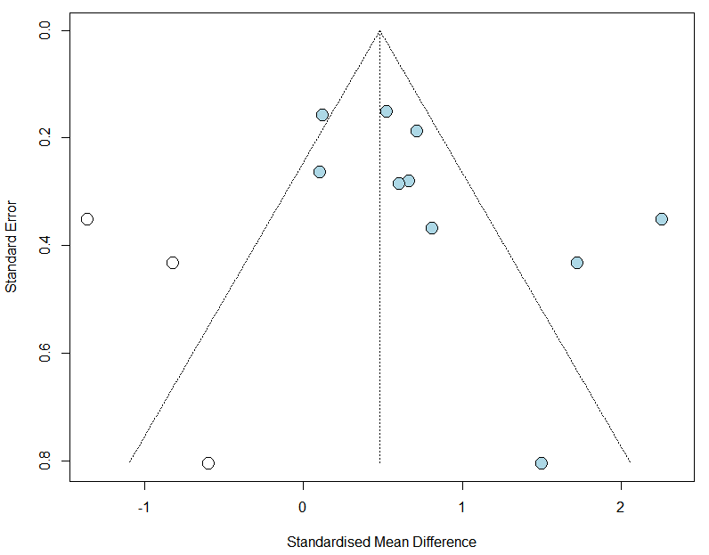
Figure S1. Funnel plot for the 10 included studies.

Figure S2. Combining two analyses with metabind.

