Spontaneous resolution of an intrapericardial thrombus as a complication of pericardiocentesis in a neonate – Supplementary Information (SI)

Joy Crombez¹, Wendy Dewals², Laura Muiño Mosquera³, Thomas Martens⁴; Karlijn Van Damme^{1,5*}, Luc Bruyndonckx^{2,5*}

¹ Department of Neonatology, Antwerp University Hospital, Edegem, Belgium
² Department of Pediatric Cardiology, Antwerp University Hospital, Edegem, Belgium
³ Department of Pediatric Cardiology, Ghent University Hospital, Ghent, Belgium
⁴ Department of Cardiac Surgery, Ghent University Hospital, Ghent, Belgium
⁵Laboratory of Experimental Medicine and Pediatrics, University of Antwerp, Antwerp, Belgium
* Both authors contributed equally

Corresponding author:
Joy Crombez, MD
Antwerp University Hospital
Drie Eikenstraat 655
2650 Edegem
Belgium
Tel +32 3 821 32 51
E-mail: joy.crombez@uza.be

Supplemental images and videos (Online Resources)

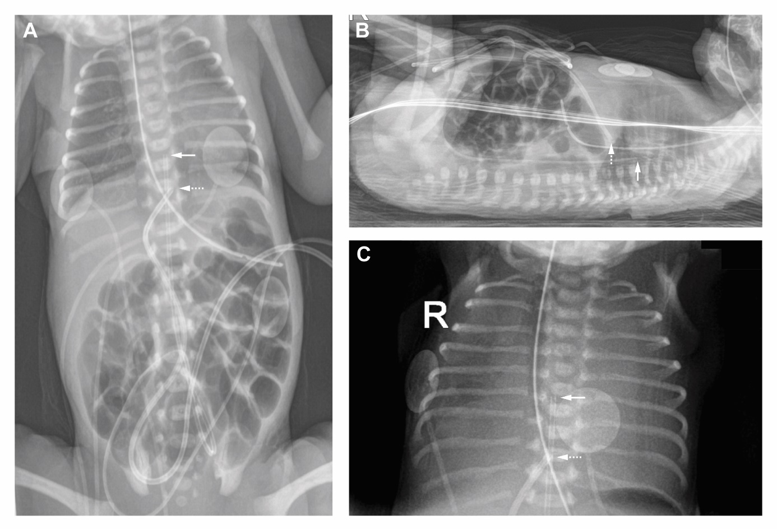
Supplementary Figure S1 A. Anterior posterior (AP) chest and abdominal radiography show an adequate position of the umbilical venous catheter tip at the level of the diaphragm (white dotted arrow) and of the umbilical arterial catheter tip in high position in the descending aorta (white arrow). B. Lateral chest and abdominal radiography confirms correct tip positions of the umbilical venous catheter (white dotted arrow) and the umbilical arterial catheter (white arrow). C. AP chest radiography at the time of clinical deterioration shows bilateral opacities. Tip of the umbilical venous catheter (white dotted arrow) appears to have migrated upward, projecting above the diaphragm. Tip of the umbilical arterial catheter (white arrow) is in correct position.

Supplementary Video S1 Echocardiography after pericardiocentesis shows the intrapericardial thrombus adjacent to the right ventricle, without hemodynamic compromise.

