Supplementary Figures
Supplementary Figure S1.Subgroup analysis according to the type of valve used (Edwards vs. Melody) in patients with mixed pulmonary valve disease and pulmonary stenosis assessing right ventricular outflow tract flow velocity at baseline and during a five year follow up period post percutaneous pulmonary valve implantation. Both valves are equally effective to reduce significantly the right ventricular outflow gradient and no significant difference was observed between the two valves at any time point. PPVI: percutaneous pulmonary valve implantation, RVOT: right ventricular outflow tract.

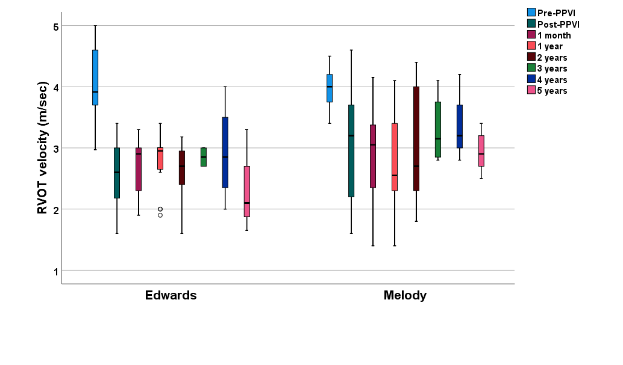
Supplementary Figure S1

