Table S1. Parental demographics
Demographics | n | %
Age
18 or under | 5 | 6
19-30 | 10 | 12
31-40 | 29 | 35
41-50 | 31 | 37
51-60 | 7 | 8
61-65 | 1 | 1
Ethnic group
White | 81 | 98
I'd rather not say | 2 | 2
Support role
Mother | 78 | 94
Father | 1 | 1
Legal guardian | 2 | 2
Foster carer | 1 | 1
Other | 1 | 1
Degree of care
Sole carer of the child | 19 | 23
Shared with partner | 64 | 77
Marital status
Never married or registered a civil partnership | 23 | 28
Married | 54 | 65
Civil partnership | 1 | 1
Divorced | 3 | 4
No response | 2 | 2
Employment status
Employed | 56 | 67
Self-employed | 8 | 10
Not in work | 1 | 1
Studying | 2 | 2
Looking after home or family | 14 | 17
Long-term sick or disabled | 2 | 2
Education
No formal education | 2 | 2
Secondary school | 7 | 8
College | 28 | 34
Vocational training | 4 | 5
Higher education (HE) | 42 | 51
Smoking status
Never smoked | 61 | 73
Ex-smoker | 16 | 19
Smoker | 6 | 7

Table S2. Children’ physical activity behaviours stratified by age.
Age group | VPA | MPA | Total
 | n (%) | n (%) | n
4 to 11 | 25 (64) | 32 (82) | 39
12 to 15 | 8 (73) | 9 (82) | 11
16 to 20 | 3 (60) | 5 (100) | 5
Total | 36 (65) | 46 (84) | 55
VPA, vigorous physical activity; MPA, moderate physical activity.
Table S3. Associations between parental demographics and child/young people’s physical activity participation.
Demographic | VPA | MPA
Age | P=0.19^{b} | P=0.01^{b}
Employment | P=0.91^{b} | P=0.27^{b}
Education | P=0.21^{b} | P=0.49^{b}
Smoking status | P=0.73ª | P=0.36ª
ª Fishers Exact; ^{b} Fishers-Freeman Halton. VPA, vigorous physical activity; MPA, moderate physical activity.

Table S4. Parental/carer age and child/young persons participation in moderate physical
activity.
Parental age | No | Yes
18 or under | 0 (0) | 3 (100)
25-35 yrs. | 6 (55) | 5 (45)
36-45 yrs. | 2 (10) | 17 (90)
46-55 yrs. | 1 (5) | 19 (95)
56+ yrs. | 0 (0) | 2 (100)
Total | 9 (16) | 46 (84)
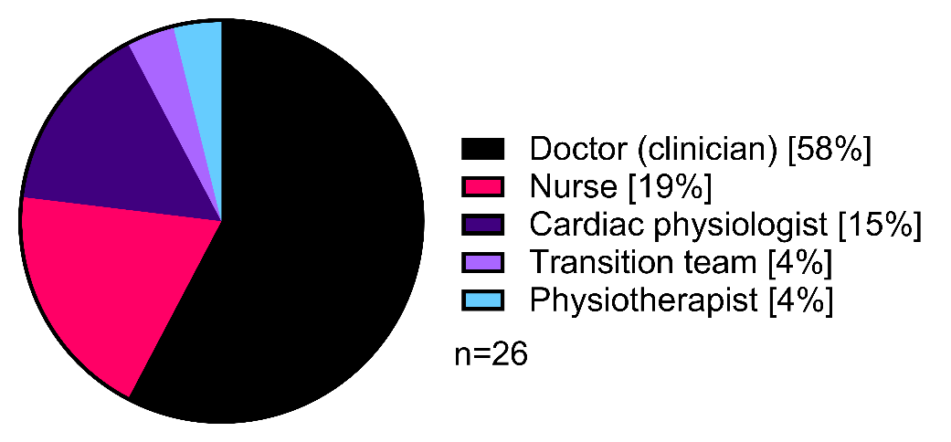

Figure S1. Health care professionals who were reported to give physical activity advice.

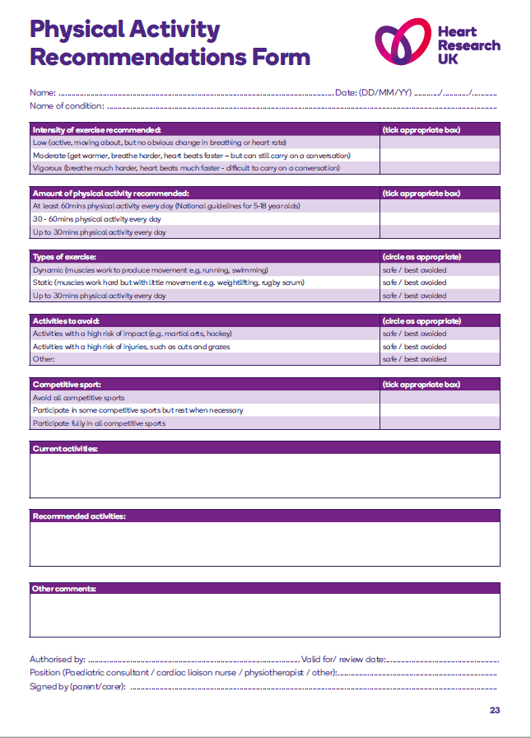 Heart Research UK Physical Activity Recommendations Form for Clinicians.
Reproduced with Permission from Heart Research UK. Available from: https://heartresearch.org.uk/chd-parents-and-guardians/
Methods
Physical activity definitions
Parents/guardians were given a written paragraph defining sedentary time, moderate physical activity, and vigorous physical activity before being asked to report their own or their child’s physical activity behaviours. Child sedentary time was defined as “sitting or reclining at school, at home, getting to and from places, or with friends including time spent sitting at a desk, sitting with friends, traveling in car, bus, train, reading, playing games or watching television” (1). Vigorous physical activities were defined as “requires hard physical effort and causes large increases in breathing or heart rate and likely prevent you from talking and completing the activity” and moderate physical activities were defined as “activities that require moderate physical effort and cause smaller increases in breathing or heart rate and during which you are likely to be able to talk”. The questions follow the Global Physical Activity Questionnaire wording were then asked: “Do you [Does your child] do any vigorous-intensity sports, fitness or recreational (leisure) activities that cause large increases in breathing or heart rate like (running or football) for at least 10 minutes continuously?” and “Do you [Does your child] do any moderate-intensity sports, fitness or recreational (leisure) activities that cause small increases in breathing or heart rate for at least 10 minutes continuously?” (1).

References
1. Armstrong T, Bull F. Development of the World Health Organization Global Physical Activity Questionnaire (GPAQ). J Public Health (Bangkok). 2006;14(2):66–70.

Questionnaire

Questions used in qualitative analysis are marked with *

Section 1: Parental demographics and physical activity behaviours
- Please indicate your age.
  - 18 or under
  - 19-25
  - 26-30
  - 31-35
  - 36-40
  - 41-45
  - 46-50
  - 51-55
  - 56-60
  - 61-65
  - 66 or over
  - I’d rather not say

- What is your ethnic group?
  - White
  - Mixed or Multiple ethnic group
  - Arab
  - Asian or Asian British
  - Black, Black British, Caribbean, or African
  - Other ethnic group:
  - I’d rather not say

- Please indicate your support role.
  - Mother
  - Father
  - Legal guardian
  - Other:
  - I’d rather not say

- Please indicate your marital status.
  - Never married and never registered a civil partnership
  - Married
  - Civil partnership
  - Separated but still legally married
  - Separated but still legally in a civil partnership
  - Divorced
  - Widowed
  - Surviving partner from a registered civil partnership
  - I’d rather not say

- Are you the main carer of your child?
- Sole carer of your child
- Share 50% with partner
- Occasional carer
- I do not have contact with my child
- Other (please specify):
- I’d rather not say.

- Please indicate one option that best describes your current role
  - Employed
  - Self-employed
  - Not in work
  - Retired
  - Studying
  - Looking after home or family
  - Long-term sick or disabled
  - Other:
  - I’d rather not say
- Please indicate your highest level of education.
  - No formal education
  - Secondary school/High school (GCSEs etc.)
  - College (A levels, BTEC etc.)
  - Vocational training
  - Bachelor’s degree
  - Master’s degree
  - Professional degree
  - Doctorate degree
  - Other:
  - I’d rather not say

- Please indicate your smoking status.
  - Never smoked
  - Ex-smoker
  - Smoker
  - Other:
  - I’d rather not say

In answering the following questions 'vigorous-intensity activities' are activities that require hard physical effort and cause large increases in breathing or heart rate and likely prevent you from talking and completing the activity, 'moderate-intensity activities' are activities that require moderate physical effort and cause smaller increases in breathing or heart rate and during which you are likely to be able to talk. Sports, fitness, and recreational (leisure) are all counted within vigorous intensity activity.

- Do you do any vigorous-intensity sports, fitness or recreational (leisure) activities that cause large increases in breathing or heart rate like [running or football] for at least 10 minutes continuously? (if “no” or “don’t know” question 10 is not asked).
  - Yes
  - No
  - I don’t know
- How much time do you spend doing vigorous-intensity sports, fitness, or recreational activities a week?
  - 0 to 30 minutes
  - 31 to 60 minutes
  - 1 to 2 hours
  - 2 to 3 hours
  - >4 hours
- Do you do any moderate-intensity sports, fitness or recreational (leisure) activities that cause small increases in breathing or heart rate for at least 10 minutes continuously? (if “no” or “don’t know” question 12 is not asked).
  - Yes
  - No
  - I don’t know
- How much time do you spend doing moderate-intensity sports, fitness, or recreational activities a week?
  - 0 to 30 minutes
  - 31 to 60 minutes
  - 1 to 2 hours
  - 2 to 3 hours
  - >4 hours

Section 2. Child’s demographics and physical activity behaviours
- Please indicate the age of your child (years):
  - 0 to 1
  - 2
  - 3
  - 4
  - 5
  - 6
  - 7
  - 8
  - 9
  - 10
  - 11
  - 12
  - 13
  - 14
  - 15
  - 16
  - 17
  - 18
  - 19
  - 20
  - 21
  - 21-30
  - Would rather not say
- What age was your child diagnosed with congenital heart disease
  - 0 to 1
  - 2
  - 3
  - 4
  - 5
  - 6
  - 7
  - 8
  - 9
  - 10
  - 11
  - 12
  - 13
  - 14
  - 15
  - 16
  - 17
  - 18
  - 19
  - 20
  - 21
  - 21-30
  - More than 30 years old
  - Would rather not say

- Please indicate the sex of your child
  - Male
  - Female
  - Other (please specify):
  - I’d rather not say
- Please indicate the congenital heart disease diagnosis your child has (select as appropriate):
Aortic stenosis (AS)
Aortic valve insufficiency
Atrial septal defect (ASD)
Atrioventricular septal defect (AVSD)
Coarctation of the aorta
Cor triatriatum
Coronary artery aneurysm
Dextrocardia
Double outlet right ventricle (DORV)
Ebstein anomaly
Fontan circulation
Hypoplastic left heart syndrome (HLHS)
Interrupted aortic arch
Mitral insufficiency
Mitral stenosis
Partial anomalous pulmonary venous return (PAPVC)
Patent ductus arteriosus (PDA)
Pulmonary arteriovenous aneurysm
Pulmonary atresia
Pulmonary stenosis
Single ventricle
Tetralogy of Fallot (ToF)
Total anomalous pulmonary venous return (TAPVR)
Transposition of the great arteries (TGA)
Tricuspid atresia or stenosis
Truncus arteriosus
Ventricular septal defect (VSD)
I don’t know
Other (please specify):

- Has your child undergone heart surgery (any type of surgery e.g. ‘open heart’, ‘keyhole’ or ‘catheter procedures’)?
  - Yes
  - No
  - Not yet but will do
  - I don’t know
  - I’d rather not say

- Does your child have any other health conditions (for example: down syndrome, learning difficulties, growth developments etc)?
  - Yes (please specify if you’d like to):
  - No
  - I’d rather not say

- How well is your child on a day-to-day basis?
  - Healthy
  - Minor illness
  - Major illness
  - Critically ill

- Does your child do any vigorous-intensity sports, fitness or recreational (leisure) activities that cause large increases in breathing or heart rate like [running or football] for at least 10 minutes continuously? (if “no” or “don’t know” question 6 is not asked)
  - Yes
  - No
  - I don’t know
- How much time does your child spend doing vigorous-intensity sports, fitness or recreational activities per week?
  - 0 to 30 minutes
  - 31 to 60 minutes
  - 1 to 2 hours
  - 2 to 3 hours
  - >4 hours
- Does your child do any moderate-intensity sports, fitness or recreational (leisure) activities that cause small increases in breathing or heart rate for at least 10 minutes continuously? (if “no” or “don’t know” question 8 is not asked).
  - Yes
  - No
  - I don’t know
- How much time does your child spend doing moderate-intensity sports, fitness or recreational activities per week?
  - 0 to 30 minutes
  - 31 to 60 minutes
  - 1 to 2 hours
  - 2 to 3 hours
  - >4 hours
The following question is about sitting or reclining at school, at home, getting to and from places, or with friends including time spent sitting at a desk, sitting with friends, traveling in car, bus, train, reading, playing games or watching television, but do not include time spent sleeping.
- How much time does your child usually spend sitting or reclining on a typical day?
  - 0 to 1 hours
  - 1 to 2 hours
  - 2 to 3 hours
  - 4 to 5 hours
  - 5 to 6 hours
  - 7 to 8 hours
  - More than 8 hours

Section 3. Parental attitudes towards physical activity
Physical activity
Using a scale of 1 (not important at all) to 5 (very important) please rate:
- How important is it for you to be physically active yourself?
1 2 3 4 5
(not important) (neutral) (very important)
- How much do you enjoy being physically active?
1 2 3 4 5
(not important) (neutral) (very important)
- How important do you think it is for your child to be physically active?
1 2 3 4 5
(not important) (neutral) (very important)
- How much do you think your child enjoys being physically active?
1 2 3 4 5
(not important) (neutral) (very important)

- How many of these regularly prevent your child from being physically active (please chose as many as applicable)
Lack of time ☐
Lack of enjoyment of activity ☐
Tiredness ☐
Unwell ☐
School/homework pressure ☐
Peer pressure ☐
Body image/body confidence ☐
Would rather do something else with spare time ☐
Concerns about weight loss / nutrition ☐
Concerns about symptoms (heart palpitations, chest pain, etc.) ☐
Concerns about physical activity with congenital heart disease ☐
Unclear what type / intensity of physical activity to do ☐
Cost of classes, coaching, subscriptions, or equipment ☐
Other:

- Do you think exercise is safe for your child with congenital heart disease?
  - Yes
  - No
  - Don’t know

6b. *What concerns do you have about your child being physically active? (please
state) [Answered only if yes or unsure to Q6]
________________________________________________________________________
________________________________________________________________________
- *What would help your child to be more physically active and what could be done by governments/hospitals/schools to help this?
________________________________________________________________________
________________________________________________________________________
- Are you aware of where you can find out more information about exercise for people/children with congenital heart disease?
  - Yes
  - No
  - Unsure
  - Optional text box – for further answers.

Section 4. Clinical experience and questions about physical activity with congenital heart disease
- How often does your child have an exercise test during clinical outpatient appointments?
  - Every appointment
  - Some appointments
  - Don’t know
  - Never

- What type of exercise test does your child have? [Only asked if a or b are selected in Q1]
  - Cycling on a bike
  - Running on a treadmill
  - Walking a distance or stepping on a box
  - Other: (please state)
  - Don’t know

- Do you consider the exercise tests useful and safe? [Only asked if a or b are selected in Q1; allow multiple responses]
  - Useful and safe
  - Useful but not safe
  - Not useful but safe
  - Not useful or safe
  - I don’t know
  - Please state_____________________________________________

- *How does your child feel about the exercise tests? [Only asked if a or b are selected in Q1; allow multiple responses]
  - Please state______________________________________________
  - I don’t know

- How often does your child receive physical activity/exercise advice during clinical outpatient appointments?
  - Every appointment
  - Some appointments
  - Don’t know
  - Never

- Which of these members of the team talk to you and your child about physical activity? [Only asked if a or b are selected in Q5; allow multiple responses]
  - Nurse
  - Physiotherapist
  - Cardiac physiologist
  - Clinician
  - Dietician
  - Psychologist
  - Exercise specialist
  - None
  - Other (please state)________________________________________________

- *Do you feel the advice you get on physical activity/exercise is consistent between doctors and/or other health care professionals? [Only asked if a or b are selected in Q5; allow multiple responses]

  - Yes
(Option to provide further information) __________
  - No
(Option to provide further information) __________
  - I don’t know
  - I’d rather not say

- Do you have any questions or concerns about physical activity that have not been answered by the clinic?
  - Yes (please specify):
  - No

- *If there is anything that you would like to raise about physical activity and exercise for young people with congenital heart disease, please feel free to use the text box to tell us

THANK YOU FOR YOUR TIME
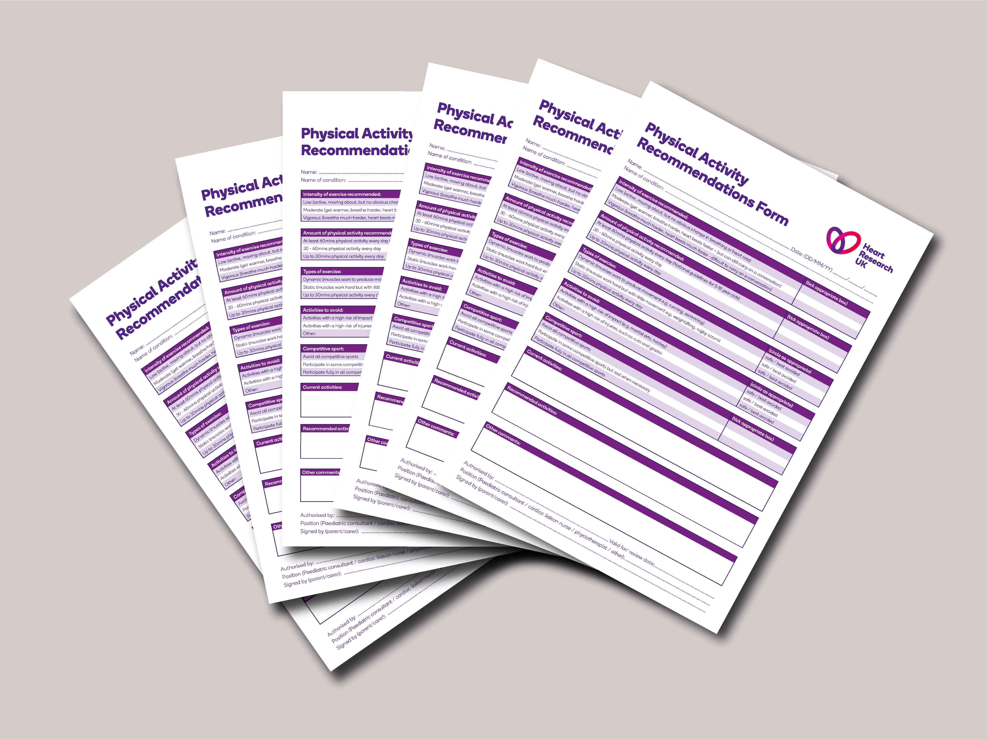
Activity recommendation forms ready on a Clinician’s desk!
Image provided by Heart Research UK.

