**Transformed by fire: Body perception in cremation burial practices in Postclassic Middle Balsas River basin, Michoacán Tierra Caliente**

Supplementary Material 1

Biological Profile of Individuals

**Methods**

The methodology employed for the reconstruction of the biological profile of the deceased established techniques commonly applied to inhumations. These techniques included the assessment of sex through dimorphic traits of the skull (Ascadi and Nemeskeri 1970 after: Buikstra and Ubelaker 1994). For the age-at-death assessment of subadult individuals, we utilized two indicators: the stage of odontogenesis (Ubelaker 1999), and the stage of epiphyseal fusion (Cunningham et al. 2016). For adult individuals, age assesment relied on the stage of cranial suture obliteration (Meindl and Lovejoy 1985), along with the examination of morphological changes in the auricular face of the ilium (Lovejoy et al. 1985). In cases where there were insufficient well-preserved diagnostic fragments to use one of the above methods, the age of an individual in the very general 'Adult' category was determined based on the general morphology of burnt human bones (McKinley 1994). The resulting age-at-death assessments were categorized into age cohorts based on McKinley's analysis (1994):

1.     Infant (0 – 4 years old)

a.     Young infant (0 – 2 years old)

b.     Older infant (3 – 4 years old)

2.     Juvenile (5 – 12 years old)

a.     Young juvenile (5 – 8 years old)

b.     Older juvenile (9 – 12 years old)

3.     Subadult (13 – 18 years old)

a.     Young subadult (13 – 15 years old)

b.     Older subadult (16 – 18 years old)

4.     Young adult (19 – 25 years old)

5.     Mature adult (26 – 40 years old)

a.     Younger mature adult (26 – 30 years old)

b.     Older mature adult (31 – 40 years old)

6.     Older Adult (>40 years old)

7. Adult (>19 years old)

The minimum number of individuals (MNI) in the analysis was determined based on the presence of more than one specific and sided bone fragments, or a significant number of bones showing different stages of human body development. The total weight of cremation burials was not used as a premise for the number of individuals interred in the burials.

**Results**

Table 1. Information about biological profile along with the diagnostic traits used to assess the age-at-death and sex of individuals buried in analyzed burials.

|  |  |  |  |  |  |  |  |  |  |
| --- | --- | --- | --- | --- | --- | --- | --- | --- | --- |
| Feature number | MNI | Age Category | | Method of age-at-death assesment | | Sex | | Method of sex assesment | |
| RT11 | 1 | Juvenile | | Dental developmentd | | N/A | | - | |
| RT14 | 1 | Adult | | Fully fused coracoid process of scapularb (>20) | | F | | Mastoid process (1) Supraorbit margin (2) Glabella (1)f | |
| RT16 | 1 | Adult | | General morphologya | | ? | | - | |
| RT19 | 1 | Mature adult | | Cranial obliterationc | | M | | Glabella (4) Supraorbit margin (4)f | |
| RT21 | 1 | Juvenile | | Unfused proximal epiphysis of tibiab (<13-15) | | N/A | | - | |
| RT22 | 2 | Infant | Mature adult | Dental developmentd | Phase 4e (29-40) | N/A | F | - | Mastoid process (2) External occipital protuberance (2)f |
| RT24 | 1 | Mature adult | | Cranial obliterationc | | ? | | - | |
| RT26 | 1 | Young juvenile | | Dental developmentd | | N/A | | - | |
| RT28 | 1 | Young juvenile | | Dental developmentd | | N/A | | - | |
| RT39 | 1 | Young juvenile | | Dental developmentd | | N/A | | - | |
| RT40 | 1 | Mature adult | | Cranial obliterationc | | F? | | Supraorbital margin (1)f | |
| RT42 | 1 | Young infant | | Dental developmentd | | N/A | | - | |
| RT43 | 1 | Older infant | | Dental developmentd | | N/A | | - | |
| RT44 | 1 | Adult | | Fully fused vertebral border of scapulab (>18-23) | | ? | | - | |
| RT45 | 1 | Adult | | Fully fused iliac crest b (>18-20) | | M? | | Supraorbital margin (4)f | |
| RT46 | 1 | Adult | | General morphologya | | F? | | Supraorbital margin (2)f | |
| RT50 | 1 | Mature adult | | Cranial obliterationc | | M? | | Glabella (4) Mastoid process (2)f | |
| RT51 | 1 | Mature adult | | Cranial obliterationc | | M? | | Supraorbital margin (4)f | |
| RT52 | 1 | Adult | | General morphologya | | ? | | - | |
| RT53 | 1 | Mature adult | | Cranial obliterationc | | M? | | Supraorbital margin (3) External occipital protuberance (3) Mastoid process (4)f | |
| RT54 | 1 | Young adult | | Phase 2e (25-28) | | ? | | - | |

a. McKinley 1994

b. Cunningham et al. 2016

c. Meindl and Lovejoy 1985; after Buikstra and Ubelaker 1994

d. Ubelaker 1999

e. Lovejoy et al. 1985

f. Ascadi and Nemeskeri 1970; after Buikstra and Ubelaker 1994

Despite the limitation of biological profile reconstruction caused by the fragmentation and alternation during the cremation process (Gonçalves et al. 2015; Jaskulska 2020; Kurila 2015; Lemmers 2012), we were able to identify the presence of individual from nearly all age cohorts, ranging from young infant to mature adults in multiple burials within analyzed sample (Tab. 1). In the case of adult individuals, the accuracy of determination of more precise data about the maturity was highly reduced due to the fact that in 75% of cases, where we were able to determine the age of the individual more precisely than ‘Adult’, we had to rely solely on the stage of cranial suture obliteration, which has proven to be one of the least reliable methods of adult age assessment and highly variable population-wise (Franklin 2010; McKinley 1994; Vodanović et al. 2011). Despite that, if we were able to identify significant amount of cranial bones with indication of cranial suture obliteration–including the sagittal, parietomastoid sutures in case of RT40 or coronoid and lamboid sutures in case of RT53–we can assume that these individuals were not Young adults, but at least within the range of Mature adult age category.  In the case of non-adult individuals, the basis for age assessment was the degree of odontogenesis. Despite the precision of this method, we did not encounter a complete dental inventory in any of the analyzed burials. Therefore, also in this case, the use of age categories is much more methodologically reasonable than indicating specific ranges of calendar years. It is worth noting that we recorded a burial, which contained only the remains of an individual of Young infant age. In the population studied so far, the youngest individuals in the cremation burials were Older infants (Budziszewski 2023).

**Paleopathological lesions**

As in the case of biological profile data, the potential of identifying the paleopathological changes on cremated bones is highly reduced, when compared to well-preserved inhumations. We identified osteoarthritic lesions in the case of three burials (Fig. 1, Fig. 2). In addition to the changes identified on vertebral articular facets in burials RT50 and RT53, a lesion on the superior articular facet of the lower thoracic vertebrae (10th-12th) from burial RT40 was identified on a very fragile bone fragment. In the latter case, the characteristic pitting was observed all over the surface of the articular facet, similarly to the two previous cases presented in the figures. Moreover, in burial RT50 we identified well-preserved fragments of both in the case of maxillae and mandibular bones with sings of full resorption of alveolar processes (Fig. 3a, Fig. 3b, Fig. 3c). It is indicative for the fully healed antemortem tooth loose. In addition, in the case of the mandibular alveolar bone a horizontal bone loss on the buccal surface of the mandibular ramus, characterized by the breakdown of its contour (Fig. 10c). This indicates a case of periodontosis, which contributed to the antemortem tooth loss of individual buried in urn RT50. These are among the most commonly recorded pathological changes in past populations (Miranda Limón 2021; Scott et al. 2021; Weiss, Jurmain 2007; Viesca, Cruzalta 1997), and the likelihood of their occurrence increases with age and due to the specific activity patterns (Chatters et al. 2022; Plomp, Boylston 2016; Weiss, Jurmain 2007). In the case of antemortem tooth loose as with other dental diseases, the likelihood of their occurrence is related, among other things, to a diet rich in carbohydrates (Chatters et al. 2022; Cucina, Tiesler 2003; Lee et al. 2019; Nelson et al. 1999). While we cannot draw any conclusions about diet on the basis of such fragmentary information on dental health, the observation of degenerative changes on vertebrae in the study population can be taken indirectly as a hint suggesting the age of adults older than the range of the ‘young adult’ category (burial RT40, RT50 and RT53).

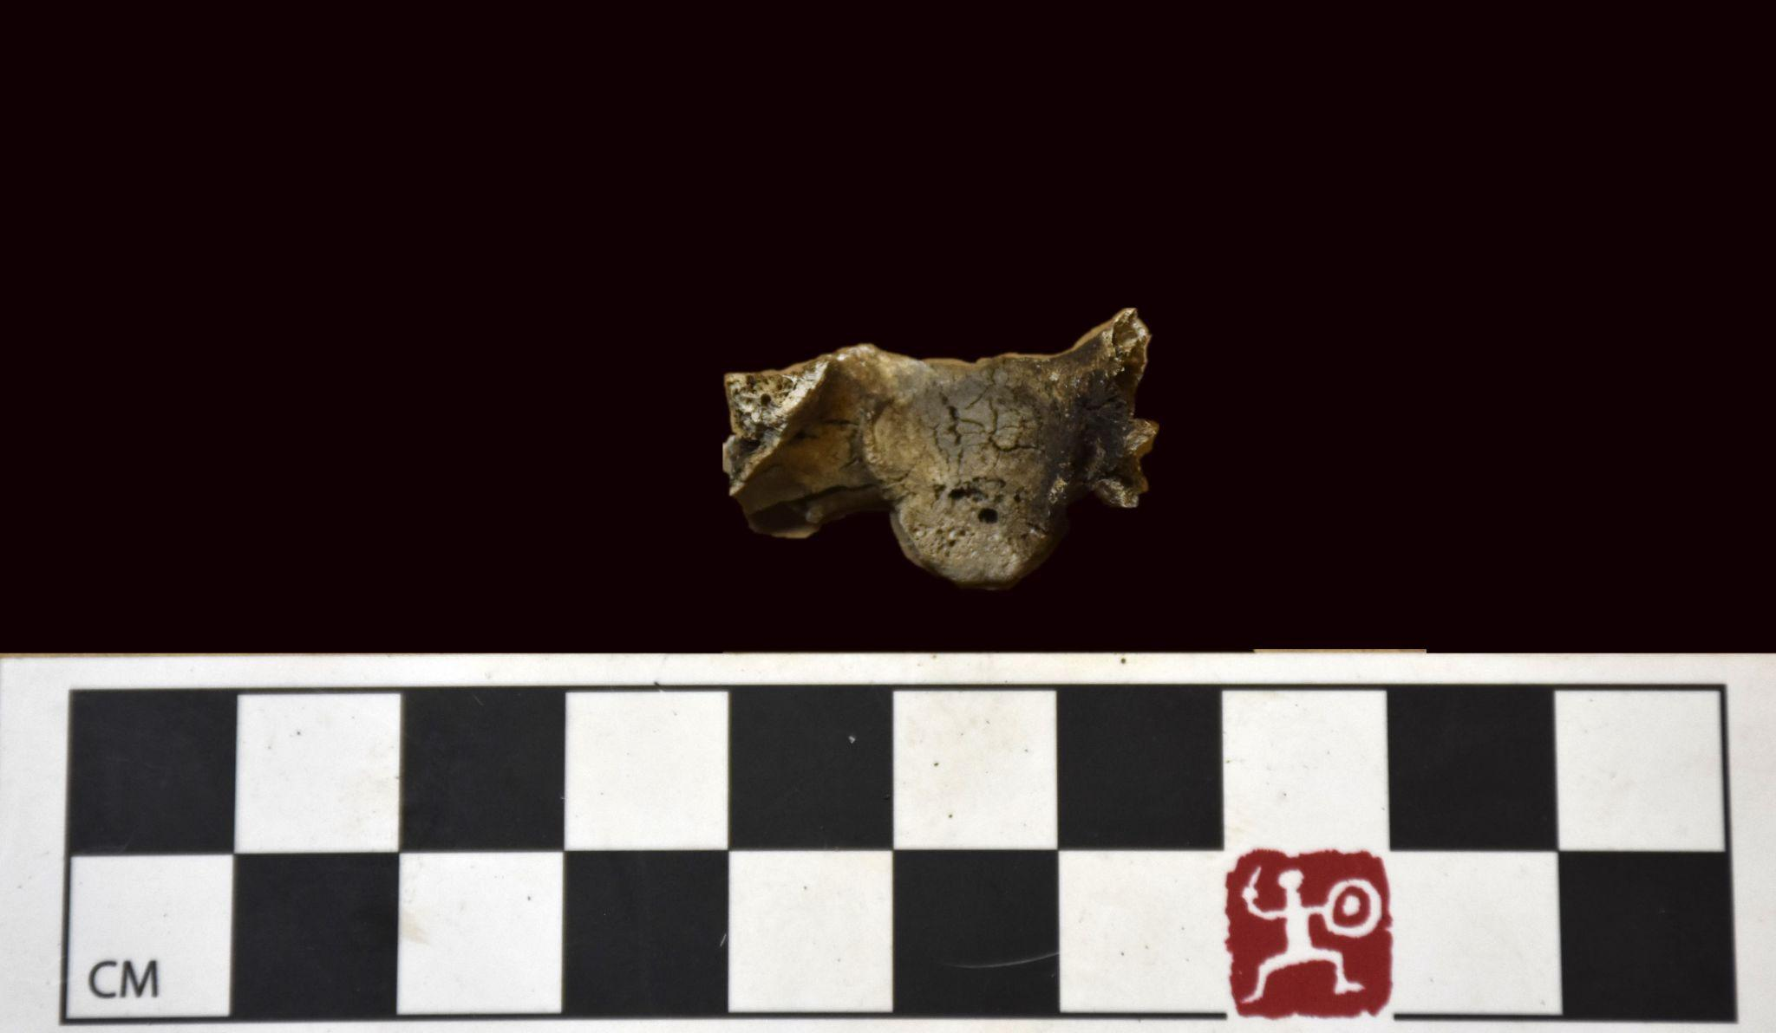

Figure 1. Osteoarthritic changes on articular surface for dens of first cervical vertebrae from burial RT50.

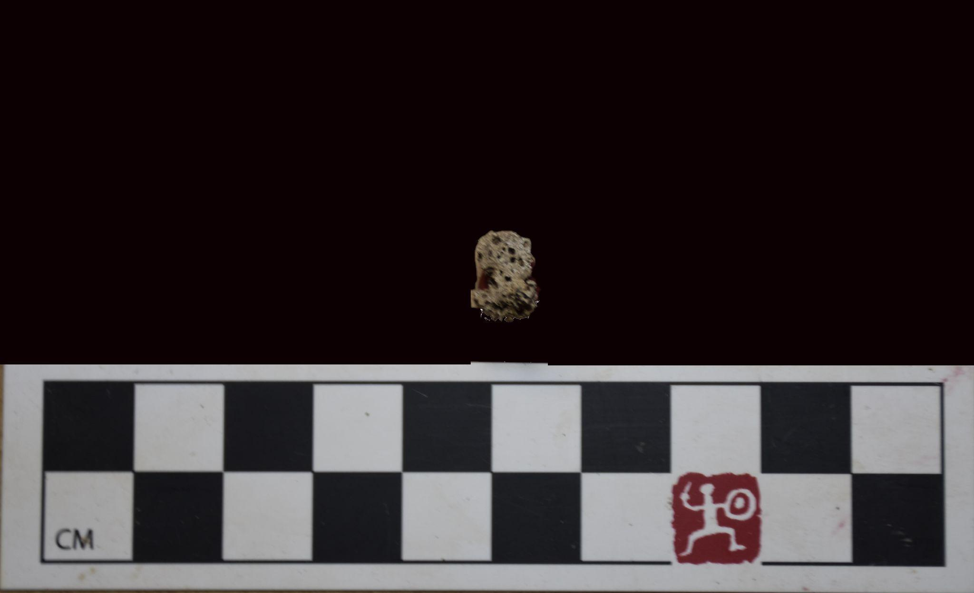

Figure 2. Osteoarthritic change on superior articular facet of thoracic vertebrae from burial RT53.

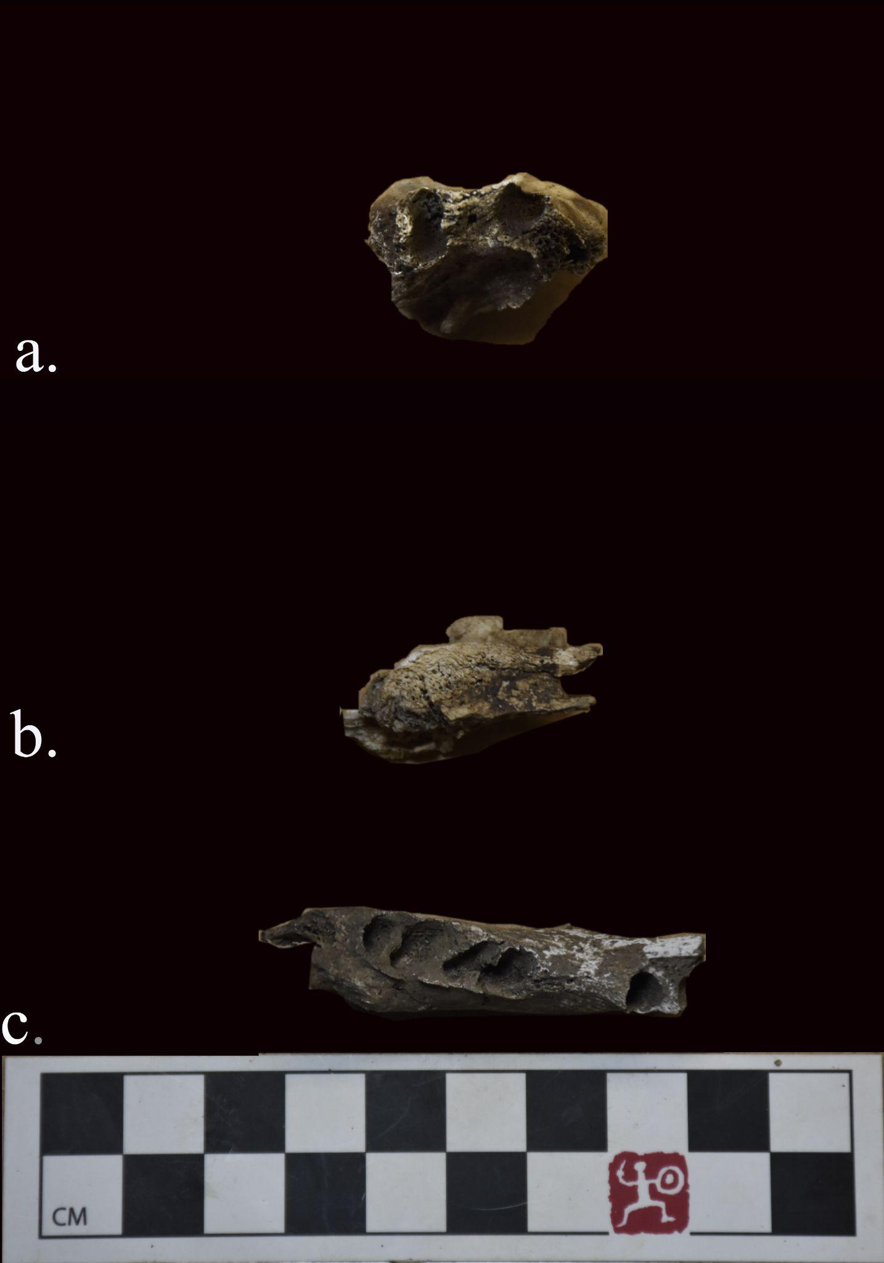

Figure 3. Fragments of alveolar processes with signs of antemortem tooth. Right maxilliae with sings of antemortem lost canine (a), left mandibular bone with signs of antemortem lost first and second molars (b), and right mandibular bone with signs of antemortem lost first and second premolars (c).

**References cited**

Budziszewski, Adam. 2023. A preliminary bioarchaeological study of the funerary urns from Los Tamarindos, Tierra Caliente, in Michoacan, Mexico. Ancient Mesoamerica:1–20. [DOI:10.1017/S0956536123000184.](https://doi.org/10.1017/S0956536123000184.)

Buikstra, Jane E., and Douglas H. Ubelaker (editors). 1994. Standards for Data Collection from Human Skeletal Remains: Proceedings of a Seminar at the Field Museum of Natural History, Organized by Jonathan Haas. Arkansas Archaeological Survey, Fayetteville.

Chatters, James C, Joaquín Arroyo-Cabrales, and Pilar Luna-Erreguerena. 2022. The Preceramic Skeletal Record of Mexico and Central America. In The Routledge Handbook of Mesoamerican Bioarchaeology, edited by Vera Tiesler, pp. 49–74. Routledge, New York.

Cucina, Andrea, and Vera Tiesler. 2003. Dental caries and antemortem tooth loss in the Northern Peten area, Mexico: A biocultural perspective on social status differences among the Classic Maya. American Journal of Physical Anthropology 122(1):1–10. [DOI:10.1002/ajpa.10267.](https://doi.org/10.1002/ajpa.10267.)

Cunningham, Craig, Louise Scheuer, and Sue Black. 2016. Developmental Juvenile Osteology. Academic Press, London.

Franklin, Daniel. 2010. Forensic age estimation in human skeletal remains: Current concepts and future directions. Legal Medicine 12(1):1–7. [DOI:10.1016/j.legalmed.2009.09.001.](https://doi.org/10.1016/j.legalmed.2009.09.001.)

Gonçalves, David, Vanessa Campanacho, Tim Thompson, and Rui Mataloto. 2015. The weight of the matter. Examining the potential skeletal weight for the bioarchaeological analysis of cremation at the Iron Age necropoli of Tera (Portugal). In The Archaeology of Cremation: Burned Human Remains in Funerary Studies, edited by Tim Thomspon, pp. 63–122. Oxbow Books, Oxford.

Jaskulska, E. 2020. *Analysis of Human Cremains*. Institute of Archaeology, University of Warsaw, Warsaw.

Kurila, Laurynas. 2015. The Accuracy of the Osteological Sexing of Cremated Human Remains: A Test Based on Grave Goods from East Lithuanian Barrows. Collegium Antropologicum 39(4):821–828.

Lee, Hyejin, Jong Ha Hong, Yeonwoo Hong, Dong Hoon Shin, and Sergey Slepchenko. 2019. Caries, antemortem tooth loss and tooth wear observed in indigenous peoples and Russian settlers of 16th to 19th century West Siberia. Archives of Oral Biology 98:176–181. [DOI:10.1016/j.archoralbio.2018.11.010.](https://doi.org/10.1016/j.archoralbio.2018.11.010.)

Lovejoy, C. Owen, Richard S. Meindl, Thomas R. Pryzbeck, and Robert P. Mensforth. 1985. Chronological metamorphosis of the auricular surface of the ilium: A new method for the determination of adult skeletal age at death. American Journal of Physical Anthropology 68(1):15–28. [DOI:10.1002/ajpa.1330680103.](https://doi.org/10.1002/ajpa.1330680103.)

McKinley, Jacqueline. 1994. The Anglo-Saxon Cemetery at Spong Hill, North Elmham, Part VIII: The Cremations. East Anglian Archaeology, Dereham.

Meindl, Richard S., and Claude Owen Lovejoy. 1985. Ectocranial Suture Closure: A Revised Method for the Determination of Skeletal Age at Death Based on the Lateral-Anterior Sutures. American Journal of Physical Anthropology 68(1):57–66. [DOI:10.1002/ajpa.1330680106.](https://doi.org/10.1002/ajpa.1330680106.)

Miranda Limón, Juan Manuel. 2021. Rheumatological therapy in Prehispanic Mesoamerica. Reumatología Clínica (English Edition) 17(8):475–481. DOI:[10.1016/j.reumae.2020.09.001](https://doi.org/10.1016/j.reumae.2020.09.001).

Nelson, Greg C, John R Lukacs, and Paul Yule. 1999. Dates, caries, and early tooth loss during the Iron Age of Oman. American Journal of Physical Anthropology: The Official Publication of the American Association of Physical Anthropologists 108(3):333–343.

Plomp, Kimberly A., and Anthea Boylston. 2016. Frequency and patterns of costovertebral osteoarthritis in two Medieval English populations. *International Journal of Paleopathology* 14:64–68. [DOI:10.1016/j.ijpp.2016.05.007.](https://doi.org/10.1016/j.ijpp.2016.05.007.)

Scott, Maryann E., William N. Dust, David M.L. Cooper, Ernest G. Walker, and Angela R. Lieverse. 2021. The physiopathology of osteoarthritis: Paleopathological implications of non-articular lesions from a modern surgical sample. International Journal of Paleopathology 32:31–40. [DOI:10.1016/j.ijpp.2020.11.001.](https://doi.org/10.1016/j.ijpp.2020.11.001.)

Ubelaker, Douglas H. 1989. *Human Skeletal Remains: Excavation, Analysis, Interpretation.* Taraxacum, Washington DC.

Vodanović, M., J. Dumančić, I. Galić, I. Savić Pavičin, M. Petrovečki, R. Cameriere, and H. Brkić. 2011. Age estimation in archaeological skeletal remains: evaluation of four non-destructive age calculation methods. The Journal of Forensic Odonto-Stomatology 29(2):14–21.

Weiss, E., and R. Jurmain. 2007. Osteoarthritis revisited: a contemporary review of aetiology. International Journal of Osteoarchaeology 17(5):437–450. DOI:[10.1002/oa.889](https://doi.org/10.1002/oa.889).