[Supplementary material]
Obsidian Procurement and Exchange at the Apogee of Empire: Wari Political Economy in Arequipa, Peru
David A. Reid^{1*}, Patrick Ryan Williams², Augusto Cardona Rosas³, Robin Coleman Goldstein⁴, Laure Dussubieux⁵, Cyrus Banikazemi¹, and Kurt Rademaker⁶

¹ Department of Anthropology, University of Illinois – Chicago, 1007 West Harrison Street, Chicago, Illinois 60607-7139, USA
²Arizona State University, School of Human Evolution and Social Change, 900 S. Cady Mall, Tempe, AZ 85284, USA
³ Centro de Investigaciones Arqueológicas de Arequipa (CIARQ), Arequipa, Peru
⁴ Department of Anthropology, Northwestern University, 1810 Hinman Avenue, Evanston, IL 60208, USA
⁵ The Field Museum of Natural History, 1400 S Lake Shore Dr, Chicago, IL 60605, USA
⁶ Department of Anthropology, Michigan State University, 655 Auditorium Drive, East Lansing, MI 48824, USA
* Author for correspondence: dreid5@uic.edu

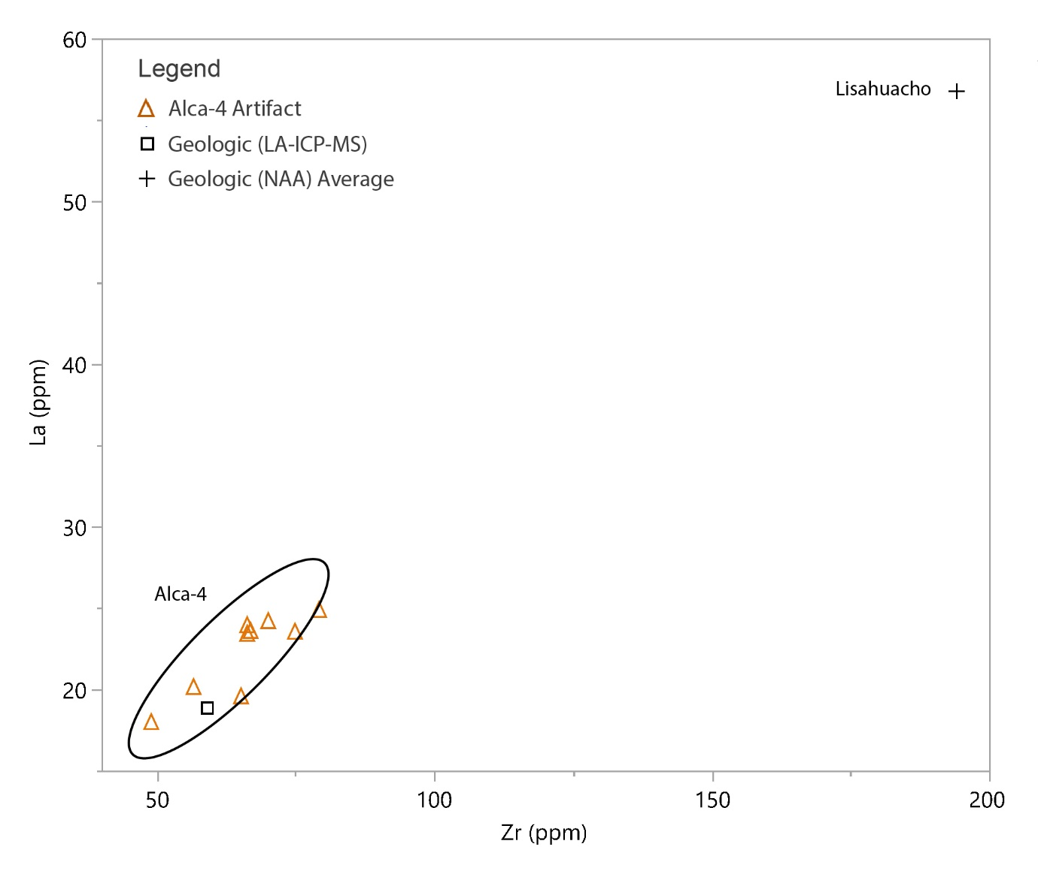
Supplemental Figure 3. Scatterplot of LA-ICP-MS ppm values of Alca-4 obsidian artifacts (color icons) versus geologic obsidians (black square icons). Solid ellipses = 95% confidence interval surrounding artifact materials only.

