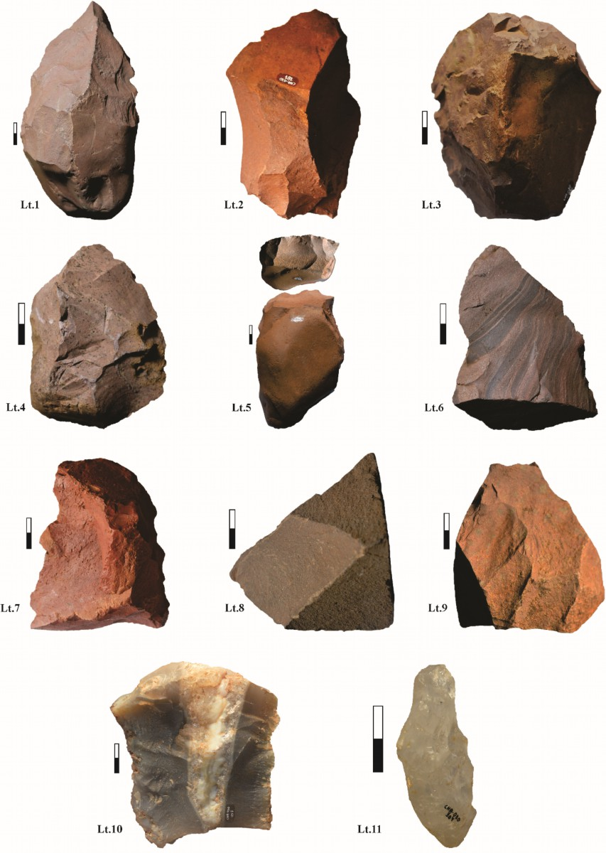
Supplemental Figure 1: Lithotypes defined in the lithic industry of the SC-CHA-030 site. Lt. 1, 2, 3, 4, 5, 6, 7: variations of V-S lithologies. Lt. 8: Mafic basalt (V). Lt. 9: Parabasaltic andesite (V). Lt. 10: Chalcedony. Lt.11: Hyaline quartz.

