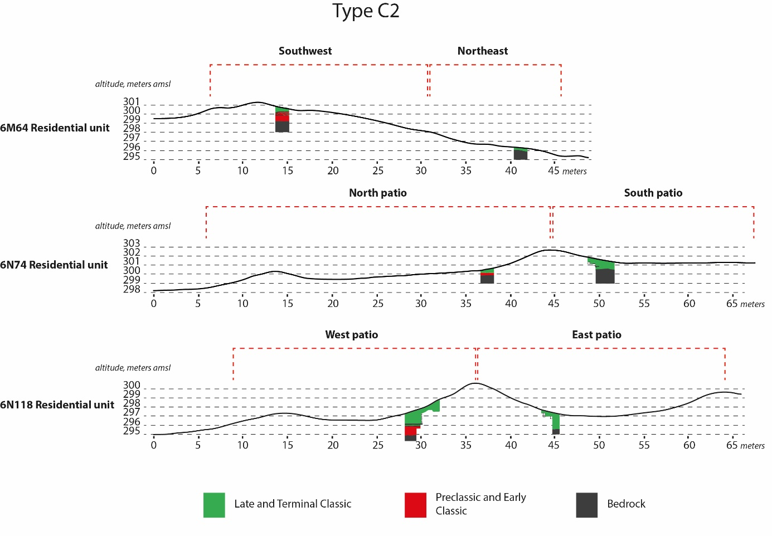

Figure 1. Profile of type C2 residential units where both patios were tested.

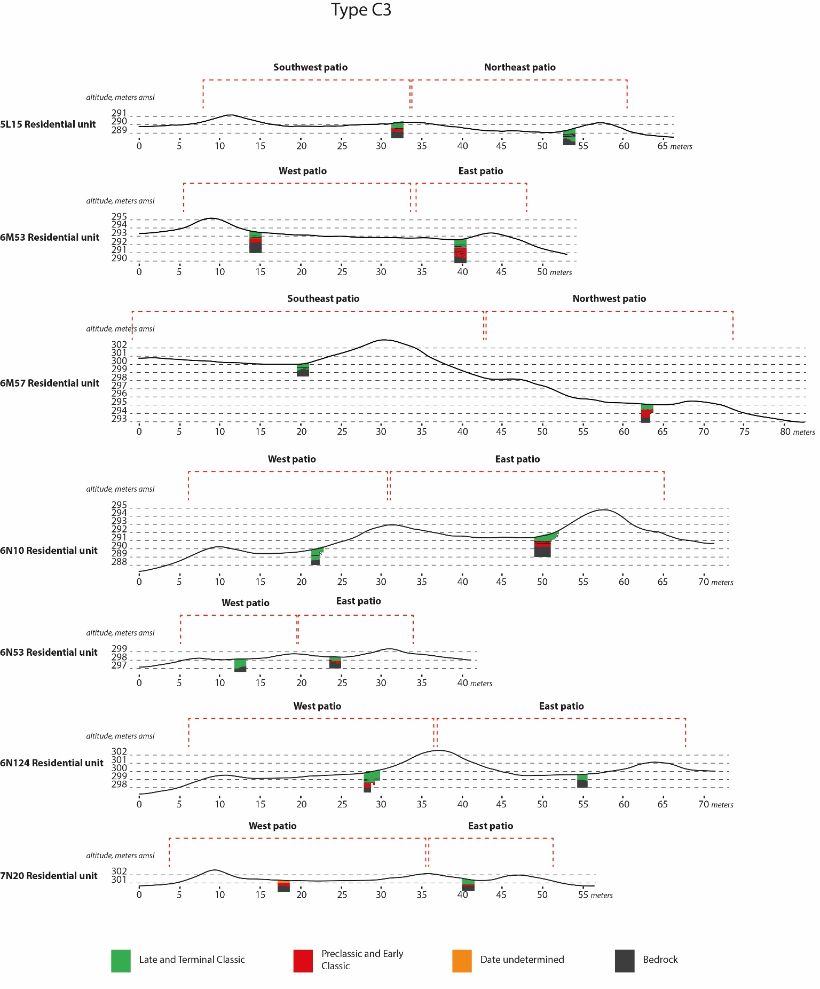

Figure 2. Profile of Type C3 residential units where both patios are tested.

Figure 2. Profile of type C3 residential units where both patios were tested.