Appendix 5. Forest plots - Prevalence of loneliness for prevalence percentages measured using a single-item question, the 20-item UCLA loneliness scale, a shortened version of the UCLA loneliness scale, and the De Jong Gierveld Loneliness Scale

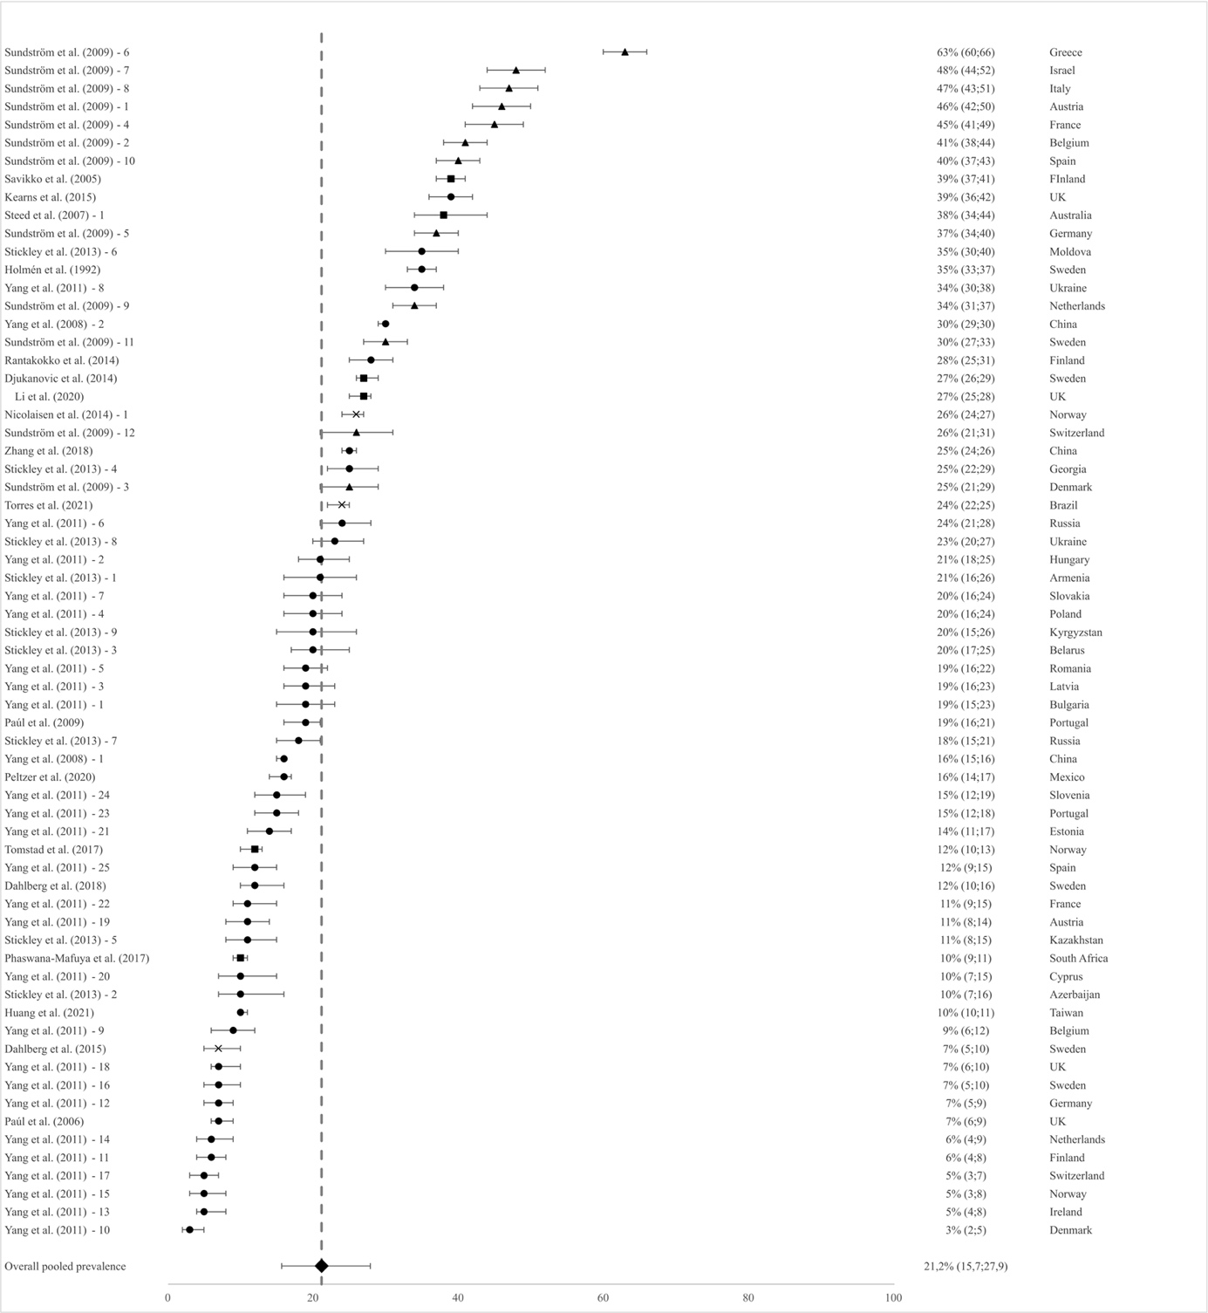

Figure A. Prevalence of loneliness for prevalence percentages measured using a single-item question
×: Telephone + CATI / ■: Self-report (postal, written, online/digital) / ●: Face-to-face / ▲: CAPI

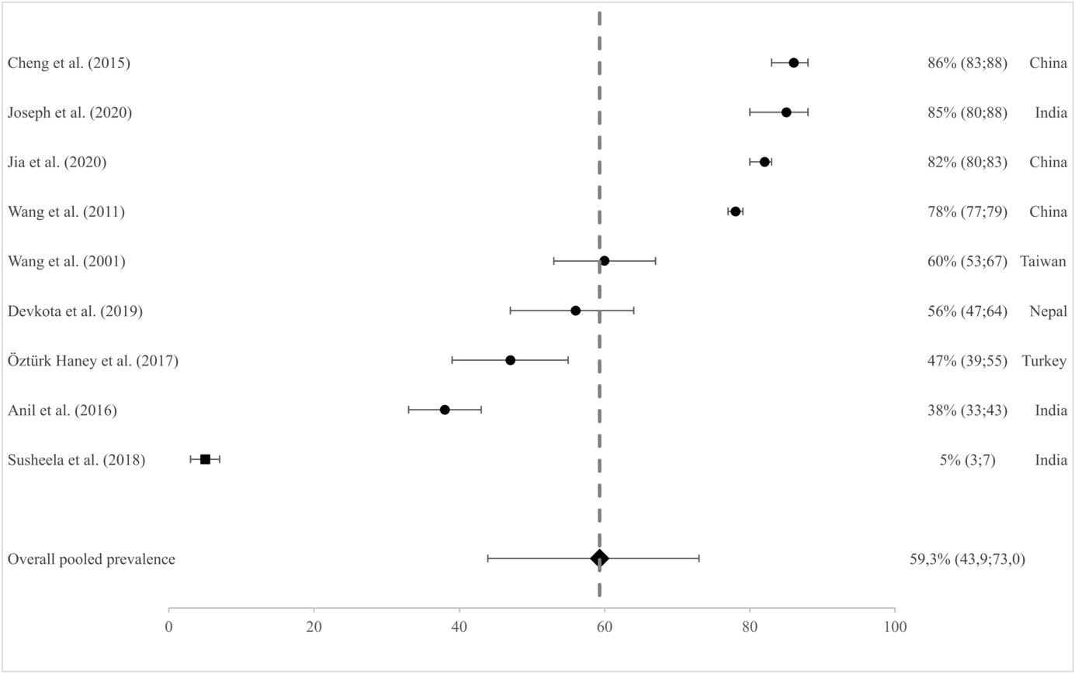

Figure B. Prevalence of loneliness for prevalence percentages measured using the 20-item UCLA loneliness scale
■: Self-report (postal, written, online/digital) / ●: Face-to-face

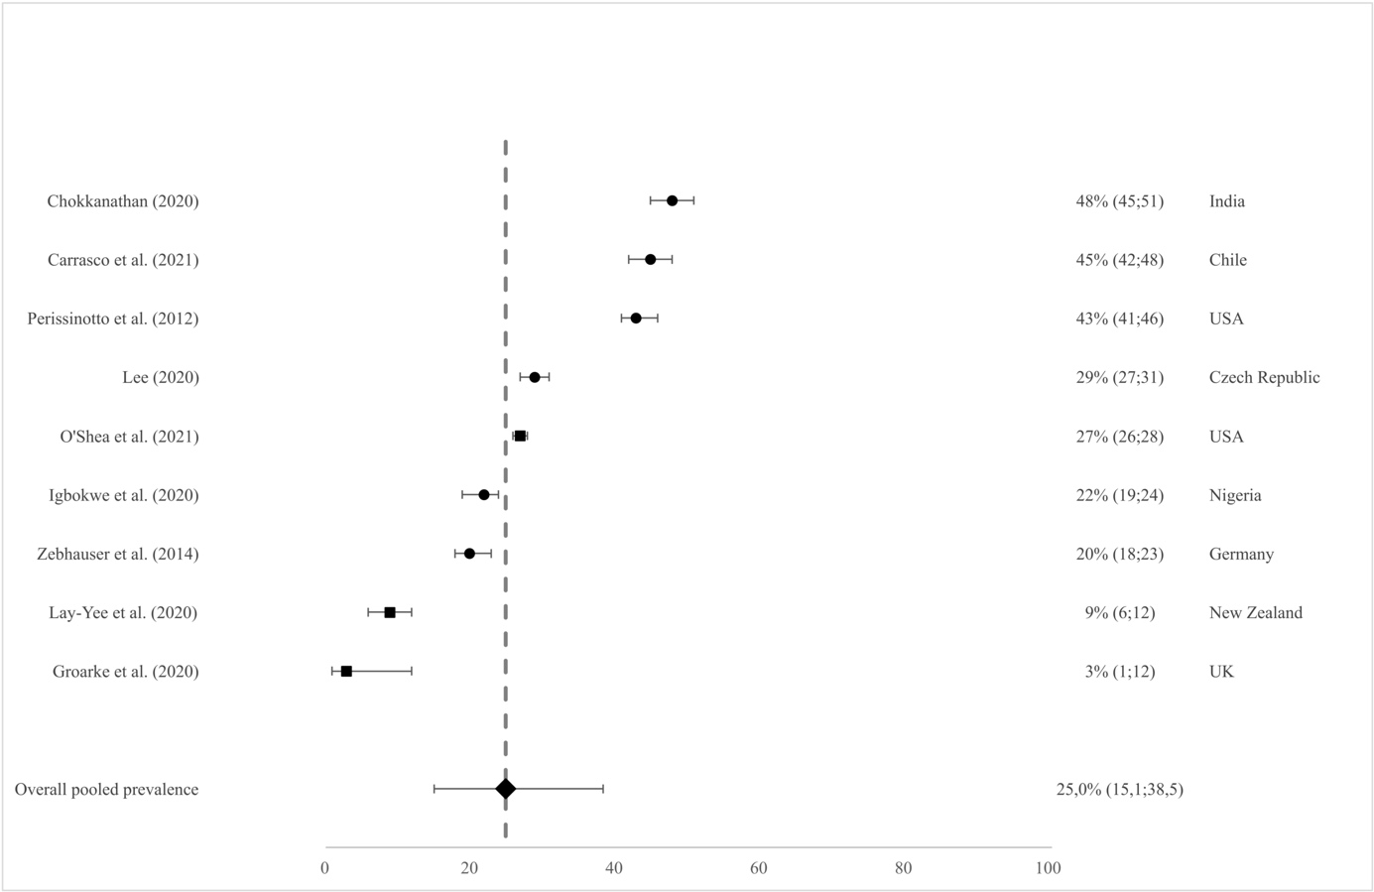

Figure C. Prevalence of loneliness for prevalence percentages measured using a shortened version of the UCLA loneliness scale
■: Self-report (postal, written, online/digital) / ●: Face-to-face

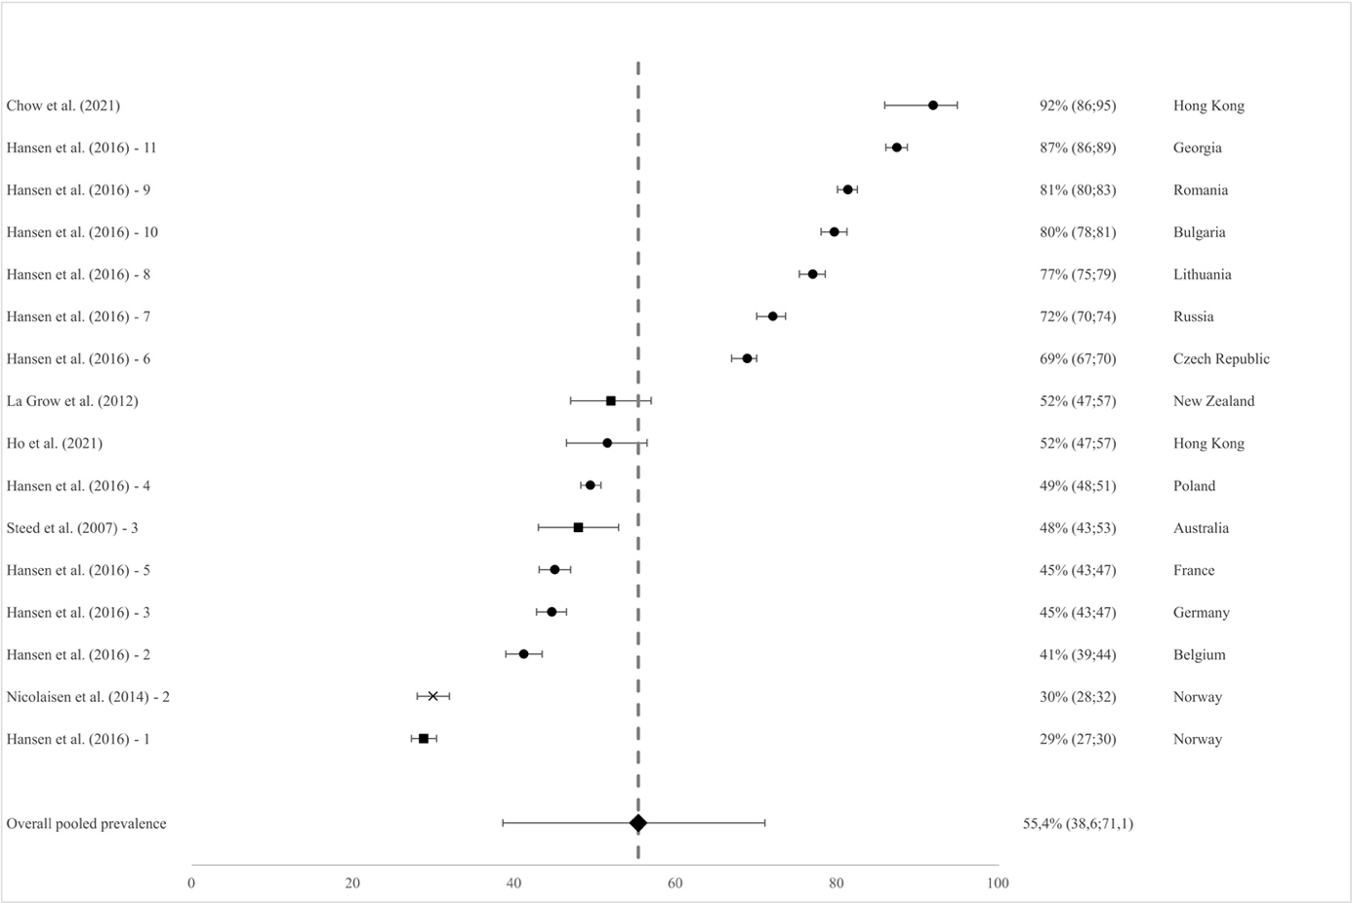

Figure D. Prevalence of loneliness for prevalence percentages measured using the De Jong Gierveld Loneliness Scale
×: Telephone + CATI / ■: Self-report (postal, written, online/digital) / ●: Face-to-face

