Supplemental Table 1. Independent variables examined as potential correlates of negative aging stereotypes

Measure | Assessment
Sociodemographic characteristics | A general sociodemographic questionnaire was used to assess age, gender, race/ethnicity, education, marital status, employment status, and household income
Military characteristics
Combat veteran | Combat veteran
10+ years in military | 10+ years in military
Physical and cognitive health characteristics
Number of medical conditions | Sum of number of medical conditions endorsed in response to question: “Has a doctor or healthcare professional ever told you that you have any of the following medical conditions?” (e.g., arthritis, cancer, diabetes, heart disease, asthma, kidney disease). Range: 0–19 conditions.
Any disability in activities of daily  living (Hardy and Gill, 2004) | The following question was asked: “At the present time, do you need help from another person to do the following?” (e.g., bathe; walk around your home or apartment; get in and out of chair). Endorsement of any of these activities was indicative of having a disability with an activity of daily living (Hardy and Gill, 2004)
Any disability in instrumental  activities of daily living. | Any disability in instrumental activities of daily living. The following question was asked: “At the present time, do you need help from another person to do the following?” (e.g., pay bills or manage money; prepare bills; get dressed). Endorsement of any of these activities was indicative of having a disability with an instrumental activity of daily living.
Somatic symptoms (Lr, 2001b) | Somatic symptoms were assessed using the Somatization subscale of the Brief Symptom Inventory-18 (Lr, 2001a), which assesses current severity of symptoms such as pains in the heart or chest, feeling weak in parts of body, and faintness or dizziness (range: 0 = Not at all to 4 = Extremely)
Physical exercise (Godin, 2011) | Score on the Godin-Shephard Leisure-Time Physical Activity Questionnaire(Godin, 2011)
Cognitive Functioning (Stewart et al., 1992)
Psychiatric and substance use disorder history
Adverse childhood experiences | The Adverse Childhood Experiences (ACEs) questionnaire (Felitti et al., 1998) assessed exposure to adverse childhood events. 10 types of childhood maltreatment were assessed (i.e., physical, emotional, sexual abuse, physical and emotional neglect), along with household dysfunction (i.e., parental separation or divorce, witnessing parental abuse, household substance use, household mental illness, and household incarceration) (Cronbach’s α=0.76).
Number of lifetime traumas | Sum of number of lifetime traumas assessed by the life events checklist for DSM-5 (LEC-5). (Weathers et al., 2013a)
Lifetime posttraumatic stress disorder | Lifetime positive screen for PTSD assessed by the PTSD Checklist for DSM-5 (PCL-5). (Weathers et al., 2013b)
Lifetime major depressive disorder | Lifetime positive screen for major depressive disorder assessed by MINI Neuropsychiatric Interview. (Sheehan et al., 1998)
Lifetime alcohol use disorder | Lifetime positive screen for alcohol use disorder assessed by MINI Neuropsychiatric Interview. (Sheehan et al., 1998)
Lifetime drug use disorder | Lifetime positive screen for drug use disorder assessed by MINI Neuropsychiatric Interview. (Sheehan et al., 1998)
Personality characteristics (Gosling et al., 2003)
Extraversion | Score on Extraversion subscale of the Ten-Item Personality Inventory.
Agreeableness | Score on agreeableness subscale of the Ten-Item Personality Inventory.
Conscientiousness | Score on conscientiousness subscale of the Ten-Item Personality Inventory.
Emotional stability | Score on emotional stability subscale of the Ten-Item Personality Inventory.
Openness to experiences | Score on openness to experiences subscale of the Ten-Item Personality Inventory.
Protective psychosocial characteristics
Resilience | Score on Connor–Davidson Resilience Scale-10. (Campbell-Sills and Stein, 2007)
Purpose in life | Score on Purpose in Life Test-Short Form. (Schulenberg et al., 2011)
Gratitude | Score on single-item measure of gratitude from Gratitude Questionnaire (McCullough et al., 2002):“I have so much in life to be thankful for” (rating 1 = strongly disagree to 7 = strongly agree).
Optimism | Score on single-item measure of optimism from Life Orientation Test-Revised (Scheier et al., 1994): “In uncertain times, I usually expect the best”) rating 1 = strongly disagree to 7 = strongly agree.
Curiosity/exploration | Score on single-item measure of curiosity/exploration from Curiosity and Exploration Inventory-II (Kashdan et al., 2009):“I frequently find myself looking for new opportunities to grow as a person (e.g., information, people, resources”) rating 1 = strongly disagree to 7 = strongly agree.
Grit | Grit was assessed on the Short Grit Scale (GRIT-S) through eight different items on a Likert scale ranging from ‘not like me at all’ to ‘very much like me and is scored from one to five. The scores for each item are added and divided by eight to make a final score that also ranges from one to five. The higher score indicates an individual with higher grit. (Duckworth and Quinn, 2009)
Mindfulness | Mindfulness was assessed using an abbreviated 3-item version of the Mindful Attention to Awareness Scale (Brown and Ryan, 2003) (MAAS) which assesses core characteristics of mindfulness, namely open awareness of and attention to what is taking place in the present moment. (It seems I am running on automatic without much awareness of what I am doing, I find myself doing things without paying attention, I rush through activities without paying attention). Responses ranged from 1 (almost always) to 6 (almost never). Responses to each of the three items were summed to create an overall mindfulness score (Cronbach’s α=0.89).
Social connectedness
Number of close friends and relatives | Response to question: “About how many close friends and relatives do you have (people you feel at ease with and can talk to about what is on your mind)?”
Secure attachment (Hazan and Shaver, 1990) | Endorsement of secure attachment (response a) to the following question: “Please select the statement below that best describes your feelings and attitudes in relationships (Hazan and Shaver, 1990): (a) feeling that it is easy to get close to others and feeling comfortable with them (secure); (b) feeling uncomfortable being close to others (avoidant); or (c) feeling that others are reluctant to get close (anxious/ambivalent).
Received social support | Score on Medical Outcomes Study Social Support Scale-5. (Sherbourne and Stewart, 1991)
Provided social support | Provided social support - Score on Medical Outcomes Study Social Support Scale-5. (Sherbourne and Stewart, 1991)
Community integration | Score on single-item measure of perceived level of community integration: “I feel well integrated in my community (e.g., regularly participate in community activities)” rating 1 = strongly disagree to 7 = strongly agree.
Religiosity/spirituality
Frequency of private spiritual  activities | Frequency of private spiritual activities on Duke University Religion Index (range: 1 = Rarely or never to 6 = More than once a day). (Koenig and Büssing, 2010)
Intrinsic religiosity | Score on measure of intrinsic religiosity on Duke University Religion Index; sample item: “In my life, I experience the presence of the Divine (i.e., God).” (range: 1 = Definitely not true to 5 = Definitely true for me). (Koenig and Büssing, 2010)

Supplemental Figure 1: Relative Importance Analysis of Negative Expectations Regarding Emotional Aging 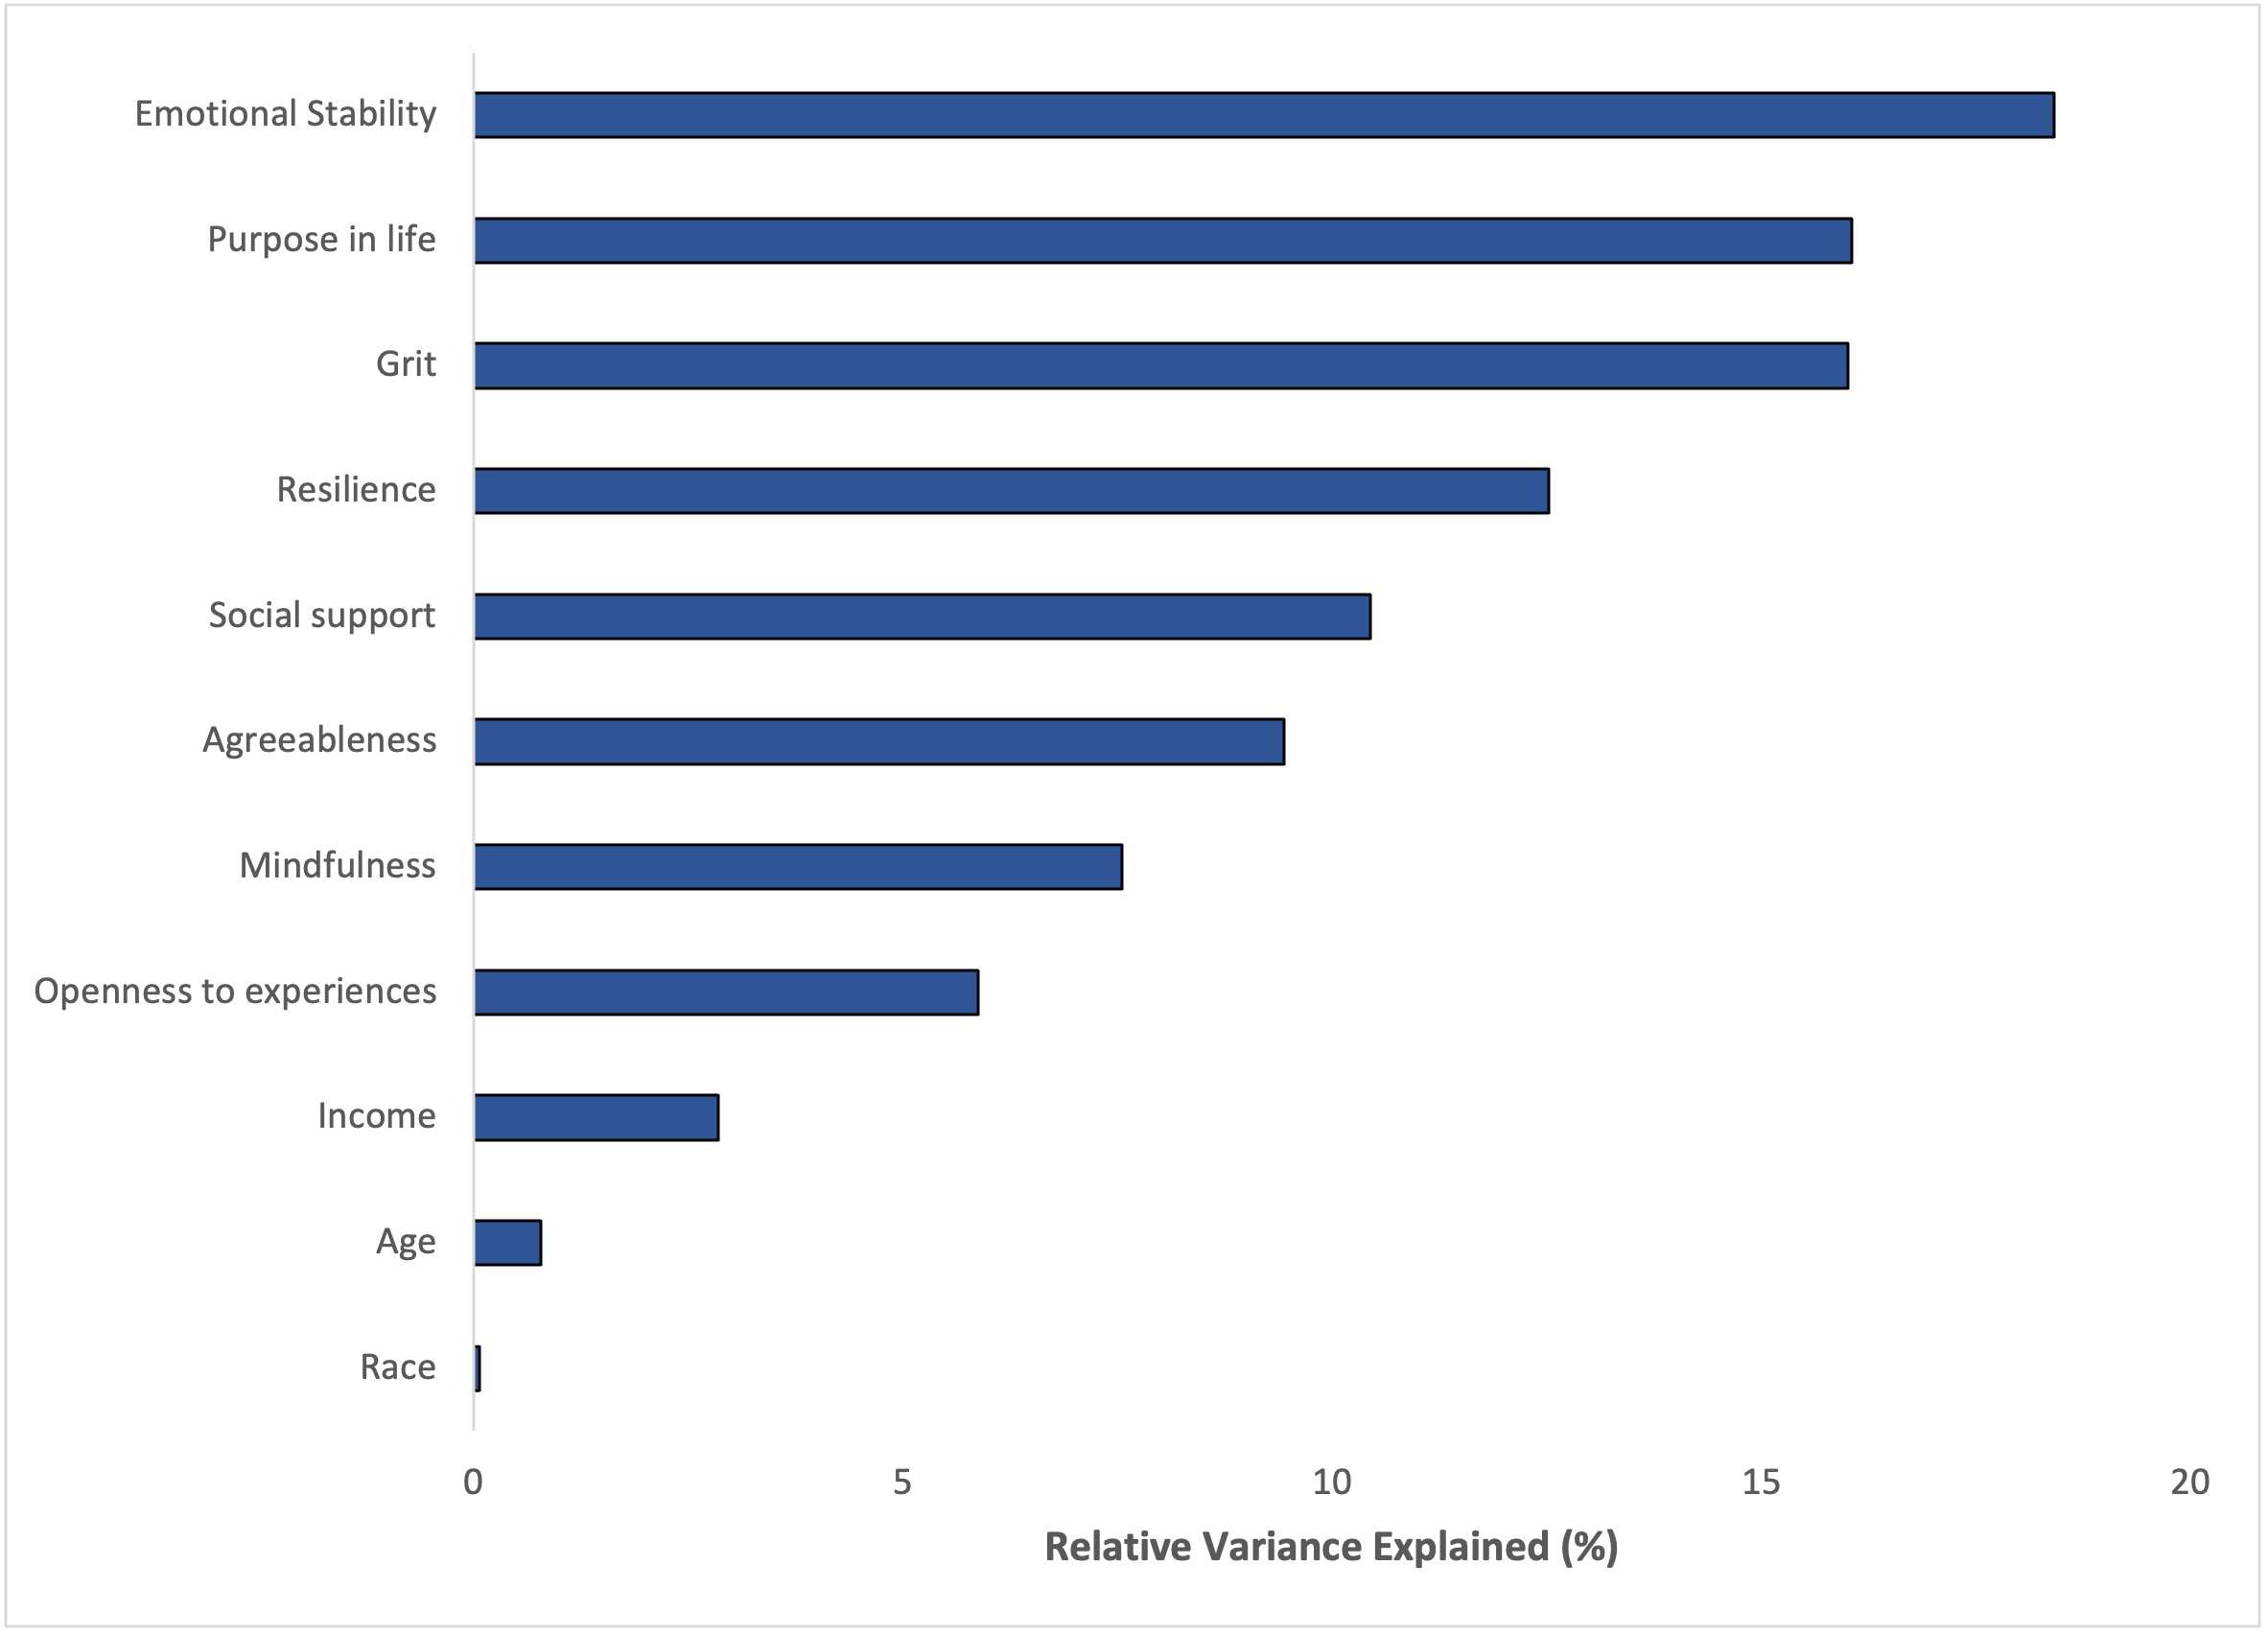

Supplemental Figure 2: Relative Importance Analysis of Negative Expectations Regarding Physical Aging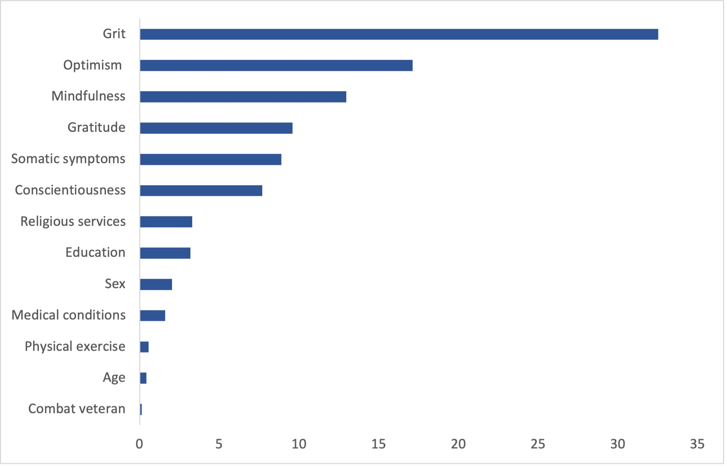

Supplemental Figure 3: Relative Importance Analysis of Negative Expectations Regarding Cognitive Aging

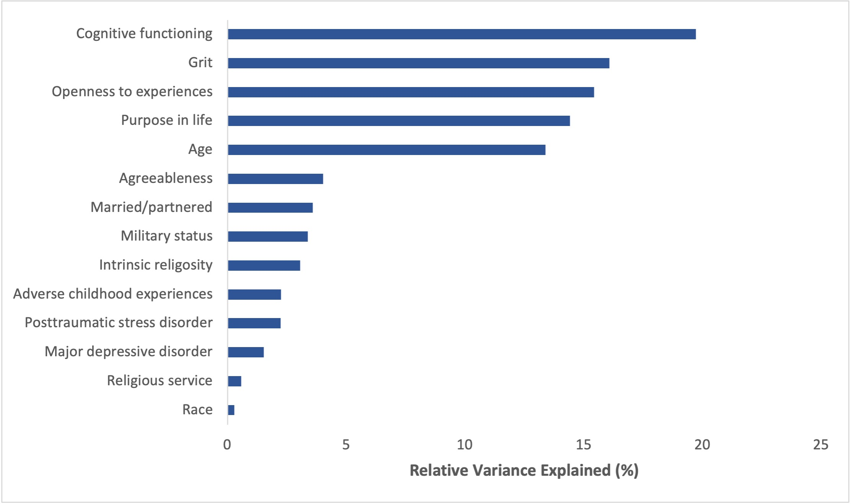

References
Brown, K. W. and Ryan, R. M. (2003). The benefits of being present: mindfulness and its role in psychological well-being. Journal of personality and social psychology, 84, 822.
Campbell-Sills, L. and Stein, M. B. (2007). Psychometric analysis and refinement of the Connor-davidson Resilience Scale (CD-RISC): Validation of a 10-item measure of resilience. J Trauma Stress, 20, 1019-1028.
Duckworth, A. L. and Quinn, P. D. (2009). Development and validation of the Short Grit Scale (GRIT–S). Journal of personality assessment, 91, 166-174.
Felitti, V. J., et al. (1998). Relationship of childhood abuse and household dysfunction to many of the leading causes of death in adults. The Adverse Childhood Experiences (ACE) Study. Am J Prev Med, 14, 245-258.
Godin, G. (2011). The Godin-Shephard leisure-time physical activity questionnaire. The Health & Fitness Journal of Canada, 4, 18-22.
Gosling, S. D., Rentfrow, P. J. and Swann Jr, W. B. (2003). A very brief measure of the Big-Five personality domains. Journal of Research in Personality, 37, 504-528.
Hardy, S. E. and Gill, T. M. (2004). Recovery from disability among community-dwelling older persons. Jama, 291, 1596-1602.
Hazan, C. and Shaver, P. R. (1990). Love and work: An attachment-theoretical perspective. Journal of personality and social psychology, 59, 270.
Kashdan, T. B., et al. (2009). The curiosity and exploration inventory-II: Development, factor structure, and psychometrics. Journal of Research in Personality, 43, 987-998.
Koenig, H. G. and Büssing, A. (2010). The Duke University Religion Index (DUREL): a five-item measure for use in epidemological studies. Religions, 1, 78-85.
Lr, D. (2001a). Brief Symptom Inventory (BSI)-18 Administration, Scoring and Procedures Manual.
Lr, D. (2001b). Brief Symptom Inventory (BSI)-18 Administration, Scoring and Procedures Manual. Minneapolis, MN: NCS Pearson. Inc.
McCullough, M. E., Emmons, R. A. and Tsang, J.-A. (2002). The grateful disposition: a conceptual and empirical topography. Journal of personality and social psychology, 82, 112.
Scheier, M. F., Carver, C. S. and Bridges, M. W. (1994). Distinguishing optimism from neuroticism (and trait anxiety, self-mastery, and self-esteem): a reevaluation of the Life Orientation Test. Journal of personality and social psychology, 67, 1063.
Schulenberg, S. E., Schnetzer, L. W. and Buchanan, E. M. (2011). The purpose in life test-short form: development and psychometric support. Journal of Happiness Studies, 12, 861-876.
Sheehan, D. V., et al. (1998). The Mini-International Neuropsychiatric Interview (MINI): the development and validation of a structured diagnostic psychiatric interview for DSM-IV and ICD-10. Journal of clinical psychiatry, 59, 22-33.
Sherbourne, C. D. and Stewart, A. L. (1991). The MOS social support survey. Social Science & Medicine, 32, 705-714.
Stewart, A. L., Ware, J., Sherbourne, C. D. and Wells, K. B. (1992). Psychological distress/well-being and cognitive functioning measures. Measuring functioning and well-being: The medical outcomes study approach, 102-142.
Weathers, F., Blake, D., Schnurr, P., Kaloupek, D., Marx, B. and Keane, T. (2013a). The life events checklist for DSM-5 (LEC-5). Instrument available from the National Center for PTSD. Retrieved September, 6, 2021.
Weathers, F., Litz, B., Keane, T., Palmieri, T., Marx, B. and Schnurr, P. (2013b). The PTSD Checklist for DSM-5 (PCL-5) 2013 Scale available from the National Center for PTSD.

