Table A1. Driscoll-Kraay standard errors, TWFE (SWIID)
 | (1) |  | (2)
VARIABLES | Gini, disp.income  TWFE |  | Gini, mkt income  TWFE
Wage ratio | -3.906*** |  | -4.429***
 | (1.191) |  | (1.244)
Unemployment | 0.227*** |  | 0.264**
 | (0.0703) |  | (0.0986)
Education | -0.0413 |  | -0.0741
 | (0.0554) |  | (0.0605)
Gov. Cons. | -0.0765 |  | -0.164
 | (0.116) |  | (0.118)
Inflation | -0.0678 |  | -0.0754
 | (0.0563) |  | (0.0500)
GDP growth | -0.0223 |  | -0.0291
 | (0.0505) |  | (0.0510)
Constant | 55.92*** |  | 62.79***
 | (5.963) |  | (6.482)
Observations | 217 |  | 217
Number of units | 15 |  | 15
All regressors lagged one year (t−1). Driscoll–Kraay standard errors in parentheses. Country and year fixed effects included; year-dummy coefficients omitted for brevity *** p<0.01, ** p<0.05, * p<0.1
.

Table A2. Wild cluster bootstrap. TWFE (SWIID)
 | (1) | (2)
VARIABLES | Gini, disp.income  TWFE | Gini, mkt income  TWFE
Wage ratio | -3.906** | -4.429**
 | (1.523) | (1.609)
Unemployment | 0.227 | 0.264
 | (0.195) | (0.194)
Education | -0.0413 | -0.0741
 | (0.0636) | (0.0820)
Gov. Cons. | -0.0765 | -0.164
 | (0.102) | (0.116)
Inflation | -0.0678 | -0.0754
 | (0.0809) | (0.0754)
GDP growth | -0.0223 | -0.0291
 | (0.0793) | (0.0860)
Constant | 55.92*** | 62.79***
 | (5.982) | (8.079)
Observations | 217 | 217
R-squared | 0.902 | 0.941
All regressors lagged one year (t−1). Standard errors clustered by country. Country and year fixed effects included; year-dummy coefficients omitted for brevity *** p<0.01, ** p<0.05, * p<0.1

Table A2.1 Disposable income Wild bootstrap test
Wild bootstrap-t, null imposed, 9999 replications, Wald test, clustering by country_id, bootstrap clustering by country_id,
> Rademacher weights:
Wage Ratio (lagged)

t(14) = -2.5657
Prob>|t| = 0.0167

95% confidence set for null hypothesis expression: [−12.65, −1.2]

Table A2.2 Market income Wild bootstrap test
Wild bootstrap-t, null imposed, 9999 replications, Wald test, clustering by country_id, bootstrap clustering by country_id,
> Rademacher weights:
Wage ratio (lagged)

t(14) = -2.7522
Prob>|t| = 0.0139

95% confidence set for null hypothesis expression: [−13.27, −1.512]

Table A3. Clusters by year, TWFE (SWIID)
 | (1) | (2)
VARIABLES | Gini, disp.income  TWFE | Gini, mkt income  TWFE
Wage ratio | -3.906*** | -4.429***
 | (1.170) | (1.286)
Unemployment | 0.227*** | 0.264***
 | (0.0641) | (0.0809)
Education | -0.0413 | -0.0741
 | (0.0591) | (0.0563)
Gov. Cons. | -0.0765 | -0.164
 | (0.0951) | (0.0976)
Inflation | -0.0678 | -0.0754
 | (0.0695) | (0.0643)
GDP growth | -0.0223 | -0.0291
 | (0.0477) | (0.0525)
Constant | 55.92*** | 62.79***
 | (5.811) | (5.766)
Observations | 217 | 217
All regressors lagged one year (t−1). Standard errors clustered by year. Country and year fixed effects included; year-dummy coefficients omitted for brevity *** p<0.01, ** p<0.05, * p<0.1

Table A4. Random effects specifications, disposable income inequality, SWIID
 | (1) | (2)
VARIABLES | Gini, disp.income (FE) | Gini, disp. income (RE)
Wage ratio | -8.576*** | -7.614***
 | (1.261) | (1.224)
Unemployment | 0.577*** | 0.556***
 | (0.0923) | (0.0906)
Education | 0.120* | 0.139**
 | (0.0613) | (0.0605)
Gov. Cons. | -0.562*** | -0.535***
 | (0.116) | (0.112)
Inflation | 0.0484 | 0.0518
 | (0.0410) | (0.0411)
GDP growth | 0.0635 | 0.0657
 | (0.0571) | (0.0572)
Constant | 45.09*** | 42.38***
 | (5.989) | (5.967)
Observations | 217 | 217
Number of units | 15 | 15
All regressors lagged one year (t−1). Standard errors clustered by country.
*** p<0.01, ** p<0.05, * p<0.1

Table A4.1. Hausman test, disposable income
Test of H0: Difference in coefficients not systematic

chi2(6) = (b-B)'[(V_b-V_B)^(-1)](b-B)
= 10.04
Prob > chi2 = 0.1228

Table A5. Random effects specifications, market income inequality, SWIID
 | (1) | (2)
VARIABLES | Gini, mkt.income (FE) | Gini, mkt income (RE)
Wage ratio | -8.243*** | -8.028***
 | (1.152) | (1.120)
Unemployment | 0.549*** | 0.570***
 | (0.0843) | (0.0825)
Education | 0.0586 | 0.0697
 | (0.0560) | (0.0550)
Gov. Cons. | -0.550*** | -0.524***
 | (0.106) | (0.103)
Inflation | 0.0231 | 0.0277
 | (0.0375) | (0.0371)
GDP growth | 0.0300 | 0.0376
 | (0.0521) | (0.0517)
Constant | 53.45*** | 51.68***
 | (5.471) | (5.481)
Observations | 217 | 217
R-squared | 0.422
Number of countryname | 15 | 15
All regressors lagged one year (t−1). Standard errors clustered by country.
*** p<0.01, ** p<0.05, * p<0.1

Table A5.1. Hausman test, market income
Test of H0: Difference in coefficients not systematic
chi2(6) = (b-B)'[(V_b-V_B)^(-1)](b-B)
= 4.16
Prob > chi2 = 0.6551

Table A6. Mundlak Random effects specifications, household income inequality
 | (1) | (2)
VARIABLES | Gini, disp.income | Gini, mkt income
Wage ratio | -8.453*** | -8.567***
 | (1.827) | (1.258)
Unemployment | 0.843*** | 0.582***
 | (0.128) | (0.0919)
Education | 0.0310 | 0.118*
 | (0.0880) | (0.0611)
Gov. Cons. | -0.749*** | -0.567***
 | (0.141) | (0.115)
Inflation | 0.0921* | 0.0483
 | (0.0534) | (0.0408)
GDP growth | -0.0121 | 0.0622
 | (0.0817) | (0.0569)
Wage ratio (country mean) | 7.445*** | 16.31***
 | (2.201) | (4.921)
Unemployment (country mean) | 0.0797 | -0.615
 | (0.151) | (0.393)
Education (country mean) | 0.243* | -0.222
 | (0.127) | (0.343)
Gov. Cons. (country mean) | 0.611*** | 0.688
 | (0.176) | (0.418)
Inflation (country mean) | 0.0237*** | 0.0130
 | (0.00249) | (0.0103)
GDP growth (country mean) | 1.144*** | 1.169
 | (0.260) | (0.984)
Constant | 18.57** | 44.21
 | (7.579) | (28.49)
Observations | 217 | 217
Number of units | 15 | 15
All regressors lagged one year (t−1). Standard errors clustered by country.
*** p<0.01, ** p<0.05, * p<0.1

Appendix Table A7. Distributed-lag estimates of the minimum-wage association with household income inequality

Variables | (1)  Gini disposable income  SWIID | (2)  Gini market income  SWIID
Wage Ratio | -2.225 | -2.062
 | (1.714) | (1.880)
Wage Ratio (L1) | -2.910* | -3.196*
 | (1.604) | (1.762)
Wage Ratio (L2) | 0.198 | -0.425
 | (1.157) | (1.548)
Unemployment | 0.341** | 0.379**
 | (0.134) | (0.146)
Education | -0.008 | -0.042
 | (0.095) | (0.114)
Gov. Cons. | -0.163 | -0.254**
 | (0.093) | (0.115)
Inflation | -0.177* | -0.179*
 | (0.100) | (0.100)
GDP growth | -0.053 | -0.045
 | (0.056) | (0.066)
Constant | 53.404*** | 60.440***
 | (7.709) | (10.150)
Year fixed effects | Yes | Yes
Observations | 180 | 180
Countries | 14 | 14
R-squared | 0.826 | 0.757
Joint p-value, MW timing terms | 0.0138 | 0.0045
Cumulative association (t to t−2) | -4.937 | -5.683
Cumulative p-value | 0.028 | 0.021
Notes. Entries report coefficients from TWFE models including the contemporaneous minimum-wage ratio and its first two lags. Standard errors clustered by country are in parentheses. All models include the baseline lagged controls and year fixed effects, omitted for brevity. “Joint p-value, MW timing terms” reports the p-value from a test of the null that the contemporaneous and lagged minimum-wage terms are jointly equal to zero. “Cumulative association (t to t−2)” reports the linear combination of the contemporaneous and two lagged minimum-wage coefficients. * p<0.10, ** p<0.05, *** p<0.01.

Table A8. Alternative controls (social spending and trade union density) TWFE, SWIID
 | (1) | (2) | (3) | (4)
VARIABLES | Gini, disp.income  TWFE | Gini, mkt income  TWFE | Gini, disp.income  TWFE | Gini, mkt income  TWFE
Wage ratio | -3.083** | -3.244** | -5.351* | -6.297*
 | (1.318) | (1.468) | (2.505) | (3.046)
Unemployment | 0.218 | 0.255 | 0.501** | 0.531**
 | (0.176) | (0.159) | (0.173) | (0.179)
Education | 0.00492 | -0.0136 | -0.0534 | -0.0392
 | (0.0566) | (0.0694) | (0.0764) | (0.0775)
Unionization |  |  | 0.120 | 0.0657
 |  |  | (0.0819) | (0.0927)
Inflation | -0.0389 | -0.0331 | -0.0549 | -0.0169
 | (0.0731) | (0.0640) | (0.0649) | (0.0719)
Gov. Social Spending | 0.635** | 0.820** | -0.288 | -0.0778
 | (0.290) | (0.282) | (0.341) | (0.330)
GDP growth | -0.00466 | -0.00301 | 0.00582 | -0.00711
 | (0.0844) | (0.0939) | (0.0447) | (0.0424)
Constant | 47.98*** | 51.67*** | 51.52*** | 53.35***
 | (4.711) | (6.065) | (6.441) | (6.339)
Observations | 221 | 221 | 140 | 140
Number of units | 15 | 15 | 13 | 13
All regressors lagged one year (t−1). Standard errors clustered by country. Country and year fixed effects included; year-dummy coefficients omitted for brevity *** p<0.01, ** p<0.05, * p<0.1

Table A9. Alternative controls (coordination and collective bargaining) TWFE, SWIID
 | (1) | (2) | (3) | (4)
VARIABLES | Gini, disp.income  TWFE | Gini, mkt income  TWFE | Gini, disp.income  TWFE | Gini, mkt income  TWFE
Wage ratio | -5.965** | -14.08 | -6.184*** | -10.62*
 | (1.202) | (6.757) | (1.446) | (5.073)
Wage coordination | -3.979*** | -2.941*
 | (0.313) | (1.012)
Collective bargaining coverage |  |  | -0.0224 | -0.0567
 |  |  | (0.0752) | (0.0669)
Unemployment | 0.277*** | 0.391*** | 0.301 | 0.447*
 | (0.0291) | (0.0563) | (0.218) | (0.208)
Education | 0.146 | 0.135 | 0.0564 | 0.0951
 | (0.0620) | (0.131) | (0.0948) | (0.0976)
Inflation | 0.0158 | -0.0838 | -0.0364 | -0.0556
 | (0.0178) | (0.0671) | (0.0915) | (0.103)
Gov. Cons. | 0.300* | 0.0615 | -0.148 | -0.321
 | (0.102) | (0.0757) | (0.315) | (0.300)
GDP growth | -0.0547 | -0.0792 | 0.00375 | 0.0388
 | (0.0441) | (0.0951) | (0.0727) | (0.0629)
Constant | 35.60*** | 47.09** | 48.17*** | 52.82***
 | (5.130) | (11.41) | (7.297) | (9.302)
Observations | 53 | 53 | 66 | 66
R-squared | 0.987 | 0.906 | 0.903 | 0.846
Number of units | 4 | 4 | 6 | 6
All regressors lagged one year (t−1). Standard errors clustered by country. Country and year fixed effects included; year-dummy coefficients omitted for brevity *** p<0.01, ** p<0.05, * p<0.1

Table A10. Non-linearity test, TWFE, SWIID
 | (1) | (2)
VARIABLES | gini_dhi_swiid | gini_mkt_swiid
Wage ratio | -7.758 | -6.000
 | (10.22) | (10.32)
Wage ratio squared (lagged) | 2.658 | 1.083
 | (6.442) | (6.516)
Unemployment | 0.206 | 0.256
 | (0.224) | (0.222)
Education | -0.0388 | -0.0731
 | (0.0652) | (0.0840)
Inflation | -0.0311 | -0.145
 | (0.156) | (0.160)
Gov. Cons. | -0.0651 | -0.0743
 | (0.0795) | (0.0745)
GDP growth | -0.0116 | -0.0247
 | (0.0621) | (0.0705)
Constant | 56.28*** | 62.93***
 | (6.327) | (8.184)
Observations | 217 | 217
R-squared | 0.763 | 0.695
Number of countryname | 15 | 15

Table A10.1
( 1) cL.mw_av_ratio#cL.mw_av_ratio = 0

F( 1, 14) = 0.17
Prob > F = 0.6862

Table A10.2
( 1) cL.mw_av_ratio#cL.mw_av_ratio = 0

F( 1, 14) = 0.03
Prob > F = 0.8703

Table A11. Anticipatory effects, placebo leads, SWIID
 | (1) | (2)
 | Baseline (same sample) | With leads (placebo)
Wage ratio | -3.124** | 0.800
 | (1.232) | (1.633)
F1 Wage ratio (t-1) |  | -1.602
 |  | (0.944)
F2 Wage ratio (t-2) |  | -4.944
 |  | (3.280)
Unemployment | 0.211 | 0.209
 | (0.188) | (0.182)
Education | -0.041 | -0.049
 | (0.057) | (0.062)
Gov. cons. | -0.050 | -0.082
 | (0.155) | (0.126)
Inflation | -0.038 | -0.045
 | (0.078) | (0.063)
GDP growth | -0.009 | -0.001
 | (0.072) | (0.075)
_cons | 54.232*** | 57.453***
 | (5.646) | (6.005)
F-test leads |  | 1.674
p-value (leads) |  | 0.225
N | 172.000 | 172.000
Within R2

Table A12. Alternative Wage Ratio Series (ECLAC)
 | (1) | (2)
VARIABLES | Disposable Gini (SWIID) | Market Gini (SWIID)
Wage ratio (ECLAC) | -6.016** | -4.234**
 | (1.940) | (1.617)
Unemployment | 0.401*** | 0.605***
 | (0.0964) | (0.122)
Education | -0.194 | -0.205*
 | (0.108) | (0.0987)
Gov. Cons. | 0.136 | -0.121
 | (0.337) | (0.280)
Inflation | 0.0360 | -0.00922
 | (0.0484) | (0.0471)
GDP growth | 0.0258 | 0.111*
 | (0.0494) | (0.0505)
Constant | 61.99*** | 67.07***
 | (8.399) | (6.592)
Observations | 60 | 60
Number of units | 12 | 12
All regressors lagged one year (t−1). Standard errors clustered by country. Country and year fixed effects included; year-dummy coefficients omitted for brevity *** p<0.01, ** p<0.05, * p<0.1

Figure A1. Informality interaction
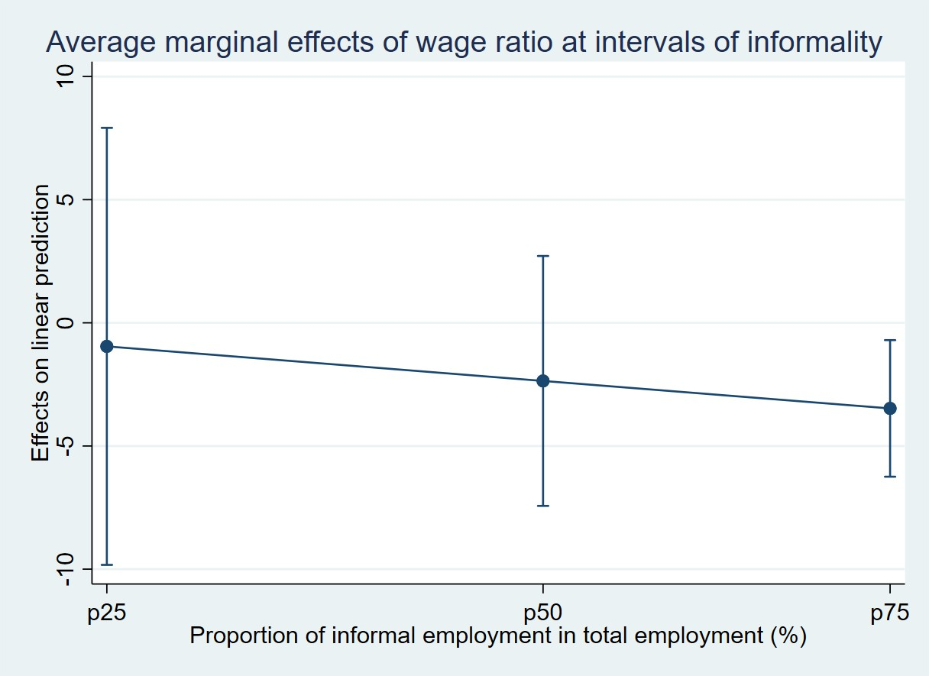

Table B1. Structural Labour Market Characteristics (Latin America, 2020, ECLAC)
Country | Labor force participation rate | Annual real average wages index (2018=100) | Real minimum wage index (2018=100) | Unemployment rate (%) | Urban population employed in low productivity jobs (%)
Argentina | 54.9 | 91.6 | 80.9 | 11.5 | 41.8
Bolivia | 67 | 99.3 | 100.2 | 4.2 | 67
Brazil | 59.3 | 105.4 | 102.3 | 13.8 | 39.3
Chile | 56.1 | 102.6 | 107.9 | 10.8
Colombia | 58.6 | 95.9 | 105.9 | 15.1 | 52.5
Costa Rica | 60.2 | 106.1 | 102.7 | 19.6
Ecuador | 62.5 | 114.6 | 103.7 | 6.2 | 64.3
El Salvador | 61.4 | 101.2 | 100.3 | 6.9 | 61.5
Guatemala |  |  | 96.3
Honduras | 59.5 |  | 101.9 | 10.9
Mexico | 55.6 | 106.9 | 130.1 | 4.4 | 47.8
Nicaragua | 69.1 | 98.5 | 97.6 | 5
Panama | 63 | 101 | 102.9 | 18.6
Paraguay | 70.2 | 100.6 | 101 | 7.7 | 55.9
Peru | 62.3 | 94.3 | 98.3 | 7.7 | 62.7
Uruguay | 60.5 | 99.5 | 102.6 | 10.1 | 33.8

