***Appendix to “US Teachers, Overwork and Perceptions of Work-Time Reductions:   
Evidence from Massachusetts”***

### Appendix A: Time-use survey

This survey should take you about 20 minutes to complete. We will ask you questions about how you spend your time, your teaching experience and a few general questions about yourself. This information will be used to find out how teachers balance work, childcare, leisure, and other activities in their lives.

Previously you responded that you are currently employed as an elementary, middle or high school teacher in a public school in Massachusetts. Is this still the case?

* Yes
* No

Please take a moment to read the Informed Consent Form. If you decide to participate, you will be asked to sign this form electronically below.

*Informed consent form displayed here*

Do you agree to maintain the confidentiality of the information discussed by all participants and researchers during the focus group session?

* I agree
* I do not agree (you will not be able to continue in the study)

When signing this form I am agreeing to voluntarily enter this study. I have had a chance to read this consent form, and it was explained to me in a language which I use. I have had the opportunity to ask questions and have received satisfactory answers. I have been informed that I can withdraw at any time. I can download a copy of the informed consent document here.

* Please enter your first and last name

Think of your last typical workday when you were teaching in a classroom. How long ago was that day?

* Within the last week
* More than one week but less than one month
* More than one month ago

*If “More than one week but less than one month”:*

What is the reason that your last typical workday was more than one week ago but less than one month ago?

* Vacation/personal days
* On leave
* On strike

Below, we ask you to report how you spent your last typical workday when you taught in a classroom. We are looking at *all* activities (work and non-work) in the time between 4:00 am in the morning until 4:00 am the following morning. If an activity is too personal, there's no need to mention it. Please enter the start time of the activity, the end time, and select the activity from the drop-down list that most closely describes what you were doing. **Please enter times using AM/PM notation or the 24-hour clock.**

Activity list:

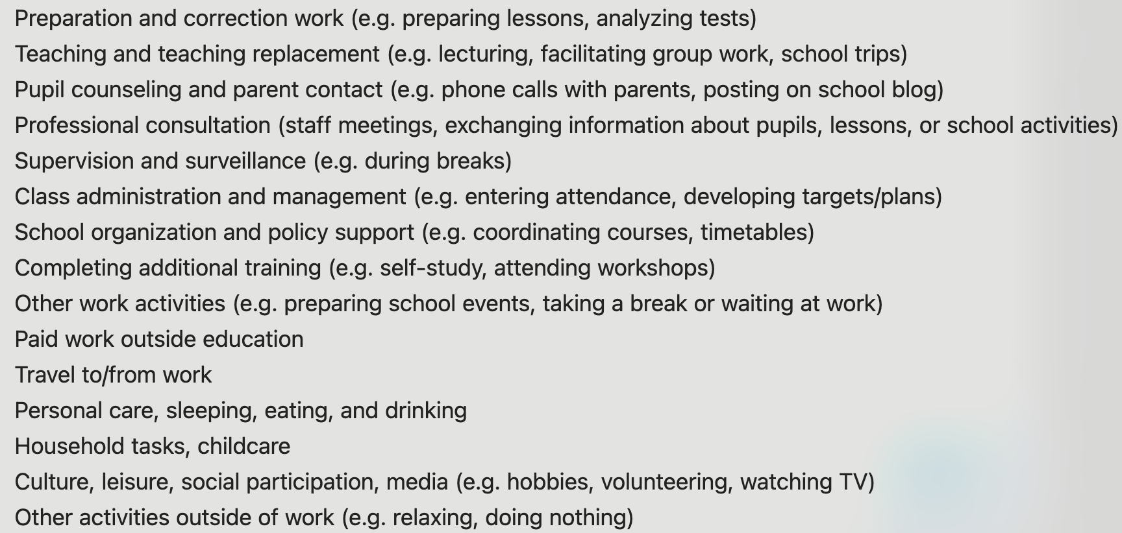

Think about a typical **weekend** during the school year. Approximately how many hours do you spend on the following activities?

Lesson planning; Grading and assessing student work; Volunteering at school-related events; Other work activities; Paid work outside of education

We would like to ask you a few more questions about yourself and your work.

Are you employed in more than one school?

* Yes
* No

Thinking about your primary employment, what is your employment status?

* Permanent employment (an on-going contract with no fixed endpoint before the age of retirement)
* Fixed-term contract

What is your current employment status as a teacher, in terms of working hours?

* Full-time (more than 90% of full-time hours)
* Part-time (between 51-90% of full-time hours)
* Part-time (less than 50% of full-time hours)

How many years of teaching experience do you have, regardless of whether you worked full- time or part-time?

What subject(s) do you teach?

* Mathematics
* Science and Technology/Engineering
* English Language Arts and Literacy
* History and Social Science
* Foreign Languages
* Arts
* Digital Literacy and Computer Science
* Comprehensive Health
* Practical and vocational skills

What is your sex?

* Male
* Female
* Non-binary / third gender
* Prefer not to say

What is your age?

* 20-29
* 30-39
* 40-49
* 50-59
* 60+

Are you of Hispanic, Latino, or Spanish origin?

* Yes
* No
* Prefer not to say

What is your race?

* White
* Black or African American
* American Indian or Alaska Native
* Asian
* Native Hawaiian or Pacific Islander
* Other
* Prefer not to say

Are you married/do you live with a long-term partner?

* Yes
* No

Do you have children in your care?

* Yes
* No

*If “Do you have children in your care?” = Yes:*

Please list the number of children in each age group

* Children less than 11 years old
* Children between 11-17 years old

*If “*Children less than 11 years old*” Is Greater Than 0:*

What is the age of your youngest child?

### Appendix B: Interview guide

Welcome everyone! My name is MY_NAME and I am part of the research group that conducts this study. Also on the call are OTHER_NAME, who is a researcher on this study, and RA_NAME who is the research assistant and helps to take notes. Thank you all very much for showing up today and sharing your thoughts with the group.

In this study, we’re interested in how you experience your workload and work-life balance as public school teachers in Massachusetts. We want to understand how you deal with these challenges, and what you see as possible ways of improving your situation.

We are hoping to hear from everybody today. If you already have shared your opinion on a topic, please wait until others have responded before speaking up a second time. Please use the “raise hand” function of Zoom or raise your hand so that I can call on people in order. Please silence your cell phones and keep your video camera on.

Your participation in this study is entirely voluntary, so you can refuse to answer a question and can end your participation at any time. Everything that is said in today’s meeting is confidential, so please don’t discuss it outside of today’s meeting. When we write up the results of our study, we will not use any personally identifiable information in our reports.

Are there any other ground rules that you need to be in place so that you are able to fully participate in today’s focus group?

Thanks, and now we are looking forward to hearing from you.

***Turn on recording***

* We would like everyone to introduce themselves by sharing your name, and one thing you enjoy doing in your free time. My name is MY_NAME, MY_THING, …
* In preparation for today, we asked you to keep a time diary on how you spent your last typical workday. What stood out to you while writing down how your time is spent?
  + What feelings came up for you as you were filling out the time diary?
* How do your work hours and workload affect your quality of life and satisfaction at work?
* We’d like you now to imagine that your work hours were significantly shorter. Let’s say your next contract specified you worked 8 fewer hours per week, but your pay and benefits stayed the same. What would you do with the free time?
  + [Probe: How would your life change?]
* One could hold various opinions on the best way to improve work-life balance for teachers. Some might say that it would be best to increase the number of hours that teachers are actually paid for. Others might say it is best to reduce the actual hours of work without losing pay. What’s your view on this?
* Is there anything anybody would like to add to today’s discussion? Something that you feel like should have been said but didn’t?

Thank you again for your participation.

***Turn off recording.***

We will send your compensation for participating in the study either via Venmo or personal check. If you would like us to donate your compensation to a charity of your choice, please let us know. We’ll send you an email to follow up.

*Hang back to answer one-on-one questions*