Appendix
Table A1. Aggregate balance sheet, 1919–23
35
Level
Level Change
Percentage Change
Description | 1919 | 1921 | 1923 | 1921–19 | 1923–21 | 1923–19 | 1921–19 | 1923–21 | 1933-29
Total loans | 25,132 | 29,236 | 30,734 | 4,104 | 1,498 | 5,602 | 16.3 | 5.1 | 22.3
Loans for securities | 9,330 | 9,203 | 9,658 | -126 | 455 | 328 | -1.4 | 4.9 | 3.5
Loans for real estate | 4,709 | 5,857 | 7,329 | 1,148 | 1,472 | 2,620 | 24.4 | 25.1 | 55.6
All other loans | 11,094 | 14,176 | 13,748 | 3,083 | -429 | 2,654 | 27.8 | -3.0 | 23.9
Total investments | 12,024 | 11,169 | 13,474 | -854 | 2,305 | 1,451 | -7.1 | 20.6 | 12.1
Treasuries | 5,425 | 4,201 | 5,716 | -1,224 | 1,515 | 291 | -22.6 | 36.1 | 5.4
Munis | 1,695 | 1,723 | 1,852 | 28 | 129 | 157 | 1.7 | 7.5 | 9.3
Other investment securities | 4,904 | 5,245 | 5,907 | 342 | 661 | 1,003 | 7.0 | 12.6 | 20.5
Total cash | 8,286 | 6,980 | 7,595 | -1,307 | 615 | -691 | -15.8 | 8.8 | -8.3
Cash in collection | 1,740 | 1,669 | 1,680 | -71 | 11 | -60 | -4.1 | 0.7 | -3.5
Currency coin | 965 | 879 | 770 | -86 | -109 | -195 | -8.9 | -12.4 | -20.2
Bankers’ balances | 5,581 | 4,432 | 5,145 | -1,149 | 713 | -436 | -20.6 | 16.1 | -7.8
Safe | 13,666 | 11,235 | 13,483 | -2,431 | 2,247 | -184 | -17.8 | 20.0 | -1.3
Other assets | 2,161 | 2,247 | 2,340 | 86 | 93 | 179 | 4.0 | 4.1 | 8.3
Total assets | 47,603 | 49,633 | 54,144 | 2,030 | 4,511 | 6,541 | 4.3 | 9.1 | 13.7
Total deposits | 37,982 | 38,934 | 44,376 | 952 | 5,442 | 6,394 | 2.5 | 14.0 | 16.8
Capital | 2,504 | 2,946 | 3,080 | 442 | 134 | 576 | 17.7 | 4.6 | 23.0
Surplus and other capital acc. | 2,905 | 3,439 | 3,738 | 534 | 299 | 832 | 18.4 | 8.7 | 28.7
Safeshare times 100 | 29 | 23 | 25 | -6 | 2 | -4 | -21.2 | 10.0 | -13.3

Table A2. Industry match for alternative dependence measures

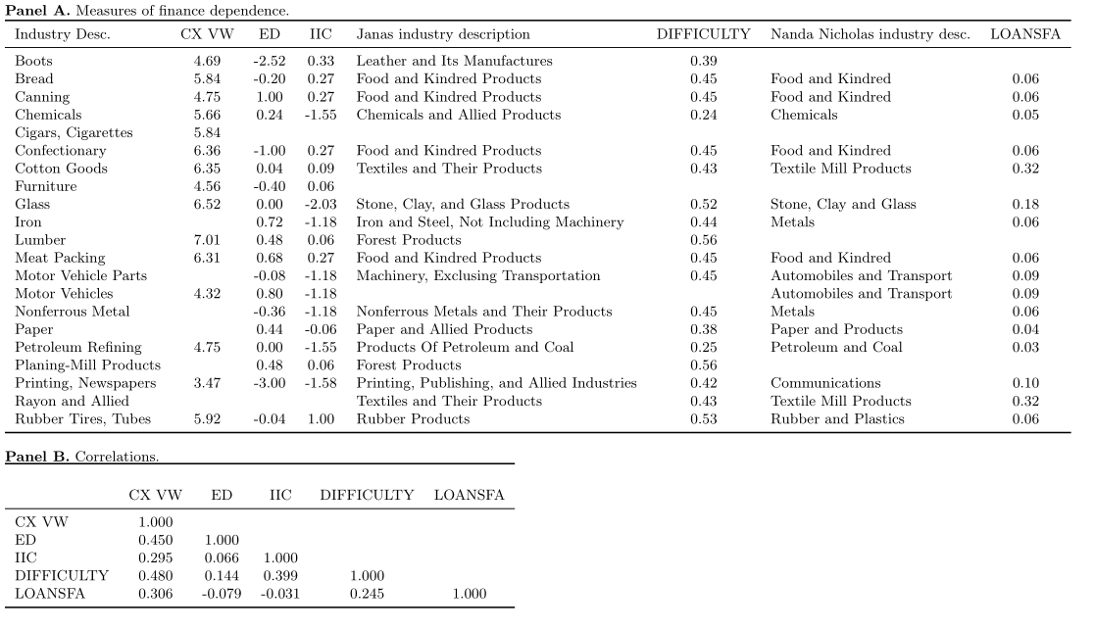
36
Note: Alternative measures described in Section III.

Table A3. State-level summary of employment in the matched industries (SAINC 9 table from the BEA; data for 1929)
State | # Ind. | Emp. | Wages | Population | Income | Emp share | Wage share
Alabama | 10 | 56,993 | 37,019,641 | 2,644,000 | 843,200,000 | 2.16 | 4.39
Arizona | 6 | 3,045 | 3,703,518 | 430,000 | 257,300,000 | 0.71 | 1.44
Arkansas | 11 | 27,538 | 22,901,523 | 1,852,000 | 560,400,000 | 1.49 | 4.09
California | 15 | 107,290 | 148,878,185 | 5,531,000 | 5,495,500,000 | 1.94 | 2.71
Colorado | 10 | 7,224 | 8,608,925 | 1,008,000 | 635,600,000 | 0.72 | 1.35
Connecticut | 9 | 18,522 | 22,165,974 | 1,594,000 | 1,640,500,000 | 1.16 | 1.35
Delaware | 6 | 2,190 | 1,905,617 | 236,000 | 243,400,000 | 0.93 | 0.78
Florida | 9 | 34,715 | 30,676,124 | 1,445,000 | 749,900,000 | 2.40 | 4.09
Georgia | 10 | 79,916 | 52,122,913 | 2,903,000 | 995,600,000 | 2.75 | 5.24
Idaho | 6 | 12,207 | 17,325,541 | 447,000 | 223,200,000 | 2.73 | 7.76
Illinois | 15 | 131,387 | 179,766,898 | 7,606,000 | 7,229,800,000 | 1.73 | 2.49
Indiana | 14 | 76,000 | 90,759,879 | 3,226,000 | 1,950,400,000 | 2.36 | 4.65
Iowa | 11 | 20,559 | 23,854,813 | 2,460,000 | 1,404,000,000 | 0.84 | 1.70
Kansas | 12 | 17,061 | 22,731,996 | 1,867,000 | 982,600,000 | 0.91 | 2.31
Kentucky | 12 | 19,148 | 17,722,160 | 2,606,000 | 1,010,800,000 | 0.73 | 1.75
Louisiana | 10 | 43,767 | 42,163,864 | 2,086,000 | 852,800,000 | 2.10 | 4.94
Maine | 10 | 17,244 | 16,571,256 | 797,000 | 477,900,000 | 2.16 | 3.47
Maryland | 14 | 25,818 | 25,924,135 | 1,621,000 | 1,257,000,000 | 1.59 | 2.06
Massachusetts | 13 | 167,442 | 187,726,218 | 4,229,000 | 3,853,400,000 | 3.96 | 4.87
Michigan | 13 | 171,286 | 271,740,464 | 4,795,000 | 3,796,800,000 | 3.57 | 7.16
Minnesota | 10 | 24,512 | 29,347,173 | 2,572,000 | 1,528,900,000 | 0.95 | 1.92
Mississippi | 8 | 35,084 | 27,955,751 | 1,998,000 | 552,900,000 | 1.76 | 5.06
Missouri | 12 | 60,448 | 68,707,966 | 3,622,000 | 2,241,600,000 | 1.67 | 3.07
Montana | 8 | 5,285 | 7,330,636 | 524,000 | 310,300,000 | 1.01 | 2.36
Nebraska | 8 | 10,839 | 13,581,553 | 1,375,000 | 803,000,000 | 0.79 | 1.69
Nevada | 3 | 158 | 288,151 | 90,000 | 78,600,000 | 0.18 | 0.37
New Hampshire | 9 | 32,055 | 31,665,113 | 467,000 | 321,300,000 | 6.86 | 9.86
New Jersey | 15 | 71,221 | 99,974,841 | 3,989,000 | 3,673,700,000 | 1.79 | 2.72
New Mexico | 5 | 2,005 | 2,034,260 | 420,000 | 170,200,000 | 0.48 | 1.20
New York | 15 | 186,653 | 286,040,689 | 12,171,000 | 14,071,100,000 | 1.53 | 2.03
North Carolina | 9 | 141,302 | 101,129,584 | 3,133,000 | 1,024,000,000 | 4.51 | 9.88
North Dakota | 3 | 884 | 1,247,601 | 674,000 | 254,000,000 | 0.13 | 0.49
Ohio | 15 | 167,436 | 238,154,381 | 6,626,000 | 5,113,900,000 | 2.53 | 4.66
Oklahoma | 9 | 12,927 | 16,868,525 | 2,372,000 | 1,065,600,000 | 0.54 | 1.58
Oregon | 8 | 44,816 | 59,054,573 | 947,000 | 630,400,000 | 4.73 | 9.37
Pennsylvania | 15 | 151,733 | 187,129,408 | 9,723,000 | 7,545,000,000 | 1.56 | 2.48
Rhode Island | 10 | 25,300 | 26,596,628 | 684,000 | 602,800,000 | 3.70 | 4.41
South Carolina | 8 | 89,107 | 58,021,309 | 1,739,000 | 464,700,000 | 5.12 | 12.49
South Dakota | 6 | 3,923 | 4,627,997 | 690,000 | 286,200,000 | 0.57 | 1.62
Tennessee | 11 | 31,276 | 26,405,187 | 2,604,000 | 971,200,000 | 1.20 | 2.72
Texas | 12 | 56,846 | 64,877,205 | 5,762,000 | 2,728,700,000 | 0.99 | 2.38
Utah | 7 | 4,014 | 3,620,885 | 508,000 | 278,200,000 | 0.79 | 1.30
Vermont | 7 | 4,303 | 4,337,013 | 359,000 | 226,300,000 | 1.20 | 1.92
Virginia | 12 | 37,864 | 31,300,795 | 2,425,000 | 1,054,500,000 | 1.56 | 2.97
Washington | 11 | 70,536 | 98,739,645 | 1,555,000 | 1,150,500,000 | 4.54 | 8.58
West Virginia | 10 | 25,122 | 31,889,558 | 1,717,000 | 787,400,000 | 1.46 | 4.05
Wisconsin | 12 | 66,206 | 77,610,687 | 2,934,000 | 1,966,800,000 | 2.26 | 3.95
Wyoming | 6 | 2,850 | 4,914,630 | 223,000 | 149,900,000 | 1.28 | 3.28

Table A4. IV Regressions first stage. IV estimates reported in Table 8. State-level instruments for fragility of the banking sector constructed by Mladjan (2016)

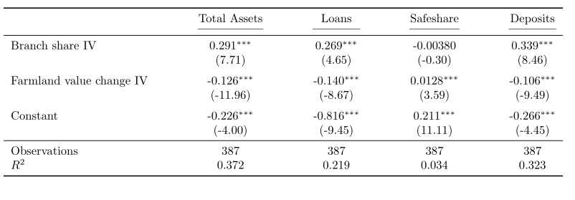
Note: ***, ** and * denote significance at the 1%, 5% and 10% levels.

Table A5. Interaction with historical district discount window usage, 1929–31
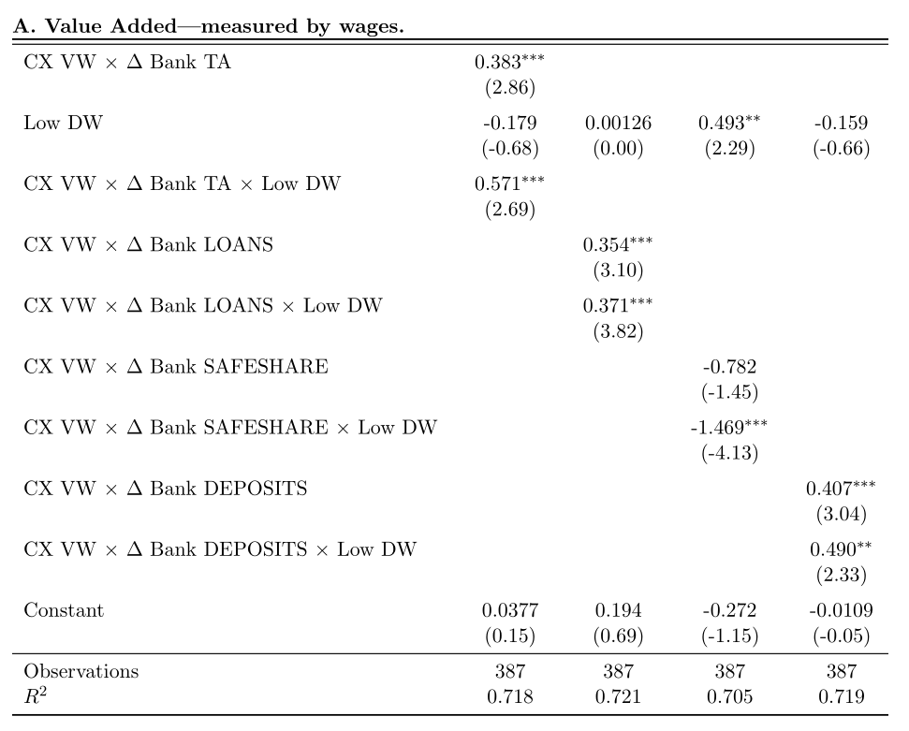

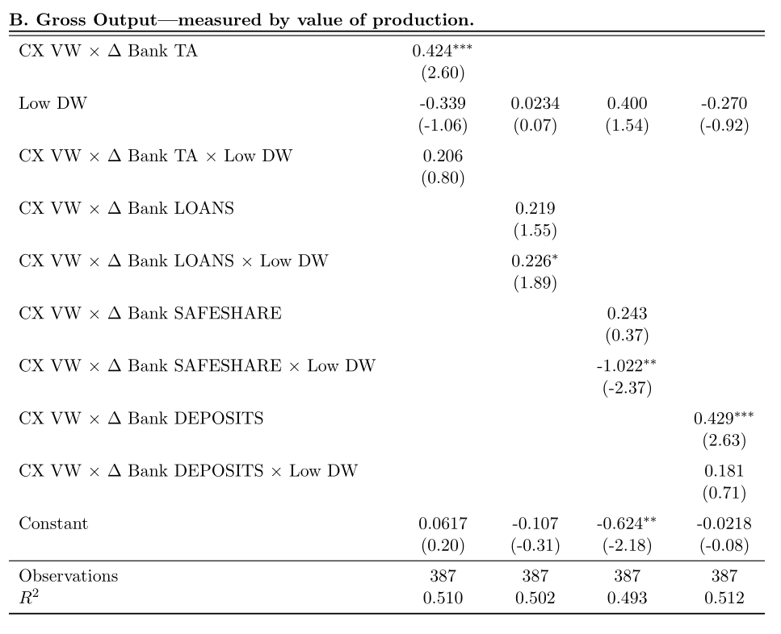

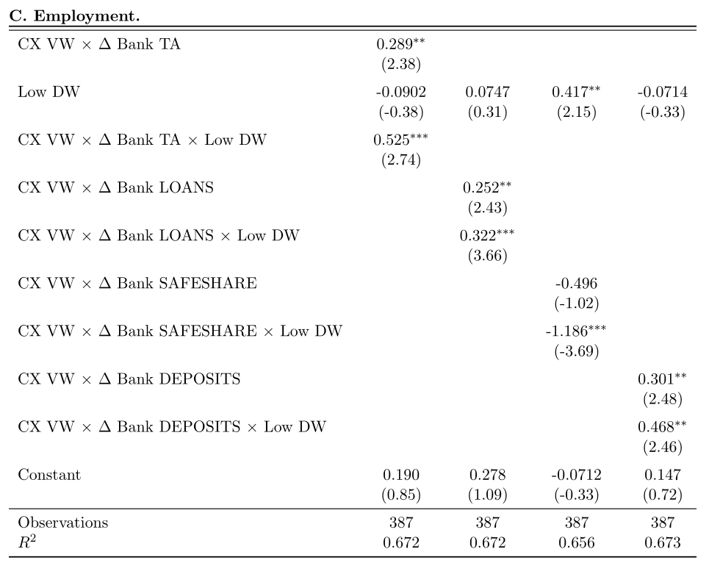

Note: Low DW is an indicator variable for states that are in Fed Districts that saw below-mean amount of discount window borrowing in 1919–28. ***, ** and * denote significance at the 1%, 5% and 10% levels.

