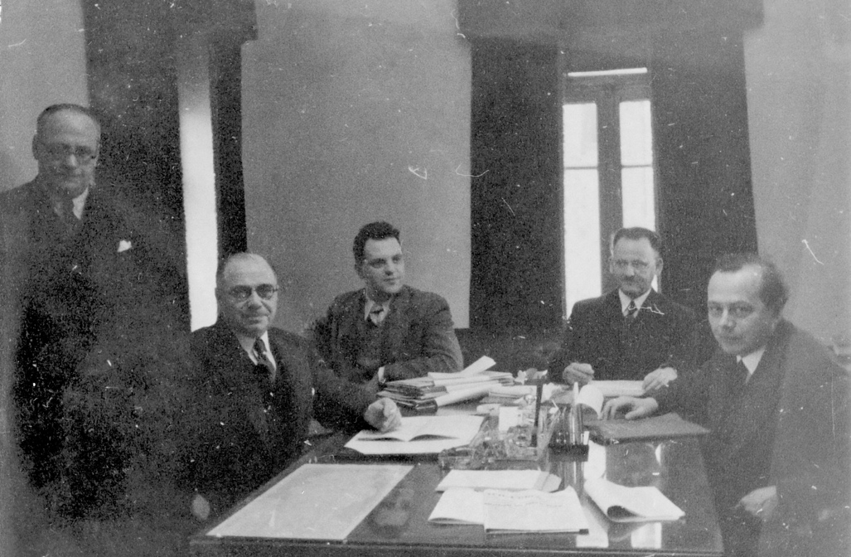

In 1938, the Turkish government, at the helm of a single-party regime, invited Jacob Lorenz, a sociologist and right-wing firebrand from Switzerland, to investigate a burning issue in Turkish society: the country’s high cost of living. What at first glance appears to be a straightforward case of interwar ‘illiberal internationalism’ turns out to have more complex origins in Turkey’s domestic politics and Lorenz’s personal ideological development.