Manuscript ID CEH-2023-0070.R2

Image and text for social media

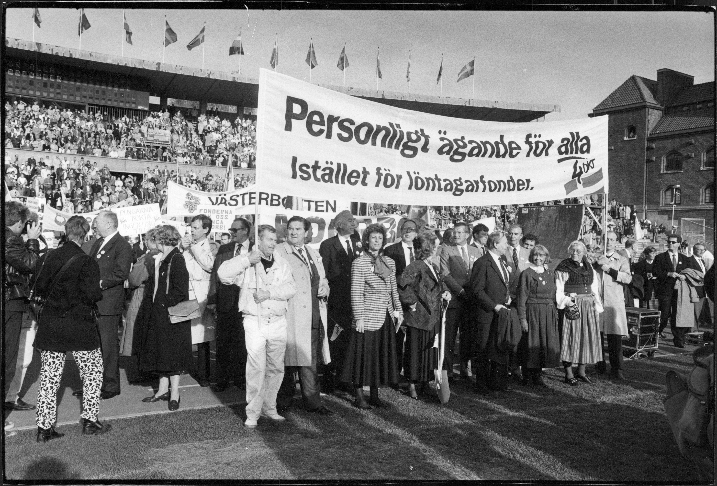
1983 demonstrations against wage earner funds in social democrat Sweden. Jenny Andersson suggests that this was not a popular business uprising against socialism, but a prepared plan for large scale privatization that she links to the creation of the socalled Business Fund in 1940.

Image source: Marie Hedberg, Aftonbladet. Digital licence from TT bild.

