Supplementary materials

To Grow or Not to Grow: questioning seed dormancy and thermal germination responses along elevational gradients in four plant taxa

Megan J. Hirst^{1,2}, Anthony R. Rendall ^{2*}, Daniel J. White^{1,2}, Ary A. Hoffman³, Jeronimo Vazquez-Ramirez^{2,4}

¹ Royal Botanic Gardens Victoria, Melbourne, Australia.
² School of Life and Environmental Sciences, Faculty of Science, Engineering and the Built Environment, Deakin University, Geelong, Burwood Campus, Melbourne, VIC, Australia.
³ Bio21 Institute, School of Biosciences University of Melbourne, Melbourne, Australia.
⁴ Department of Biology, University of Copenhagen, Denmark.

* Corresponding author: a.rendall@deakin.edu.au

Table S1. Species or sub-species used in this study, including population and elevation. * indicates seed sourced through commercial means and/or collected from an ex situ seed orchard. Conservation status is shown for taxa listed under the Flora and Fauna Guarantee Act 1988 (State-level) or Environment Protection and Biodiversity Conservation Act 1999 (National-level). Mean annual temperature and total annual rainfall is derived from the Australian Bureau of Meteorology for the year of seed collection.

Species | Status | Life Form | Code | Elevation (m) | Seed age (years) | Location | Mean annual temperature (°C) | Total annual rainfall (mm) | Seed size (length:width) | Seed weight (μ (n = 100) g)
Brachyscome barkerae | FFG: Endangered (EN) | Forb | BRA_BAR | 1600 | 7 | Alpine  National Park, Snowy Range | 7.87 | 932 | 1.880 : 1.066 | 0.021
Brachyscome  decipiens | Native occurs outside alpine areas | Forb | BRA_DEC_1 | 1642 | 9 | Pretty Valley wet  depression, Bogong High Plains | 6.32 | 2069 | 2.544 : 1.196 | 0.045
Brachyscome  decipiens | Native occurs outside alpine areas | Forb | BRA_DEC_2 | 1816 | 9 | Pretty Valley  rocky outcrop, Bogong High Plains | 6.16 | 1786 | 2.823 : 1.196 | 0.065
Brachyscome  dentata | Native | Forb | BRA_DEN_1 | 52 | 10 | Truganina, VIC | 14.91 | 735 | NA | 0.028
Brachyscome foliosa | FFG: Endangered (EN) | Forb | BRA_FOL | 1609 | 9 | Sun Valley Open grassland plain, Bogong High Plains | 6.32 | 2069 | 1.564 : 0.818 | 0.018
Brachyscome melanocarpa | FFG: Critically Endangered (CR | Forb | BRA_MEL | 31 | 7 | Murray Sunset National Park | 18.07 | 251 | 2.181 : 1.130 | 0.020
Brachyscome muelleroides | FFG: Endangered (EN); EPBC: Vulnerable (VU) | Forb | BRA_MUE | 113 | 11 | Ulupna Island, floodplains | 15.81 | 739 | 0.825 : 0.605 | 0.005
Brachyscome  nivalis | Native | Forb | BRA_NIV_1 | 1665 | 8 | Basalt Hill, rocky  outcrop,Bogong High Plains | 7.33 | 1839 | 2.173 : 1.658 | 0.044
Brachyscome  nivalis | Native | Forb | BRA_NIV_2 | 1764 | 9 | Ruined Castle, rocky outcrop, Ruined Castle, Bogong High Plains | 7.80 | 1639 | 2.307 : 1.582 | 0.045
Brachyscome  spathulata | Native | Forb |  | 1801 | 10 | Mt Howitt,  scattered open grassland | 7.88 | 1573 | 2.915 : 1.742 | 0.047
Brachyscome  tadgellii | FFG:  Endangered (EN) | Forb | BRA_TAD_1 | 80 | 3 | *Seed orchard  Cranbourne Botanic Garden, outdoor research plots | 15.35 | 695 | 2.091 : 1.812 | 0.045
Brachyscome  tadgellii | FFG:  Endangered (EN) | Forb | BRA_TAD_2 | 1642 | 9 | Pretty Valley wet  depression, Bogong High Plains | 6.32 | 2069 | 2.150 : 1.861 | 0.039
Brachyscome  tadgellii | FFG:  Endangered (EN) | Forb | BRA_TAD_3 | 1642 | 9 | Pretty Valley wet  depression, Bogong High Plains | 6.32 | 2069 | 2.153 : 1.820 | 0.038
Callistemon  brachyandrus | FFG:  Endangered (EN) | Shrub | CAL_BRA | 150 | 11 | Hattah-Kulkyne  National Park. | 17.08 | 534 | 0.949 : 0.239 | 0.003
Callistemon forresterae | FFG: Endangered (EN); EPBC: Vulnerable (VU) | Shrub | CAL_FOR | 150 | 14 | East  Gippsland | 15.41 | 1047 | 1.457 : 0.279 | 0.004
Callistemon kenmorrisonii | FFG: Endangered (EN); EPBC: Vulnerable (VU) | Shrub | CAL_KEN | 150 | 16 | East  Gippsland | 15.02 | 909 | 1.416 : 0.310 | 0.006
Callistemon nyallingensis | FFG: Critically Endangered (CR) | Shrub | CAL_NYA | 320 | 16 | East  Gippsland | 15.49 | 805 | 1.138 : 0.246 | 0.004
Callistemon pityoides | Native | Shrub | CAL_PIT | 1100 | 4 | Cobungra  (Vic Alps) | 12.68 | 940 | 1.044 : 0.301 | 0.004
Deyeuxia affinis | FFG: Critically Endangered (CR) | Grass | DEY_AFF | 1686 | 11 | Alpine National Park, Head of Middle Ck, ~700 m S from track to Cope Hut | 6.81 | 2392 | 1.383 : 0.496 | 0.019
Deyeuxia  talariata | FFG:  Endangered (EN) | Grass | DEY_TAL | 1416 | 11 | Alpine National Park ~200m  below top of Playgrounds near Mt Cobberas | 7.74 | 1300 | 1.822 : 0.614 | 0.030
Eucalyptus pauciflora subsp. parvifructa | FFG: Vulnerable (VU) | Tree | EUC_PAR | 1178 | 16 | Grampians | 10.91 | 883 | 1.784 : 1.199 | 0.106
Eucalyptus pauciflora subsp.acerina | FFG: Endangered (EN) | Tree | EUC_ACE | 1687 | 14 | Mt Baw Baw National Park life form, near summit of Mt Baw Baw at top of ski lift | 10.12 | 1512 | 1.845 : 1.212 | 0.105
Eucalyptus pauciflora subsp.hedraia | FFG: Critically Endangered (CR) | Tree | EUC_HED | 1612 | 12 | Falls Creek Ski Village, Bogong High Plains | 7.14 | 1626 | 2.121 : 1.343 | 0.154
Eucalyptus pauciflora subsp.niphophila | Native | Tree | EUC_NIP | 1786 | 11 | Alpine  National park, summit of Mt Pinnibar | 8.13 | 1582 | 1.802 : 1.142 | 0.109
Eucalyptus  pauciflora subsp.pauciflora | Native | Tree | EUC_PAU | 47 | 12 | Gippsland Plain | 14.85 | 684 | 2.221 : 1.509 | 0.138

Table S2. Pairwise comparisons between treatment levels (Treatment) and different temperatures (Contrast). Where treatment is left blank reflects no interactive effects of treatment and temperature.
Category | Treatment | Contrast | Estimate | SE | p
Eucalyptus pauciflora subsp. | Control | 10℃ - 15℃ | -0.453 | 0.613 | 0.948
 | Control | 10℃ - 20℃ | -0.854 | 0.576 | 0.573
 | Control | 10℃ - 25℃ | -0.843 | 0.613 | 0.644
 | Control | 10℃ - 30℃ | -0.752 | 0.614 | 0.738
 | Control | 15℃ - 20℃ | -0.402 | 0.511 | 0.935
 | Control | 15℃ - 25℃ | -0.390 | 0.546 | 0.953
 | Control | 15℃ - 30℃ | -0.299 | 0.548 | 0.982
 | Control | 20℃ - 25℃ | 0.012 | 0.505 | 1.000
 | Control | 20℃ - 30℃ | 0.103 | 0.507 | 1.000
 | Control | 25℃ - 30℃ | 0.091 | 0.540 | 1.000
 | GA | 10℃ - 15℃ | -2.757 | 0.429 | <0.001
 | GA | 10℃ - 20℃ | -3.327 | 0.430 | <0.001
 | GA | 10℃ - 25℃ | -4.278 | 0.452 | <0.001
 | GA | 10℃ - 30℃ | -3.935 | 0.434 | <0.001
 | GA | 15℃ - 20℃ | -0.570 | 0.346 | 0.466
 | GA | 15℃ - 25℃ | -1.521 | 0.366 | <0.001
 | GA | 15℃ - 30℃ | -1.179 | 0.355 | 0.008
 | GA | 20℃ - 25℃ | -0.951 | 0.366 | 0.070
 | GA | 20℃ - 30℃ | -0.608 | 0.355 | 0.427
 | GA | 25℃ - 30℃ | 0.342 | 0.376 | 0.893
Callistemon sp. |  | 10℃ - 15℃ | -3.511 | 0.550 | <0.001
 |  | 10℃ - 20℃ | -5.583 | 0.630 | <0.001
 |  | 10℃ - 25℃ | -6.763 | 0.726 | <0.001
 |  | 10℃ - 30℃ | -6.281 | 0.680 | <0.001
 |  | 15℃ - 20℃ | -2.071 | 0.599 | 0.005
 |  | 15℃ - 25℃ | -3.252 | 0.681 | <0.001
 |  | 15℃ - 30℃ | -2.769 | 0.642 | <0.001
 |  | 20℃ - 25℃ | -1.181 | 0.704 | 0.448
 |  | 20℃ - 30℃ | -0.698 | 0.673 | 0.838
 |  | 25℃ - 30℃ | 0.483 | 0.723 | 0.963
Brachyscome sp. |  | 10℃ - 15℃ | -0.444 | 0.232 | 0.312
 |  | 10℃ - 20℃ | -0.352 | 0.235 | 0.566
 |  | 10℃ - 25℃ | 0.642 | 0.233 | 0.046
 |  | 10℃ - 30℃ | 1.571 | 0.240 | <0.001
 |  | 15℃ - 20℃ | 0.092 | 0.240 | 0.995
 |  | 15℃ - 25℃ | 1.085 | 0.238 | <0.001
 |  | 15℃ - 30℃ | 2.015 | 0.245 | <0.001
 |  | 20℃ - 25℃ | 0.993 | 0.241 | <0.001
 |  | 20℃ - 30℃ | 1.923 | 0.248 | <0.001
 |  | 25℃ - 30℃ | 0.930 | 0.244 | 0.001
Deyeuxia sp. |  | 10℃ - 15℃ | -0.523 | 0.329 | 0.502
 |  | 10℃ - 20℃ | -1.084 | 0.324 | 0.007
 |  | 10℃ - 25℃ | -0.884 | 0.329 | 0.055
 |  | 10℃ - 30℃ | -0.577 | 0.340 | 0.434
 |  | 15℃ - 20℃ | -0.560 | 0.300 | 0.337
 |  | 15℃ - 25℃ | -0.361 | 0.308 | 0.769
 |  | 15℃ - 30℃ | -0.054 | 0.320 | 1.000
 |  | 20℃ - 25℃ | 0.199 | 0.299 | 0.964
 |  | 20℃ - 30℃ | 0.506 | 0.310 | 0.478
 |  | 25℃ - 30℃ | 0.307 | 0.303 | 0.850

Table S3. Pairwise comparisons of treatment in relation to different species. There was no difference between Brachyscome sp. and treatment so main effects are reported. No species or treatment effects were observed to Callistemon sp.
Category | Species | Contrast | Estimate | SE | p
Eucalyptus pauciflora subsp. | E.p.acerina | Control vs. GA | -3.980 | 0.680 | <0.001
 | E.p.hedraia | Control vs. GA | -4.080 | 0.441 | <0.001
 | E.p.niphophila | Control vs. GA | -3.960 | 0.404 | <0.001
 | E.p.parvifructa | Control vs. GA | -2.490 | 0.458 | <0.001
 | E.p.pauciflora | Control vs. GA | 1.060 | 0.587 | 0.072
Brachyscome sp. |  | Control vs. GA | -0.270 | 0.166 | 0.104
Deyeuxia sp. | D.affinis | Control vs. GA | -1.250 | 0.228 | <0.001
 | D.talariata | Control vs. GA | -0.220 | 0.391 | 0.574

Table S4. Pairwise comparisons in germination rate and species
Category | Contrast | Estimate | SE | p
Eucalyptus pauciflora subsp. | E.p.acerina vs. E.p.hedraia | -0.929 | 0.401 | 0.140
 | E.p.acerina vs. E.p.niphophila | -2.392 | 0.394 | <0.001
 | E.p.acerina vs. E.p.parvifructa | -1.650 | 0.408 | <0.001
 | E.p.acerina vs. E.p.pauciflora | -4.883 | 0.463 | <0.001
 | E.p.hedraia vs. E.p.niphophila | -1.463 | 0.295 | <0.001
 | E.p.hedraia vs. E.p.parvifructa | -0.722 | 0.313 | 0.144
 | E.p.hedraia vs. E.p.pauciflora | -3.954 | 0.380 | <0.001
 | E.p.niphophila vs. E.p.parvifructa | 0.741 | 0.301 | 0.100
 | E.p.niphophila vs. E.p.pauciflora | -2.491 | 0.362 | <0.001
 | E.p.parvifructa vs. E.p.pauciflora | -3.233 | 0.380 | <0.001
Callistemon sp. | C.brachyandrus vs. C.forresterae | -3.275 | 0.581 | <0.001
 | C.brachyandrus vs. C.kenmorrisonii | -25.746 | 5870.0* | 1.000
 | C.brachyandrus vs. C.nyallingensis | -5.054 | 0.642 | <0.001
 | C.brachyandrus vs. C.pityoides | 0.043 | 0.489 | 1.000
 | C.forresterae vs. C.kenmorrisonii | -22.470 | 5870.0* | 1.000
 | C.forresterae vs. C.nyallingensis | -1.778 | 0.642 | 0.045
 | C.forresterae vs. C.pityoides | 3.318 | 0.570 | <0.001
 | C.kenmorrisonii vs. C.nyallingensis | 20.692 | 5780.0* | 1.000
 | C.kenmorrisonii vs. C.pityoides | 25.788 | 5870.0* | 1.000
 | C.nyallingensis vs. C.pityoides | 5.096 | 0.636 | <0.001
Brachyscome sp. | B.barkerae vs. B.decipiens [RA] | 6.084 | 0.455 | <0.001
 | B.barkerae vs. B.decipiens [WA] | 4.444 | 0.361 | <0.001
 | B.barkerae vs. B.dentata | -2.467 | 0.466 | <0.001
 | B.barkerae vs. B.foliosa | 2.139 | 0.345 | <0.001
 | B.barkerae vs. B.melanocarpa | 3.182 | 0.367 | <0.001
 | B.barkerae vs. B.muelleroides | 0.655 | 0.339 | 0.774
 | B.barkerae vs. B.nivalis [BHR] | -0.334 | 0.339 | 0.999
 | B.barkerae vs. B.nivalis [RCR] | 1.353 | 0.334 | 0.004
 | B.barkerae vs. B.spathulata | 5.968 | 0.518 | <0.001
 | B.barkerae vs. B.tadgellii [CRA] | -4.022 | 0.408 | <0.001
 | B.barkerae vs. B.tadgellii [PVWA] | -1.69 | 0.355 | <0.001
 | B.barkerae vs. B.tadgellii [PVWB] | 1.242 | 0.334 | 0.013
 | B.decipiens [RA] vs. B.decipiens [WA] | -1.64 | 0.466 | 0.026
 | B.decipiens [RA] vs. B.dentata | -8.551 | 0.562 | <0.001
 | B.decipiens [RA] vs. B.foliosa | -3.945 | 0.457 | <0.001
 | B.decipiens [RA] vs. B.melanocarpa | -2.901 | 0.470 | <0.001
 | B.decipiens [RA] vs. B.muelleroides | -5.429 | 0.453 | <0.001
 | B.decipiens [RA] vs. B.nivalis [BHR] | -6.418 | 0.455 | <0.001
 | B.decipiens [RA] vs. B.nivalis [RCR] | -4.731 | 0.449 | <0.001
 | B.decipiens [RA] vs. B.spathulata | -0.116 | 0.591 | 1.000
 | B.decipiens [RA] vs. B.tadgellii [CRA] | -10.106 | 0.516 | <0.001
 | B.decipiens [RA] vs. B.tadgellii [PVWA] | -7.774 | 0.471 | <0.001
 | B.decipiens [RA] vs. B.tadgellii [PVWB] | -4.842 | 0.449 | <0.001
 | B.decipiens [WA] vs. B.dentata | -6.911 | 0.485 | <0.001
 | B.decipiens [WA] vs. B.foliosa | -2.305 | 0.364 | <0.001
 | B.decipiens [WA] vs. B.melanocarpa | -1.262 | 0.383 | 0.053
 | B.decipiens [WA] vs. B.muelleroides | -3.789 | 0.359 | <0.001
 | B.decipiens [WA] vs. B.nivalis [BHR] | -4.778 | 0.360 | <0.001
 | B.decipiens [WA] vs. B.nivalis [RCR] | -3.091 | 0.354 | <0.001
 | B.decipiens [WA] vs. B.spathulata | 1.524 | 0.527 | 0.163
 | B.decipiens [WA] vs. B.tadgellii [CRA] | -8.466 | 0.429 | <0.001
 | B.decipiens [WA] vs. B.tadgellii [PVWA] | -6.135 | 0.377 | <0.001
 | B.decipiens [WA] vs. B.tadgellii [PVWB] | -3.202 | 0.354 | <0.001
 | B.dentata vs. B.foliosa | 4.606 | 0.470 | <0.001
 | B.dentata vs. B.melanocarpa | 5.649 | 0.490 | <0.001
 | B.dentata vs. B.muelleroides | 3.122 | 0.465 | <0.001
 | B.dentata vs. B.nivalis [BHR] | 2.133 | 0.464 | <0.001
 | B.dentata vs. B.nivalis [RCR] | 3.82 | 0.462 | <0.001
 | B.dentata vs. B.spathulata | 8.435 | 0.616 | <0.001
 | B.dentata vs. B.tadgellii [CRA] | -1.555 | 0.507 | 0.102
 | B.dentata vs. B.tadgellii [PVWA] | 0.776 | 0.471 | 0.915
 | B.dentata vs. B.tadgellii [PVWB] | 3.709 | 0.462 | <0.001
 | B.foliosa vs. B.melanocarpa | 1.044 | 0.370 | 0.194
 | B.foliosa vs. B.muelleroides | -1.483 | 0.343 | 0.001
 | B.foliosa vs. B.nivalis [BHR] | -2.472 | 0.343 | <0.001
 | B.foliosa vs. B.nivalis [RCR] | -0.786 | 0.338 | 0.501
 | B.foliosa vs. B.spathulata | 3.829 | 0.520 | <0.001
 | B.foliosa vs. B.tadgellii [CRA] | -6.161 | 0.412 | <0.001
 | B.foliosa vs. B.tadgellii [PVWA] | -3.829 | 0.360 | <0.001
 | B.foliosa vs. B.tadgellii [PVWB] | -0.897 | 0.338 | 0.280
 | B.melanocarpa vs. B.muelleroides | -2.527 | 0.365 | <0.001
 | B.melanocarpa vs. B.nivalis [BHR] | -3.516 | 0.366 | <0.001
 | B.melanocarpa vs. B.nivalis [RCR] | -1.829 | 0.360 | <0.001
 | B.melanocarpa vs. B.spathulata | 2.786 | 0.531 | <0.001
 | B.melanocarpa vs. B.tadgellii [CRA] | -7.204 | 0.436 | <0.001
 | B.melanocarpa vs. B.tadgellii [PVWA] | -4.873 | 0.384 | <0.001
 | B.melanocarpa vs. B.tadgellii [PVWB] | -1.941 | 0.361 | <0.001
 | B.muelleroides vs. B.nivalis [BHR] | -0.989 | 0.337 | 0.146
 | B.muelleroides vs. B.nivalis [RCR] | 0.698 | 0.332 | 0.663
 | B.muelleroides vs. B.spathulata | 5.313 | 0.516 | <0.001
 | B.muelleroides vs. B.tadgellii [CRA] | -4.677 | 0.407 | <0.001
 | B.muelleroides vs. B.tadgellii [PVWA] | -2.346 | 0.354 | <0.001
 | B.muelleroides vs. B.tadgellii [PVWB] | 0.586 | 0.332 | 0.867
 | B.nivalis [BHR] vs. B.nivalis [RCR] | 1.687 | 0.333 | <0.001
 | B.nivalis [BHR] vs. B.spathulata | 6.302 | 0.519 | <0.001
 | B.nivalis [BHR] vs. B.tadgellii [CRA] | -3.688 | 0.405 | <0.001
 | B.nivalis [BHR] vs. B.tadgellii [PVWA] | -1.357 | 0.352 | 0.008
 | B.nivalis [BHR] vs. B.tadgellii [PVWB] | 1.575 | 0.333 | <0.001
 | B.nivalis [RCR] vs. B.spathulata | 4.615 | 0.513 | <0.001
 | B.nivalis [RCR] vs. B.tadgellii [CRA] | -5.375 | 0.404 | <0.001
 | B.nivalis [RCR] vs. B.tadgellii [PVWA] | -3.044 | 0.350 | <0.001
 | B.nivalis [RCR] vs. B.tadgellii [PVWB] | -0.111 | 0.328 | 1.000
 | B.spathulata vs. B.tadgellii [CRA] | -9.99 | 0.576 | <0.001
 | B.spathulata vs. B.tadgellii [PVWA] | -7.659 | 0.535 | <0.001
 | B.spathulata vs. B.tadgellii [PVWB] | -4.726 | 0.513 | <0.001
 | B.tadgellii [CRA] vs. B.tadgellii [PVWA] | 2.332 | 0.411 | <0.001
 | B.tadgellii [CRA] vs. B.tadgellii [PVWB] | 5.264 | 0.404 | <0.001
 | B.tadgellii [PVWA] vs. B.tadgellii [PVWB] | 2.932 | 0.350 | <0.001
Deyeuxia sp. | D.affinis vs. D. talariata | 1.420 | 0.231 | <0.001
*C.kenmorrisonii had either perfect germination, or no germination between treatments precluding comparisons
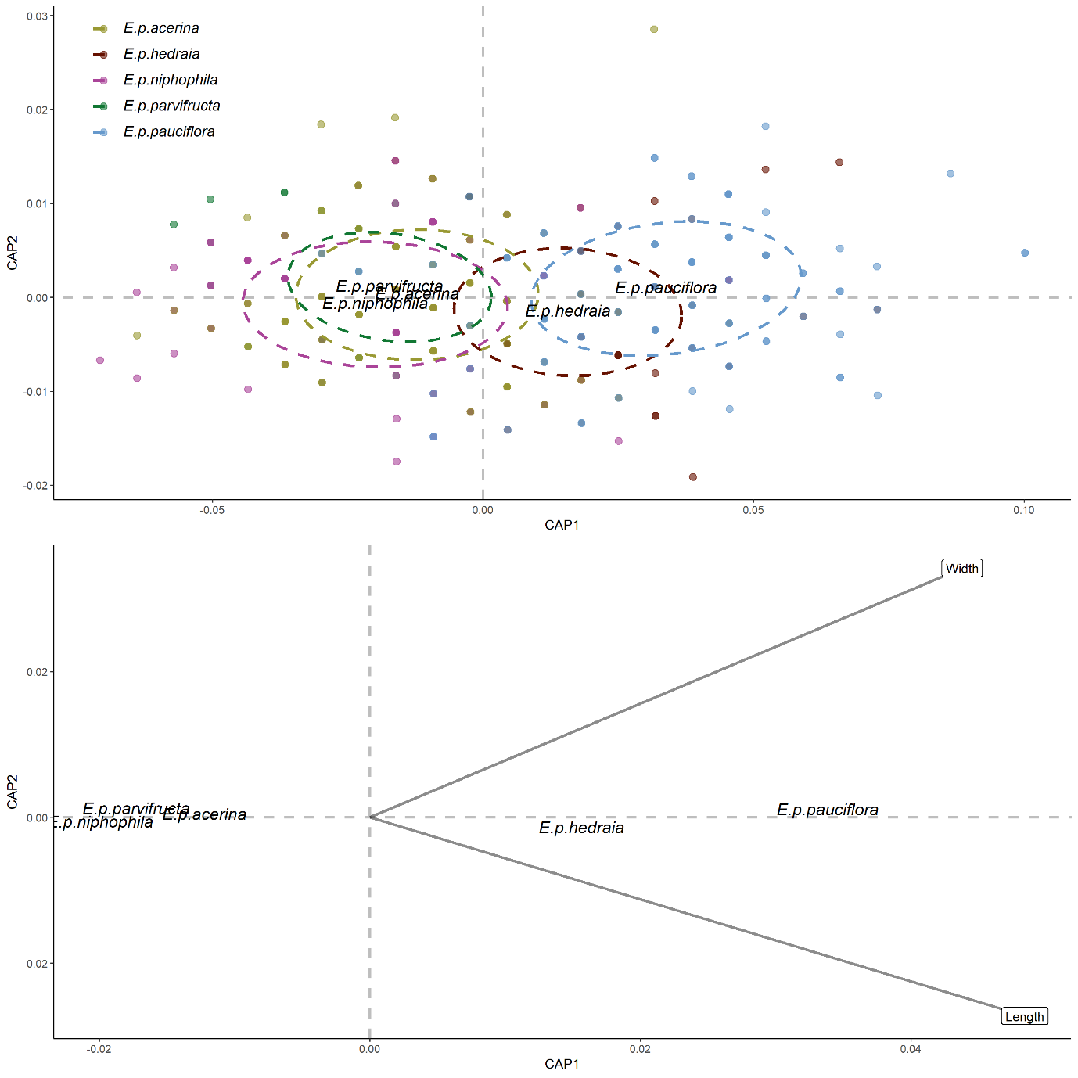
Figure S1. Canonical Analysis of Principle Coordinate of seed size (length and width) in relation to sub-species of Eucalyptus pauciflora. Top panel include individual seeds with points closer together being similar in size. Circles represent 95% distribution bounds. Bottom figure represents seed width and length in relation to the centroids of each species

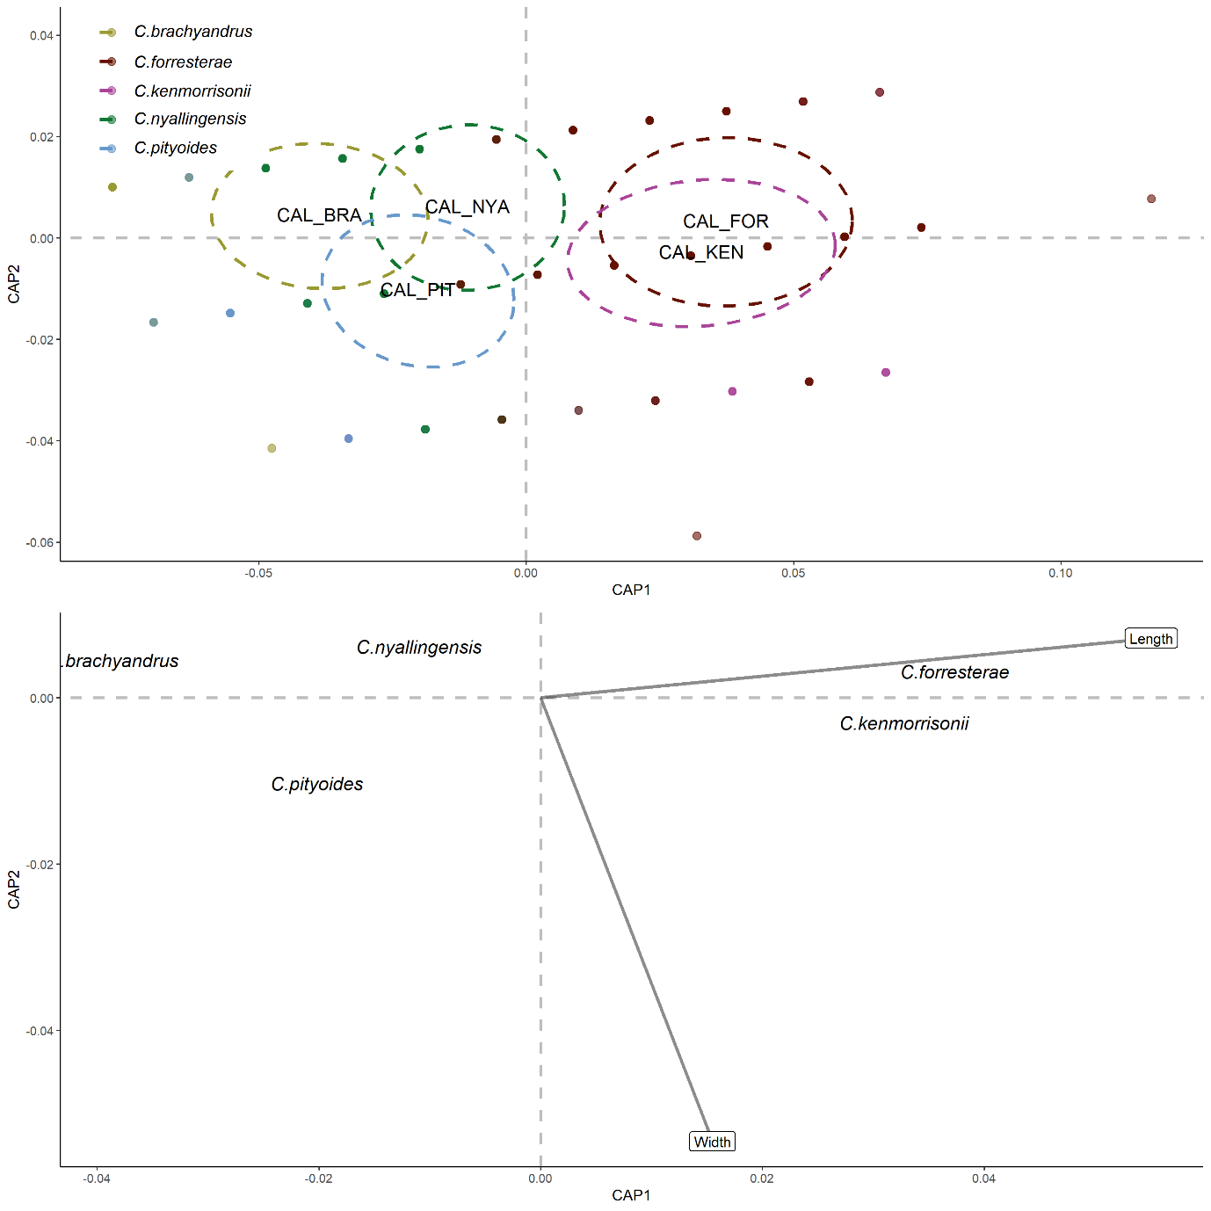
Figure 2. Canonical Analysis of Principle Coordinate of seed size (length and width) in relation to sub-species of Callistemon spp.. Top panel include individual seeds with points closer together being similar in size. Circles represent 95% distribution bounds. Bottom figure represents seed width and length in relation to the centroids of each species

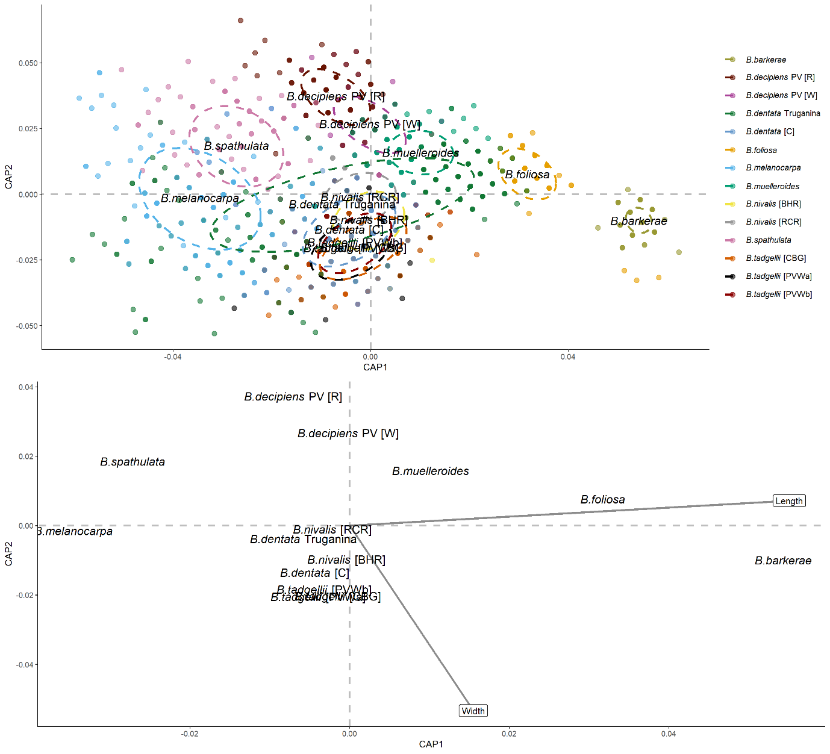
Figure 3. Canonical Analysis of Principle Coordinate of seed size (length and width) in relation to sub-species of Brachyscome spp.. Top panel include individual seeds with points closer together being similar in size. Circles represent 95% distribution bounds. Bottom figure represents seed width and length in relation to the centroids of each species

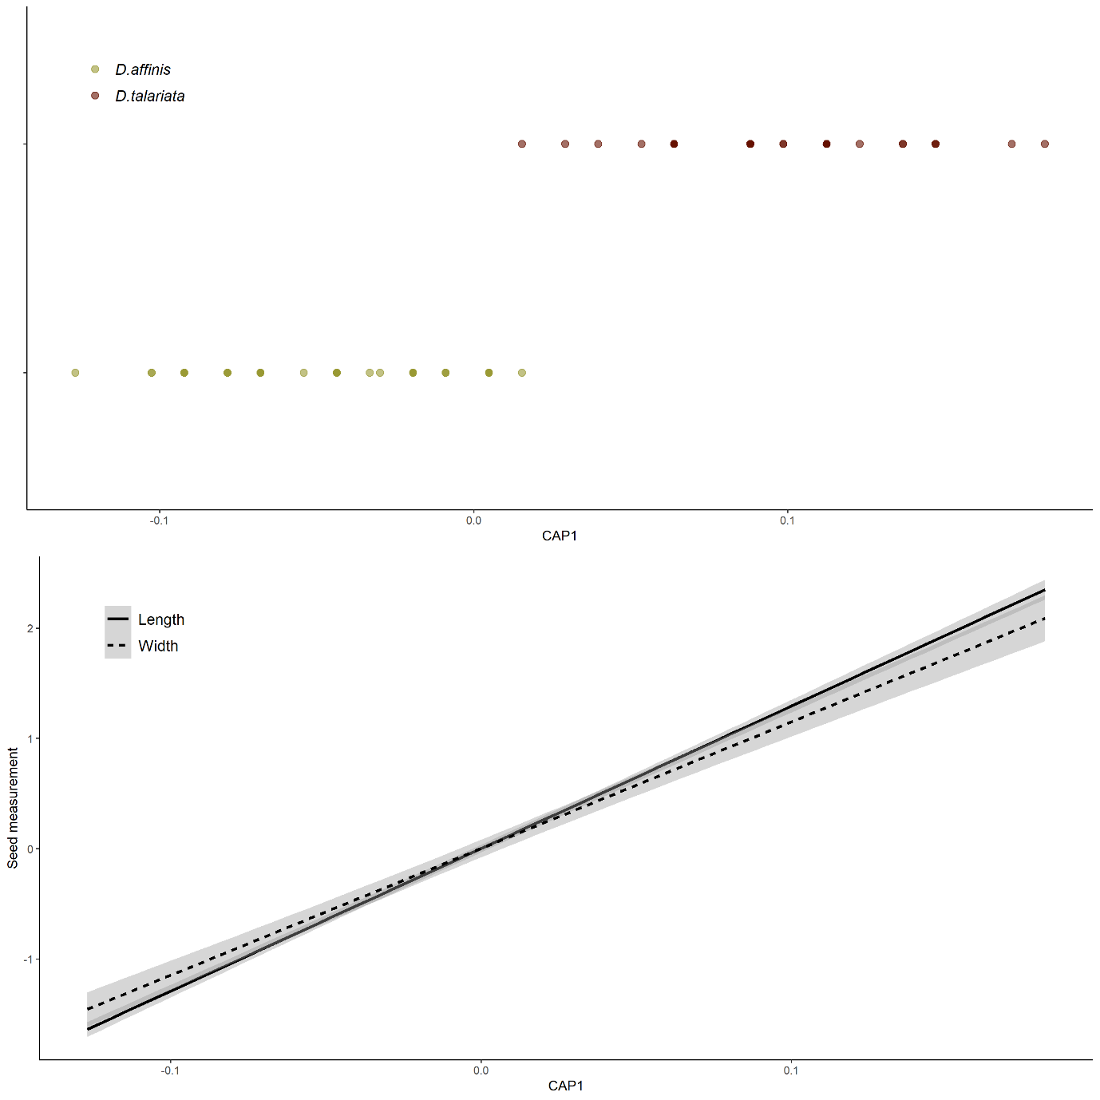
Figure 4. Canonical Analysis of Principle Coordinate of seed size (length and width) in relation to sub-species of Deyeuxia spp.. Top panel include individual seeds with points closer together being similar in size. Circles represent 95% distribution bounds. Bottom figure represents seed width and length in relation to the centroids of each species

