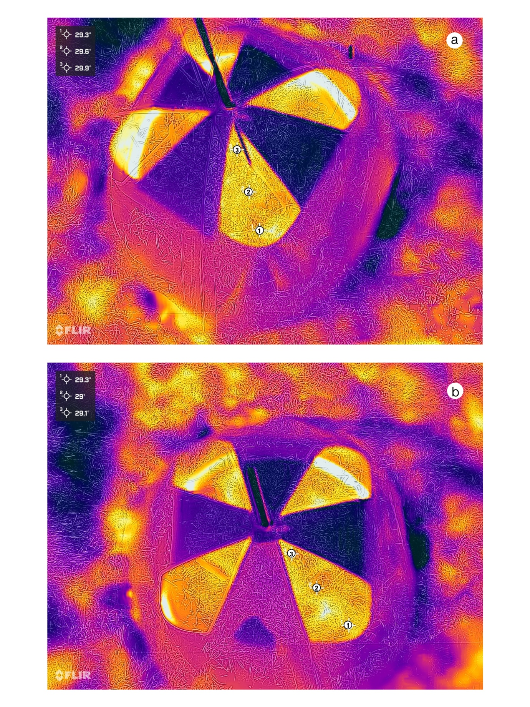

**Figure S2.** Thermal images of two chambered plots showing the effect of the chambers on the soil temperature. Both pictures (a and b) show the temperature values for three chosen points along a spatial gradient from outside the plot to the center.