**Supplementary figure 1**. Phenology and reproduction of trees in varzea forests from Central Amazonia in relation to the flood pulse: (A) Fruits of *Crataeva* *tapia* floating in water. (B) Germination of *Vitex* *cymosa* in water. The arrow shows the primary root. (C) *Psidium acutangulum* with fruits (yellow circle) during the flood season, in June. (D) Dry season or terrestrial phase in the varzea forest. The arrow indicates the maximum water level reached in the last flood (watermark on the tree trunks). (E) Seedlings growing in exposed soil near the riverbank and (F) inside the forest (arrow) about one month after the flood. Photos D, E and F were taken in September, about two months after the beginning of the water retreat. (G) Bar graph showing the rise (↑) and fall (↓) of the Negro River at Manaus over the annual cycle (> 10 m). The mean monthly water level from 2012-2022 is depicted. The number inside each bar is the monthly change in the river water level. The horizontal dark bar is the period of fruit collection for the present study. Negro River water level at the Manaus harbor station measured daily by the Capitania dos Portos (Port Authority) and available at https://www.portodemanaus.com.br/. The red bars (▬) in A and B = 1 cm.

**Supplementary figure 2.** Germination curves for flooded and non-flooded seeds of ten tree species of Central Amazonian floodplains. Non-flooded seeds (soil) were placed in trays filled with soil from varzea that was kept damp, but not saturated. Submerged seeds (underwater) were kept in trays filled with water (water column held between 5 - 7 cm). In both treatments, four replicates of 25 seeds each were used. Lag time (mean number of days + standard errors) is the interval of time (on the x-axis) during which the value along the y-axis was zero (the time needed to initiate germination). P-values in bold indicate significant differences in lag time between the two treatments (*p ≤* 0.05).

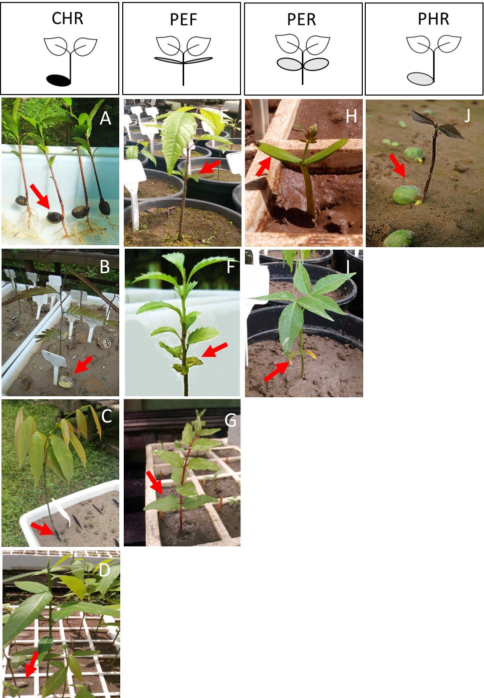

**Supplementary figure 3.** Seedling functional types (leaves in white, seeds in black, cotyledons in grey). Crypto-hypogeal with reserve storage cotyledons (CHR): seedlings of (A) *Pouteria glomerata*, (B) *Macrolobium acaciifolium,* (C) *Campsiandra laurifolia* and (D) *Nectandra amazonum*. Phanero-epigeal with foliaceous cotyledons (PEF): seedlings of (E) *Vitex cymosa* (F) *Ilex inundata,* (G) *Psidium acutangulum*. Phanero-epigeal with reserve storage cotyledons (PER): seedlings of (H) *Cassia leiandra* and (I) *Crataeva tapia*. Phanero-hypogeal with reserve storage cotyledons (PHR): seedlings of (J) *Sorocea duckei*. The red arrows are pointing to the cotyledons.

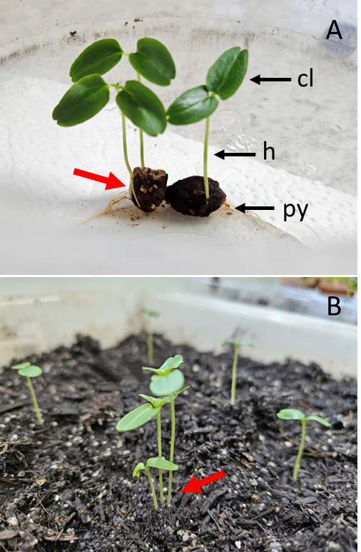

**Supplementary figure 4.** (A) Recently germinatedseeds of *Vitex cymosa* with production of one, two (A) or three (B) seedlings from a single pyrene (multilocular pyrene, red arrows). (cl) cotyledonary leaf, (h) hypocotyl and (py) pyrene.