Appendix I
Bayesian model of the VLD-T450
This Bayesian model includes a set of eight radiocarbon dates obtained from the chamber and one additional date from the postholes inside the ditched enclosure. Phase 1 models the initial use of the chamber. Phase 2, which begins simultaneously with the end of Phase 1, represents the burials on top of the mound, once the chamber had been sealed. The temporal proximity between individuals 450(1) and 450(3) is so chronologically indistinguishable that their deposition has been modelled as practically contemporaneous. Thus, Phase 1 ends at the same time as Phase 2 (β₁ = α₂). Finally, a single date reflects the deposition of human remains in one of the postholes inside the enclosure surrounding the chamber (Phase 3). The Bayesian model can be expressed as follows:
α₁ > β₁ = α₂ > β₂ > α₃ > β₃

According to the model, the funerary activity began around 4241-4047 cal BC considering the earliest date of 450(2): Beta-602434. Given the archaeological information, the model includes the explicit condition that individual 450(2) was buried before individual 450(3) (θ_{i} > θ_{j}). This indicates that individual 450(2) was indeed buried prior to 450(3), with the temporal gap between them falling within the estimated ranges. Phase 1 ended (β₁) at the same time that the start of Phase 2 (α₂), between 4036–3835 cal BC (Fig. 1).
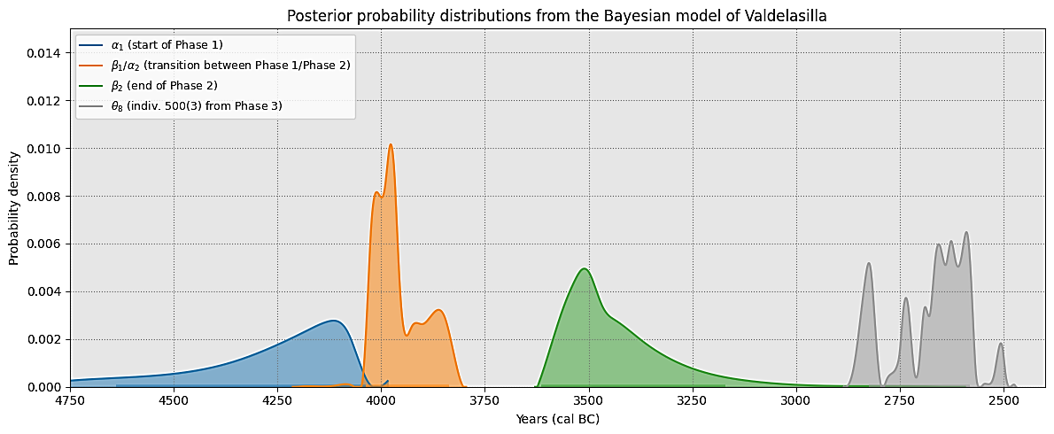
Fig. 1: Informative posterior probability distributions from the Bayesian model of Tomb 450.
The date Beta-573595, corresponding to individual 450(1) and included in Phase 1, overlaps statistically with Beta-610103, associated with individual 450(3) from Phase 2. Therefore, we assume that the latter, from the second funerary level, died shortly after the individual found at the base. The probability that individual 450(1) died before individual 450(3) is 61.69%, which, in archaeological terms, suggests a degree of contemporaneity between them.
According to the model the end of Phase 2 occurs between 3612–3193 cal BC (95% of HPD: 3612-3207, 3205 – 3193 cal BC). The duration of Phase 2 is estimated to be between 262 to 798 years (95% of HPD: 262-783, 785 – 798 years), suggesting a long period of burial activity in the chamber. The temporal offsets between the burials suggest a non-linear and possibly discontinuous pattern of use, based on the comparative analysis of the posterior distributions of θ parameters associated with Phase 2 (Table 1).
Comparison | P(θᵢ > θⱼ) | Mean Δt (years) | 95% HPD
450(3) before 450(7) | 98.0% | 162 | [21, 307]
450(3) before 450(6) | 100.0% | 293 | [148, 437]
450(3) before 450(4) | 100.0% | 338 | [199, 481]
450(3) before 450(8) | 100.0% | 356 | [204, 570]
450(7) before 450(6) | 98.8% | 131 | [16, 292]
450(7) before 450(4) | 100.0% | 176 | [57, 355]
450(7) before 450(8) | 100.0% | 194 | [62, 382]
450(6) before 450(4) | 79.9% | 44 | [-73, 179]
450(6) before 450(8) | 83.6% | 62 | [-67, 246]
450(4) before 450(8) | 58.1% | 18 | [-98, 196]

Table 1. Pairwise comparisons of posterior distributions for calibrated calendar dates (θ) of burials from Phase 2. The table reports, for each pair (θᵢ, θⱼ), the posterior probability that θᵢ occurred at the same time or later than θⱼ, along with the mean and 95% HPD for the temporal difference (Δt = θᵢ − θⱼ, in years).
The date of the individual 450(3) displays an almost absolute difference with the next dated individual, 450(7). This difference reinforces the idea that, following the sealing of the chamber and the initial burial, there was a disruption in the sequence or rhythm of funerary activity. The date of the individuals 450(7) and 450(6) show a mean gap of 131 years (Table 2). In contrast, among individuals 450(6), 450(4), and 450(8) appear to be shorter, likely less than 100 years. In the case of the chronological relationship between 450(4) and 450(8), the result suggests a nearly contemporaneous interment.
Finally, according to the model, a minimum of 482 years may have elapsed between the end of Phase 2 and the only radiocarbon date attributed to Phase 3 (indv. 500(31), θ₈), with Δt(β₂ − θ₈) having a 95% HPD interval of 482–1009 years. The posterior estimate of θ₈ places the individual’s death between 2862 and 2501 cal BC.

