Supplementary information

Supp 1. Total count of representations of Upper Palaeolithic hands in Europe.
Cave | Province/Region | Country | Nº Hands | Cave | Province/Region | Country | Nº Hands
Abri du Poisson | Dordogne | France | 1 | Garma | Cantabria | Spain | 36
Abri Labattut | Dordogne | France | 1 | Gorham | Cádiz | Spain | 1
Altamira | Cantabria | Spain | 9 | Grande Grotte d'Arcy | Bourgogne | France | 9
Archambeau (Les Eyzies) | Dordogne | France | 1 | Higuerón/Tesoro | Málaga | Spain | 1
Ardales | Málaga | Spain | 9 | Lastrilla | Cantabria | Spain | 3
Askondo | Bizkaia | Spain | 1 | Maltravieso | Cáceres | Spain | 60
Baume-Latrone | Gard | France | 11 | Margot | Mayenne | France | 8
Bayol | Gard | France | 6 | Merveilles | Lot | France | 6
Bédeilhac | Ariège | France | 2 | Montera del Torero | Cádiz | Spain | 1
Bernifal | Dordogne | France | 4 | Moseguellos | Valencia | Spain | 4
Beyssac | Dordogne | France | 1 | Moulin de Laguenay | Corrèze | France | 3
Bison | Dordogne | France | 3 | Nerja | Málaga | Spain | 1
Bourgnetou | Lot | France | 1 | Paglicci | Puglia | Italy | 5
Calaveras | Alicante | Spain | 1 | Palomas IV | Cádiz | Spain | 4
Candamo | Asturias | Spain | 1 | Pasiega B | Cantabria | Spain | 2
Castillo | Cantabria | Spain | 78 | Pech-Merle | Lot | France | 12
Chauvet | Ardèche | France | 11 | Pedroses | Asturias | Spain | 2
Combarelles | Dordogne | France | 1 | Perciata | Sicilia | Italy | 6
Combe-Nègre | Lot | France | 1 | Pileta | Málaga | Spain | 12
Cosquer | Bouches-du-Rhône | France | 69 | Pindal | Asturias | Spain | 1
Cudón | Cantabria | Spain | 2 | Portel | Ariège | France | 2
Ebbou | Ardèche | France | 1 | Roc de Vézac | Dordogne | France | 2
Emilie | Ardèche | France | 2 | Roucadour | Lot | France | 16
Erberua | Pyrénées-Atlantiques | France | 5 | Salitre | Cantabria | Spain | 1
Estrellas | Caádiz | Spain | 5 | Tibiran | Hautes-Pyrénées | France | 11
Fieux | Lot | France | 14 | Tito Bustillo | Asturias | Spain | 1
Font-de-Gaume | Dordogne | France | 4 | Trois-Frères | Ariège | France | 7
Fuente del Salín | Cantabria | Spain | 23 | Victoria | Málaga | Spain | 1
Fuente del Trucho | Huesca | Spain | 57 | Vilhonneur (Les Garennes) | Charente | France | 1

Supp 2. Direct, indirect and relative dating of representations of hands from the Upper Palaeolithic.
Site | Lab Code | Method | Sample Ref. | Sample (Material) | Sample Description (Sampling area) | Dat.  C(mg) | δ13C | Age  (yr BP) |  | Age (cal BP)  95% confid. | Reference
DIRECT DATATIONS
Cosquer | GifA92409 | Accelerator Mass Spectrometry (AMS)14C Dating | N°1D | Hand Stencil 07  (Panneau des Mains)  Right hand with folded or "mutilated"  fingers: | Hand stencil MNR007 in front of the feline (left of the little finger)  Purified charcoal  fraction | 0.86 | –24 | 27,110 ± 400 |  | 31,885–30,531  IntCal13 calibration data | Clottes, J., et al., 1992; 1995 ; Valladas et al., 2017
Cosquer | GifA92424 | Accelerator Mass Spectrometry (AMS)14C Dating |  |  | HAF (acid humic fractions) | 0.44 | –22 | 26,180 ± 330 |  | 30,997–29,633 | Clottes, J., et al., 1992; 1995 ; Valladas et al., 2017
Cosquer | GifA92491 | Accelerator Mass Spectrometry (AMS)14C Dating |  |  | Hand stencil MNR007 | 1.59 | –27 | 27,110 ± 350 |  | 31,650–30,651 | Clottes, J., et al., 1992; 1995 ; Valladas et al., 2017
Cosquer | GifA95358 | Accelerator Mass Spectrometry (AMS)14C Dating |  | Hand Stencil 12  (Puits noyé)  Left hand with intact and outstretched  fingers: | Hand stencil  MNN012 | 0.63 | –24 | 24,840 ± 340 |  | 29,701–28,136  IntCal13 calibration data | Clottes, J., et al., 1992; 1995 ; Valladas et al., 2017
Cosquer | GifA95372 | Accelerator Mass Spectrometry (AMS)14C Dating |  |  | HAF | 0.26 | –26 | 23,150 ± 620 |  | 28,577–26,150 | Clottes, J., et al., 1992; 1995 ; Valladas et al., 2017
Cosquer | GifA96073 | Accelerator Mass Spectrometry (AMS)14C Dating |  | Hand Stencil 19  (Puits noyé)  Left hand with folded small, ring and fore-fingers  Purified charcoal fraction). | Hand stencil MNN019  (Panel III) | 1.3 | –21 | 27,740 ± 410 |  | 32,766–31,014 | Clottes, J., et al., 1992; 1995 ; Valladas et al., 2017
Cosquer | GifA14172/  SacA39203 | 14C on the Artemis ANIS (LMC14, CE, Saclay) | PRV1105-24 | Hand Stencil 01  (Puits noyé) | Hand stencil MNN001 (left end of the halo, at the level of the wrist) | 1.042 | –25 | 26,900 ± 290 |  | 31,365–30,620  IntCal13 calibration data | ( Clottes, J., et al., 1992; 1995 ; Valladas et al., 2017
Cosquer | GifA14228/  SacA39210 | 14C on the Artemis ANIS (LMC14, CE, Saclay) | PRV1105-24 | Hand Stencil 01  (Puits noyé) | HAF | 0.212 | –23 | 28,060 ± 550 |  | 33,404–31,106 | Vanrell and Olive (2012)
Cosquer | GifA14173/  SacA39204 | 14C on the Artemis ANIS (LMC14, CE, Saclay) | PRV1105-25 | Hand Stencil 09  (Puits noyé) | Hand stencil MNN009  (right of the distal end of the atrial) | 0.718 | –25 | 26,310 ± 270 |  | 31,029–29,868 | Vanrell and Olive (2012)
Fuente del Salín | GX-27.757-AMS | AMS |  | Black Negative Hand  (Panel_8_Mano_1)  Purified charcoal fraction | Direct dating on black hand in negative |  | -24,50% | 18200 ± 70 |  | 22,097-21435 | (González Morales & Moure Romanillo, 2008)
Gorham | Beta-238027 | 14C-AMS |  | Negative Hand 1 | Negative Hand 1 |  |  | 16,990±90 |  | 20,210−20,750  Intcal13 and marine13 curves | (Simón-Vallejo, Cortés-Sánchez, Finlayson, Giles-Pacheco, Rodríguez-Vidal, Calle Román, et al., 2018; Simón-Vallejo, Cortés-Sánchez, Finlayson, Giles-Pacheco, Rodríguez-Vidal, Román, et al., 2018)
INDIRECT DATATIONS (association or superposition)
Abri Labattut |  |  |  | Negative hand on fallen block within a Gravettian layer | Negative hand  Stratigraphically earlier than the  upper level of Perigordian V with  Noailles Burins (Noaillian) = early  Gravettian or older. |  |  | Gravettian |  | 26,500 and 23,500 BP. | (Delluc & Delluc, 1991)  Delluc & Delluc 1984
Abri du Poisson |  |  |  | Previously fallen decorated ceiling |  |  |  | Gravettian |  |  | (Delluc & Delluc, 1991)
Castillo | Gif A-91004 |  |  | Charcoal | Bison 18a on red negative hands / Large bison facing right  Wall near the entrance  Nos 18 in Fig. 139 | 5.7 (datable 0.82) |  | >13,060±200 |  | > 16,351–14,448 | (Valladas et al., 1992)
Castillo | Gif A-91172 |  |  | Charcoal | Bison 18b on red negative hands / Large bison facing right  Wall near the entrance  Nos 19 in FIg. 139 | 10.6 (datable 0.69) |  | >12,910±180 |  | > 16,140–14,362 | (Valladas et al., 1992)
Castillo | GifA-96068 | AMS radiocarbon dates |  | Purified Charcoal  fraction) | Bison 18a  Superimposed on two red hinds and two red hand stencils  Panel of the Polychromes |  |  | > 13,520±130 |  | > 16,140–14,362 | Moure & González Sainz, 2000).
Castillo | GifA-96079 |  |  | Purified Charcoal  fraction) | Bison 18a  superimposed on three, perhaps four red hand stencils):  Panel of the Polychromes |  |  | 12,620±110 |  | > 15,689–14,196 | Moure & González Sainz, 2000).
Fuente del Salín | GrN18574 |  |  | Charcoal | Great home at the foot of the paintings  hearth was documented in  Level 2, at the foot of an ensemble of red hand stencils. |  | 26.6‰ | 22,340 | +510 -480 | 25,740−27,530 | (Moure Romanillo and González Morales, 1992; González Morales & Moure, 2008),)
 |  |  |  |  |  |  |  |  |  | 22,580±100 years BP
Fuente del Salín |  |  |  | Bone | bone fragment recovered on the floor elsewhere  in the same chamber |  | 21.5‰ |  |  | 23,190±900
Gargas | GiFA-92369 |  |  | Bone fragment placed in a natural crack next to Hand 4 in Panel 4 of the  Entrance Chamber |  |  |  | 26,860±460 |  | 29,900−31,580 | ( Clottes , Valladas, et al., 1992b)
Grande Grotte d'Arcy |  |  |  | Burnt bone fragment | bone found at the foot of a panel with partially represented hands/partial stencil |  |  | 26,700 ± 410 |  |  | (Baffier  & Girard, 1995).
Grande Grotte d'Arcy |  |  |  | Burnt bone fragment |  |  |  | 26,100 ± 390  (fraction humique) |  |  | (Girard et al., 1995)
Grande Grotte d'Arcy |  |  |  | Charcoal |  |  |  | 28,250 ± 430 |  |  | (Girard et al., 1995)
Grande Grotte d'Arcy |  |  |  | Charcoal |  |  |  | 27,630 ± 400 |  |  | (Girard et al., 1995)
Grande Grotte d'Arcy |  |  |  | Burnt bone fragment |  |  |  | 24,660 ± 330  (Gif/Y.) |  |  | (Girard et al., 1995)
Grande Grotte d'Arcy |  |  |  | Burnt bone fragment |  |  |  | 26,250±500 (Oxford) |  |  | (Girard et al., 1995)
Pech-Merle | GifA-95357 |  |  | Charcoal | Scored horse.  Charcoal from right  hand horse in the  Spotted Horse  panel of which  Hand stencils are  part |  |  | 24,640±390 |  | 30,330-28,560 | (Lorblanchet et al., 1995)
Pech-Merle |  |  |  | Piece of charcoal collected from the floor opposite the Panel of the Dotted Horses |  |  |  | 11,380±390 |  |  | (Lorblanchet, 1981),
Pech-Merle |  |  |  | Reindeer metacarpal  with cut marks |  |  |  | 18,400±350 |  |  | (Valladas et al., 1990).
Grotte de Vilhonneur (Les Garennes) | Beta - 216141 |  |  |  | Human rib n°18 |  |  | 27 110 ±210 |  |  | (Airvaux et al., 2006) (Henry-Gambier et al., 2007).
Grotte de Vilhonneur (Les Garennes) | Beta - 216142 |  |  |  | Human Scab n°19 |  |  | 26 790 ±190 |  |  | (Airvaux et al., 2006) (Henry-Gambier et al., 2007).
Grotte de Vilhonneur (Les Garennes) | Beta - 216143 |  |  |  | Hyena Crust |  |  | 28 410 ±230 |  |  | (Airvaux et al., 2006) (Henry-Gambier et al., 2007).
Moulin de Laguenay |  |  |  |  | Archaeological layer located just below the paintings. Dating the charcoal.  Numerous fragments of the wall bearing red and black pigment that may be associated with the parietal paintings. |  |  | 26,770±380 |  | Assumed to be Gravettian on the basis of wider regional parallels,  and presumed association with hearth dated to ~26-27 ka (uncal)  BP. | (Pigeaud & Primault, 2007b)
Chauvet | GifA-101468 |  |  | humic acid fraction; | Black outline of a possible mammoth  found under a red hand stencil |  |  | 26,340±330 |  | 31,330-30,435 | (Feruglio et al., 2011)
Chauvet |  |  |  | Charcoal | Several pieces of charcoal on the floor of the Gallery of the Red Dots Panel  Piece collected at the foot of the panel with hand |  |  | 26,360±290 BP |  |  | (Valladas et al., 2001).
 |  |  |  |  |  |  |  | 26,250±280 |  |  | (Valladas et al., 2001).
INDIRECT DATATIONS (U/Th and TL)
La Garma |  |  |  | Fig. VI/29 | A calcite sample taken a few centimetres away from a hand motif (Fig. VI/29) in the Galeria Inferior of La Garma Cave  No direct stratigraphic relation exists between the painting and the calcite, and  This determination cannot therefore be used to constrain the age of the stencil. |  |  | 33,000±2,000 BP |  |  | (Arias & Ontañón,  2008)
La Garma | MAD-2073 | TL |  | Fig IX/17 | “ |  |  | 478087±39800 |  |  | (Arias & Ontañón,  2008)
La Garma |  |  |  |  | Calcitic scab superimposed on a red spot near a negative hand |  |  |  |  | Date approximative of 28,500  (U/Th) | (González Sainz, 2005)
Castillo | O-58 |  |  |  | CAST-8  Calcitic scab. Overlays red stippled negative hand stencil of Techo de las Manos  Side passage to the left of the Panel of the Hands |  |  | >24,340±120  (U/Th)  (Age corrected) |  |  | (Pike et al., 2012Garcia-Diez et al., 2015)
Castillo | 0-64 (CAST9-A) |  |  |  | CAST-9  Upper part of sample CAST-9 |  |  | 20,810±120  (Age corrected) |  |  | (Pike et al., 2012Garcia-Diez et al., 2015)
Castillo | 0-65  (CAST-9B) |  |  |  | Lower part of sample CAST-9 |  |  | 22,260±110  (Age corrected) |  |  | (Pike et al., 2012Garcia-Diez et al., 2015)
Castillo | O-82 |  |  |  | CAST-6  Calcite crust. Sample superimposed on a negative hand  Sample overlays red negative hand stencil, and underlies yellow  outline bison of Hand Panel  For one of these hands (Fig. 3A), located in the main part of the panel. From the same hand 0-82 and 0-90 are drawn. |  |  | >37,630±340  (U/Th)  (Age corrected) |  |  | (Pike et al., 2012Garcia-Diez et al., 2015)
 | 0-90 |  |  |  | CAST-5  Red hand overlapping calcite crust.  For one of these hands (Fig. 3A), located in the main part of the panel. From the same hand 0-82 and 0-90 are drawn. |  |  | 25,020±290 (U/TH) (Age corrected) |  |  | (Pike et al., 2012Garcia-Diez et al., 2015)
Fuente del Trucho | FT-1a |  |  |  | Negative Hand 1a |  |  | >25,110 (U/Th) |  | >25,110 | (Hoffmann et al., 2017)
Fuente del Trucho | FT-1b |  |  |  | Negative Hand 1b |  |  | >26,050 (U/Th) |  | >25,110 | (Hoffmann et al., 2017)
Fuente del Trucho | FT-2b |  |  |  | Negative Hand 2a |  |  | >25,200 (U/Th) |  | >25,110 | (Hoffmann et al., 2017)
Fuente del Trucho | FT-2c |  |  |  | Negative Hand 2c |  |  | >25,720 (U/Th) |  | >25,110 | (Hoffmann et al., 2017)
Fuente del Trucho | FT-8 |  |  |  | Negative Hand 8 |  |  | >26,400 (U/Th) |  | >25,110 | (Hoffmann et al., 2017)
Fuente del Trucho | FT-9 |  |  |  | Negative Hand 9 |  |  | >26,730 (U/Th) |  | >25,110 | (Hoffmann et al., 2017)
Fuente del Trucho | FT-10 |  |  |  | Negative Hand 10 |  |  | >26,240 (U/Th) |  | >25,110 | (Hoffmann et al., 2017)
Fuente del Trucho | FT-11 |  |  |  | Negative Hand 11 |  |  | >27,370 (U/Th) |  | >25,110 | (Hoffmann et al., 2017)
Maltravieso |  |  |  |  | Sample superimposed on a red negative hand (MAL13) |  |  | >66,700 (U/Th) |  |  | (Hoffmann Standish García-Diez et al., 2018)
STYLISTIC COMPARISON
Abri du  Poisson |  |  |  |  |  |  |  |  |  | Assumed to be Gravettian on the basis of wider comparisons. Close  proximity to engraved salmonid. Archaeological levels contain Aurignacian, Gravettian (Noaillian) and Solutrean levels. | Roussot 1984a.  Delluc & Delluc 1991.
Baume-Latrone |  |  |  |  |  |  |  |  |  | Prints are located away from the cave's figurative art (thought to be Solutrean) and finger tracings. | Leroi-Gourhan 1968.  Drouot 1984a.
Bayol |  |  |  |  |  |  |  |  |  | Dating of cave's  is unclear: possibly Solutrean. | Leroi-Gourhan 1968.  Drouot 1984b.
Bédeilhac |  |  |  |  |  |  |  |  |  | Parietal art includes numerous black and red dots: figurative art  of Middle and Late Magdalenian. | Gailli et al. 1984.Gailli  2006, 99-100.
Bernifal |  |  |  |  |  |  |  |  |  | Stencil found in close proximity to mammoth of same colour which (like the rest of the cave's figurative art) is thought to be Magdalenian. Breuil saw the hand/s as Aurignacian. | Leroi-Gourhan 1968.  Roussot 1984b.
Combarelles |  |  |  |  |  |  |  |  |  | Breuil thought the stencil Aurignacian: Combarelles engravings are early and Middle Magdalenian. | Barrière 1984a.
Combe-Nègre |  |  |  |  |  |  |  |  |  | Assumed to be Gravettian on the basis of wider regional parallels.  Black punctuations, animal outlines in black. | Lorblanchet 2010,  390-2.
Erberua |  |  |  |  |  |  |  |  |  | Ensemble VII contains  Magdalenian engravings as with the other of the cave's ensembles. | Larribau &  Prudhomme 1984.
Les Fieux |  |  |  |  |  |  |  |  |  | Assumed to be Gravettian or earlier on the grounds of associations and wider regional parallels e.g. Pech-Merle. Net  punctuations and lines, animal outline engravings. | Lorblanchet 2010,  323-7.
Font-de-  Gaume |  |  |  |  |  |  |  |  |  | Cave's archaeology contains Mousterian, Aurignacian, Gravettian, Solutrean and Magdalenian levels. Figurative art is Magdalenian: Breuil thought the stencils Aurignacian. | Leroi-Gourhan 1968.  Roussot 1984d.
Margot |  |  |  |  |  |  |  |  |  | Assumed to be Late Magdalenian on the basis of the cave's archaeology, figurative engravings with similarities to other regional examples of Magdalenian art, and  lack of Gravettian in the region, but the cave's Aurignacian is more  abundant that its Magdalenian. | Pigeaud et al. 2006.  Jaubert & Feruglio  2007.
Merveilles |  |  |  |  |  |  |  |  |  | Red dots, animal outlines in red and black. Assumed to be Gravettian on the basis of wider regional parallels | Lorblanchet 2010.  Leroi-Gourhan 1968.
Roucadour |  |  |  |  |  |  |  |  |  | Assumed to be Gravettian on the basis of wider regional parallels. | Lorblanchet 1984c.  2010, 351-2; 363.
Tibiran |  |  |  |  |  |  |  |  |  | Contains finger engravings. Figurative art is Middle Magdalenian. | Leroi-Gourhan 1968.  Clot 1984. Pradel 1975.
Trois-Frères |  |  |  |  |  |  |  |  |  | Associated with numerous red points and traces. Breuil thought the stencils Aurignacian: cave's figurative art is Middle Magdalenian. | Bégouën & Clottes  1984.
Altamira |  |  |  |  |  |  |  |  |  | Assumed to be Aurignacian (or earlier) based on U-series minimum ages obtained for other red dots and images. | Saura Ramos 1999.  García-Diez et al. 2013 (dating).
Ardales |  |  |  |  |  |  |  |  |  | Cave's figurative art is  Magdalenian. | Blacksmiths & Mirror  Cantalejo Duarte 2006.  Mijares 2011.

Supp. 3. France hand stencil finger combinations.

FRANCE

Gargas (Casteret, 1930)
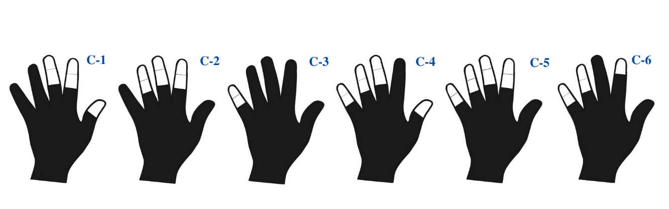

Gargas (Leroi-Gourhan, 1967)

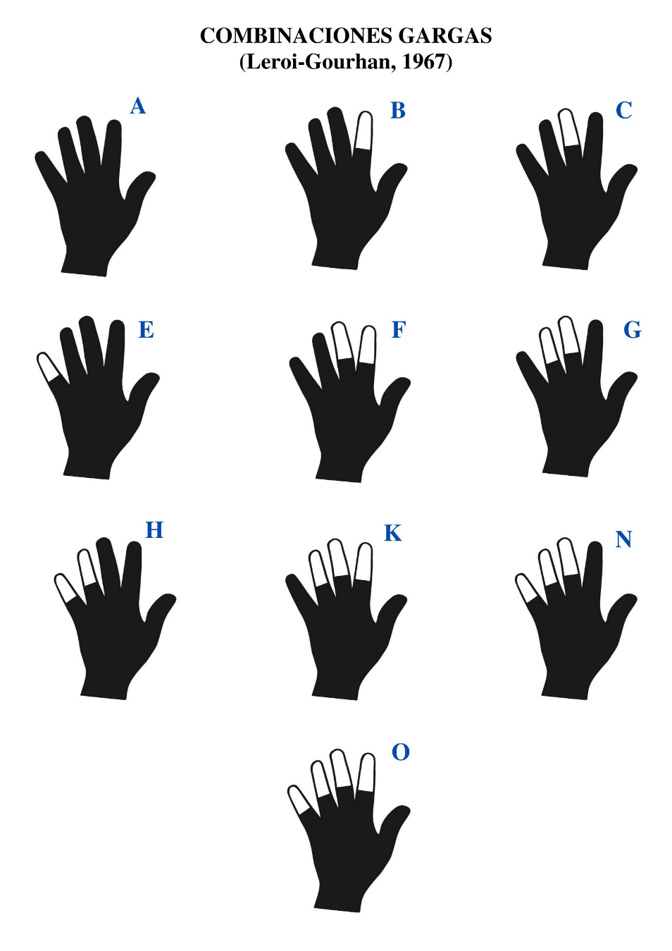

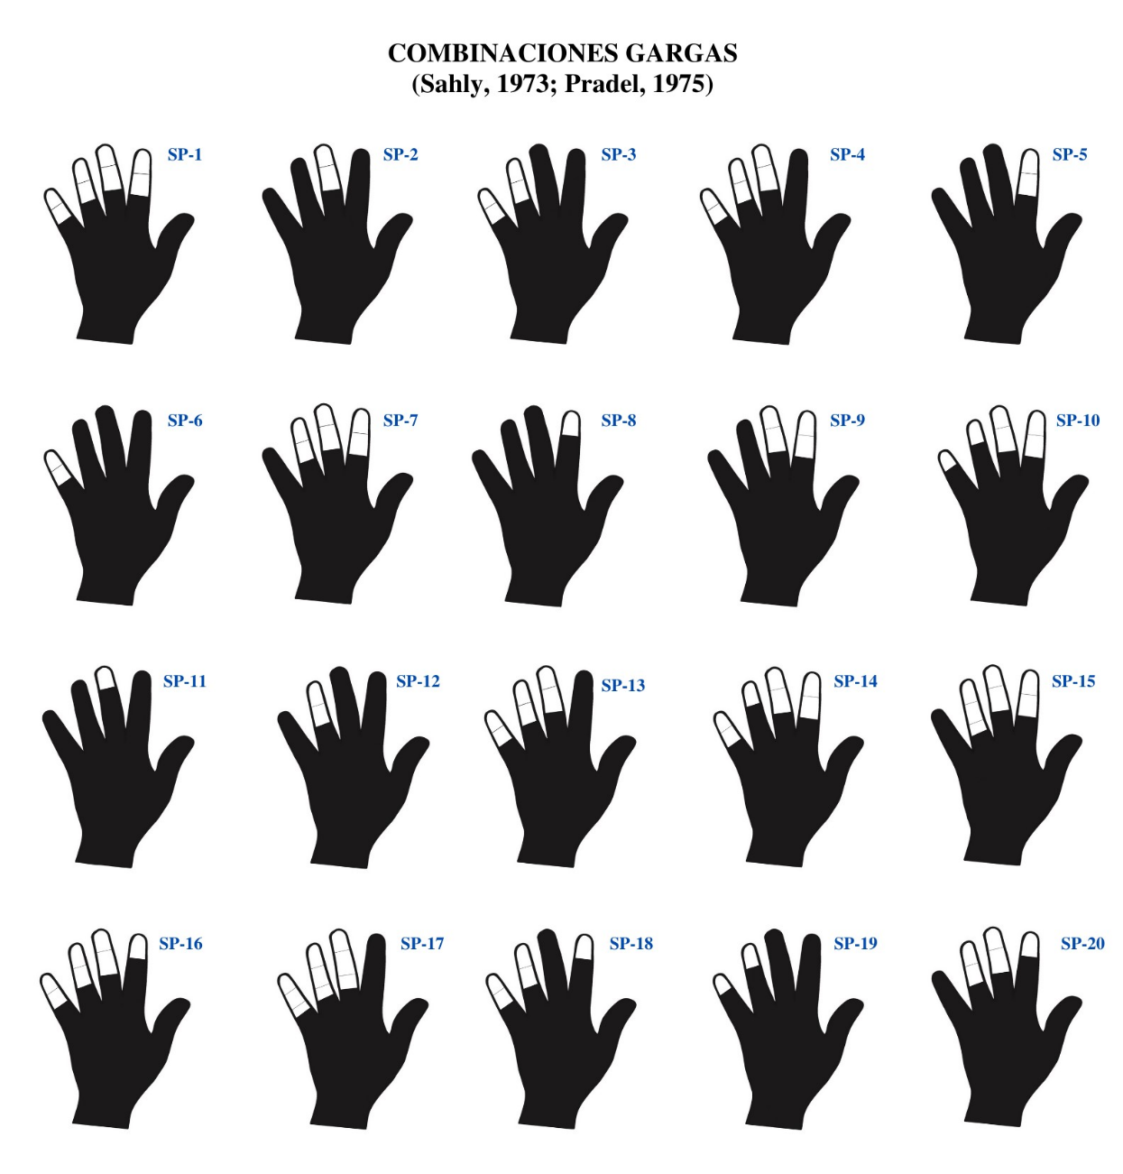
Gargas (Sahly 1973; Pradel, 1975)
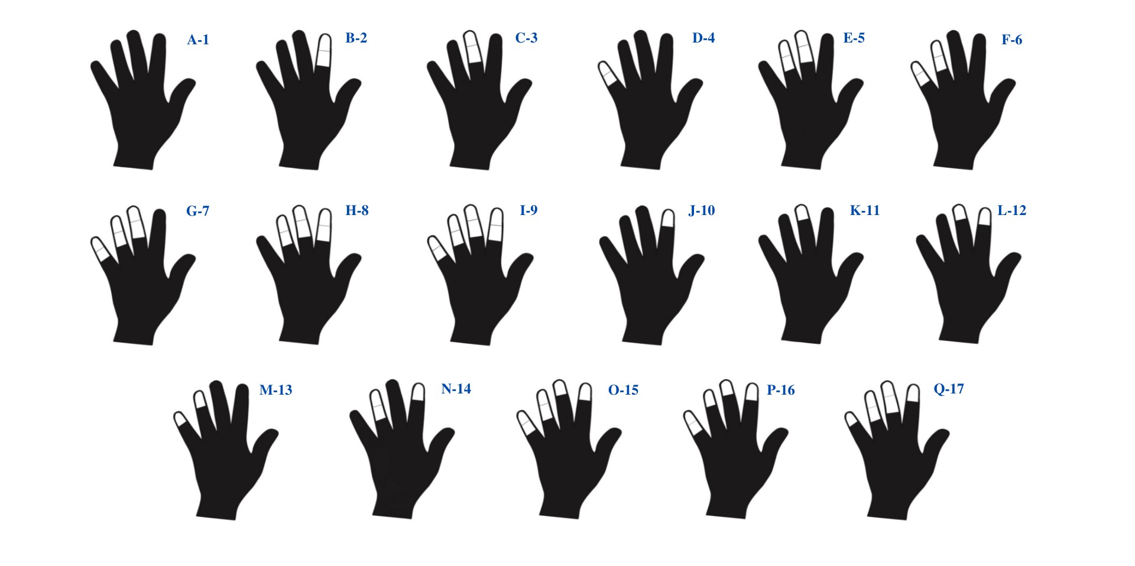
Gargas (Barrière, 1976)
Cosquer (Rouillon, 2016)

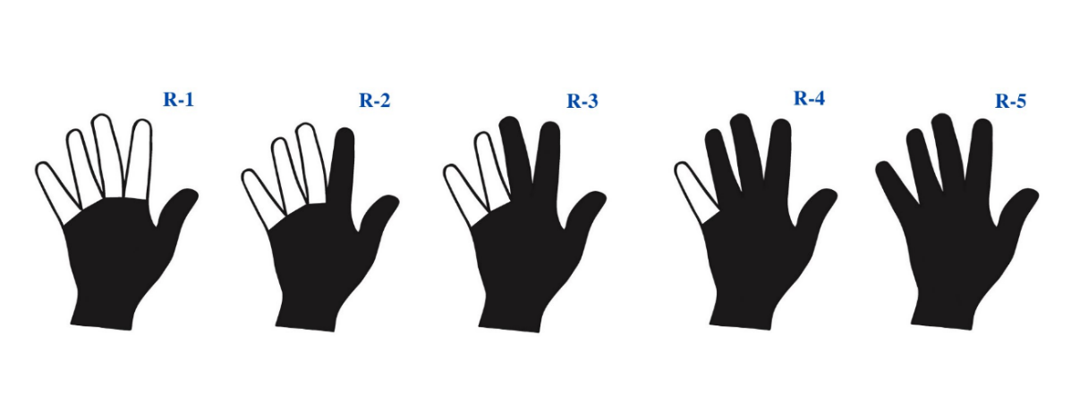

Supp. 4. Factorial analysis results
$'1'
[1] "ESP. ARD.02" "ESP. CAST.24" "ESP. CAST.16" "ESP. CAST.23" "ESP. CAST.17"
[6] "ESP. CAST.39" "ESP. CAST.03" "ESP. CAST.06" "ESP. CAST.07" "ESP. CAST.08"
[11] "ESP. CAST.63" "ESP. CAST.62" "ESP. PS.09" "ESP. PS.16" "ESP. PS.21"
[16] "ESP. PS.04" "ESP. SAL.03" "ESP. PS.05" "ESP. PS.15" "ESP. TRU.42"
[21] "ESP. TRU.16" "ESP. MALT.35" "ESP. MALT.47" "ESP. MALT.45" "ESP. MALT.46"
[26] "ESP. MALT.37" "ESP. MALT.60" "ESP. MALT.24" "ESP. EXIT.01"
$'2'
[1] "ESP. ALT.02" "ESP. ALT.05" "ESP. ALT.01" "ESP. ALT.08" "ESP. CAST.36"
[6] "ESP. CAST.35" "ESP. CAST.40" "ESP. CAST.28" "ESP. CAST.34" "ESP. CAST.32"
[11] "ESP. CAST.72" "ESP. CAST.73" "ESP. CAST.14" "ESP. CAST.15" "ESP. CAST.22"
[16] "ESP. CAST.20" "ESP. CAST.53" "ESP. CAST.55" "ESP. CAST.31" "ESP. CAST.58"
[21] "ESP. CAST.52" "ESP. CAST.51" "ESP. CAST.45" "ESP. CAST.02" "ESP. CAST.38"
[26] "ESP. CAST.37" "ESP. CAST.41" "ESP. CAST.43" "ESP. CAST.21" "ESP. CAST.27"
[31] "ESP. CAST.04" "ESP. CAST.05" "ESP. CAST.44" "ESP. CAST.68" "ESP. CAST.78"
[36] "ESP. CAST.69" "ESP. CAST.77" "ESP. CAST.61" "ESP. CAST.13" "ESP. CAST.12"
[41] "ESP. CAST.11" "ESP. CAST.10" "ESP. CAST.09" "ESP. MOS.01" "ESP. SALT.12"
[46] "ESP. PS.14" "ESP. PS.13" "ESP. TRU.20" "ESP. TRU.55" "ESP. TRU.46"
[51] "ESP. TRU.13" "ESP. TRU.24" "ESP. TRU.18" "ESP. TRU.27" "ESP. TRU.14"
[56] "ESP. TRU.11" "ESP. TRU.32" "ESP. TRU.07" "ESP. GAR.25" "ESP. GAR.31"
[61] "ESP. GAR.20" "ESP. GAR.22" "ESP. MALT.56" "ESP. MALT.58" "ESP. MALT.59"
[66] "ESP. MALT.11" "ESP. MALT.16" "ESP. PALO.04" "ESP. PIL.08" "ESP. TIT.01"
$'3'
[1] "ESP. ARD.01" "ESP. EST.03" "ESP. EST.01" "ESP. EST.05" "ESP. TRU.05"
[6] "ESP. TRU.29" "ESP. TRU.43" "ESP. MALT.28" "ESP. MALT.29" "ESP. MALT.31"
[11] "MALT.34 ESP.34" "MALT.36" "MALT.14" "MALT.38" "MALT.33"
[16] "ESP. MALT.06" "ESP. MALT.39" "ESP. MALT.52" "ESP. MALT.53" "ESP. MALT.54"
[21] "MALT.57 ESP." "MALT.48" "MALT.51" "MALT.02" "MALT.13"
[26] "MALT.12" "MALT.10" "MALT.01" "MALT.50" "MALT.04"
[31] "ESP. MALT.17" "ESP. PALO.01" "ESP. PALO.02" "ESP. . 03" CLUB
$'4'
[1] "ESP. TRU.51" "ESP. TRU.52" "ESP. TRU.53" "ESP. TRU.33" "ESP. TRU.40"
[6] "ESP. TRU.39" "ESP. TRU.41" "ESP. TRU.47" "ESP. TRU.26" "ESP. TRU.19"
[11] "ESP. TRU.06" "ESP. TRU.30" "ESP. MALT.55" "ESP. PIL.11"
$'5'
[1] "ESP. CUD.01" "ESP. EST.02" "ESP. PS.17" "ESP. TRU.37" "ESP. TRU.09"
[6] "ESP. GAR.29" "ESP. MALT.41" "ESP. MALT.42" "ESP. MALT.19" "ESP. MALT.30"
[11] "ESP. MALT.32" "ESP. MALT.27" "ESP. MALT.03" "ESP. MALT.18" "ESP. MALT.20"
[16] "ESP. MALT.22" "ESP. MALT.25" "ESP. PIL.12"
$'6'
[1] "ESP. ALT.04" "ESP. ALT.07" "ESP. ASK.01" "ESP. CAL.01" "ESP. CAST.26"
[6] "ESP. CAST.25" "ESP. CAST.49" "ESP. CAST.71" "ESP. CAST.74" "ESP. CAST.66"
[11] "ESP. CAST.60" "ESP. CAST.33" "ESP. CAST.59" "ESP. CAST.48" "ESP. CAST.50"
[16] "ESP. CAST.67" "ESP. CAST.70" "ESP. CUD.02" "ESP. PS.08" "ESP. SALT.10"
[21] "ESP. PS.11" "ESP. PS.20" "ESP. PS.22" "ESP. PS.07" "ESP. TRU.21"
[26] "ESP. TRU.03" "ESP. TRU.54" "ESP. TRU.45" "ESP. TRU.25" "ESP. TRU.23"
[31] "ESP. TRU.56" "ESP. GAR.15" "ESP. GAR.19" "ESP. GAR.11" "ESP. GAR.36"
[36] "ESP. GAR.21" "ESP. GAR.18" "ESP. GAR.07" "ESP. GAR.04" "ESP. GAR.03"
[41] "ESP. GAR.35" "ESP. GAR.01" "ESP. GAR.05" "ESP. LAST.01" "ESP. LAST.02"
[46] "ESP. LAST.03" "ID_302" "ESP. PIL.10" "ESP. PIL.07"
$'7'
[1] "ESP. ALT.03" "ESP. CAST.46" "ESP. CAST.64" "ESP. PS.06" "ESP. SALT .02"
[6] "ESP. TRU.01" "ESP. TRU.35" "ESP. TRU.36" "ESP. TRU.17" "ESP. GAR.34"
[11] "ESP. GAR.08" "ESP. GAR.12" "ESP. GAR.27" "ESP. GAR.28" "ESP. GAR.32"
[16] "ESP. GAR.33" "ESP. GAR.17" "ESP. GAR.02" "ESP. MALT.15" "ESP. MALT.43"
[21] "MALT.44" "MALT.40" "MALT.49" "MALT.09" "MALT.07"
[26] "ESP. MALT.21"

Supp.5. Characterization of each experimental technique
N° | Technique | Pigment type | Wall type | Summary of characteristics | Splatters
A | Brush | Dry | Damp | Technique characterized by an opaque and homogeneous appearance. The halo is continuous, with abrupt edges and totally conditioned by the artist's will.  The traces of the brushstrokes are visible, as well as those of the hair in certain places. | No
B | Brush | Liquid | Dry | Technique very similar in appearance to the first one (A). In this case the brushstrokes are less visible. The halo is very opaque, with abrupt edges, also depends entirely on the will of the artist. | No
C | Brush. Forceful paint projection | Liquid | Dry | Technique that can be refuted with a fair degree of certainty. The shape of the hand is not perceptible, and the drips and marks of the paint prevent the definition of the motif. | Yes, many, on the walls and on the floor.
D | Short bristle brush | Liquid | Dry | This technique produces a very inhomogeneous result, which does not allow us to appreciate the shape of the hand stencil. The projected drops are very large and separated. The shape of the halo is very irregular. | Yes, some on the walls and floor.
E | Stamp | Dry | Damp | Technique whose most characteristic result is the formation of a drawn outline, in which the interdigital spaces are absent.  The width of the tool creates an impression of finger thickness that does not correspond to the real model. The buffer marks are visible, and the halo formed is abrupt. It is also observed that the painted surface is not homogeneous, as the pigment does not penetrate into the cracks of the wall. | No
F | Stamp | Liquid | Dry | Technique very similar to that used with dry pigment stamping on a wet wall (E), which gives a similar appearance of fingers with very wide and poorly defined interdigital spaces. Also visible are the traces of the tampon, the outline of which is very characteristic. Similarly, the pigment does not reach the crevices of the support. | Yes, some large drops.
G | Finger | Dry | Damp | This technique, like stamping techniques, has a characteristic drawn appearance. The outline is well defined, depending on the artist's will, and the pigment does not slip on the irregularities of the support. The overall appearance is quite similar to that of the brush (A & B), but without traces of bristles or lines. The pigment is also very condensed. | No
H | Finger | Liquid | Dry | Technique that produces a very homogeneous and characteristic rough outline. As with the finger application of dry pigment on a wet wall (G), the paint does not reach the small holes in the wall. | No
I | 1 tube. Water in the mouth | Dry | Dry | Technique characterized by a very diluted pigment, not very opaque, which does not allow to define the hand in an appreciable way. | Yes, some on the ground, with medium intensity.
J | 1 tube. Liquid Paint projection | Liquid (seco mesclado en la boca) | Dry | Technique defined by the scarce definition of the hand, due to the great liquidity of the paint. This characteristic causes the paint to slide between the hand and the wall, preventing the fingers from being drawn. The halo is not very diffuse. | Yes, on the floor and wall, large drops.
K | 1 tube. Dry pigment projection | Dry | Damp (cave) | Convincing technique that gives a defined and very clean result. The halo is smooth and the surface is uniform and shiny. However, it is slightly less opaque than the venturi technique (L) and direct mouth projection (N). The technique is a bit tedious, as it requires filling the tube with pigment (at least 7 times for a negative hand), which requires the intervention of at least two people. Numerous small lumps of hematite can be observed around the form, leaning on the irregularities of the wall. | Yes, the dry pigment falls in flakes. Powder remains on the surrounding irregularities.
L | Airbrush (venturi effect) | Liquid | Dry (cave) | A very efficient, fast and clean technique that provides a convincing result with a smooth halo and a uniform, opaque surface. No dripping marks are present. | Yes, very few on the ground.
M | 1 tube | Dry | Dry (cave) | The results of this technique are exactly the same as those obtained using a tube of dry pigment on a wet wall (K). The pigment is well fixed to the wall. | Yes, the dry pigment falls in flakes. Powder remains on the surrounding irregularities.
N | Direct mouth projection | Liquid | Dry (cave) | A convincing, fast and effective technique, but which requires specific management and possible training on the part of the operator if the result is to be achieved. May produce drips and larger droplets depending on the skill of the person blowing. The direction of blowing can be observed in the shapes of the halo droplets. | Yes, large drops on the ground.

Supp. 6. R Complete code.
## Install necessary packages
install.packages(c("FactoMineR", "factoextra", "tidyverse","xlsx","reprex"))
library(xlsx)
library(FactoMineR)
library(factoextra)
library(ggplot2)
library(tidyverse)
library(reprex)
library(scales)
library(ggrepel)

# Install and load required libraries if not already installed
library(FactoMineR)
library(factoextra)
library(readxl)

# Load required libraries
library(FactoMineR)
library(factoextra)
library(readxl)

# Ensure all columns are treated as factors
Combinaciones_copia[] <- lapply(Combinaciones_copia, factor)

# Check the structure of the data after conversion to factors
cat("Data structure after conversion to factors:\n")
str(Combinaciones_copia)

# Run Multiple Correspondence Analysis (MCA)
cat("Running MCA...\n")
res.mca <- MCA(Combinaciones_copia, graph = FALSE)

# If MCA was successful, proceed with visualization
if (!is.null(res.mca)) {
cat("MCA analysis completed successfully. Generating plots...\n")

# Visualize scree plot
fviz_screeplot(res.mca)

# Visualize variable contributions
fviz_contrib(res.mca, choice = "var", axes = 1, top = 20, palette = "jco")
fviz_contrib(res.mca, choice = "var", axes = 2, top = 20, palette = "jco")

# Run Hierarchical Clustering on Principal Components (HCPC)
cat("Running HCPC...\n")
clusters <- HCPC(res.mca, nb.clus = -1, graph = FALSE)

# Visualize clusters and dendrogram
fviz_cluster(clusters, repel = TRUE, show.clust.cent = TRUE, palette = "jco",
ggtheme = theme_minimal(), main = "Cluster Factor Map")
fviz_dend(clusters, cex = 0.1, k_colors = c("#CD534CFF", "#868686FF", "#EFC000FF", "#0073C2FF"))
} else {
cat("Error: MCA analysis did not complete successfully.\n")
}

# Remove columns with null or constant values
a2 <- a2[, apply(a2, 2, function(x) length(unique(x)) > 1)] # Remove constant columns

# Generate factor map without ellipses
library(ggplot2)
fviz_mca_ind(res.mca,
geom = "point",
col.ind = "cos2", # Color based on quality of representation
palette = "jco",
legend.title = "Cos2",
ggtheme = theme_minimal()) +
ggtitle("MCA Individual Factor Map") +
scale_color_gradient(low = "blue", high = "red")

library(ggplot2)
library(viridis)

fviz_mca_ind(res.mca,
geom = "point",
col.ind = "cos2",
palette = "jco",
legend.title = "Cos2",
ggtheme = theme_minimal(),
addEllipses = TRUE, # Add confidence ellipses
ellipse.level = 0.95) +
ggtitle("MCA Individual Factor Map with Ellipses") +
scale_color_viridis(option = "D")

# Run HCPC again
c <- HCPC(res.mca, nb.clus = -1, graph = FALSE)

# View cluster assignment results
c$data.clust

library(factoextra)
library(viridis)

# Extract group assignments
grupos <- c$data.clust$clust

# Create factor map with ellipses by group
fviz_mca_ind(res.mca,
geom = "point",
col.ind = grupos,
palette = "jco",
addEllipses = TRUE,
ellipse.level = 0.95,
legend.title = "Group",
ggtheme = theme_minimal()) +
ggtitle("Factor Map with Group Ellipses (MCA)") +
scale_color_viridis_d()

# Extract group assignments
grupos <- c$data.clust$clust

# Extract individual names (typically row names of your original dataset)
individuos <- rownames(a2)

# Create dataframe with individuals and their assigned group
grupo_individuos <- data.frame(Individuo = individuos, Grupo = grupos)

# Create a list of individuals per group
lista_grupos <- split(grupo_individuos$Individuo, grupo_individuos$Grupo)

# Show the list of individuals by group
print(lista_grupos)

# Visualize hierarchical clustering with individual labels
fviz_cluster(c,
geom = "point",
show.clust.cent = TRUE,
repel = TRUE,
label = "all",
palette = "jco",
ggtheme = theme_minimal(),
main = "Hierarchical Clustering of MCA")

# View group assignments for each individual
c$data.clust[, c("ind", "clust")]

# Create list of individuals by group
grupos_individuos <- split(c$data.clust$ind, c$data.clust$clust)

# Show individuals by group
grupos_individuos

# Run chi-square and Fisher tests for each variable
c <- HCPC(res.mca, nb.clus = -1, graph = FALSE)
grupos <- c$data.clust$clust
for (var in colnames(Combinaciones_copia)) {
cat("\nVariable:", var, "\n")
print(chisq.test(table(grupos, Combinaciones_copia[[var]])))
}
fisher.test(table(grupos, Combinaciones_copia[[var]]))

# Vector of groups detected by HCPC
grupos <- c$data.clust$clust

# Create table to store results
chi_resultados <- data.frame(
Variable = character(),
Chi_Squared = numeric(),
df = numeric(),
P_Value = numeric(),
stringsAsFactors = FALSE
)

# Iterate through each variable in the factorial analysis
for (var in colnames(Combinaciones_copia)) {
tabla <- table(grupos, Combinaciones_copia[[var]])

if (ncol(tabla) > 1) {
test <- suppressWarnings(chisq.test(tabla))

chi_resultados <- rbind(chi_resultados, data.frame(
Variable = var,
Chi_Squared = round(test$statistic, 2),
df = test$parameter,
P_Value = round(test$p.value, 5),
stringsAsFactors = FALSE
))
}
}

# Sort results by p-value (most significant at top)
chi_resultados <- chi_resultados[order(chi_resultados$P_Value), ]

# Mark statistical significance
chi_resultados$Significativo <- ifelse(chi_resultados$P_Value < 0.05, "Yes", "No")

# Display sorted results table
print(chi_resultados)

