Appendix 1 - Positionality Statements

In qualitative research, positioning oneself is essential to acknowledge the impact that our background, acts and beliefs might have had on the study.

EP:

I am an educated western woman who undertook these workshops from the perspective of an archaeologist. This approach might have influenced the workshops themselves as well as the content of stories. Despite having experience working in Latin America and being fluent in Spanish, it was the first time that I was working in Galapagos. My position on the topic of plastic pollution is also important to note: my research looks at plastic pollution in Galapagos, a topic that can trigger ecological anxiety and be overwhelming at times. Due to several changes in my PhD, the organisation of workshops became the core of my PhD, which means that there were important elements at stake for the workshops to work efficiently. The workshop settings were sometimes challenging with at times more than thirty students participating in one workshop. An attempt for reflexivity was undertaken by keeping notes during the workshop and thinking about positionality throughout the analysis, annotating potential biases.

AG:

I am an educated western woman who undertook these workshops from the perspective of a conservation biologist and environmental educator. I am also a permanent resident of the Galapagos Islands and have been living and working there for over twenty years. In the past five years, I have been leading educational activities and citizen science projects related to the marine plastic contamination issue in the archipelago. This is part of an overarching programme that includes physical, biological and social components. My personal experience and perceptions of the local context might have influenced the workshops themselves as well as the content of stories and answers to the surveys. At the same time, my knowledge of the local context has allowed me to avoid some misunderstandings and offer my own expertise on the topic to students when asking questions notably about remote accumulation beaches. Apart from the educational aspect and building on pre-existing networks of environmental education in Galapagos, there were no particular elements at stake for me in undertaking the workshops.

Appendix 2 - Coding strategy

* NVivo

After removing the stories that did not answer any of the questions, 137 stories, including comics and illustrated stories, with full consent were analysed. As the stories were all transcribed, we ensured that they were authentic (saying things about the writer’s perceptions and values) and real (the researcher discovers information about participants that they might even not realise) (Savin-Baden and Howell Major 2013, 238). We here used a deductive approach by importing and adapting the codebook used in our previous study (Praet et al. 2023a, see Table 1 and Supplementary materials). As the activities had a similar design (pre- and post-survey, a set of similar orienting questions and the task of writing an artefact’s journey) and only differed in the format (online for Praet et al. 2023a, in person for this study), the set codebook was a useful tool that had already been approved by a multidisciplinary team to look at perceptions of MPL by schoolchildren from Latin American countries along the Pacific coast. We explored inductive coding following a thematic approach related to the concept of object itineraries in a previous study (Praet et al. 2023b).

* Codebook

Just as in Praet et al. (2023a), the codebook has four overarching themes: the object as a product, the object as waste, the solutions and the story’s structure. These themes allowed us to consider all aspects of the questions asked of the students (Table 1). The first theme looks at the type of object used, its emotions, who used it and for how long (questions 1, 2 and 4). The second theme gathered information about the object’s journey (duration, emotions, types and consequences of interactions with the environment, animals and humans, process of becoming waste) (questions 3, 5 and 6). The third theme focused on preventive and reactive solutions along with their actors (question 7). The fourth theme provides contextual information about narrative type, location of the story and movement of the object. The use of the ReCiBa codebook allowed for direct comparison of themes present in the stories on the East Pacific and in Galapagos. It should be noted that the codes that did not appear in any of the 137 stories were deleted and a couple of codes were created within the pre-established categories (e.g. animals interacting with wildlife were sometimes species only present in Galapagos).

Table 1: Relationship between the questions asked in the workshop, the coded overarching themes and the way results are reported in this study

| **Questions** | **Overarching themes** | **Reporting of results** |
| --- | --- | --- |
| What is the object? | Object as product | Sources |
| How old is the object? | Object as product | Sources |
| Where is the object from? | Object as product/ structure of the story | Sources |
| How was the object used and by whom? | Object as product/ structure of the story | Sources |
| How did the object enter the environment? | Object as waste | Sources |
| How did the object interact with the environment? | Object as waste | Impacts |
| What actions might have prevented the object from entering the environment? | Solutions | Solutions |

Appendix 3 - Number of respondents per question. A pair-wised approach was adopted for the before/after question before undertaking Wilcoxon signed rank test.

| **Category** | **Question** | **Answer type** | **Before/after** | **Respondents** |
| --- | --- | --- | --- | --- |
| Relationship with nature | How often do you visit the beach? | Every day; Every week; Every month; A few times a year; Once a year or less; Never | no | 160 |
| Pro-environmental behaviour | Do you recycle at home? | Yes/No (+give an example) | no | 160 |
| Pro-environmental behaviour | Have you ever been involved in an organised beach clean-up or litter pick-up? | Yes/No  If yes, where? with whom? | no | 160 |
| Solutions | Name one solution to avoid marine plastic litter to reach the ocean | Open question | no | 160 |
| Self-reported knowledge | How much do you think you know about marine litter? | Likert: 1 (I know nothing) to 5 (I know a lot) | yes | 123 |
| Self-reported knowledge | I know how I can reduce marine plastic litter. | Likert: 1 (I strongly disagree) to 5 (I strongly agree) | yes | 153 |
| Perception of origin | Marine litter comes from domestic activities in the archipelago. | Likert: 1 (I strongly disagree) to 5 (I strongly agree) | yes | 158 |
| Perception of origin | Marine litter comes from fishing activities. | Likert: 1 (I strongly disagree) to 5 (I strongly agree) | yes | 158 |
| Perception of origin | Marine litter comes from distant areas of Galapagos. | Likert: 1 (I strongly disagree) to 5 (I strongly agree) | yes | 156 |
| Perception of abundance | How much litter have you seen around your school or college? | Likert: 1 (very dirty) to 5 (very clean) | yes | 159 |
| Perception of abundance | How much litter have you seen around your neighbourhood? | Likert: 1 (very dirty) to 5 (very clean) | yes | 157 |
| Perception of abundance | How much litter have you seen on the beach you visit the most? | Likert: 1 (very dirty) to 5 (very clean) | yes | 157 |
| Perception of impacts | Marine plastic litter affects the appearance of beaches | Likert: 1 (I strongly disagree) to 5 (I strongly agree) | yes | 159 |
| Perception of impacts | It is common for marine plastic litter to damage wildlife around the world. | Likert: 1 (I strongly disagree) to 5 (I strongly agree) | yes | 158 |
| Perception of impacts | Marine plastic litter poses a danger to human health. | Likert: 1 (I strongly disagree) to 5 (I strongly agree) | yes | 157 |
| Perception of impacts | The way my family and I deal with the litter in our house can affect the litter in the sea. | Likert: 1 (I strongly disagree) to 5 (I strongly agree) | yes | 158 |
| Pro-environmental behaviour | Pick up litter on the ground around my school or college. | 1= never, 2= rarely, 3= sometimes, 4=often, 5= always | yes | 159 |
| Pro-environmental behaviour | Picking up litter on the ground in the streets of my neighbourhood. | 1= never, 2= rarely, 3= sometimes, 4=often, 5= always | yes | 159 |
| Pro-environmental behaviour | Pick up litter found on the beach. | 1= never, 2= rarely, 3= sometimes, 4=often, 5= always | yes | 159 |
| Pro-environmental behaviour | Recycle. | 1= never, 2= rarely, 3= sometimes, 4=often, 5= always | yes | 159 |
| Pro-environmental behaviour | Not buying single-use plastic. | 1= never, 2= rarely, 3= sometimes, 4=often, 5= always | yes | 157 |
| Pro-environmental behaviour | Try to convince family and friends to use less single-use plastic. | 1= never, 2= rarely, 3= sometimes, 4=often, 5= always | yes | 158 |
| Pro-environmental behaviour | Trying to convince people in my community to use less single-use plastic. | 1= never, 2= rarely, 3= sometimes, 4=often, 5= always | yes | 159 |
| Interest | How interested are you in learning more about marine plastic litter? | 1= not interested to 5= very interested | yes | 153 |
| Interest | How important is it for you to reduce marine plastic litter? | 1= not important at all to 5= very important | yes | 150 |
| Feedback | How much did you enjoy the activity? | from not at all to very much | no | 156 |
| Feedback | I learned something about marine litter in this activity | Likert: 1 (I strongly disagree) to 5 (I strongly agree) | no | 158 |
| Feedback | I learned something new about marine litter's origin | Likert: 1 (I strongly disagree) to 5 (I strongly agree) | no | 158 |
| Feedback | I learned something new about marine litter's potential impacts on wildlife | Likert: 1 (I strongly disagree) to 5 (I strongly agree) | no | 158 |
| Feedback | I learned something new about actions to reduce plastic marine litter | Likert: 1 (I strongly disagree) to 5 (I strongly agree) | no | 157 |
| Feedback | I would encourage family and friends to take part in the activity | Likert: 1 (I strongly disagree) to 5 (I strongly agree) | no | 158 |
| Feedback | Would you agree to share your story online and/or in an exhibition? | Yes with my name/ Yes without my name/ No | no | 158 |

Appendix 4 - Codebook

The codebook includes the codes used to analyse the data, their description, their occurrence where files correspond to the number of stories where the code appears, and references indicate the number of times a code occurs across all stories.

| **Name** | **Description** | **Files** | **References** | **% of stories** |
| --- | --- | --- | --- | --- |
| Object as a product | This codes for the stage when the main object in the story is a product being manufactured, stored and used. Once it is discarded, the object is not considered as a product anymore but enters the category of “object as waste”. | 136 | 325 | 99.3% |
| How was the object used and who used it | This codes for the context of the object use: 1) the length of use of the object 2) the interaction of the object, either with adults or with children/teens | 104 | 158 | 75.9% |
| Length of use of the object | This codes for the “life” of the object: how long has it been used? There are three categories: 1) less than a day 2) between days and months 3) over a year. This will enable us to say how recurrent is replacing the object with a new one and to see which solutions are proposed for the type of objects. The length of use refers to the time between the first use of the object and it entering the environment as waste. The codes are used only when there are temporal elements specified in the story. | 57 | 57 | 41.6% |
| Between days and months | This codes for a length of use that is more than a day but less than a year. For instance, fishing bags or chlorine gallons are usually used a couple of months before being disposed of. | 31 | 31 | 22.6% |
| Less than a day | The object can be used less than a day. This typically refers to single-use plastics that are not reused and directly discarded after use. For instance, plastic bottles that are said to be not reused. | 16 | 16 | 11.7% |
| Over a year | This length of use typically refers to the use of an object over a year. That is typical the case for toys, unless when explicitly stated. A toy might be broken or lost before that although that remains accidental. | 10 | 10 | 7.3% |
| Who interacts with the object | This codes for the category of people (either children or adults) mostly interacting with the object. It can be an adult coming back from the supermarket or a child playing with a toy. | 94 | 101 | 68.6% |
| Adults | The category of adults refers to people that are not at school anymore and interact with the object. It can be the family of the children, other adults. This code mostly contrasts with the “children/teens” category. | 76 | 78 | 55.5% |
| Children and teens | This code considers together children and teens because most stories do not specify the age of the people interacting with the object. This is contrasting with the role of adults. | 21 | 22 | 15.3% |
| What is the object | This code gathers all the elements that relate to the object being the focus of the story, going from product to waste. This includes the type of object and also its emotions as product, before becoming waste. | 136 | 167 | 99.3% |
| Emotions of the object | When the object has human characteristics such as thinking, talking or a name, this code enables us to infer an emotion that the object possesses as product. | 13 | 24 | 9.5% |
| Negative | This code gathers negative emotions felt by the object. It can be tiredness, impatience, apprehension, … | 9 | 13 | 6.6% |
| Apprehensive | This codes for the negative feeling of apprehension towards a future event, such as feeling nervous or preoccupied. | 2 | 2 | 1.5% |
| Bored | This code for the object being bored (i.e. finding the situation little interesting and not having much to do). It differs from impatience, a more active emotion of the object not controlling the long waiting time. | 2 | 2 | 1.5% |
| Impatient | This codes for a lack of patience or the object being tired to be waiting to be used. It differs from apprehension as it does not include concern regarding the future. It also differs from the object being bored (i.e. just finding the situation uninteresting). | 3 | 3 | 2.2% |
| Suffering | This codes for the object suffering from the situation, either mentioning it explicitly or referring to its journey in a negative way. | 2 | 2 | 1.5% |
| Tired | This codes for the object stating that it is tired, notably from the journey. | 2 | 2 | 1.5% |
| Uncertain | This code is for a general lack of understanding and clarity about the current situation. | 1 | 1 | 0.7% |
| Positive | This code gathers emotions that are positive, bringing either happiness or excitement to the object. | 9 | 11 | 6.6% |
| Excited | When the object is looking forward to being used, sold, or getting to know the world, we code this under “excited”. It also includes excitement to go somewhere or meet someone. It is a positive feeling regarding any future event. | 2 | 2 | 1.5% |
| Happy | This codes for object mentioning their happiness in the present. It can be for instance when the object gets to be functional in their intended use. It is only restricted to the object as a product rather than as waste. | 8 | 8 | 5.8% |
| Type of object | The type of object codes for the category of object (the main object in the story) explicitly mentioned in the text. A description per object type does not seem useful as those items are literally mentioned in the stories. Some objects were not specifically identified and only referred to as PET bottles, hence the broader category. | 136 | 143 | 99.3% |
| Angermeyer information sign | This is an information sign with attention hours of the Angermeyer Point restaurant in Puerto Ayora, Santa Cruz (since 2001). The back of the sign has green marks, potentially from algae, and corrosion marks. It was recently broken in half (cut is fresh) after being weakened in this section. | 5 | 6 | 3.6% |
| Bucket | This is the bottom part of a red bucket made of high-density polyethylene. There are several inscriptions on the bucket successively giving information about material, origin and age: HDPE (2), … Ecuatorianos Guayaquil Ecuador, a clock with years indicating 98. It also had a mollusc stuck with visible remains of a shell. | 15 | 16 | 10.9% |
| Chinese fishing sack | This is a fishing sack that has Chinese inscriptions on it. It also shows a table with different weights from less than 100g to more than 600g. | 17 | 18 | 12.4% |
| Chlorine gallon | This is a big chlorine (5%) gallon with recommended use for cisterns, swimming pools, to avoid bad smells, in food industries, in hospitals. It has a lot number (2021015), an expiry date (15/10/2023) and a production date (15/10/2021). It is an Ecuadorian company and has a contact number and email on the label. | 2 | 2 | 1.5% |
| Clorox bottle | This is a Clorox bottle (500ml) that has a label with a barcode and inscriptions of an Ecuadorian company (Montecristi for Clorox del Ecuador S.A.). It has bumps and remains of eggs laid by a winkle. | 8 | 8 | 5.8% |
| Copropag Galapagos bag | This is a fishing sack of the Galapagos traditional fishing cooperative Copropag. It has inscriptions: por favor no arrojar al mar (please do not throw it in the sea). | 15 | 16 | 10.9% |
| Frisbee | This is an orange worn yet complete frisbee. It has the inscription Mall del Sol, a famous mall in Guayaquil, mainland Ecuador. | 9 | 10 | 6.6% |
| Hulk | This is an action figurine of Marvel’s Hulk. Its green colour has faded on its back and its joints are corroded. It is also missing the head. | 12 | 12 | 8.8% |
| Life buoy | This codes for an orange plastic life buoy. It has several inscriptions on it: 5556 (model), 2.5kg (weight), Life buoys (brand), SOLAS96 (compliance with Safety Of Life At Sea regulation), MSO.81.(70) (regulation on testing of life-saving appliances). It is only a section of the life buoy and it lacks the foam. | 14 | 14 | 10.2% |
| PET beverage bottle | This codes for PET bottles for beverages when not specified if they are the 220V or Nongfu Spring bottle. | 39 | 41 | 28.5% |
| 220V bottle | This is a blue 220V bottle. It is an energy drink sold for 1$ (price is on the cap). It has a barcode with information on the origin: the bottle is produced by the Tesalia Springs Company, an Ecuadorian company. There is a date that is difficult to read on the bottle cap. | 16 | 16 | 11.7% |
| Nongfu Spring bottle | This is a bottle that has a weathered label that represented a mountain. The bottle cap has an inscription: Nongfu Springs. It also includes a date: 2019/07/31 and a number: 222950 Y5. On the bottom, it has the plastic category 1 (corresponding to Polyethylene Terephthalate - PET). | 18 | 19 | 13.1% |
| Object as waste | This code gathers all elements relating to the object as waste, once it does not fulfil its intended use but is abandoned and enters the environment as waste, as a matter out of place. It also calls for elements when the objects enter recycling plants or landfills and is considered as waste, rather than as a product. | 136 | 969 | 99.3% |
| Duration of the journey | This relates to the length of the journey (days, months or years) from temporal elements specified in the stories. | 51 | 53 | 37.2% |
| Between a day and a month | This codes for any journey lasting less than a month. | 9 | 9 | 6.6% |
| Between a month and a year | This codes for any journey lasting between a month and a year. | 17 | 19 | 12.4% |
| Over a year | This codes for any journey lasting over a year. | 25 | 25 | 18.2% |
| Emotions of the object | When the object has human features such as thinking, talking or a name, this code enables us to infer an emotion such as hope, feeling powerless, guilty or so. | 17 | 28 | 12.4% |
| Negative | This code gathers negative emotions subdivided into feelings 1) regarding a past event and 2) regarding a present event. | 16 | 25 | 11.7% |
| Awareness of being harmful | This codes for the object becoming aware of its impact on the environment. | 3 | 3 | 2.2% |
| Fear | This codes for the object as waste feeling afraid. | 2 | 2 | 1.5% |
| Powerlessness | This codes for the object feeling powerless facing its situation. It is a feeling anchored in the present. Powerless corresponds to the impossibility of doing anything to change its situation. | 5 | 5 | 3.6% |
| Sadness | This codes for the object as waste feeling sad. | 8 | 11 | 5.8% |
| Sense of futility | This codes for perceiving the object’s life as futile or not seeing the point of it. | 2 | 2 | 1.5% |
| Tired |  | 1 | 1 | 0.7% |
| Positive | This code gathers positive emotions divided into a) feelings regarding a future event (hope) and b) feeling regarding the present (happiness). | 3 | 3 | 2.2% |
| Happiness | This codes for happiness felt by the object. It can be happiness when being nostalgic or happy about the outcome of the situation (when being picked up for example). | 3 | 3 | 2.2% |
| How did the object interact with its environment | This codes for the part of the story where the object as waste interacts with its surrounding environment. It can interact with animals and humans in different ways. | 97 | 320 | 70.8% |
| Animals interacting with plastics | This code gathers sections discussing interactions between animals and plastics: their nature (subdivided into harmful and non-harmful), and the type of animals involved. | 52 | 139 | 38.0% |
| Type of animals | This codes for all animals interacting with and being noticed by the object, either on the beach or in the sea. | 44 | 68 | 32.1% |
| Bird |  | 9 | 9 | 6.6% |
| Crab |  | 4 | 4 | 2.9% |
| Dolphin |  | 2 | 2 | 1.5% |
| Fish |  | 16 | 16 | 11.7% |
| Iguana |  | 3 | 3 | 2.2% |
| Micro-organisms | This codes for mentions of the plastic as support for micro-organisms. | 5 | 5 | 3.6% |
| Molluscs and crustaceans | This code excludes crabs although they are crustaceans. | 6 | 6 | 4.4% |
| Rat |  | 1 | 1 | 0.7% |
| Sea lion |  | 2 | 2 | 1.5% |
| Shark |  | 3 | 3 | 2.2% |
| Turtle |  | 14 | 14 | 10.2% |
| Whale |  | 2 | 2 | 1.5% |
| Type of interaction between animal and waste | This codes for the type of interaction between the object and the environment: 1) a discussion between both. 2) the animal trying to eat the object, or eating it. 3) an intoxication of the animal upon contact with the object. 4) the animal getting stuck in the plastic or the plastic sticking onto the animal. 5) growth of organisms on the object, either micro or macro-organisms. 6) Thought about the broader pollution, plastic or other. | 40 | 71 | 29.2% |
| Harmful | This codes for the interactions being specified and harmful towards the animal a) intoxication, b) entanglement, c) ingestion. | 29 | 42 | 21.2% |
| Asphyxia | This code refers to the literal mention of asphyxia because of plastic provoking death. | 2 | 2 | 1.5% |
| Bites | This codes for animals biting the plastic object. While it can lead to its ingestion, it does not always imply ingestion of the object. | 5 | 7 | 3.6% |
| Entanglement | This codes for animals getting entangled/wrapped/trapped in plastic objects. | 4 | 4 | 2.9% |
| Ingestion | This codes for animals ingesting the plastic objects or parts of it. | 25 | 28 | 18.2% |
| Intoxication | This codes for animals being intoxicated by the components of plastic. It refers to the plastic toxicity specifically. | 1 | 1 | 0.7% |
| Not harmful | This codes for interactions that are not harmful towards the animal such as 1) discussion and 2) overgrowth. | 16 | 29 | 11.7% |
| Dialogue | This code for animals and plastic objects having conversations together. | 3 | 6 | 2.2% |
| Game | This codes for animals playing with plastic objects. | 2 | 2 | 1.5% |
| Mode of transport | This codes for the plastic being used as mode of transportation for the animal. | 1 | 1 | 0.7% |
| Nest | This codes for the plastic being used as part of a bird’s nest. | 2 | 2 | 1.5% |
| Overgrowth | Type of interaction between animals and the object can include the growth of organisms, either micro or macro. Organisms that are visible are considered as macro whereas non visible organisms are considered as micro-organisms. | 7 | 9 | 5.1% |
| Macro-organisms | Macro-organisms growing onto plastic are any organism visible to the naked eye. In our stories, we only have three types of macro-organisms mentioned: crustaceans, molluscs and algae. | 6 | 8 | 4.4% |
| Algae |  | 2 | 2 | 1.5% |
| Crustaceans |  | 3 | 3 | 2.2% |
| Molluscs |  | 2 | 2 | 1.5% |
| Micro-organisms | Micro-organisms can also grow onto plastics and are not visible to the naked eye. Some stories include mention of organisms that are not visible but cause harm. | 1 | 1 | 0.7% |
| Place to lay eggs | This refers to the use of plastics as a place to lay eggs, notably in the case of the Clorox bottle where a mollusc laid eggs. | 2 | 2 | 1.5% |
| Shelter | This codes for the plastic object being used as a shelter or refuge space by an animal. | 5 | 5 | 3.6% |
| Humans interacting with the waste | This codes for people interacting with the object once it is considered waste. It can be divers or recyclers picking up the litter on the beach, scientists in a laboratory, … The interaction is not limited to picking up the waste but includes anything from noticing it, picking it up, studying it once on land or leaving it in the sea. | 58 | 158 | 42.3% |
| Human actors of the interaction | This codes for who actually picks up/studies/notices the waste. | 54 | 71 | 39.4% |
| Fishers | Fishers can notice the presence of waste, pick it up and bring it back to land. | 2 | 2 | 1.5% |
| General public | This codes for the general public taking action towards the waste: it can be picking it up, noticing it or even studying it without being a citizen scientist, a fisher or taking part in such a programme. | 7 | 7 | 5.1% |
| Participants in litter picking | This codes for participants in coastal clean-ups or urban litter picking. Those events can be community based. | 20 | 20 | 14.6% |
| Professional and citizen scientists | This codes for professional and citizen scientists picking up or studying the waste. | 13 | 13 | 9.5% |
| Recyclers | This codes for professionals picking up the waste and/or recycling it as part of local waste management. | 3 | 3 | 2.2% |
| Staff from Galapagos institution | This codes for the staff from the Galapagos National Park Directorate (GNPD), the Charles Darwin Foundation, the Galapagos Marine Reserve (GMR) or any other institution, notably picking up the waste or studying it. | 11 | 11 | 8.0% |
| Students during the workshop | This codes for actions of students during the workshop, notably studying the waste. | 12 | 13 | 8.8% |
| Tourists | National or international tourists can also react to the presence of waste in the environment. | 1 | 1 | 0.7% |
| Outcome of the interaction | This code gathers actions once the waste has been noticed, picked up or studied. | 11 | 12 | 8.0% |
| Disposal | This codes for the object being disposed of once it has been studied or picked up. It can be thrown in a bin as long as it does not involve recycling it or re-use, making another object of it. This code usually emphasises disposing of the object adequately (in the correct bin). | 3 | 3 | 2.2% |
| Re-use | This codes for re-use of objects for a similar or different purpose. It contrasts with industrial recycling. | 3 | 4 | 2.2% |
| Recycling | This codes for stories literally using the word recycling. This occurs after the object is picked up and can suggest industrial recycling. | 5 | 5 | 3.6% |
| Type of interaction | This gathers codes regarding attitudes and actions towards the waste: noticing it, picking it up, and studying the waste. | 56 | 75 | 40.9% |
| Noticing the waste without acting | This codes for human actors noticing the waste without further action. | 3 | 3 | 2.2% |
| Picking up the waste | This codes for human actors picking up the waste, either individually, or as part of community actions such as beach clean-ups. | 51 | 52 | 37.2% |
| Studying the waste | This codes for human actors studying the waste and extracting information about it. | 20 | 20 | 14.6% |
| Potential consequences of plastic presence in the environment | This codes for general statements evoking the potential threats that plastic poses to the environment. It is often suggested as a potential outcome, emphasising the danger of plastics presence in the environment. | 20 | 23 | 14.6% |
| How does the object become waste | This category will allow us to understand the (human and environmental) factors leading to littering, the events happening once the object is waste and the human behaviour behind this practice. | 133 | 399 | 97.1% |
| Factors contributing to the object's journey | This code describes how the object entered the sea after being forgotten, thrown or lost. It can be through natural events (tide, river, wind) and/or human action (sectors). These sub-codes are not mutually exclusive and certain story combine the presence of rain, river and ocean, whereas others only mention one contributing factor/sector. Following Schiffer (1976), a distinction is made between natural factors and cultural ones. | 123 | 248 | 89.8% |
| Cultural - Contributing sectors | Anything related to humans’ actions (rather than human biological processes) will be cultural. Sectors and individual contributing can do so accidentally or intentionally. | 115 | 152 | 83.9% |
| Fishing industry | This codes for fishing industries independently from the scale as contributors to the object entering the environment. They can be specifically identified as international fishing fleets or national fishing vessels or fishers. | 44 | 57 | 32.1% |
| International | This codes for international fishing fleets, often Asian ones, contributing to the object’s entry into the environment. | 14 | 19 | 10.2% |
| National | This code gathers national fishing vessels (Ecuadorian) as well as local fishing boats from Galapagos. | 26 | 30 | 19.0% |
| General public | This codes for humans being responsible for the object entering the sea. General public refers to people in general, without specifying if they are for example tourists, local, or fishermen. | 19 | 20 | 13.9% |
| Health sector | This codes for mentions of health institutions (e.g. hospital) responsible for the disposal of the object. | 1 | 1 | 0.7% |
| Local people | This code identifies local people as contributors to the entry of the object into the environment. It can be accidental or intentional. | 17 | 24 | 12.4% |
| Mainland activities | This code gathers descriptions of activities in mainland Ecuador that contribute to the arrival of the object in the environment. | 8 | 9 | 5.8% |
| Marine activities | This codes for activities at sea that are not fishing nor cruise tourism. For example, they can describe transportation. They might also just lack specific elements to determine which type of marine activity is described. | 11 | 12 | 8.0% |
| Plastic industries | This codes for the responsibility of industries producing plastic objects and the role they play in plastics’ disposal. | 3 | 3 | 2.2% |
| Tourism | This code gathers tourism as a factor contributing to the object’s entry into the environment. It can be maritime or terrestrial tourism, and refer directly to tourists contributing to the issue, or to the activities related to tourism (e.g. tourism boat, …). | 25 | 25 | 18.2% |
| Natural | Following Schiffer, natural factors are the result of nature’s processes, and environmental and animal actions will be classed as natural factors. | 68 | 96 | 49.6% |
| Animal | Any animal can take up voluntarily or involuntarily litter and drop it in the ocean. | 1 | 1 | 0.7% |
| Currents | This codes for currents identified as contributors to the object’s journey. | 41 | 44 | 29.9% |
| Rain | This codes for rain washing down the streets and the environment, resulting in movement of the object towards the sea. | 2 | 2 | 1.5% |
| Rocks | This codes for rocks having an impact on the object’s journey, often getting the object stuck in the environment. | 8 | 8 | 5.8% |
| Tide | This codes for the tide being responsible for the entry of the object within the ocean. This most often corresponds to objects being abandoned on the beach. | 10 | 10 | 7.3% |
| Wave | This codes for actions of waves that contribute to the object’s journey. | 5 | 5 | 3.6% |
| Wind | This codes for the action of wind provoking the movement of the litter and it getting closer to the ocean/sea. | 26 | 26 | 19.0% |
| What human actions or behaviours caused this outcome | This question will allow us to understand the behaviours behind littering and the emotions associated to it. | 120 | 151 | 87.6% |
| Behaviour behind the action | This codes for the behaviour behind the action that led to the discard of the object: was it an intentional act or an accident? | 119 | 125 | 86.9% |
| Accidental origin | This codes for an unintended action leading to the object being discarded. It includes the object being forgotten or lost during a moment of inattention. | 79 | 80 | 57.7% |
| Intentional origin | This codes for an intended act of leaving the object, throwing it away not properly or disposing of it. This does not mean that the action is on purpose to harm the ocean. It just means that the person was aware of discarding it in the environment contrasting with the accidental origin. | 45 | 45 | 32.8% |
| Inferring emotions of the culprit | This codes for emotions of the culprit, as the one responsible of discarding the litter. Does that person act guilty, indifferent, sad or thoughtless? | 24 | 26 | 17.5% |
| Feeling guilty | This codes for the person responsible for the act feeling guilty despite of it being either intentional or accidental. Guilt can happen directly after the object being thrown or much more after. Guilt shows by a feeling of responsibility or regret regarding a specific behaviour leading or contributing to the object being discarded. This feeling of guilt can lead to behavioural changes. | 4 | 4 | 2.9% |
| Indifference | This codes for actions of people that do not care and show an indifferent attitude towards marine litter and their own behaviour. It is different from thoughtlessness because the later reflects the absence of knowledge about some consequences of our actions. | 10 | 10 | 7.3% |
| Sadness | This codes for the culprit acting (e.g. crying) and feeling sad when the object becomes waste (most often accidentally). | 5 | 5 | 3.6% |
| Thoughtlessness | This codes for the lack of awareness of consequences of one’s actions or the lack of education about the topic of litter and waste disposal. It does not reflect indifference, rather a lack of knowledge about the consequences. | 6 | 7 | 4.4% |
| What was the consequence of this interaction | This codes for the consequences of the interaction between the object and the environment. These interactions have consequences for: a) animal => impact on health B) object = > deterioration c) environment and us | 75 | 169 | 54.7% |
| Environment | This codes for impacts of plastic presence on the environment generally, on animals and on human health. | 36 | 48 | 26.3% |
| Abundance of plastic pollution | This codes for sections of the stories noticing the abundance of plastics in the sea or on the beach. | 14 | 17 | 10.2% |
| Aesthetics of the environment | This may create an impact on the aesthetics of the environment, and notably have repercussions on tourism. | 2 | 2 | 1.5% |
| Death of the animal | This codes for a deadly outcome for the animal when interacting with the plastic object. | 15 | 15 | 10.9% |
| Human health | This codes for impacts of the plastic on human health, notably when discussing the ingestion of micro-plastics that are present in fish that humans consume. | 2 | 2 | 1.5% |
| Pollution | This codes for impact of the presence of the object on the environment in the form of pollution. The object is perceived as a contaminant. | 12 | 12 | 8.8% |
| Object | This codes for the impact of the interaction on the object itself, subdivided into the type of deterioration and the factor of deterioration. | 60 | 121 | 43.8% |
| Factor of deterioration | This code looks at the potential factors of deterioration divided into biotic and abiotic elements. | 34 | 50 | 24.8% |
| Abiotic | This codes for abiotic factors of deterioration (physicochemical reactions) such as sea salt, sun, action of waves, …. | 20 | 32 | 14.6% |
| Exposure to sun | This codes for the exposure of the object to the sun, leading for example to a loss of colour or a loss of shape. | 18 | 19 | 13.1% |
| Rain | This codes for rain contributing to the object’s deterioration. | 3 | 3 | 2.2% |
| Seawater | This codes for seawater being identified as a factor contributing to the object’s deterioration. | 7 | 8 | 5.1% |
| Waves | This code for the deterioration of the object by the action of waves. | 1 | 1 | 0.7% |
| Biotic | This codes for biotic actions (led by living organisms) causing the object to deteriorate. In this case, biotic actions are undertaken by animals only. | 16 | 16 | 11.7% |
| Animal bites | This codes for animal bites being the reason for the degradation of objects. For example, fish, birds and marine mammals can bite the object. | 9 | 9 | 6.6% |
| Growth of organisms | This codes for the growth of organisms (micro or macro) contributing to the deterioration of objects. | 6 | 6 | 4.4% |
| Not specified | This codes for stories noticing the deterioration of the object although without specifying the factors of deterioration. It is often the case for stories saying, after a long time at sea, the object lost its colour/shape/… Sentences usually emphasise the time spent without mentioning clearly what kind of impacts it had. | 2 | 2 | 1.5% |
| Type of deterioration | This codes for the type of deterioration noticed in the object. The object can: 1) break into micro-plastics 2) loose parts 3) loose material properties: buoyancy, size, shape and colour | 53 | 71 | 38.7% |
| Breaking into microplastics | This codes for the transformation of macroplastic into microplastics, either explicitly or mentioning the breaking of the object into tiny particles of plastic. | 9 | 9 | 6.6% |
| Loss of material properties | This codes for the object deteriorating by losing material properties such as buoyancy, size, shape, smell, or colour. | 39 | 44 | 28.5% |
| Buyoancy | This codes for objects seeing changes from floating to sinking (or the other way around). This codes for any mention of buoyancy. | 1 | 1 | 0.7% |
| Colour | This codes for a change of colour, that can be due to whitening through exposure to the sun or due to the growth of algae turning the object into a greenish colour. Both cases happen in the stories. | 16 | 17 | 11.7% |
| Shape | A change in shape might also occur for the object, notably for plastic bottles being squashed. | 7 | 7 | 5.1% |
| Size | This codes objects that notice a change in size, that can be due to loss of parts or shrinking. | 1 | 1 | 0.7% |
| Smell |  | 2 | 2 | 1.5% |
| Loss of parts | This codes for an object losing parts due to biotic or abiotic factors. It differs from material properties such as shape, colour, size and buoyancy that do not necessarily imply that the object has lost some elements. | 16 | 16 | 11.7% |
| Solution |  | 48 | 117 | 35.0% |
| What actions could have prevented this outcome | This includes the solutions that the story offers either as an encouragement, as general ideas or as portrayed in the story itself. | 47 | 73 | 34.3% |
| Preventive solutions | This code focuses on preventive actions to limit plastic pollution. Preventive actions include personal changes (doing by an individual) and social actions (requiring broader actions often by a third party). | 44 | 63 | 32.1% |
| Personal- Change of attitude | This codes for encouraging a personal change of attitude to prevent litter from entering the ocean. It can either be deciding to recycle, to reuse objects, reduce consumption, to dispose properly. | 31 | 43 | 22.6% |
| Be more careful | This codes for being more careful when using plastic objects and paying more attention to avoid contributing to the plastic object’s entry in the environment. | 12 | 13 | 8.8% |
| Look after Galapagos | This codes for suggestions to care more and look after Galapagos and its biodiversity and unique environment. | 5 | 5 | 3.6% |
| Proper disposal | This code refers to disposing of litter properly: not throwing it in the environment, put litter in a bin. | 9 | 9 | 6.6% |
| Re-use | This codes for an object being re-used and/or re-purposed by individuals before its disposal. | 4 | 4 | 2.9% |
| Recycling | This codes for literal mentions of recycling by participants. This usually means classifying litter at home but can also refer to industrial recycling. It differs from objects being re-used or re-purposed. | 8 | 8 | 5.8% |
| Reduction of consumption | This codes for a reduction in use and consumption of plastics so they do not enter our environment. | 4 | 4 | 2.9% |
| Social- Action | This codes for actions that depend on a third person rather than a personal change. This is subdivided into: raising awareness, monitor plastic pollution, convincing the industry, policies, stopping plastic production, and offering alternatives to the use of plastic. | 16 | 20 | 11.7% |
| Alternative to plastic | This code applies to suggestions of using alternatives to plastic by changing the material and/or the design of objects to avoid plastic litter ending up in the sea. | 5 | 5 | 3.6% |
| Awareness | This codes for raising awareness about plastic pollution and share the knowledge on the topic with the population. | 8 | 8 | 5.8% |
| Convince the industry | This code gathers solutions to influence the industry about the impacts of plastics on the environment. | 1 | 2 | 0.7% |
| Monitor plastic pollution | This code is for monitoring, for example through the use of drones, of plastic pollution. | 1 | 1 | 0.7% |
| Policies | This codes for any suggested measures or policies to limit plastic pollution. | 1 | 1 | 0.7% |
| Stop plastic production | This codes for suggestion to avoid producing plastic or stopping the production. | 3 | 3 | 2.2% |
| Reactive solutions | This codes for solutions to tackle the plastic pollution that we are currently facing, such as beach clean-ups and recycling the plastic picked up on the beach. It does not code for actions aiming at avoiding plastic getting there in the first place. | 8 | 10 | 5.8% |
| Litter picking | This codes for picking up the litter as part of a group or as individuals. This relates to community actions such as beach clean-ups or the general public feeling responsible and picking up the waste. | 6 | 6 | 4.4% |
| Re-use | This codes for re-use of a littered object (hence a reactive solution) for the same or different purpose. | 3 | 3 | 2.2% |
| Waste processing | This codes for professional waste processing such as litter being incinerated or processed in a landfill. | 1 | 1 | 0.7% |
| Who should take action | This codes for the recommendation to take action and whose responsibility it is. Stories can suggest action from individuals or from the society more broadly. | 41 | 44 | 29.9% |
| Individuals | This codes for individuals being asked to take action, either the reader or the protagonist. It is different than action required at the society-level. | 16 | 16 | 11.7% |
| Protagonist | This code includes both the protagonist of the story taking action or the main character when the story is told from an external narrator (3rd person). | 14 | 14 | 10.2% |
| Reader | This codes for calling the reader out on potential behaviours and asking to take actions. | 2 | 2 | 1.5% |
| Society | This codes for general recommendations that are directed towards people in general rather than asking actions from specific individuals. It also includes recommendations that do not ask anyone specifically. It can be inclusive or exclusive. | 27 | 28 | 19.7% |
| Exclusive | This codes for the call for action on people excluding the protagonist and saying people should take action and recycle, with no “we” or “let’s”. Exclusive includes the third person plural "they" as it does not include the protagonist. | 6 | 6 | 4.4% |
| Inclusive | This code for the call on people to take action in an inclusive way, such as: let’s all take care of the planet. | 21 | 22 | 15.3% |
| Structure of the story | This code gathers all contextual elements of the story regarding its structure through a) the location where the story takes place, and b) the protagonist of the story. | 137 | 783 | 100.0% |
| Location | The location code gathers elements about: 1) the country where the story takes place 2) the movement: does the story starts and ends in the same place? 3) the place where the story occurs: a restaurant, a manufacture, … All places and countries mentioned in the story are considered, from the object as product to the object as waste. | 135 | 652 | 98.5% |
| Geography | All countries mentioned in the stories are coded here. They can be mentioned as the place of production, use or discard, and several countries can be mentioned in one story. | 104 | 185 | 75.9% |
| Americas | This codes for countries on the American continent mentioned in the stories. A difference is made between Galapagos and mainland Ecuador for a better understanding of the context. | 96 | 147 | 70.1% |
| Caribbean |  | 1 | 1 | 0.7% |
| Chile |  | 1 | 1 | 0.7% |
| Colombia |  | 3 | 3 | 2.2% |
| Galapagos | This code refers to elements identifying Galapagos (e.g. beach, shops). | 83 | 95 | 60.6% |
| Mainland Ecuador | This code for elements identifying places or trends in continental Ecuador. | 41 | 42 | 29.9% |
| Mexico |  | 1 | 1 | 0.7% |
| USA |  | 2 | 2 | 1.5% |
| Asia | This codes for the Asian continent being mentioned, with sometimes countries being specifically identified. | 35 | 37 | 25.5% |
| China |  | 34 | 34 | 24.8% |
| Europe | This codes for mentions of Europe in the stories. | 1 | 1 | 0.7% |
| Movement | This codes for the journey of the object, trying to highlight the trends in object production, use and disposal. Do children think the problem is national or international? | 106 | 120 | 77.4% |
| Story starts in another place as it ends | This codes for stories that start and ends in a different region or country, reflecting the travel of the object. Stories evoking travel of the main characters will also be coded under this code. | 92 | 103 | 67.2% |
| Story starts in the same place as it ends | This code is used for stories starting and finishing in the same place. There are two variations: a) the story starts and ends in the same place/region but the object still travels and accidentally ends up in the same place. b) the story starts and ends in the same place/region and there is no notice of travel of the object in the story. | 17 | 17 | 12.4% |
| The object has not travelled | This code is for stories that stay at a local level, i.e. in the same area. For example, in Galapagos, this may be in the same island. Discussing several islands will be considered as a journey of the object. | 15 | 15 | 10.9% |
| The object has travelled | This codes for a story where the object travels outside of the region/country of origin but accidentally comes back the region/country it had been discarded. | 2 | 2 | 1.5% |
| Place | This codes for the places where the object goes. It is separated between: a) the object as product and b) the object as waste. | 130 | 347 | 94.9% |
| Object as a product | This codes for the places mentioned in the parts of the story where the object is a product. It therefore includes types of places mentioned in both the production (manufacture,), selling (small shop, supermarket) and the use of the object (beach, sea, restaurant). | 119 | 221 | 86.9% |
| Airplane | This codes for airplane transport of the product. | 5 | 5 | 3.6% |
| Beach | This codes for the beach as a place where the object is used, either when someone plays on the beach, has lunch there, … | 27 | 29 | 19.7% |
| Boat | This codes for any type of boat/ship where the object is used. It can include different purposes: fishing, tourism, cleaning, … | 67 | 77 | 48.9% |
| Home | This code gathers objects used as products at home. | 4 | 4 | 2.9% |
| Hospital | This codes for the hospital as the place where the object is used as a product. | 1 | 1 | 0.7% |
| Hotel | This codes for hotels being the place where the object is used as product. | 1 | 1 | 0.7% |
| Industry | This codes for any type of industrial setting described during the production phase of the object. | 51 | 52 | 37.2% |
| Mall | This code identifies when a mall or commercial centre is mentioned in stories. Here, most references to malls are related to a frisbee with an inscription, Mall del Sol, a mall in Guayaquil, mainland Ecuador. | 7 | 7 | 5.1% |
| Restaurant | This codes for restaurant as a place where the object was used. It also includes small food stalls. | 5 | 5 | 3.6% |
| Shop | This codes for small shops where the object might be sold or used. It contrasts to supermarkets by the scale. It will be coded to shop any time it says shop/tienda. | 27 | 30 | 19.7% |
| Supermarket | This codes for the supermarket as a place where the object is sold. Only places literally called supermarkets or malls are coded under this code, any other shop is coded under “shop”. | 3 | 3 | 2.2% |
| Truck | This codes for trucks transporting the object as a product, often from the industry to the shop, mall or supermarket. | 7 | 7 | 5.1% |
| Object as waste | This codes for the places mentioned in the part of the story where the object is considered as waste. The object can be in the sea and then picked up and transported to a landfill or a laboratory. | 97 | 125 | 70.8% |
| Animal's stomach | This codes for the object as waste being found in an animal’s stomach due to ingestion of plastic. | 7 | 7 | 5.1% |
| Beach | This codes for the object as waste being found on a beach, either lost/discarded there or having washed ashore. | 81 | 82 | 59.1% |
| Boat | This codes for boat/ship identified as carrying the object as waste. | 2 | 2 | 1.5% |
| Garbage patch | This codes for specific mentions of the Garbage patch where the object as waste goes through/ends during its journey. | 3 | 3 | 2.2% |
| Harbour | This codes for the object as waste being found in the harbour. | 6 | 6 | 4.4% |
| Laboratory | This codes for any scientific setting where the object can be analysed after it has been picked up as waste. | 2 | 2 | 1.5% |
| Laguna | This codes for laguna as a place where the waste ends up. | 1 | 2 | 0.7% |
| Landfill | This codes for the arrival of the object as waste to a landfill. | 1 | 1 | 0.7% |
| Museum | This codes for the plastic object being exposed in a museum. | 1 | 1 | 0.7% |
| Recycling area | This codes for waste going to a recycling area and being turned into another object. It has to be differentiated from landfill where the object is just thrown without any potential for recycling and reuse mentioned in the text. | 1 | 1 | 0.7% |
| School | This codes for the object as waste ending up in the school, often as part of the story-writing workshop. | 12 | 12 | 8.8% |
| Seabed | This codes for the object sinking and ending up on the seabed. | 2 | 2 | 1.5% |
| Urban area | This codes for mentions of waste in an urban environment, such as on the street. | 4 | 4 | 2.9% |
| Narrative | This codes for the narration adopted in the story: - a first person narration told by a human - a first person narration told by an object - a third person narration told from an external perspective. | 128 | 131 | 93.4% |
| External | This codes stories written from the third person, providing an external perspective on the narrative. | 101 | 104 | 73.7% |
| Human | This codes for stories written from the first person, adopting a human perspective. | 11 | 11 | 8.0% |
| Object | This codes for stories written from the first person adopting the perspective of an object. | 16 | 16 | 11.7% |

Appendix 5 - Emotion of the culprit throwing the object

| Code | Definition | Example |
| --- | --- | --- |
| Feeling guilty | This codes for the person responsible for the act feeling guilty despite it being either intentional or accidental. Guilt can happen directly after the object being thrown or much more after. Guilt shows by a feeling of responsibility or regret regarding a specific behaviour leading or contributing to the object being discarded. | *The sea carried it away from his grasp - Damn! - is all he said, he was quite annoyed with himself because he knew that if the frisbee started to be destroyed, the marine animals could eat those plastics and they could die. He said to himself to promise to get it back.* |
| Sadness | This codes for the culprit acting (e.g. crying) and feeling sad when the object becomes waste (most often accidentally). | *Albert swam and swam to where his frisbee had fallen but .... couldn't find it, he came out of the water sad and asked himself: - with this strong wind and the sea where will my frisbee end up? He asked himself this question several times and left.* |
| Thoughtlessness | This codes for the lack of awareness of consequences of one’s actions or the lack of education about the topic of litter and waste disposal. It does not reflect indifference, rather a lack of knowledge about the consequences. | *People started to buy but they didn't know that the bottles could be recycled so they threw them on the beach or in the sea without knowing that it polluted the sea.* |
| Indifference | This codes for actions of people that do not care and show an indifferent attitude towards marine litter and their own behaviour. It is different from thoughtlessness because the later reflects the absence of knowledge about some consequences of our actions. | *And the kids didn't mind but the bag killed quite a few fish because the fish thought it was food and the moment the fish ate part of the bag they drowned and died.* |

Appendix 6 - Non harmful interactions between animals and plastic objects

| Code | Definition | Example |
| --- | --- | --- |
| Mode of transport | This codes for the plastic being used as a mode of transportation for the animal. | *And by then a rat grabbed the bottle and took it to the sea, so that it could serve as a boat to sail to another island. With the waves, the rat and the bottle reached Santa Cruz, the same island where the bottle came from.* |
| Game | This code is for animals playing with plastic objects. | *I remember spending two months at sea, sad and useless at the same time, but also various animals such as dolphins, boobies and fur seals playing with me as if I were a ball.* |
| Nest | This codes for the plastic being used as part of a bird’s nest. | *The bird took the bottle to its nest, but the bottle fell from the tree where the bird´s nest was.* |
| Place to lay eggs | This refers to the use of plastics as a place to lay eggs, notably in the case of the Clorox bottle where a mollusc (gastropod) laid eggs. | *On picking it (*the bottle) *up, it could be seen that a snail had laid its eggs on it.* |
| Dialogue | This code for animals and plastic objects having conversations together. | *Bucket and Uma lived together for a long time and when they exchanged stories of their former life, Bucket remembered the times when Antonio used to play with her and became a bit sad.* |
| Shelter | This codes for the plastic object being used as a shelter or refuge space by an animal. | *First came the tiny fish that used me as shelter from predators and as a food source, eating whatever they could… even me.* |
| Overgrowth | Type of interaction between animals and the object can include the growth of organisms, either micro or macro. | *The bottle was in a really bad state, over the past few days, tiny crustaceans called barnacles had adhered to the container .* |

Appendix 7 - Codes for factors leading the object’s deterioration (abiotic=A; biotic=B)

| Code | Definition | Example |
| --- | --- | --- |
| A- waves | This code for the deterioration of the object by the action of waves. | *One day, while I was doing nothing, I saw a big piece of land in the distance, I wanted to get there but I had no arms, luckily a current appeared and pushed me, when I managed to see the beach a big and wild wave dragged me and hit me against the rocks again and again.* |
| A- rain | This codes for rain contributing to the object’s deterioration. | *The lost toy was left on the beach upside down and with the rain and the sun the toy deteriorated over time.* |
| A- seawater | This codes for seawater being identified as a factor contributing to the object’s deterioration. | *It was a long trip and as there had been sun, rain and sea water, the rope holding the buoy broke and left the buoy in the middle of the sea.* |
| A- exposure to sun | This codes for the exposure of the object to the sun, leading for example to a loss of colour or a loss of shape. | *I just slept and counted the clouds, the sun took away a lot of my colour and some animals came near me thinking I was food, they never did anything serious, they came near me, touched me a little bit and then left....* |
| B- growth of organisms | This codes for the growth of organisms (micro or macro) contributing to the deterioration of objects. | *The days began to pass, the sun began to destroy it and small types of bacteria started to grow up on the surface.* |
| B- animal bites | This code for animal bites being the reason for the degradation of objects. For example, fish, birds and marine mammals can bite objects. | *The bottle was carried by different currents until a pelican pecked at it and took it to the Galapagos, as the pelican was an endemic species.* |

Appendix 8 - Frequency of visits to the beach

Participants were asked how often they go to the beach in the pre-survey.

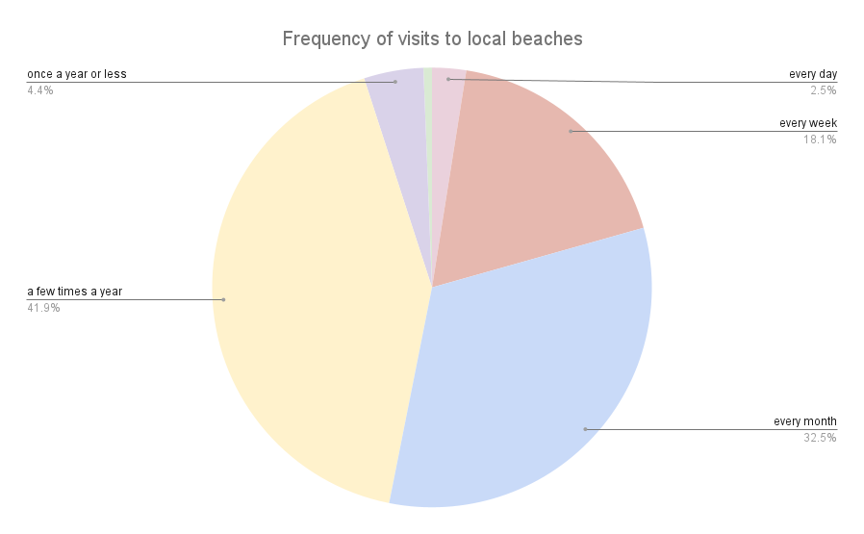

Appendix 9 - Results of the Wilcoxon signed rank test undertaken on R. Significance is indicated in bold (p-value <0.05) compared with statistical non-significance (p-value>0.05). Increase and decrease refer to increase of the mean indicating a general tendency although this may be non significant.

| **Category** | **Question** | **Scale** | **P-value** | **Increase/decrease** |
| --- | --- | --- | --- | --- |
| Self-reported knowledge | How much do you think you know about marine litter? | from 1= I know nothing and 5= I know a lot | 0.177 | increase |
| Self-reported knowledge | I know how I can reduce marine plastic litter. | from 1= I know nothing and 5= I know a lot | 0.655 | increase |
| Perception of origin | Marine litter comes from domestic activities in the archipelago. | from 1= I fully disagree to 5= I fully agree | 0.94 | increase |
| Perception of origin | Marine litter comes from fishing activities. | from 1= I fully disagree to 5= I fully agree | 0.583 | increase |
| Perception of origin | Marine litter comes from distant areas of Galapagos. | from 1= I fully disagree to 5= I fully agree | 0.367 | decrease |
| Perception of abundance | How much litter have you seen around your school or college? | from 1= very dirty to 5= very clean | **0.02** | increase |
| Perception of abundance | How much litter have you seen around your neighbourhood? | from 1= very dirty to 5= very clean | 0.41 | increase |
| Perception of abundance | How much litter have you seen on the beach you visit the most? | from 1= very dirty to 5= very clean | 0.56 | decrease |
| Perception of impacts | Marine plastic litter affects the appearance of beaches | from 1= I fully disagree to 5= I fully agree | **0.00631** | decrease |
| Perception of impacts | It is common for marine plastic litter to damage wildlife around the world. | from 1= I fully disagree to 5= I fully agree | 0.416 | increase |
| Perception of impacts | Marine plastic litter poses a danger to human health. | from 1= I fully disagree to 5= I fully agree | 0.81 | increase |
| Perception of impacts | The way my family and I deal with the litter in our house can affect the litter in the sea. | from 1= I fully disagree to 5= I fully agree | 0.273 | decrease |
| Pro-environmental behaviour | Pick up litter on the ground around my school or college. | 1= never, 2= rarely, 3= sometimes, 4= often, 5= always | **0.000888** | decrease |
| Pro-environmental behaviour | Picking up litter on the ground in the streets of my neighbourhood. | 1= never, 2= rarely, 3= sometimes, 4= often, 5= always | 0.507 | decrease |
| Pro-environmental behaviour | Pick up litter found on the beach. | 1= never, 2= rarely, 3= sometimes, 4= often, 5= always | 0.416 | decrease |
| Pro-environmental behaviour | Recycle. | 1= never, 2= rarely, 3= sometimes, 4= often, 5= always | **0.00399** | decrease |
| Pro-environmental behaviour | Not buying single-use plastic. | 1= never, 2= rarely, 3= sometimes, 4= often, 5= always | 0.407 | increase |
| Pro-environmental behaviour | Try to convince family and friends to use less single-use plastic. | 1= never, 2= rarely, 3= sometimes, 4= often, 5= always | 0.85 | decrease |
| Pro-environmental behaviour | Trying to convince people in my community to use less single-use plastic. | 1= never, 2= rarely, 3= sometimes, 4= often, 5= always | 0.203 | increase |
| Interest | How interested are you in learning more about marine plastic litter? | 1= not interested to 5= very interested | **0.0431** | decrease |
| Interest | How important is it for you to reduce marine plastic litter? | 1= not important at all to 5= very important | **0.0267** | decrease |

Appendix 10 - Perceived cleanliness of surrounding environment

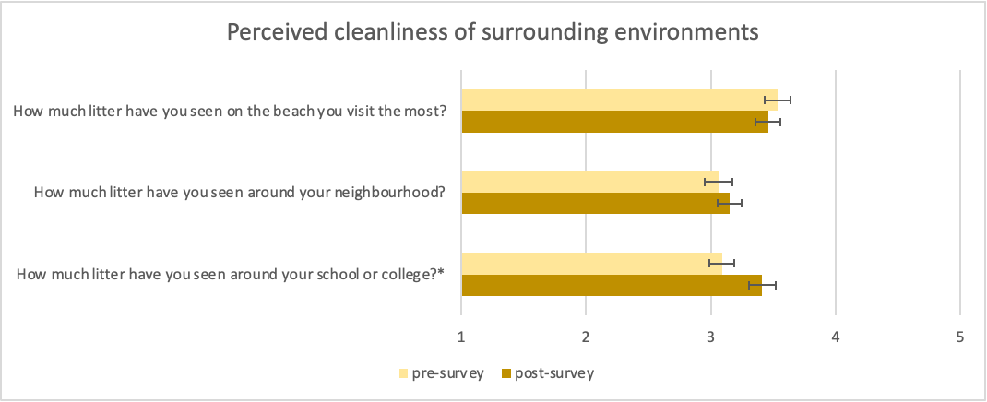

Change in perceived cleanliness before (pre-survey) and after the activity (post-survey) when participants were asked how they perceived their surroundings, from very dirty (1) to very clean (5). The standard error is indicated and * highlights questions with statistically significant change with p-value <0.05.

Appendix 11 - Self-reported knowledge and interest

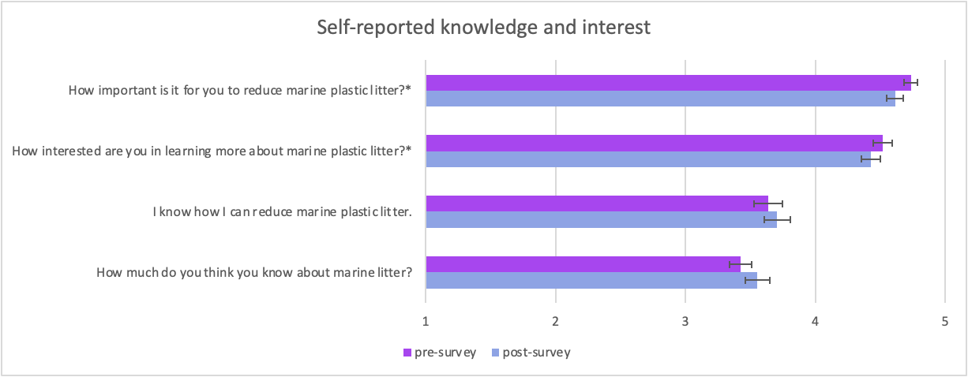

Change in self-reported knowledge and interest in the topic before (pre-survey) and after the activity (post-survey) when participants were asked how interested they were in the topic from 1 (no interest) to 5 (a lot of interest), how important it was to them from 1 (not important at all) to 5 (very important), how much they knew about it from to from 1=nothing to 5= a lot, and if they knew how to reduce MPL from 1= I strongly disagree to 5= I strongly agree. The standard error is indicated and * highlights questions with statistically significant change with p-value <0.05.

Appendix 12 - Suggested solutions by workshop participants

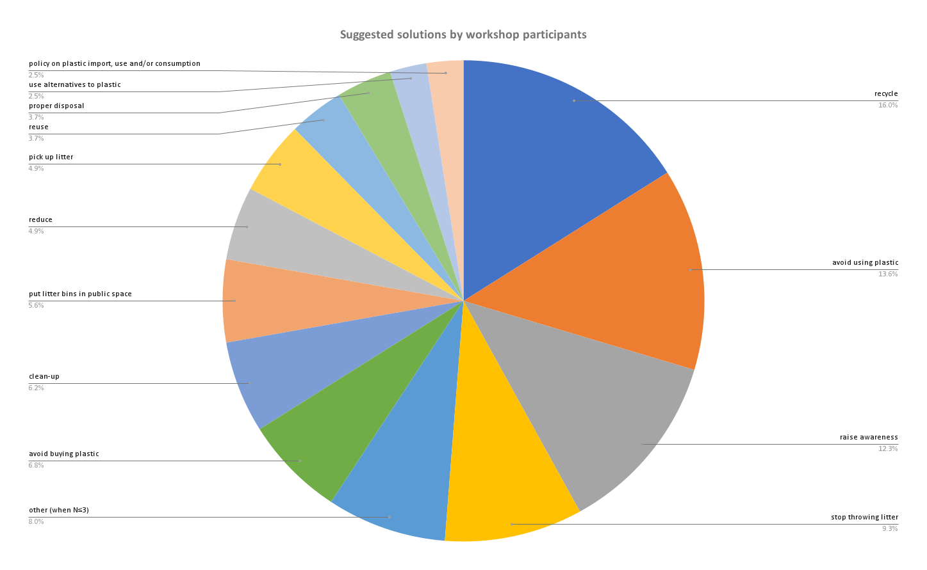

Suggested solutions by workshop participants in the first survey when asked the question “Name one thing you could do to prevent MPL from reaching the ocean”. The category “other” gathers all suggestions that were mentioned by three participants or less.

Appendix 13 - Meaning of recycling for participants

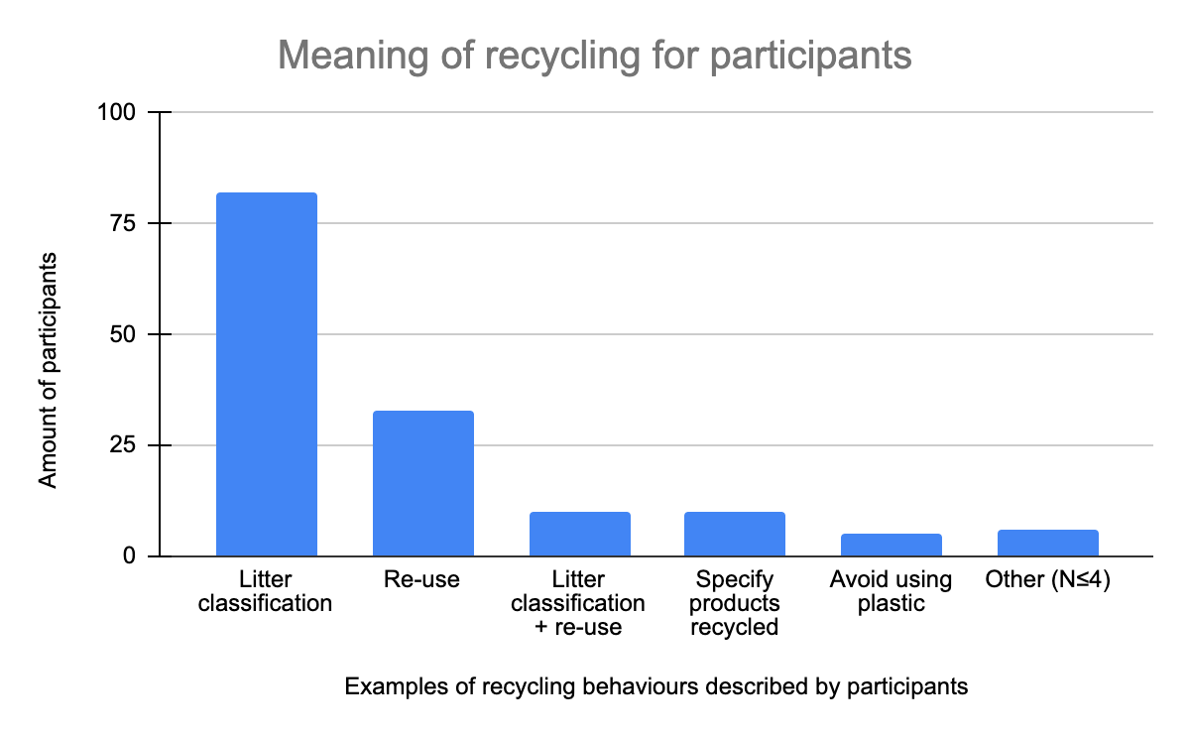

Distribution of definitions when participants were asked to exemplify recycling in the surveys.