Supplementary material
A. OSL dating - methods
90-125 μm quartz was purified by wet-sieving, dissolving carbonates by 8% HCl, removing heavy minerals and some feldspars by magnetic separation, and dissolving the remaining feldspars and etching the quartz with 40% HF (for 40 min), followed by soaking in 16% HCl overnight to dissolve any fluorides which may have precipitated.
Samples were measured using a preheat of 10s @ 260ºC, a test dose of 3 Gy and a test dose preheat of 5 s @ 220ºC, following dose recovery tests over a range of preheats that determined the best recovery under these measurement conditions. De was measured on 2 mm aliquots using a modified single aliquot regenerative (SAR) protocol.
Alpha, beta and gamma dose rates were calculated from the radioactive elements measured by ICP MS (U & Th) or ICP-OES (K). Moisture contents were estimated as 3±2%. Cosmic dose rates were estimated from current burial depths.
The average De and errors were calculated using the central age model (CAM) after removing distinct outliers.

B. ¹⁴C dating - methods
Three identified faunal remains were dated by the DirectAMS lab. Results are presented in units of percent modern carbon (pMC) and the uncalibrated radiocarbon age before present (BP). All results have been corrected for isotopic fractionation with an unreported δ¹³C value measured on the prepared carbon by the accelerator. The pMC reported requires no further correction for fractionation, and calibration was completed online by IntCal20, Northern Hemisphere (Reimer et al., 2020).

C. Rock art study - methods
A rock art survey was conducted in 2020-2021, covering an area of ca. 21 km² and encompassing Har Tzuriaz and its immediate environs. The rock art panels are on limestone surfaces covered with a dark desert crust, and they are of two major geological groups: The Eocene Avdat group on top of Har Tzuriaz and the Paleocene Arava formation conglomerate on the plateau below.
The terms used in this survey include site (an area of 25x25 m with rock art in it), panel (continuous rock surface with rock art on it), and element (a single defined engraving). Each panel was documented by its coordinates, slope gradient, orientation, and location on the rock. Each element was documented by size, direction, and patination hue using the Munsell Color Soil Chart. All panels were photographed multiple times, depending on the quantity of elements.
Deliberate breaking of the stone’s crust by techniques of engraving, chiseling, or pecking, exposes the white limestone and creates the elements of rock art, sometimes visible from a distance. Over time chemical and biogenic processes gradually form a new varnish on the rock surface and cover the white engraved scars with an ever darkening crust. This process is time-progressive and produces hue differences between engravings that make it possible to determine the relative chronology of the elements on the panel (Anati 1999; Eisenberg-Degen and Rosen 2013) because the rock crust (varnish, patina, etc.) regenerates over time on the engravings until full coverage. A study of rock surfaces of the Avdat group formation found that the rock crust consists of manganese, iron, and clay; a microbial front attacks the rock beneath it, decomposes it, and creates a porous layer (Krumbein and Jens 1981). The fixation of airborne manganese (a component of the dust carried by desert winds) in cavities of the rock crust is carried out through biogenic processes (Dorn 2013) or non-biogenic agents (Goldsmith et al. 2014), and is a significant component in the formation of the dark desert crust.
The engravings were divided into five categories according to their hue, using the Munsell Color Soil Chart. This division can be used to create a relative chronology between elements on the same panel.
- Dark, heavy patination on the elements, Munsell Chart 7.5 YR 2.5/1, 3/2, 3/4.
- Brown, Munsell Chart 7.5 YR 4/3, 4/4.
- Light brown, Munsell Chart 7.5 YR 5/8, 6/4.
- Light orange yellow, Munsell Chart 7.5 YR 6/6, 7/6.
- Yellow-white, Munsell Chart 7.5 YR, 7/8, 8/4.
The division into five major crust color categories, as used here (1 is the darkest and 5 the lightest), helps to create relative chronology with “layers” of activity in the rock art assemblage of a given region, based on geological and climatological similarities. The patina shade is recorded for each element on a studied panel, and is then used in intra- and inter- panel comparisons, providing the basis for relative chronology; such a chronology is limited in accuracy but can still be used in large assemblages of elements providing reliable statistical results (Eisenberg-Degen and Rosen 2013).
Furthermore, in order to characterize the patina layers on the desert kite panel, a pXRF test was carried out on all the elements on this panel. The main measured component was Manganese (Mn) because it is airborne and originates from an external source (Goldsmith et al. 2014), and it gradually accumulates on the engraved elements )Andreae et al. 2021). Iron (Fe) levels were also measured.

D. Results: the sites, dates and finds

Figure S1. An aerial photo of TS12, an open-air rectangular shrine with a massive western wall, at the beginning of excavation; note the round tumulus constructed on top of the shrine wall.

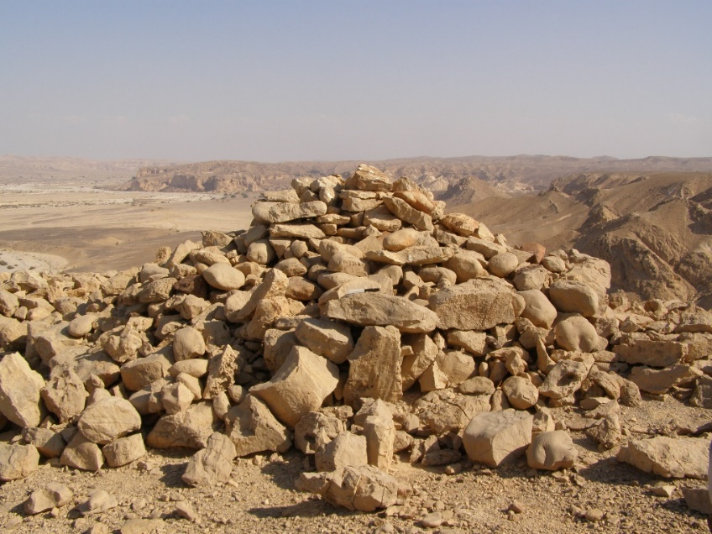
Figure S2. Tumulus T2 before excavation. Note the black and white 20 cm scale on a horizontal slab in the middle of the photo.

Table S1. A) ¹⁴C dates from two burial structures in the Tzuriaz area. B) OSL dates from the Nahal Eshel kite and Har Tzuriaz. C) Probability curves for the ¹⁴C dates of teeth from T2 and N2. All dates after Galili 2022.
A)
AMS lab number | Height and context | find | ¹⁴C age ±1σ year BP  un-calibrated | Calibrated range BCE  ±1σ
041006 | TC 1 T2  397.26  Burial, 14 cm above surface | Organic material | 2959 ± 20 | 1261- 1100 BC 93.4%  1093-1083 BC 1.1%  1066-1058 BC 1%
041007 | TC 1 T2  397.12  Burial surface elevation | Organic material | 3026 ± 32 | 1398-1196 BC 92.8%  1173-1163 BC 1.2%  1143-1131 BC1.5%
041008 | TC 1 T2  397.18  Burial, 6 cm above surface | Textile | 2969 ± 23 | 1271-1111 BC 94.7%
041010 | TC 1 T2  397.12  Burial surface elevation | Tooth | 3453 ± 26 | 1829-1687 BC 70.9%  1880-1837 BC 24.6%
043005 | TC 1 T2  397.76 | Gazelle horn | 288 | 1550 AD 42.2ֵ%  1646 AD 53.2%
043006 | TC 1 T2  397.71-73 | Ibex horn | 266 | 1658 AD 95.4%
043007 | TC 1 T2  397.88 | Gazelle horn |  | 1724 AD 32.3%  1835 AD 30.7%  1883 AD 32.4%
041011 | TC 1 N2  399.10  12 cm below surface | Tooth | 793 ± 20 | 1220-1275 AD 95.4%

B)
Lab  code | Description | Burial  Depth  (m) | K  (%) | U  (ppm) | Th  (ppm) | Ext. α  (μGy/a) | Ext. β  (μGy/a) | Ext. γ  (μGy/a) | Cosmic  (μGy/a) | Dose rate  (μGy/a) | N | OD  (%) | De  (Gy) | Age (years  before 2021)
Nahal Eshel Kite
ESL-2 | Pit B, base | 0.6 | 0.26 | 3.7 | 1.5 | 11 | 684 | 535 | 204 | 1435±58 | 19/19 | 17 | 8.2±0.3 | 5710±330
ESL-5 | Upper support wall, base | 0.65 | 0.25 | 3.9 | 1.2 | 12 | 696 | 542 | 199 | 1448±59 | 18/19 | 38 | 10.8±0.9 | 7480±680
ESL-1 | Pit A, middle section | 0.55 | 0.28 | 5.4 | 1.6 | 16 | 914 | 728 | 207 | 1864±72 | 18/19 | 21 | 7.7±0.3 | 4130±230
ESL-6 | Pit A, base | 0.75 | 0.17 | 5.4 | 0.7 | 15 | 815 | 658 | 193 | 1681±74 | 19/19 | 17 | 13.0±0.6 | 7750±470
Har Tzuriaz (top)
TZR-2 | TC1, T2 | 0.65 | 0.49 | 1.9 | 2.6 | 7 | 640 | 445 | 199 | 1291±41 | 19/19 | 10 | 3.9±0.1 | 3040±130
TZR-3 | TC1, N2 | 0.30 | 0.42 | 2.2 | 2.8 | 8 | 629 | 464 | 229 | 1330±41 | 19/19 | 25 | 0.87±0.06 | 650±50
TZR-7 | TC12, Tumulus | 0.50 | 0.46 | 2.2 | 3.1 | 8 | 668 | 492 | 210 | 1379±42 | 16/17 | 26 | 5.1±0.3 | 3680±270
Open air shrine
TZR-13 | Base of stone wall | 0.15 | 0.41 | 1.9 | 2.2 | 7 | 570 | 403 | 253 | 1233±37 | 19/19 | 28 | 8.9±0.6 | 7200±520
TZR-14 | Base of stone wall | 0.30 | 0.31 | 2.1 | 1.7 | 7 | 514 | 377 | 299 | 1127±35 | 17/17 | 22 | 8.9±0.5 | 7870±500

OD – Overdispersion. No. aliquots – the number of aliquots used for the average De out of those measured.

C)
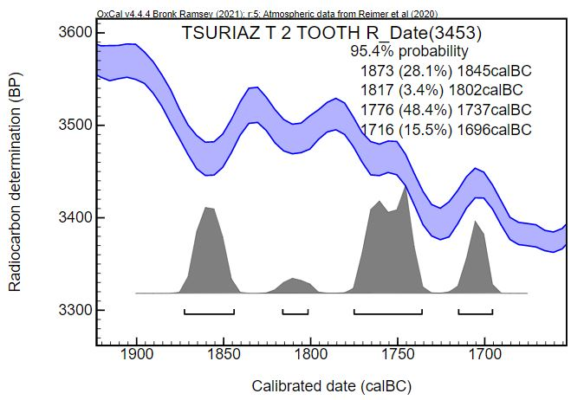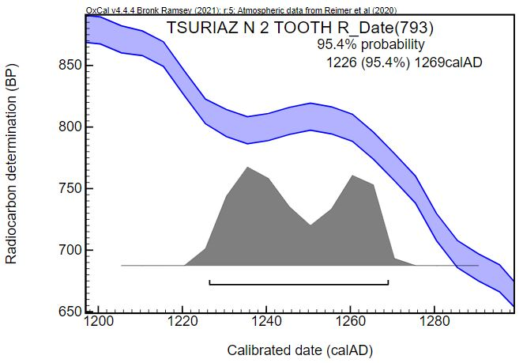

The faunal remains from the excavated tumuli
Tumuli T1 and T2 yielded 11 animal bones (Fig. S3). The small assemblage is mainly composed of wild taxa and includes two complete gazelle horn cores (Fig. S3: 2, 5), both of which were discovered with their sheath, two Capra horn cores, and three cervical vertebrae and three long bones of an unidentified medium ungulate (Fig. S3: 4). Two vertebrae were found in articulation (Fig. S3: 6) and one of them bore a sign of a clean cut through the bone. Such a butchery pattern occurred while decapitating the head, a butchery practice that most probably was carried out with a metal cleaver. Remains of other animals include only one complete mandible of a rock hyrax (Procavia capensis) (Fig. S3: 7), which might be intrusive from the matrix accumulated above the deposits.
Morphologically the shape of the Capra horn cores is clearly broad on their base (anterior part), with high similarity to female horn cores of ibex (Capra ibex nubiana) (Fig. S3: 1, 3). Similarly, the gazelle horn cores show high similarity in the sharp posterior twisting shape to Dorcas gazelle (Gazella dorcas).
The excellent bone preservation is attested by the presence of the keratinous horn sheath that was preserved intact. The bone assemblage exhibits minor signs of surface weathering; the majority of the bones bear no signs of surface cracking or exfoliation. In addition, no evidence for destruction of skeletal elements by carnivores has been documented. All of these factors indicate that the bones were quickly covered after deposition and sustained only minimal post-depositional disturbance and in situ bone attrition.
Table S2. Provenance of identified faunal remains from tumuli T1 and T2.
Tumulus | Context | Skeletal elements | Figure
T2 | Cist, upper part | Ibex horn with sheath. | Fig. S3-1.
T2 | Cist, upper part | Gazelle horn with sheath. | Fig. S3-2.
T2 | Cist, upper part | Ibex horn. | Fig. S3-3.
T2 | Cist, upper part | Gazelle horn with sheath. | Fig. S3-5.
T2, inside the cist | Cist, upper part | A capra limb bone shaft; three cervical vertebrae, two in articulation. | Fig. S3-4; S3-6.
T1, the cist | Cist, upper part | A complete mandible of a hyrax. | Fig. S3-7.

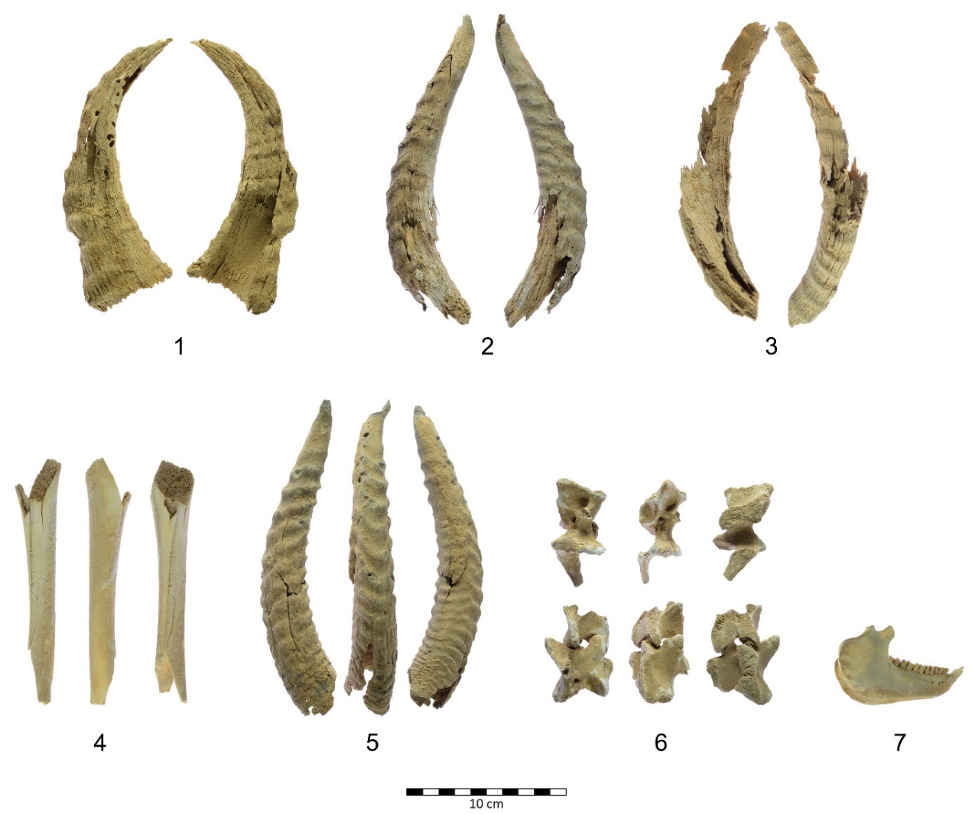
Figure S3. Identified faunal remains from excavated tumuli. 1) Ibex horn with sheath from the cist of T2. 2) Gazelle horn with sheath from T2. 3) Ibex horn from T2. 4) A Capra limb bone from the cist of T2. 5) Gazelle horn with sheath from T2. 6) Three chopped cervical vertebrae, two are in articulation (bottom), from the cist of T2. 7) A complete mandible of a hyrax from the top of the cist in T1.

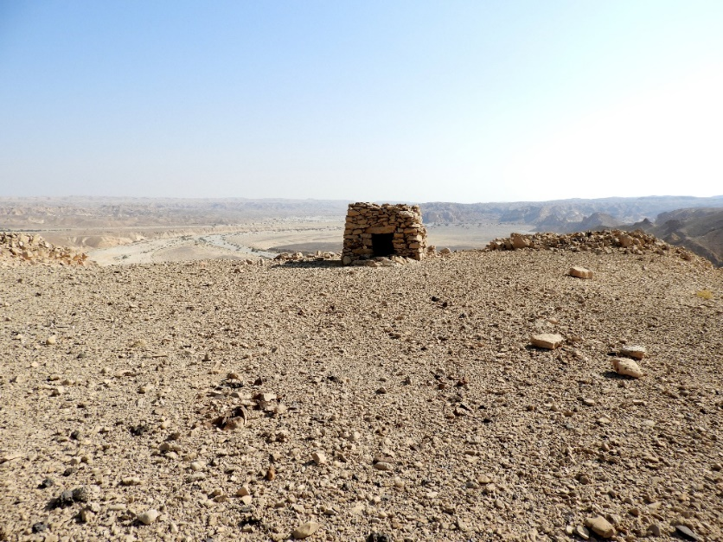
Figure S4. A structure similar to a "Tower tomb" N2 before excavation.

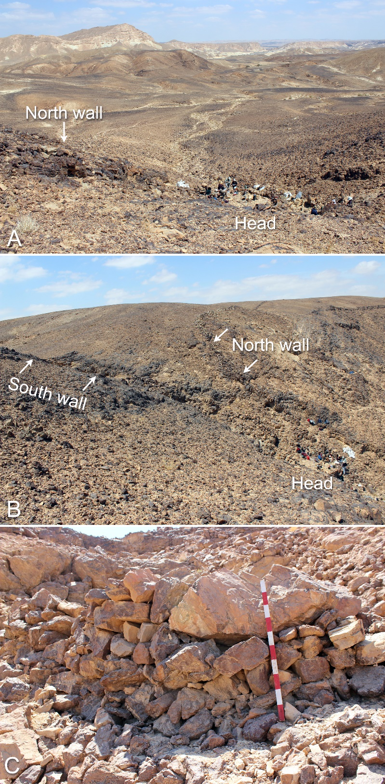
Figure S5. A) The head of the Nahal Eshel kite, during excavation, as seen from the middle of the guiding funnel. The escarpment of Har Tzuriaz is visible at the top of the photo. B) A view from the south on the guiding funnel and the cliff on which the kite was built. C) A view of the outer wall of the kite head from downslope; note the huge boulder incorporated in the wall (behind the top of the scale). Scale – 1 m.

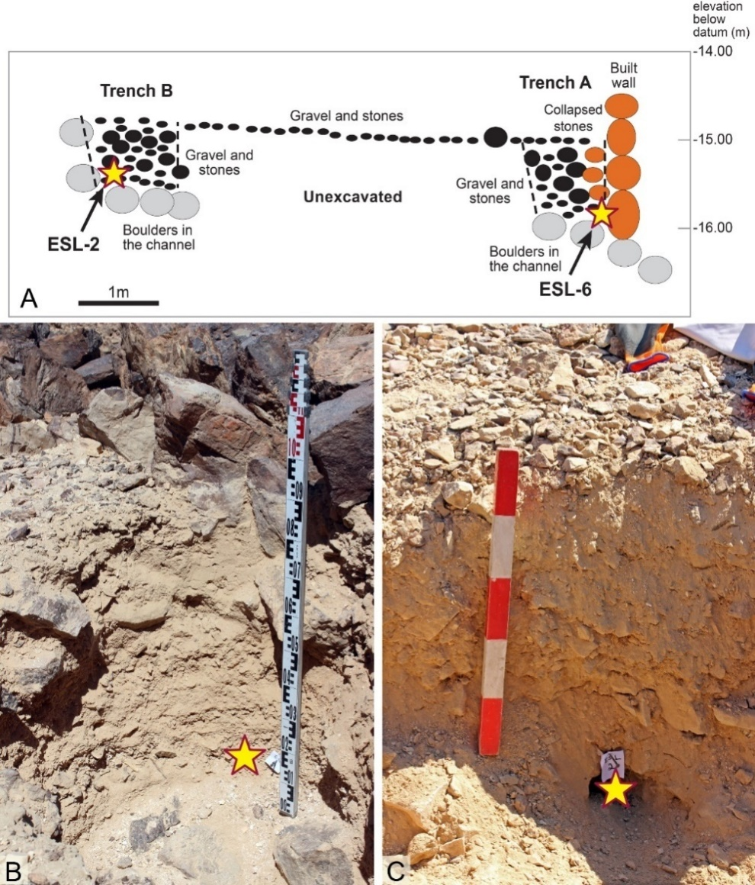
Figure S6. A) Schematic section through the head of the Nahal Eshel kite with location of trenches A and B, the head wall, the provenance of OSL samples (marked by stars), and the channel bed with naturally deposited boulders. B) Location of sample ESL-6 at the base of Trench A; C) Location of sample ESL-2 at the base of Trench B.

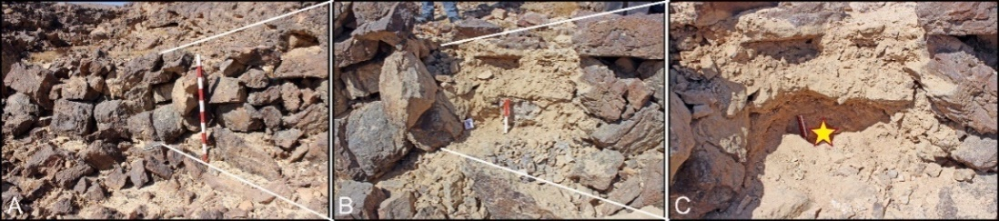
Figure S7. Provenance location of OSL sample ESL-5 behind and near the base of the southern guiding wall. A) The guiding wall looking west. B) Sediment accumulated behind the wall, after temporary removal of several stones from the wall. C) A close-up of the OSL sampling location (marked by a star).

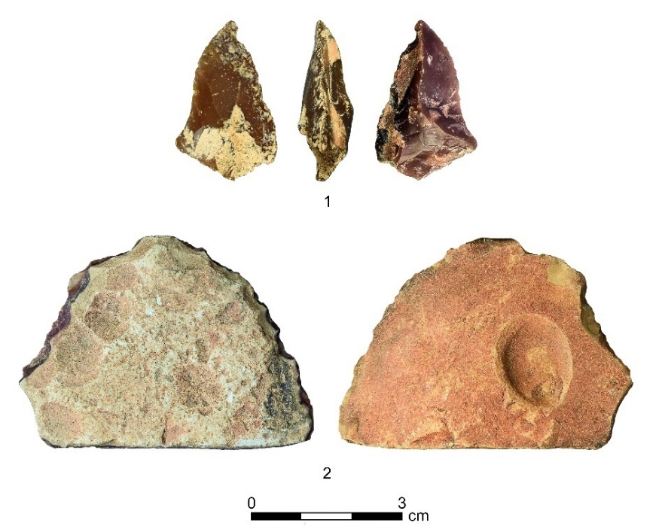
Figure S8. Two flint tools found in the head of the kite. 1) A broken pointed tool, both converging sides are simply retouched; 2) A tabular scraper; note the heavily patinated ventral face.

Rock art study results
The results of the pXRF Mn measurements on the kite panel (Fig. S10) are illuminating and distinct: Mn levels range between 17,154 and 22,720 ppm in the rock’s patina and between 1,617 and 6,782 ppm in the crusts of the studied elements; the average for the kite (5,246) and element 9 (6,506) are clearly much higher than the studied zoomorphs (3,209) and anthropomorph 3,135 (Table S3A). The average (4,204) and especially the large standard deviation (1,600) of the other elements are less coherent, perhaps because only one measurement was taken per each, or they reflect several cases of superposition and corrections.
Furthermore, the engraved elements were classified into three groups: A – rock surface patina, B – kite and element 9, and C – all other elements. An ANOVA was used to assess overall differences in Mg levels, followed by Tukey’s HSD post-hoc test to evaluate significant differences between all possible pair-wise comparisons (Table S3B). All three groups are statistically distinct.
A similar picture emerges from the iron level measurements, where levels range between 37,531 and 43,193 ppm in the rock’s patina, and between 16,602 and 30,881 for the engravings. The average for the kite (25,659) and element 9 (28,821) are higher than the studied zoomorphs (20,699) and anthropomorph (22,819).
The Mn and Fe measurements suggest two main periods of engraving, the earlier in which the desert kite and element 9 were carved, and the later in which the rest of the images were added. However, the differences between the two engraved sets likely reflect a few generations at most. Also noteworthy is the fact that the panel lacks categories 4 and 5.

Table S3A. Mn and Fe average measurements (ppm) and data of engraved elements on the Har Tzuriaz kite panel.
Provenance | AVG Mn | STD | Range | AVG Fe | STD | Range | n
Kite | 5246 | 577 | 4572-6224 | 25659 | 3423 | 18858-29789 | 9
Element 9 | 6506 | 371 | 6244-6769 | 28821 | 2049 | 27372-30270 | 2
Zoomorph 14 | 3533 | 464 | 2996-4065 | 21707 | 1831 | 19130-23249 | 4
Zoomorph 15 | 3093 | 856 | 2270-3978 | 18257 | 1131 | 17372-19532 | 3
Camel 16 | 3146 | 463 | 2819-3473 | 23983 | 2326 | 22339-25627 | 2
Ibex 17 | 2796 | 280 | 2598-2993 | 19062 | 238 | 18894-19230 | 2
Elements 14-17 | 3209 | 567 | 2270-4065 | 20699 | 2588 | 17372-25627 | 11
Anthropomorph 20 | 3135 | 400 | 2852-3419 | 22819 | 560 | 22423-23214 | 2
Other elements | 4204 | 1600 | 1617-7486 | 22986 | 3480 | 16602-30881 | 17
Surface | 19646 | 1977 | 17154-22720 | 38830 | 2586 | 36438-43193 | 5

Table S3B. An ANOVA test between the three major rock art groups on the kite panel.
 |  | comparison | p
A | Rock surface patina | A-B | <0.001
B | Kite + element 9 | A-C | <0.001
C | Other elements | B-C | 0.002

Figure S9. Rock art motif percentage by hue category in the Har Tzuriaz survey. Category 1 is the darkest and oldest, category 5 is the brightest and youngest.

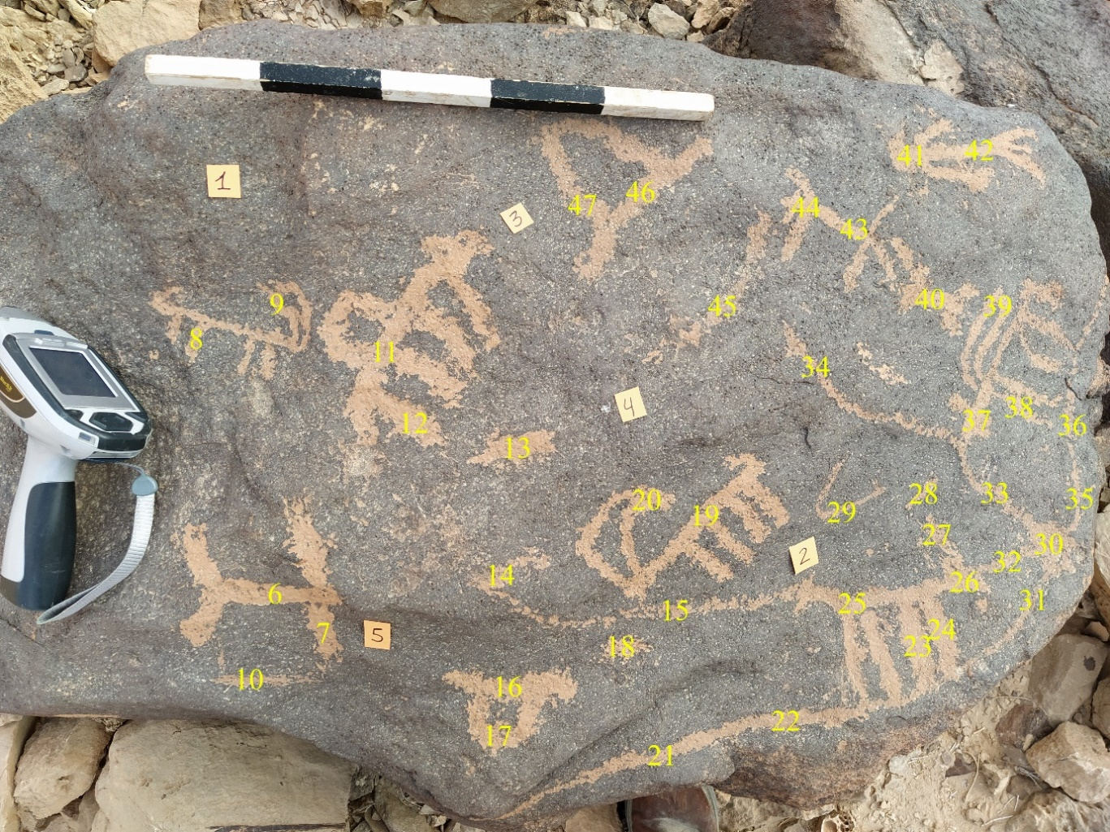
Figure S10. The kite panel and location of Mn and Fe measurements using a pXRF device.
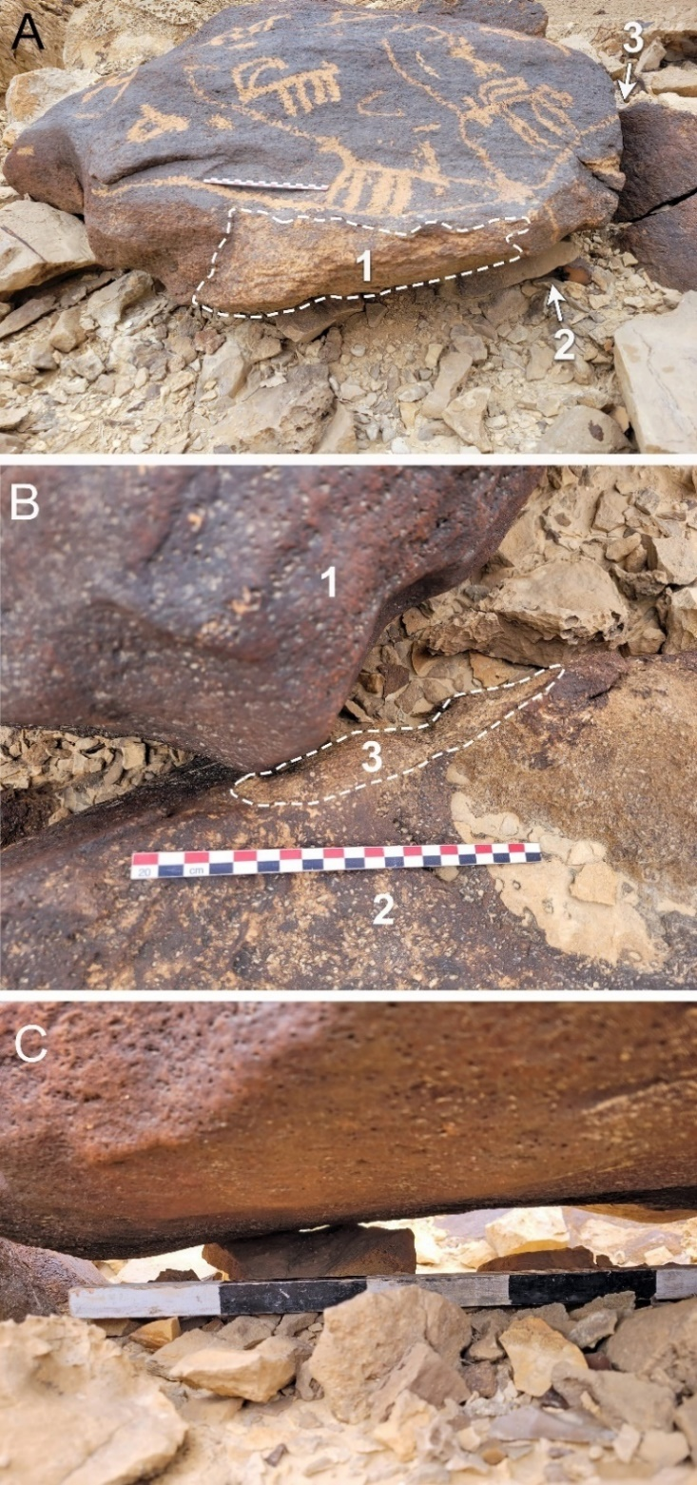

Figure S11. The setting of the flat stone bearing the engraving of the kite. A) A diagonal view of the stone showing evidence for previous partial burial of the side according to the eroded patina (1); the location of a supporting stone set under the main stone (2); location of friction between the engraved stone and a larger boulder (3). B) A close-up view of the top corner of the engraved stone (1), causing surface damage (3) on a large nearby stone (2), scale – 20 cm. C) A view from the side on the bottom of the engraved stone; it is partially in the air and supported by a small stone, scale intervals – 10 cm.

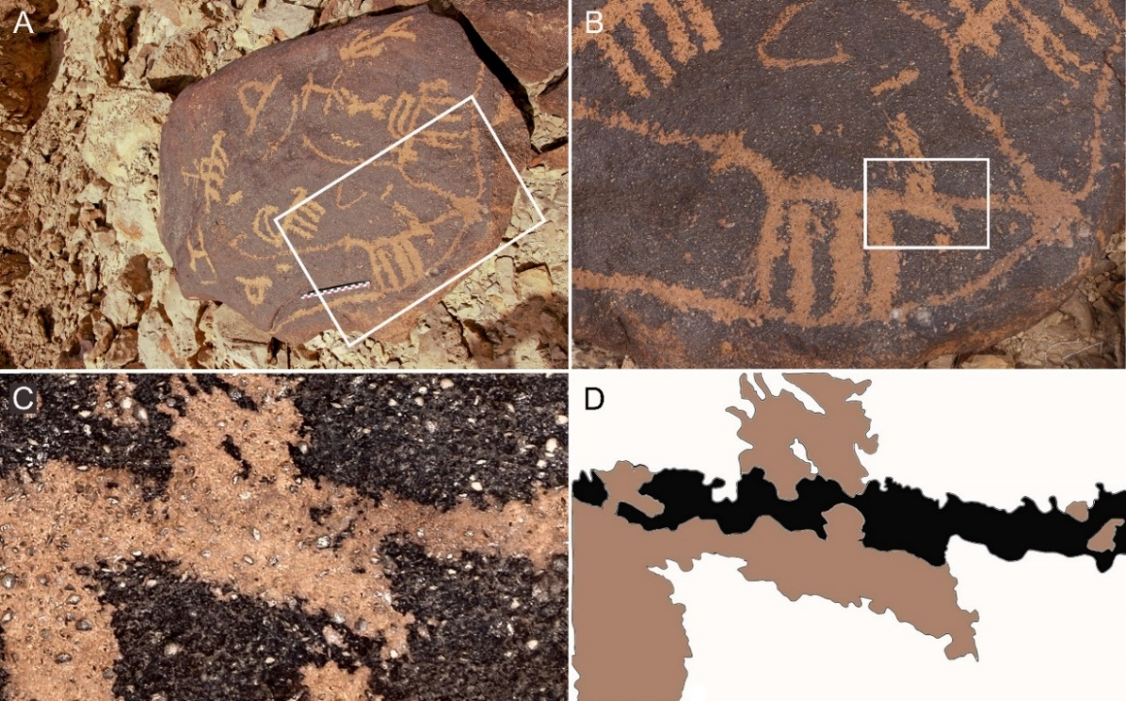

Figure S12. An example of renovating incised lines, according to the hues of patination. A) The panel and the location of B. B) A quadruped between two lines and the location of C. C) A close-up of the two patination shades. D) Tracings of C with the two patinations in distinct colors (the black is older than the brown).

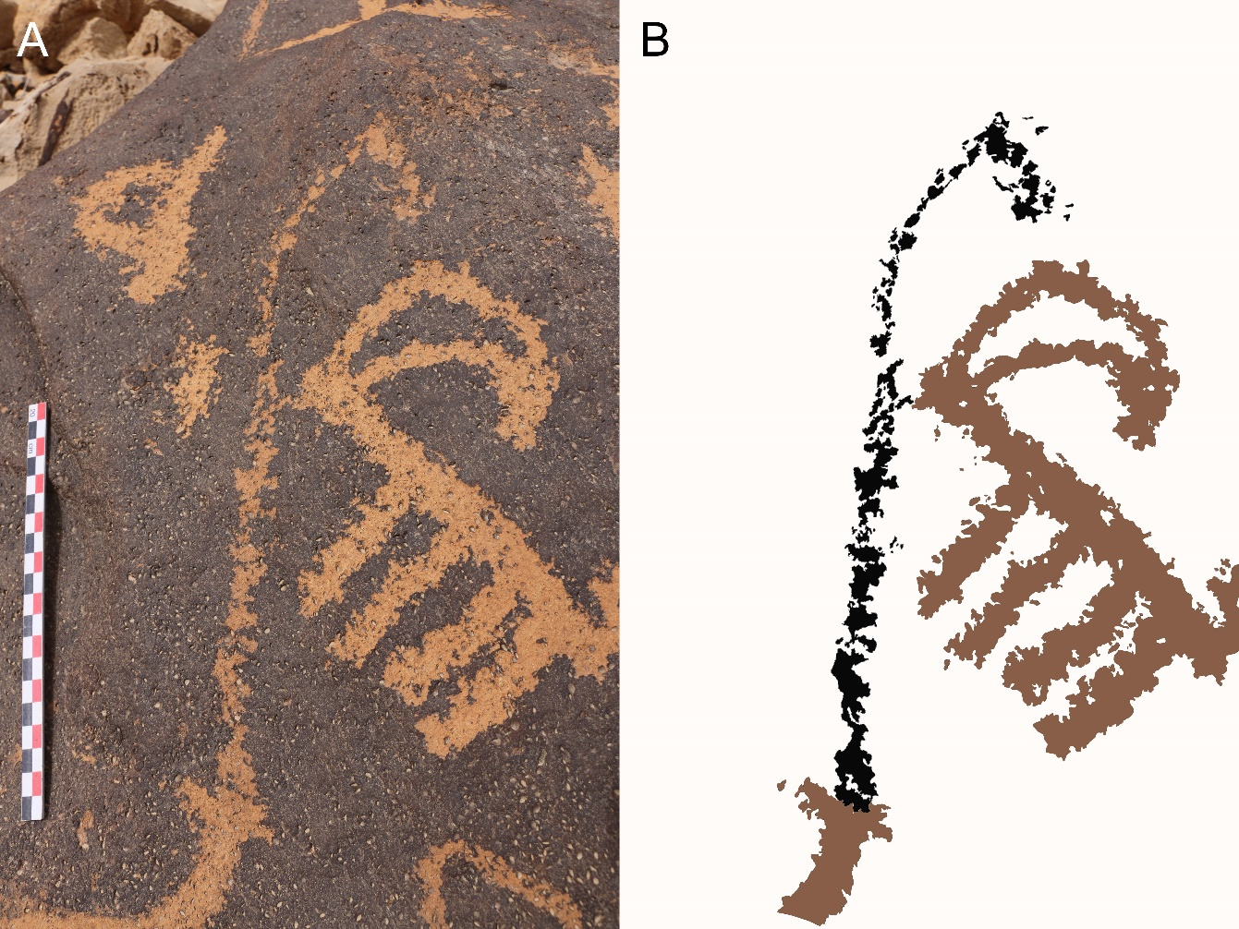
Figure S13. An example of the guiding wall (the elongated line) with two patinations. A) A close-up photo. B) Tracings of the guiding wall and ibex in A, with the two patinations in distinct colors (the black is older than the brown).
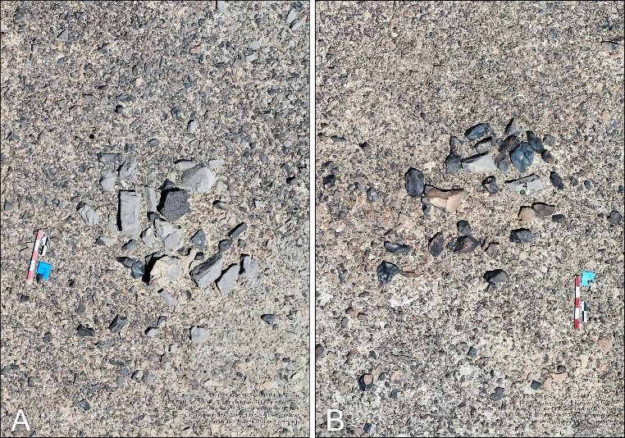

Figure S14. Stone features 2 (A) and 4 (B) beyond the entrance to the kite’s funnel (see Fig. 2 for their location). They may have served as the bases of perishable blinds or locations for setting hunting nets or cloth flags for scaring the game into the kite.

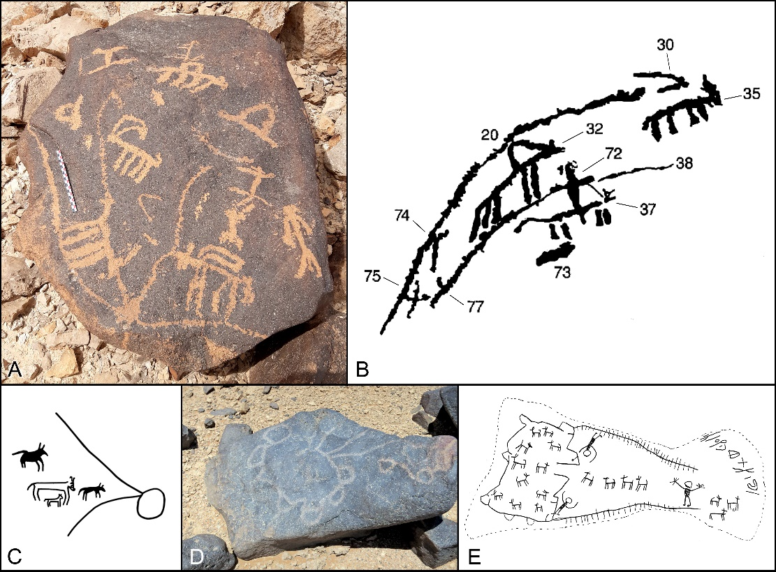
Figure S15. Five examples of rock art depictions of kites. A) The Har Tzuriaz kite. B) The Har Michiya kite; elements 20 and 38 are the kite’s arms; elements 74, 75 and 77 are attached to 20 (Eisenberg-Degen 2010 fig. 3). C) engraved kite from Sinai (Hershkovitz et al. 1987). D) The Wisad Pools partial depictions of two corral-type kites (Hill et al. 2020 fig. 4). E) The kite depicted on a stone from the cairn of Hanii (Harding 1953).

REFERENCES

Andreae, M. O., Al-Jibrin, F. H., & Alsharekh, A. M. 2021 Iconographic and archaeometric studies on the rock art at Musayqira, Al-Quwaiyah Governorate, central Saudi Arabia. Arabian Archaeology and Epigraphy, 32(S1):153–182. doi.org/10.1111/aae.12191
Galili, R. 2022. Landscape Archaeology, Spatial and Typological Aspects and Post Sedimentation Process in Cairn Sites in the Negev. Unpublished Doctoral Dissertation. Ben- Gurion University, Israel.
Reimer, P., Austin, W., Bard, E., Bayliss, A., Blackwell, P., Bronk Ramsey, C., Butzin, M., Cheng, H., Edwards, R., Friedrich, M., Grootes, P., Guilderson, T., Hajdas, I., Heaton, T., Hogg, A., Hughen, K., Kromer, B., Manning, S., Muscheler, R., Palmer, J., Pearson, C., van der Plicht, J., Reimer, R., Richards, D., Scott, E., Southon, J., Turney, C., Wacker, L., Adolphi, F., Büntgen, U., Capano, M., Fahrni, S., Fogtmann-Schulz, A., Friedrich, R., Köhler, P., Kudsk, S., Miyake, F., Olsen, J., Reinig, F., Sakamoto, M., Sookdeo, A., & Talamo, S. 2020. The IntCal20 Northern Hemisphere radiocarbon age calibration curve (0–55 cal kBP). Radiocarbon 62(4):725–757. doi:10.1017/RDC.2020.41

