Additional tables, figures and appendiCES

Spatio-temporal distribution and habitat selection of the vulnerable Iberian Grey Shrike Lanius meridionalis in the French Mediterranean scrublands

Alexandre Millon¹, Olivier Hameau², Annabelle Piat³, Beya Boumaza¹ & Agathe Leriche¹

¹Aix Marseille Univ, Avignon Univ, CNRS, IRD, Institut Méditerranéen Biodiversité & Ecologie (IMBE), Aix-en-Provence, France
²Ligue pour la Protection des Oiseaux Provence Alpes-Côte-d’Azur, Hyères, France
³Parc naturel régional des Alpilles, Saint-Rémy de Provence, France

In the following order :
Tables S1-S2 ; Figures S1-S2-S3 ; Appendix 1; Figure S4; Appendix 2; Figure S5

Table S1: Summary of the occupancy data for the Iberian grey shrike in the Mediterranean scrubland of south-eastern France.
Year | 2013 | 2015 | 2017 | 2019 | 2021 | 2023 | Average ± 1 SD
Nb of plots surveyed | 254 | 268 | 195 | 177 | 184 | 198 | 213 ± 38
Nb of plots occupied | 61 | 67 | 39 | 45 | 59 | 55 | 54.3 ± 10.5
% of plots occupied | 24.0 | 25.0 | 20.0 | 25.4 | 32.1 | 27.8 | 25.7 ± 4.0

Table S2: Summary statistics of the habitat-related explanatory variables used to model site occupancy of the Iberian grey shrike in South-Eastern France.
Explanatory variables |  |  |  | Percentiles
 | unit | Mean | Standard deviation | 10th | 25th | 50th | 75th | 90th
Altitude | m asl | 242.65 | 140.73 | 95.61 | 143.81 | 204.25 | 318.01 | 460.66
Total Potential Irradiation (between March and June) | GWh.m⁻² | 0.73 | 0.04 | 0.67 | 0.71 | 0.74 | 0.76 | 0.77
Time since last fire | Year (compared to 2023) | 33.55 | 15.79 | 17 | 22 | 32 | 42 | 63
Distance to human infrastructure | m (in 2023) | 144.58 | 118.35 | 23.85 | 54.27 | 114.03 | 203.19 | 307.48
Track length | m | 352.14 | 398.16 | 0.00 | 0.00 | 221.86 | 606.14 | 906.67

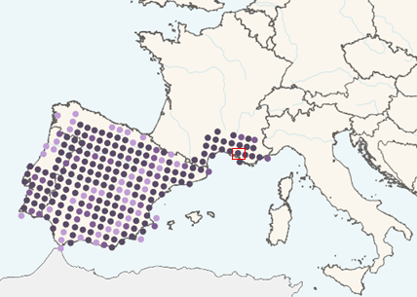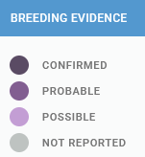
Figure S1: Map of the global distribution of the Iberian grey shrike, with indication of breeding evidence (from EBBA2 https://ebba2.info/live/maps/species/Lanius-meridionalis/ebba2/breeding/). The red rectangle indicates the location of the study area.

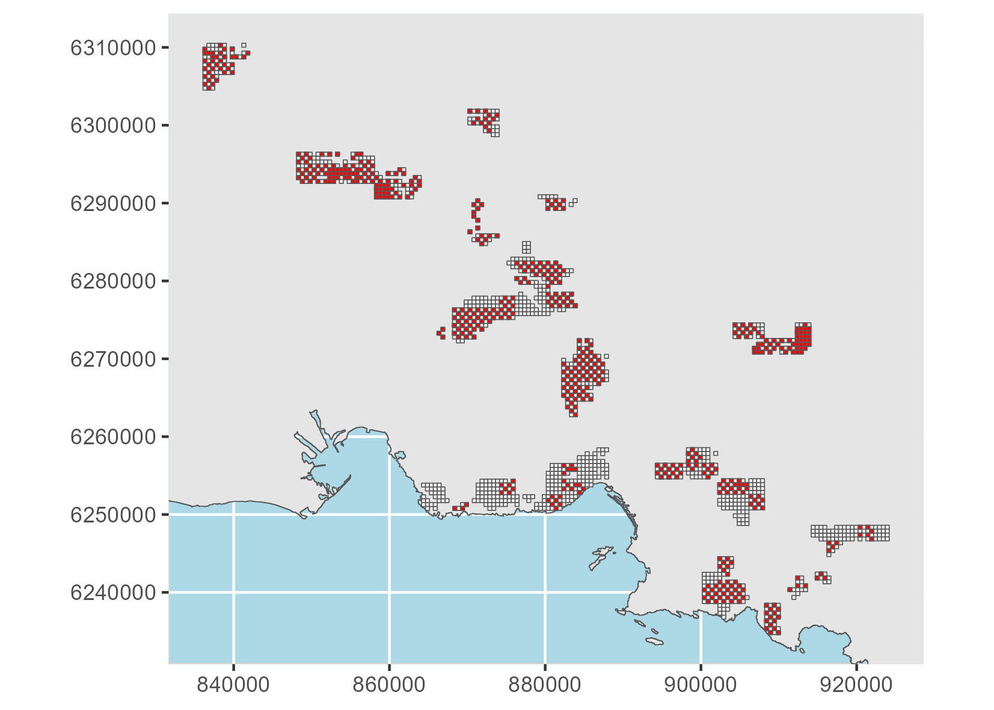
Figure S2: Map of the study area showing the grid cells of suitable scrubland habitats (white) and plots monitored at least once during the six surveys occurring every other year between 2013 and 2023 (in red). SCR EPSG 2154.

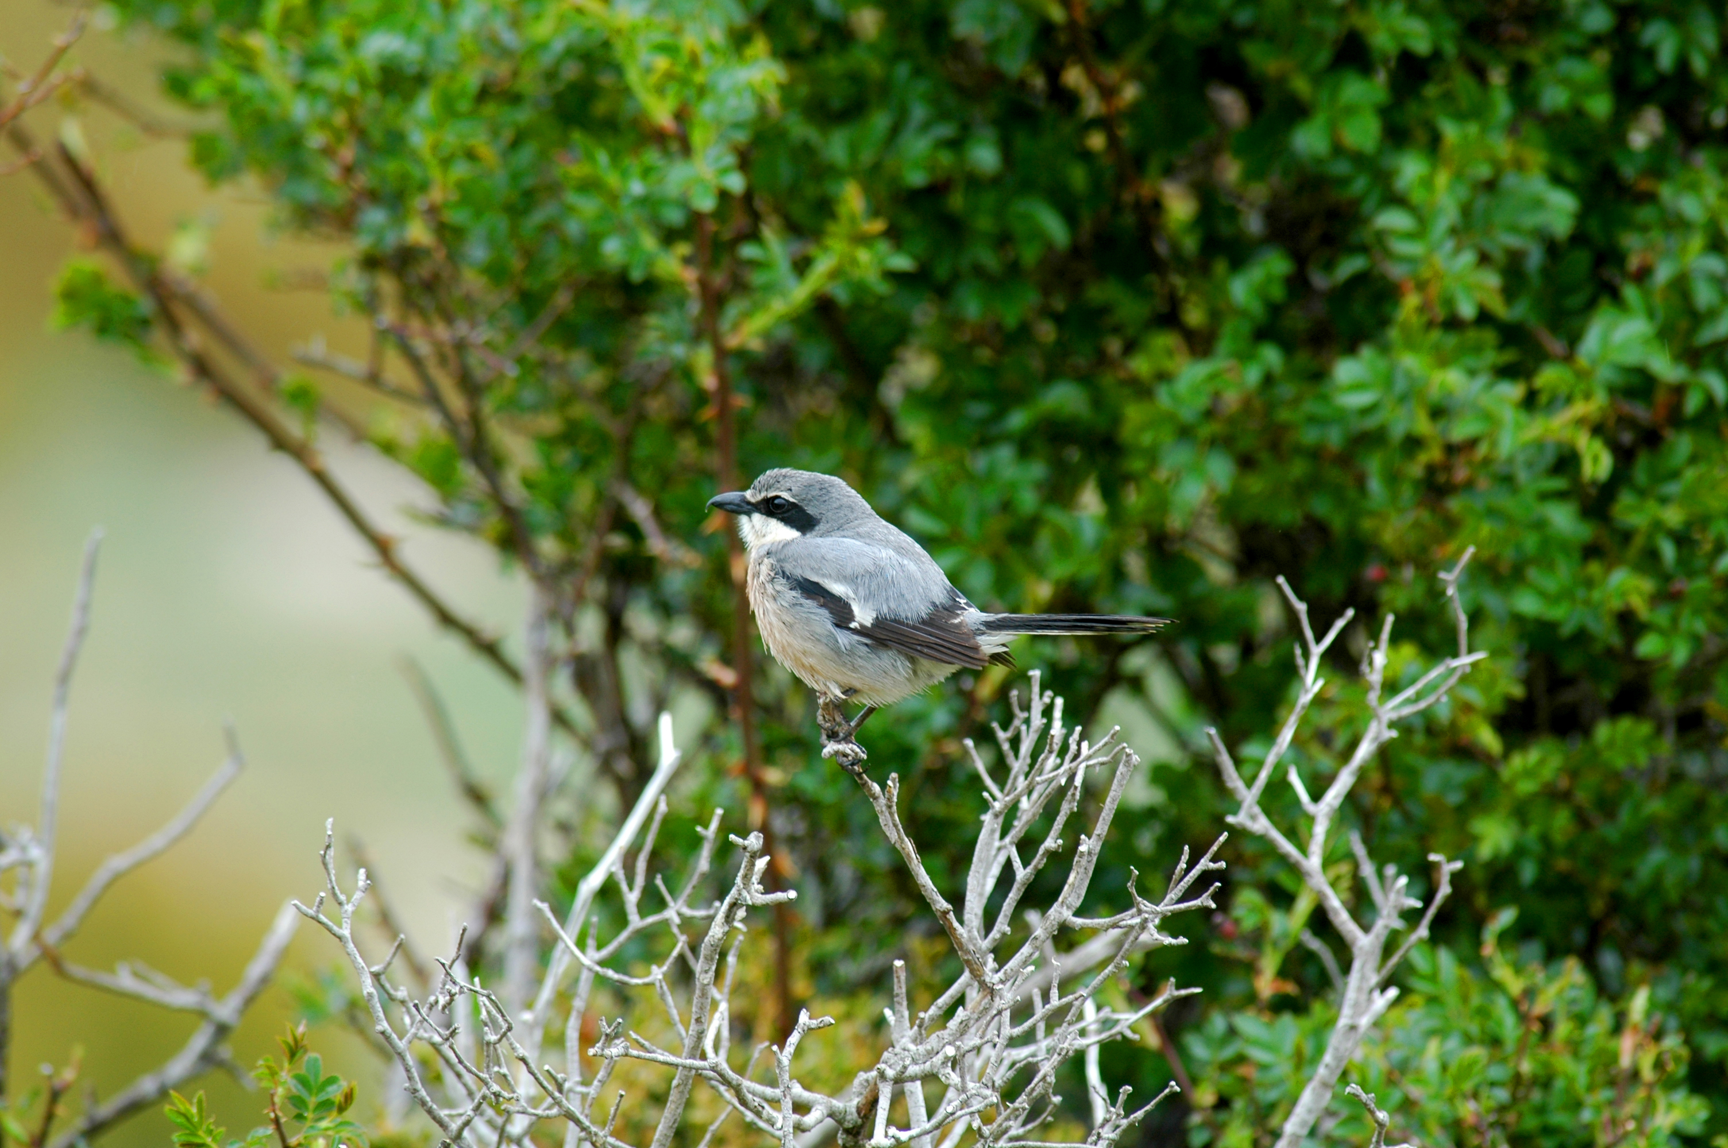
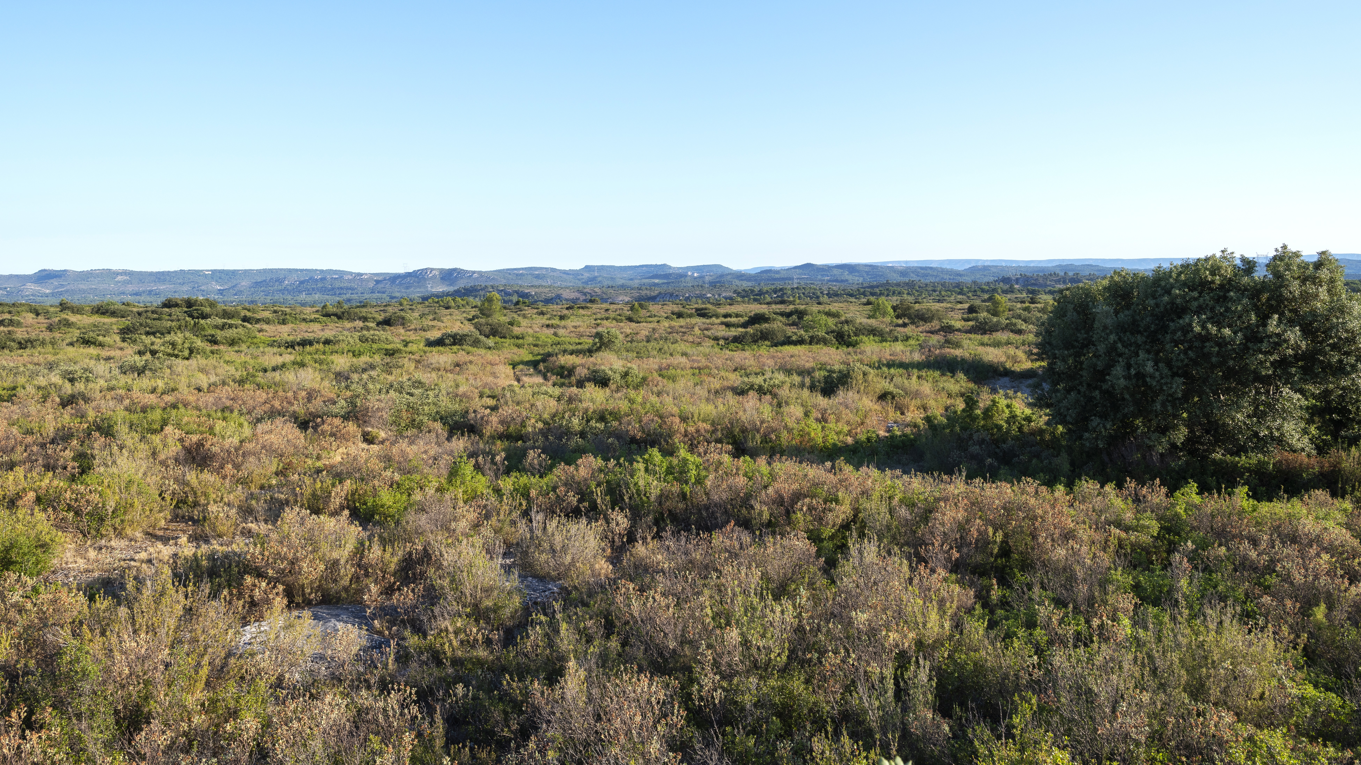
Figure S3: Pictures of an Iberian grey shrike (top; © B. Eliotout) and of of a suitable scrubland habitat in south-eastern France (bottom; © O. Hameau).

Appendix 1: Evaluating the risk of double counting in the Iberian grey shrike survey.
We adopted a staggered distribution of the 25-ha plots in order to minimise the risk of a shrike being detected in two different plots. This spatial organization however does not reduce the risk to 0, especially when neighbouring 2×2 km cells were surveyed in the same year with opposite staggered distribution chosen leading to adjacent plots being indeed monitored. In such a case, indeed four plots out of 16 shared a 250m-long side.
To evaluate this risk in the first year of the study (2013), we asked the observers to localize each of individual shrike observations on a map. We then carried out a “visual” sensitivity analysis in order to verify the robustness of our sampling design. First, we draw a circular plot with a 250-m radius around the barycenter of all individual shrike observations made over the two sampling occasions in each surveyed cell, assuming this approximates the size of a shrike territory. We then searched for overlaps between neighbouring territories and found only three instances (see below), all located in the area with the highest shrike density (Garrigues de Lançon, the central patch in Figure 3). In two cases, the plots belonged to the same cell and the observers considered they indeed correspond to two different territories. In only one instance was recorded a possible overlap between two plots belonging to a different cell where we could not tell with certainty whether it was indeed two different territories. This represents only one case out of 61 occupied plots recorded in 2013 (<0.5%).
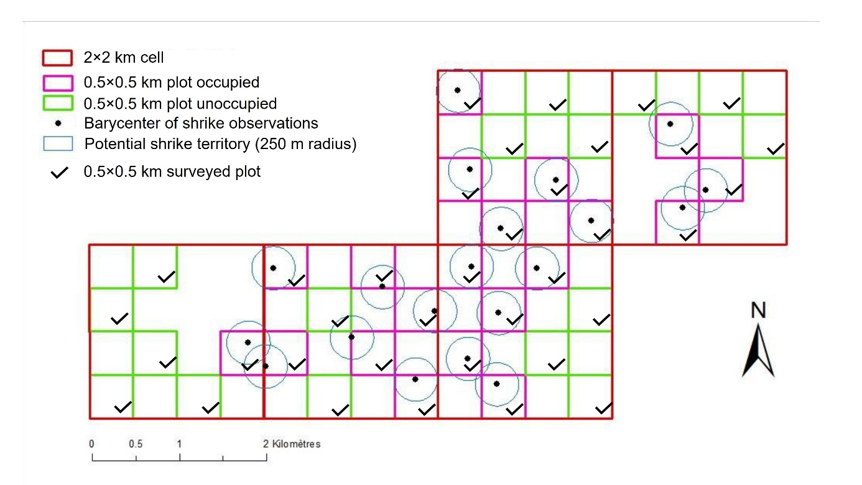
Such a low frequency of uncertain data results from the staggered distribution of plots in combination with the relatively low proportion of occupied plots (1 out of 4 in average). We are therefore confident our analysis did not suffer from this potential bias (double counting in neighbour plots).

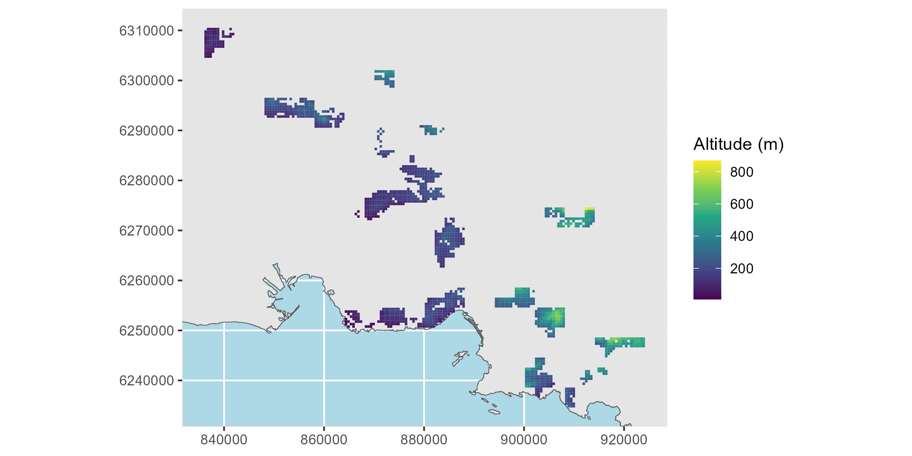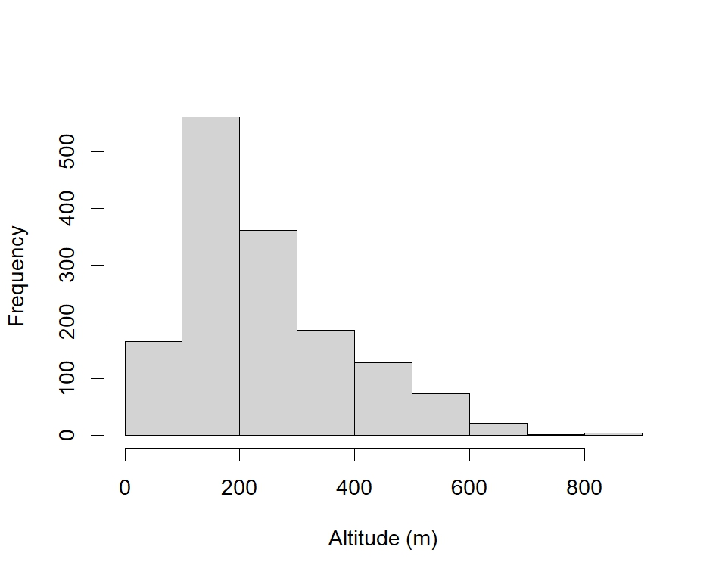 Figure S4: Maps (SCR EPSG 2154; top panel) and histogram (bottom panel) of the habitat-related explanatory variables (continued on next four pages).

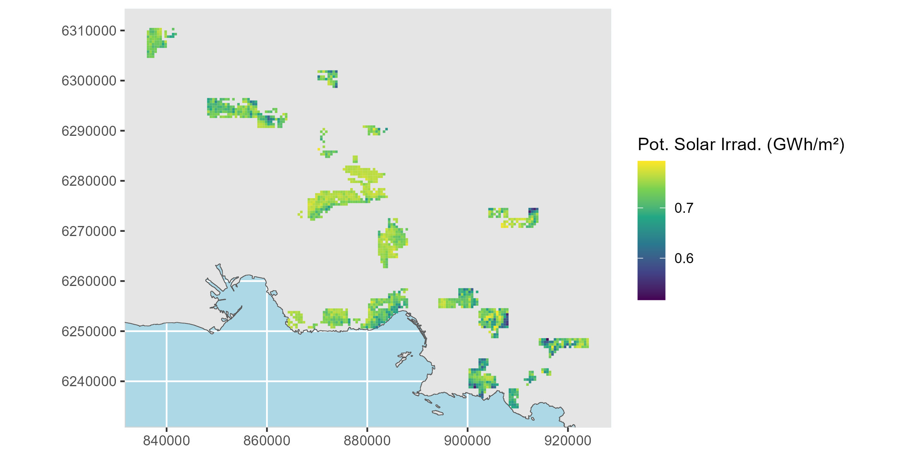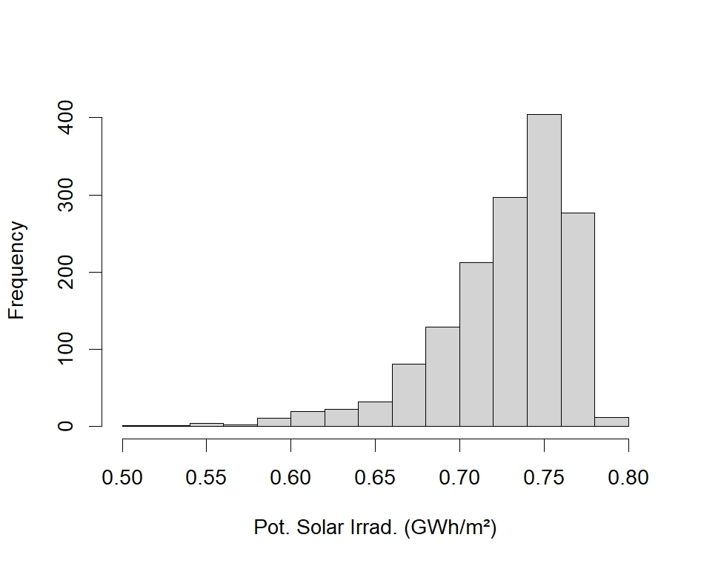
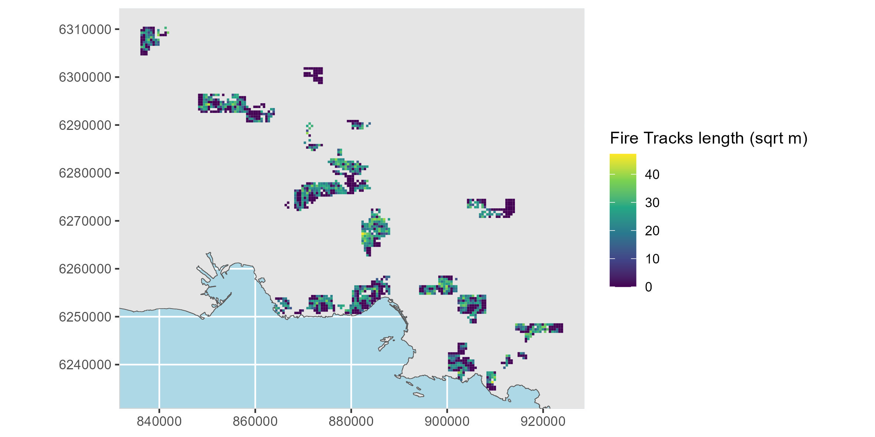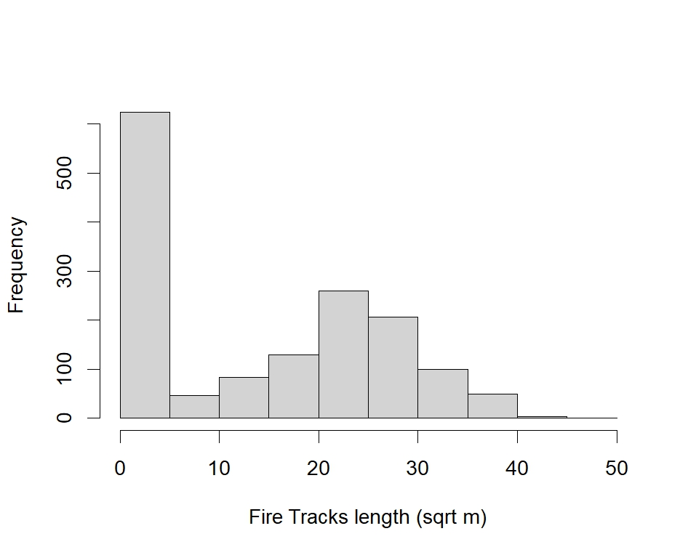

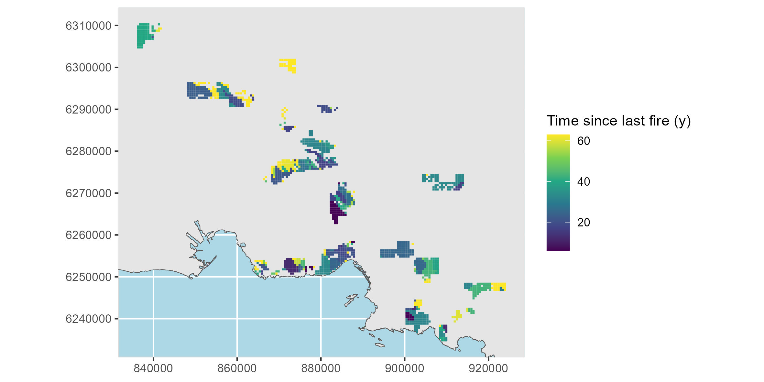
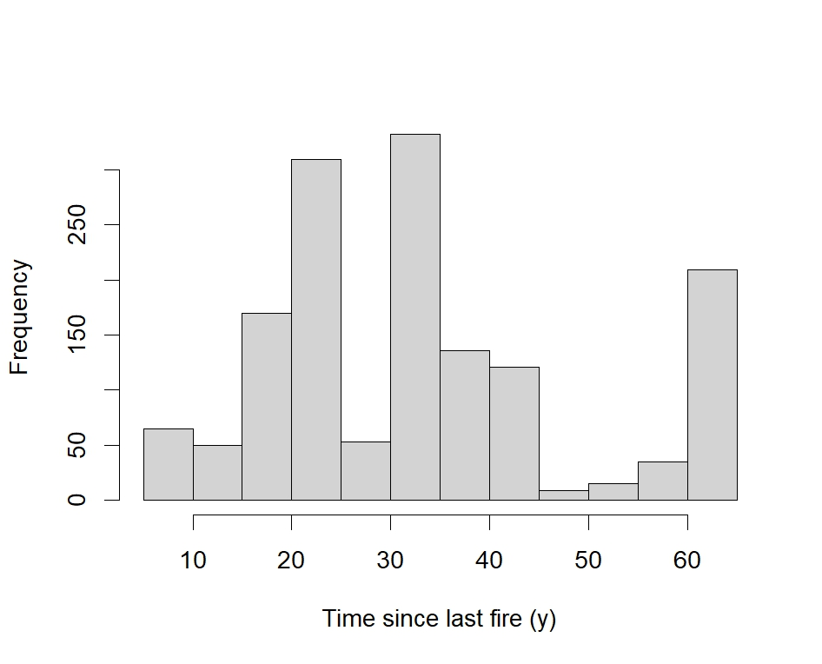
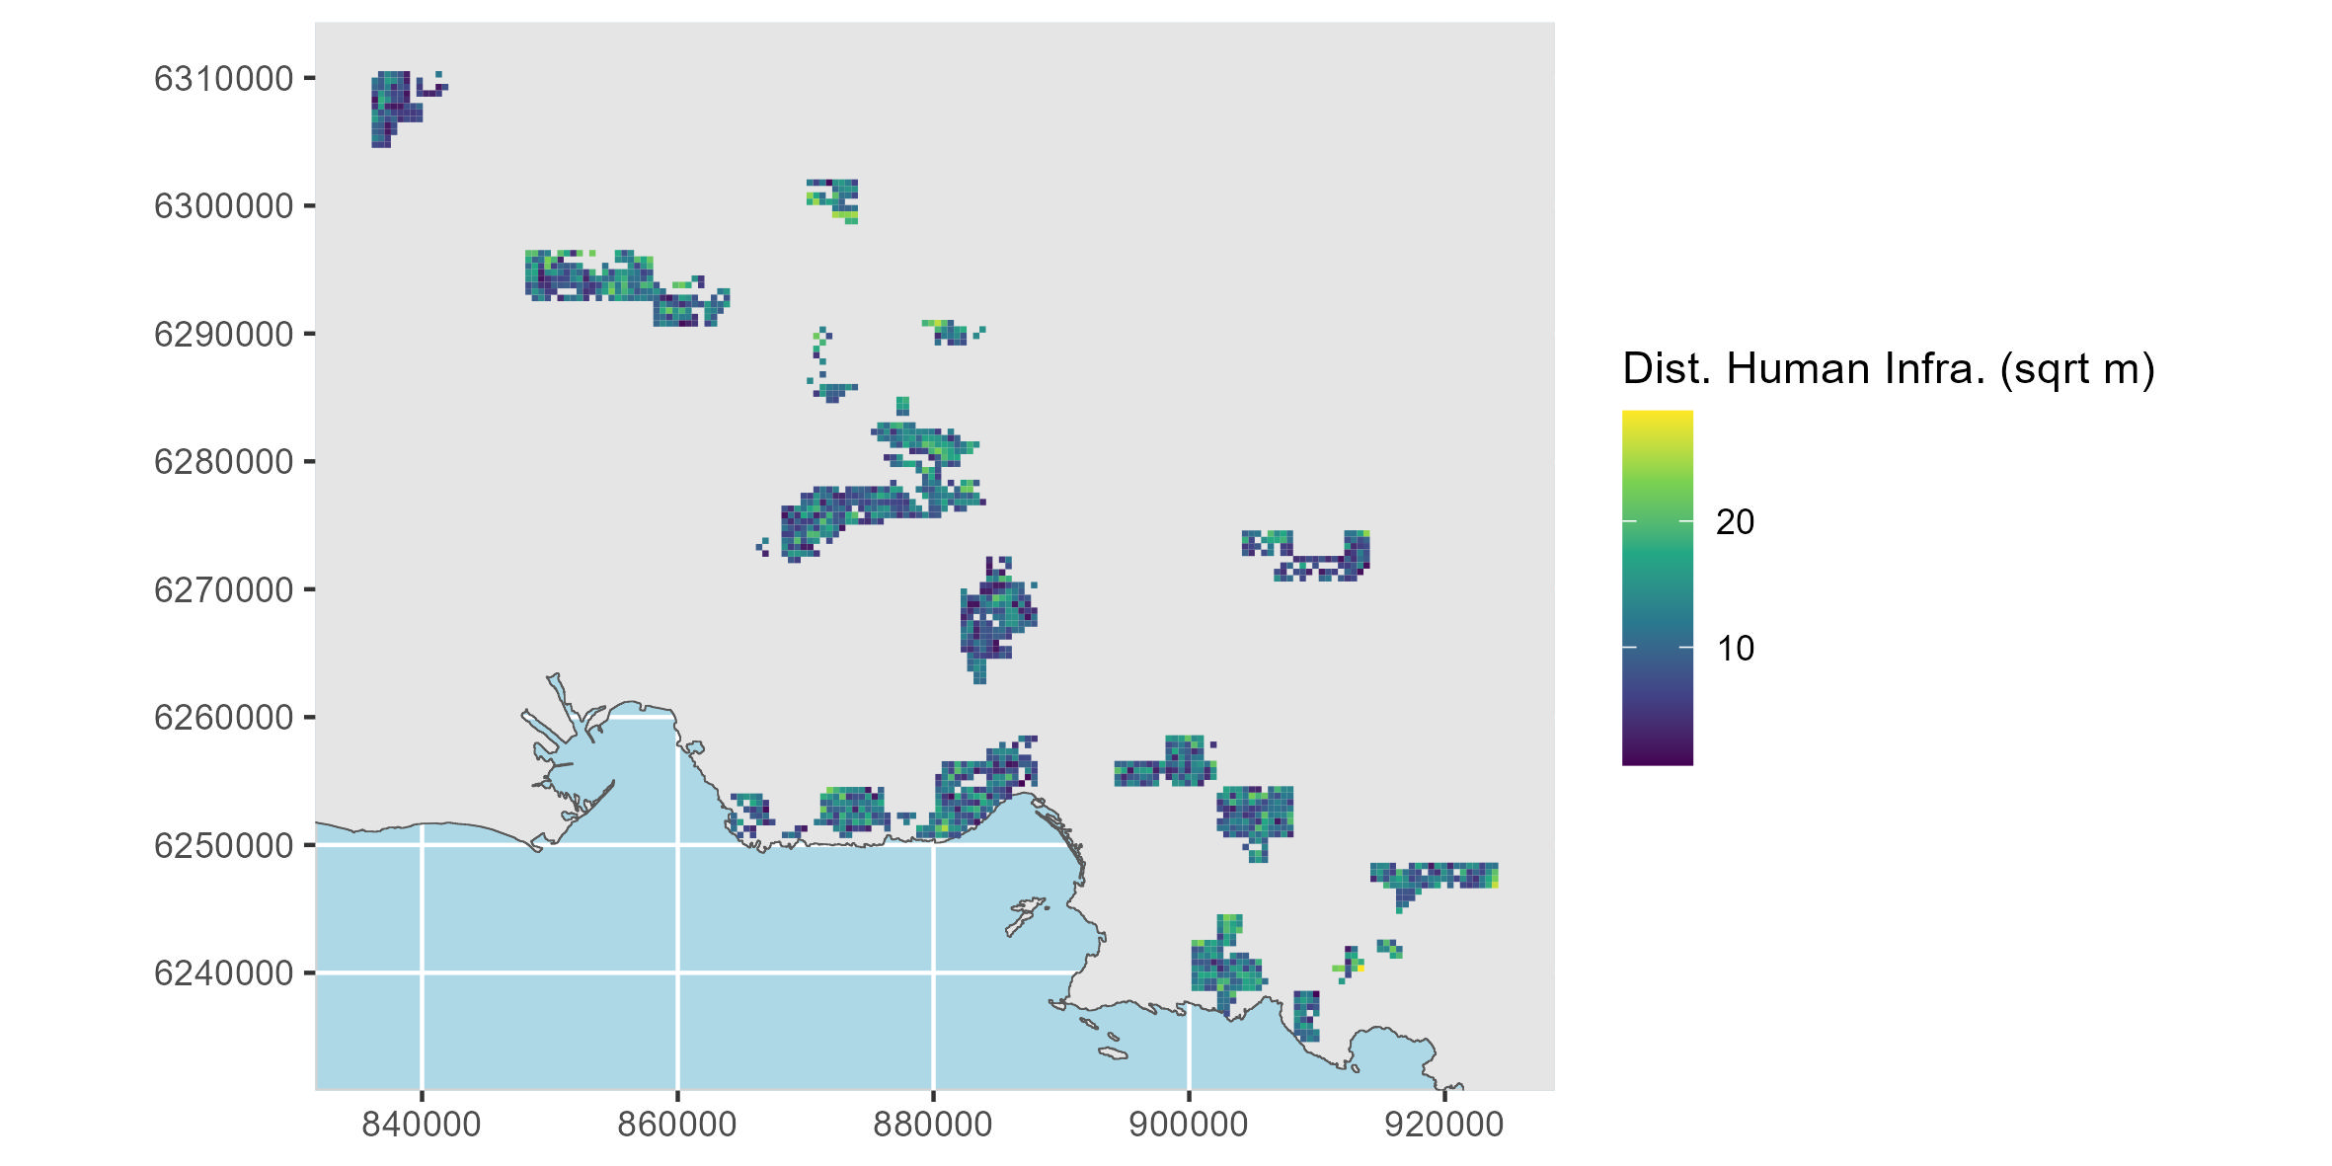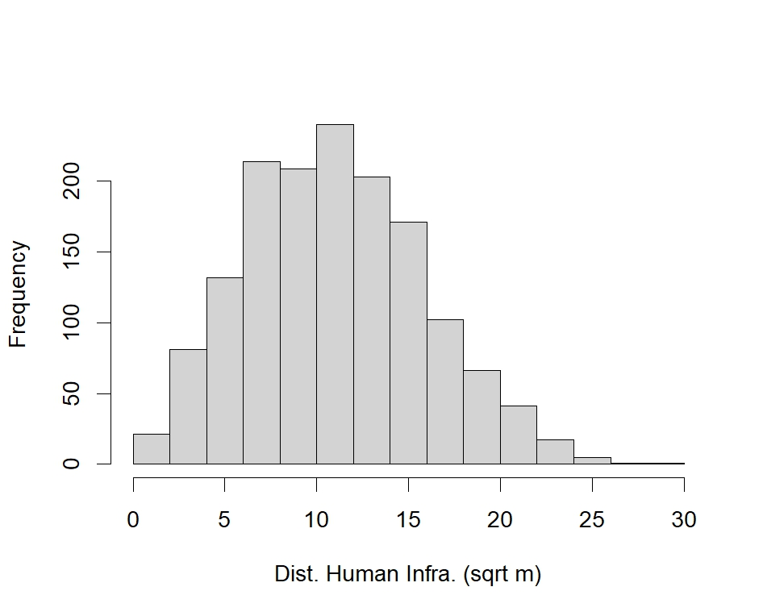

Appendix 2: Detailed methodology about the calculation of the habitat-related explanatory variables
used to model the probability of occurrence of the Iberian Grey Shrike
Track length (m) – Fire tracks, corresponding to cleared linear paths, with 25 meters wide safety cleared strip on both sides, to facilitate access for fire-fighting forces, contribute to the opening up of habitats. We extracted the sum of fire track length within each 0.5×0.5 km plot by intersecting the data from SIG-DFCI 13© (The fire brigade unit to protect forests against fire) with the 0.5×0.5 km grid (using st_intersection function from sf R library), calculating the length of each track’s portion (st_length) and computing the sum of the length of all portions of tracks within each 0.5x0.5 plot.
Time since last fire (number of years) – Vegetation fires are currently the main factor of habitat opening in the study area. The time elapsed since the last vegetation fire in the plot reveals somehow the degree of habitat openness and area of bare ground. Fire data contain the spatial extent and date of all fires that occurred in the study area between 1960 and 2022 (source: DDTM Bouches-du-Rhône & DDT Vaucluse). A fire was considered to have had a significant impact on the degree of habitat openness within a plot if its extent covered at least 25% of the plot. To extract these impacting fires, we intersected the fire dataset with the 0.5×0.5 km grid (st_intersection), computed the proportion of the plot covered by each individual fire, and filtered for those with proportion ≥ 25%. Then for each plot and for each year of survey, we computed the time since the last fire as t_{y} = (y-1) - (y_{r}) , y being the year of the survey and y_{r} being the year of the most recent fire before year y. Fires that occurred the year before the year of the survey (y) were considered as the one having an impact on the habitat openness of the year y (fires typically occur in the second half of the year, i.e. after the breeding season). When no fire occurred since 1960, we set y_{r} to 1955.
Topography – Mean Altitude (m above sea level) and mean Slope (degrees) across the 0.5x0.5km plot were computed from the 25m resolution Digital Elevation Model (dem) RGE ALTI®(IGN), using function terrain from the terra R library. A value of slope was first calculated for each 25 m x 25 m pixel using the eight 25 m x 25 m neighbor pixels (as the slope is the difference between the elevation of the given pixel and the elevation of its neighbors). Then the slope values of the four 25 m x 25 m pixels included into each 0.5x0.5 km were averaged to compute the mean slope value per plot. We changed the text accordingly
Potential Global Irradiation (MWh.m⁻²) – Potential solar energy received on the ground, which depends mainly on topography and exposure at the scale of the study area, is expected to favour the abundance of insects (Uhler et al., 2021), and thus the main food resource for shrikes, particularly during the breeding season (March to June). Daily Global Irradiation in Wh.m⁻², was computed at the extent of the whole study area for the period from the 1st of March to the 30th of June using the Potential incoming solar radiation tool in Qgis 3.34, with the 25-m resolution dem and default settings. We then computed the sum of the 122 rasters in R and extract the mean potential Global Irradiation for the breeding period per plot. Mean Potential Global Irradiation value by plot was then divided by 1 million.
Distance to human infrastructure (m) – In order to assess for each plot, each surveyed year, its degree of disturbance of human origin, we extracted from a land-cover database the distance between plot’s centroid and the closest human infrastructures. We used the OSO database (Inglada et al., 2017), which provides at a 10-m spatial and at 1-year temporal resolution (2016-2023) the classification of land into 17 classes for the 2016-2017 period (a) and into 24 classes for the 2018-2023 period (b). We used the nncross function of the spatstat.geom R library to compute each year the minimum distance of the plot centroid to human infrastructures, considering as so the impervious surfaces (including classes: “dense urban areas” (41 in a and 1 in b), “scattered urban areas” (42 in a and 2 in b), “Industrial and commercial areas” (43 in a and 3 in b) and “roads” (44 in a and 4 in b). OSO land-cover data for 2016 were used to compute the variables for plots surveyed in 2013 and 2015.

Figure S5: Moran’s I correlogram of the residuals from the site-occupancy model (N = 1276 plot×year), a lag of 500m and a weighted neighbour matrix build using the row standardised approach (« W »).
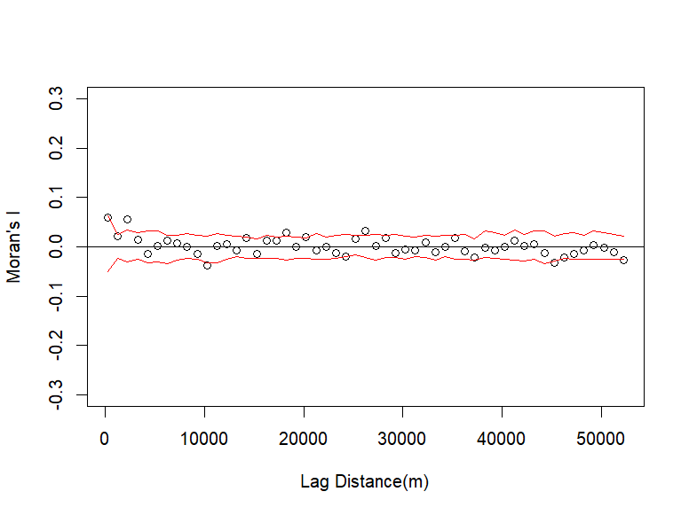

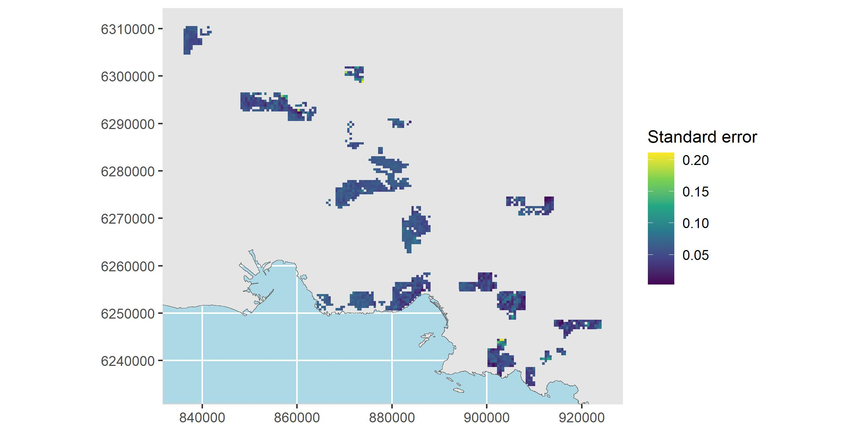
Figure S6: Map of standard errors associated to the predicted probabilities of occupancy of the Iberian grey shrike in the Mediterranean scrubland of south-eastern France (to be compared with Figure 4 in the main text.

